SUBCOURSE EDITION
SS 0120 A

US ARMY SIGNAL CENTER AND FORT GORDON

EMPLOY COMMUNICATIONS SYSTEMS OF A
MANEUVER BRIGADE/BATTALION/
BATTALION TASK FORCE

(SC 25C)

DEVELOPMENT DATE: SEPTEMBER 1992

EMPLOY COMMUNICATIONS SYSTEMS OF
A MANEUVER BRIGADE/BATTALION/BATTALION TASK FORCE

Subcourse Number SS0120

EDITION B

United States Army Signal School
Fort Gordon, Georgia 30905

5 Credit Hours

Edition Date: September 1992

SUBCOURSE OVERVIEW

This subcourse is designed teach you how a maneuver brigade, battalion, and battalion task force are organized, and what signal support they require. This subcourse also covers signal support considerations for units equipped with Army Tactical Communications Systems, signal plans and orders, and signal support in low intensity conflict.

The prerequisite for this subcourse is that you are a graduate of the Signal Officer Basic Course.

This subcourse reflects the doctrine which was current at the time it was prepared. In your own work situation, always refer to the latest official publications.

Unless otherwise stated, the masculine gender of singular pronouns is used to refer to both men and women.

TERMINAL LEARNING OBJECTIVE

ACTION: You will learn how to employ communications systems of a maneuver brigade, battalion, and battalion task force.

CONDITION: Given this subcourse.

STANDARD: To demonstrate competency, you must achieve a minimum of 70% on the subcourse examination.

i SS0120

TABLE OF CONTENTS

Section Page

Subcourse Overview i

Administrative Instructions iv

Grading and Certification Instructions v

Lesson 1: Organization of a Maneuver Brigade/Battalion/
Battalion Task Force 1-1

Practice Exercise 1-19

Answer Key and Feedback 1-21

Lesson 2: Signal Support Requirements of a Maneuver Brigade/Battalion/
Battalion Task Force 2-1

Part A: Single-Channel Radio and Wire Communications 2-2

Part B: Radio and Wire Diagrams in the Maneuver Brigade 2-5

Part C: Radio and Wire Diagrams in the Maneuver Battalion 2-14

Part D: Maneuver Battalion (Heavy and Light) Signal
Support System 2-16

Part E: Summary 2-33

Practice Exercise 2-35

Answer Key and Feedback 2-39

Lesson 3: Signal Support Considerations of Units Equipped with
Army Tactical Communications Systems 3-1

Practice Exercise 3-15

Answer Key and Feedback 3-19

SS0120 ii

Lesson 4: Signal Estimate, Paragraph 5 of Operations Order,
Signal Annex of Operations Order 4-1

Practice Exercise 4-19

Answer Key and Feedback 4-23

Lesson 5: Heavy-Light/Light-Heavy Task Force Signal Support
Systems in Support of Offensive and Defensive Operations 5-1

Part A: Signal Systems Planning 5-2

Part B: Communications Operations in Support of
TF Operations 5-16

Part C: Summary 5-24

Practice Exercise 5-25

Answer Key and Feedback 5-27

Lesson 6: Signal Support Considerations in Contingency Operations 6-1

Part A: Signal Support in a LIC Environment 6-2

Part B: Signal Support Planning 6-4

Part C: Summary 6-13

Practice Exercise 6-15

Answer Key and Feedback 6-17

Examination E-1

Appendix: Acronyms and Abbreviations A-1

Student Inquiry Sheets

iii SS0120

THIS PAGE INTENTIONALLY LEFT BLANK

SS0120 iv

GRADING AND CERTIFICATION REQUIREMENTS

Examination: This subcourse contains a multiple-choice examination covering the material in the six lessons. After studying the lessons and working through the practice exercises, complete the examination. Mark your answers in the subcourse booklet, then transfer them to the ACCP examination response sheet. Completely black out the lettered oval which corresponds to your selection. Use a number 2 lead pencil to mark your responses. When you complete the ACCP examination response sheet, mail it in the preaddressed envelope you received with this subcourse. You will receive an examination score in the mail. You will receive five credit hours for the successful completion-of this examination.

*** IMPORTANT NOTICE ***

THE PASSING SCORE FOR ALL ACCP MATERIAL IS NOW 70%.

PLEASE DISREGARD ALL REFERENCES TO THE 75% REQUIREMENT.

v SS0120

THIS PAGE INTENTIONALLY LEFT BLANK

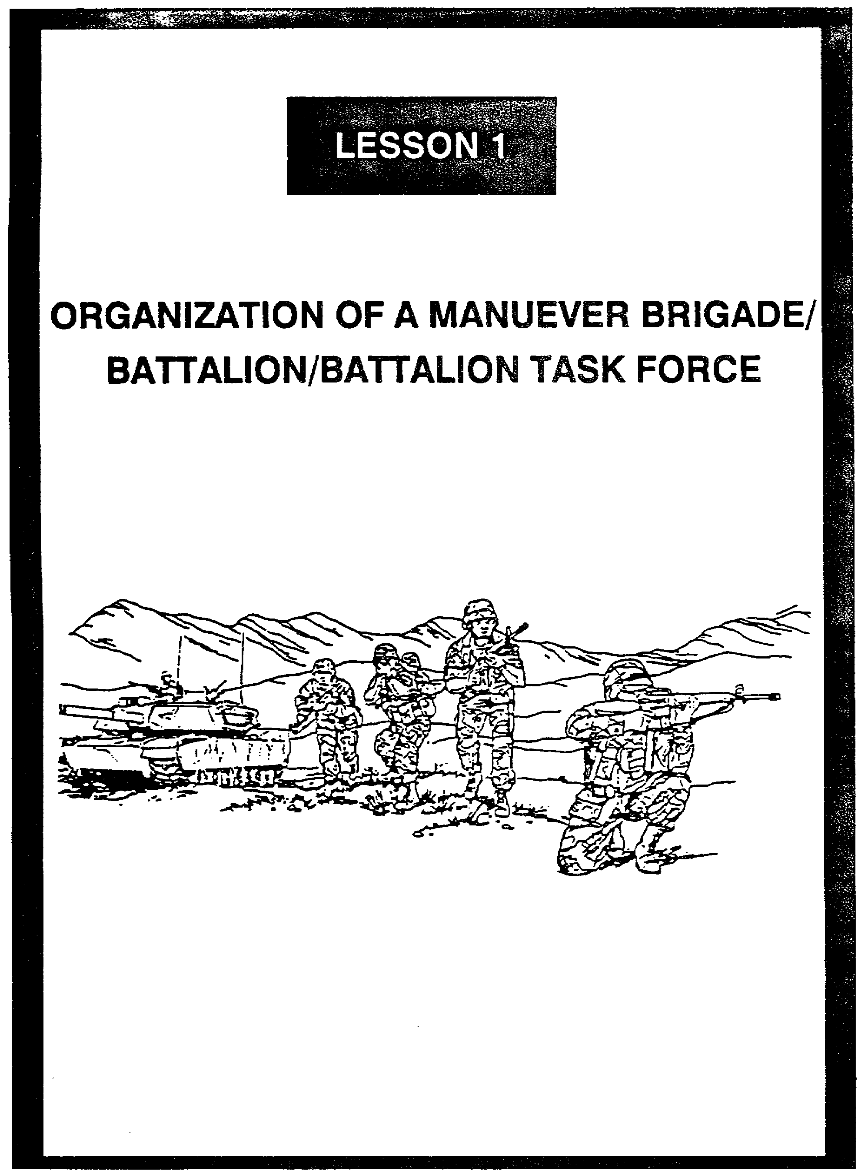

LESSON 1

ORGANIZATION OF A MANEUVER BRIGADE/BATTALION/
BATTALION TASK FORCE

Critical Tasks: 01-5840.07-0002
01-5841.07-0001

OVERVIEW

LESSON DESCRIPTION:

In this lesson, you will learn about the organization and composition of a maneuver brigade, battalion, and battalion task force.

TERMINAL LEARNING OBJECTIVE:

ACTION: Explain the organizational structure for a maneuver brigade, battalion, and battalion task force.

CONDITION: You will have this lesson.

STANDARD: To demonstrate competency, you must achieve a minimum of 70% on the subcourse examination.

REFERENCES: The material in this lesson was derived from the following publications:
FM 7-20, FM 7-30, FM 11-50, FM 24-1, FM 24-22, FM 71-2, FM 71-3, FM 71-100, FM 101-5-1, TRADOC Pamphlet 11-9, TOE Handbook 07015L-CTH, and TOE Handbook 307245L-CTH.

INTRODUCTION

Maneuver brigades and battalions are the division's fighting forces. As a signal officer, you may be assigned to one of these echelons, where you will be working with the operations officer and advising the commander on signal matters. You must know how these units are organized so you can provide the finest signal support. Before you study the maneuver brigade and battalion organizations, you need to know the various types of divisions and the overall mission of each.

1-1 SS0120

1. Types of Divisions. The Army has six types of divisions (armored, mechanized, infantry, light infantry, airborne, and air assault).

a. Armored and mechanized divisions. The Army's heavy divisions (armored and mechanized) provide mobile, armor-protected firepower. Because of their mobility and survivability, the heavy divisions are employed over wide areas where they are afforded long-range and flat-trajectory fire. They destroy enemy armored forces and seize and control land areas, including populations and resources. During offensive operations, heavy divisions can rapidly concentrate overwhelming combat power to break through or envelop enemy defenses. They then strike to destroy fire support, command and control, and service support elements. Using mobility for rapid concentration to attack, reinforce, or to block, they defeat an enemy while economizing forces in other areas. Heavy divisions operate best in basically open terrain where they can use their mobility and long-range, direct fire weapons to the best advantage.

b. Infantry division. The infantry division is predominantly a dismounted, ground-gaining, combined arms force capable of operations across the entire spectrum of conflict. It can be effectively employed in most terrain and environmental conditions where heavy forces cannot exercise their full battlefield mobility and firepower. The infantry division is best employed in terrain favoring dismounted operations, such as urban areas. When the division is organized with motorized combat assets, its tactical mobility and antiarmor potential is greatly increased.

c. Light infantry division. The organization of the light infantry division provides the flexibility to accomplish missions on a global basis on different types of terrain and against a variety of enemy forces. It differs from other divisions in both design and concept of employment. The light infantry division is rapidly deployable and is organized to fight as part of a larger force, in conventional conflicts, or independently in a low intensity conflict (LIC). The ability of the light infantry division command and control structure to readily accept augmentation forces permits task organizing for any situation from low to high-intensity conflicts. The factors of mission, the enemy situation, terrain, troops and time available (METT-T) largely determine the augmentations required. Although employed as an entity, the division method of operation is to disperse widely throughout a large area and conduct synchronized but decentralized operations which exploit the advantages of restricted terrain and limited visibility. Mass is achieved through the combined effects of synchronized, small-unit operations and fires, rather than the physical concentration and weight of forces. Massing of light division forces only occurs when the risk is low and the payoff is high.

d. Airborne division. The airborne division is tailored for airdrop operations and can be deployed more rapidly than other U.S. divisions. The range of aircraft and instrumentation capability provide the Air Force with the capability to accurately deliver the airborne division into virtually any objective area under almost any weather condition.

SS0120 1-2

(1) The airborne division conducts airborne assaults in the enemy's rear to secure terrain or to interdict routes of resupply or enemy withdrawal. It is ideally suited to seize, secure, and repair airfields to provide a forward operating base for follow-on air-landed forces. It can conduct air assault operations, as well as other missions normally assigned to infantry divisions.

(2) The staff must give special consideration to attack by enemy armor or motorized formations. The division does not have sufficient armor protection to defeat heavier armored formations at close range. Substantial numbers of antitank weapons in the division compensate for, but do not completely offset an enemy armor advantage.

e. Air assault division. The air assault division combines strategic mobility with an extremely high degree of tactical mobility within its area of operations. The air assault division conducts combat operations with infantry, aviation, and the needed combat support (CS) and combat service support (CSS) to strike over extended distances and terrain obstacles to attack the enemy.

(1) The air assault division provides the operational foundation, experience, and tactics for air assault division operations. However, the air assault division no longer only conducts airmobile operations. You need to know the distinction between airmobile and air assault. Airmobility is the use of Army aircraft whenever and however they improve our ability to fight. Essentially, movement of troops and equipment from one secure area to another is conducted, then the helicopters depart the area of operations after insertion. Conversely, air assault operations involve combat, CS, and CSS elements (aircraft and troops) deliberately task organized for tactical operations. Aviation is the prime mover and aircraft are integrated with ground forces. In addition, air assault operations generally involve insertions and extractions under hostile conditions, as opposed to the mere air movement of troops to and from secure locations about the battlefield.

(2) Once deployed on the ground, air assault infantry battalions fight like those of the infantry division; however, the normal task organization of organic aviation permits rapid aerial redeployment. The essence of air assault tactics is a rapid tempo of operations over extended ranges. Execution of successive air assault operations enables the division commander to seize and maintain the tactical initiative.

2. Divisional Base. Before studying maneuver brigades and battalions, you need to understand the hierarchical relationship, starting at division. This discussion will be limited to maneuver units; you will not study the entire divisional base, which includes combat support and combat service support units. The division/maneuver brigade relationship is illustrated in Figure 1-1, page 1-4.

1-3 SS0120

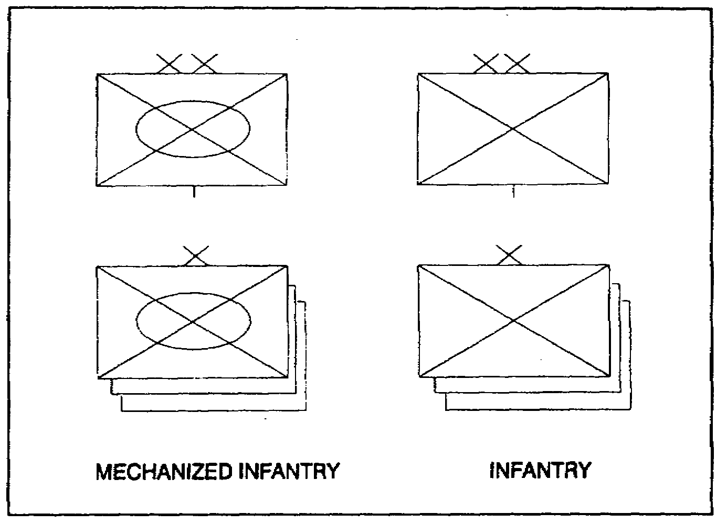

Figure 1-1. Division/maneuver brigade relationship

3. Maneuver Brigade. The maneuver brigade headquarters (HQ) provides the command and control facilities necessary to employ attached and supporting units. The only unit permanently assigned to the brigade is the brigade headquarters and headquarters company (HHC). The necessary combat, CS, and CSS units to accomplish the brigade mission are attached, under operational control (OPCON), or placed in support of the brigade. The HQ company furnishes logistics support, to include ground command vehicle support personnel for the brigade HQ staff sections and security. A brigade normally controls from two to five maneuver battalions. A division commands and controls from two to five ground maneuver brigades.

4. Light Infantry Maneuver Brigade. The light infantry maneuver brigade (Figure 1-2) is particularly suitable for conducting contingency operations in a LIC environment or supporting a heavy force in a heavy-light mix. The light infantry maneuver brigade is task organized with augmentation forces t enable it to perform its mission. When organized for combat, the brigade has between two and five maneuver battalions plus supporting CS and CSS elements provided by the division. Each of these elements has a certain relationship to the brigade; they are not organic to the brigade, but are assigned to it or under its OPCON.

a. The brigade HHC is the only unit permanently assigned to the brigade. It provides command, control, and supervision of the operation of the light infantry brigade and attached units.

SS0120 1-4

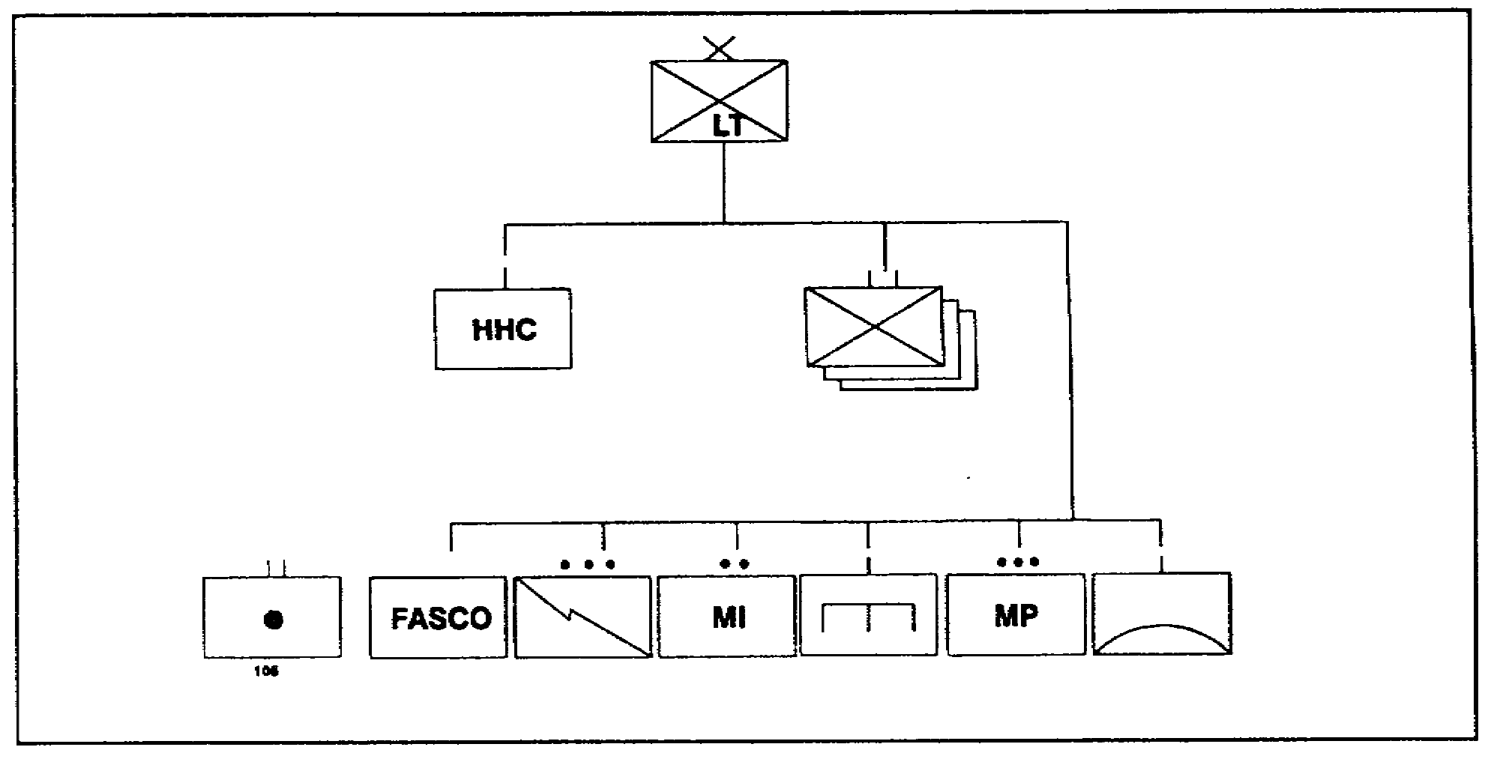

Figure 1-2. Light infantry maneuver brigade organization

b. The mission of the three infantry battalions is to close with the enemy by means of fire and maneuver to destroy or capture him, or to repel his assault by fire, close combat, and counterattack.

c. A 105mm towed howitzer field artillery (FA) battalion provides direct support to the brigade. The FA battalion commander also serves as the brigade fire support coordinator (FSCOORD).

d. An engineer company from the division engineer battalion provides the brigade with obstacle-breaching support mine field clearing capability.

e. Two Mobile Subscriber Equipment (MSE) extension nodes from a platoon in the area signal company of the division signal battalion provide the brigade access to the area common user system.

f. An intelligence and electronic warfare (IEW) section from the division's military intelligence battalion establishes ground surveillance radars (GSR) to detect the presence of enemy ground activity beyond the established perimeter defense.

g. An officer from the forward area support coordination office (FASCO) coordinates logistical support to the brigade and its tactical units. He operates in the brigade support area (BSA) and reports to the division support command (DISCOM) commander. The FASCO coordinates logistic support missions between the brigade and its supporting

1-5 SS0120

DISCOM elements. The DISCOM elements in the BSA are organized into forward area support teams (FAST). One of the FASTs provides direct support maintenance for signal equipment.

h. A military police (MP) platoon from the division's MP company conducts reconnaissance of main supply routes, performs a variety of area security operations, processes enemy prisoners of war, and maintains law and order.

i. An air defense battery from the division's air defense battalion provides air defense support.

5. Light Infantry Maneuver Battalion. Its mission is to close with the enemy by means of fire and maneuver in order to destroy or capture him, or to repel his assault by fire, close combat, and counterattack. The battalion conducts stability operations in an internal defense and development mission in a LIC environment. There are 560 soldier (34 officers, one warrant, and 525 enlisted) in the light infantry maneuver battalion (Figure 1-3).

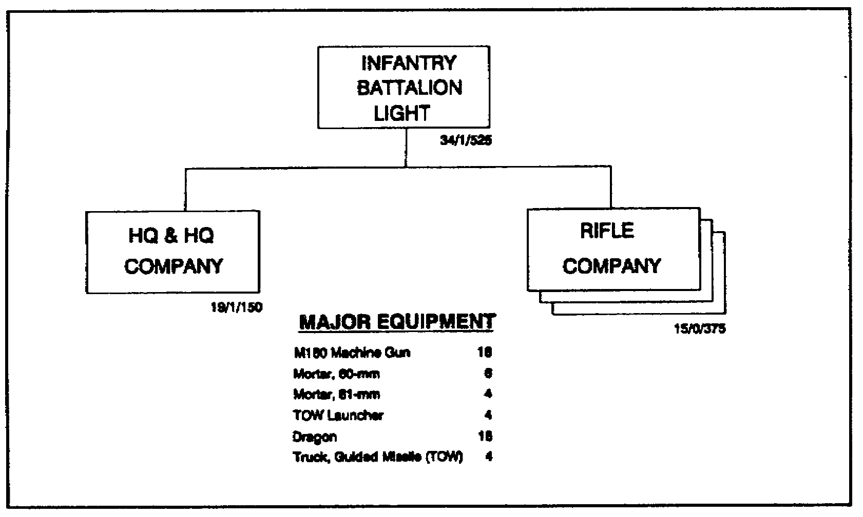

Figure 1-3. Light infantry maneuver battalion

a. The HHC has 170 solders (19 officers, one warrant, and 150 enlisted). Its organization is shown in Figure 1-4. The battalion HQ provide command, control, and supervision of the operation of the light infantry battalion and attached units. The HQ company provide unit administration and logistical support of the battalion staff sections. It also provides reconnaissance, mortar and antitank fire support, unit administration, and logistical and unit-level health services support for the battalion and attached units.

SS0120 1-6

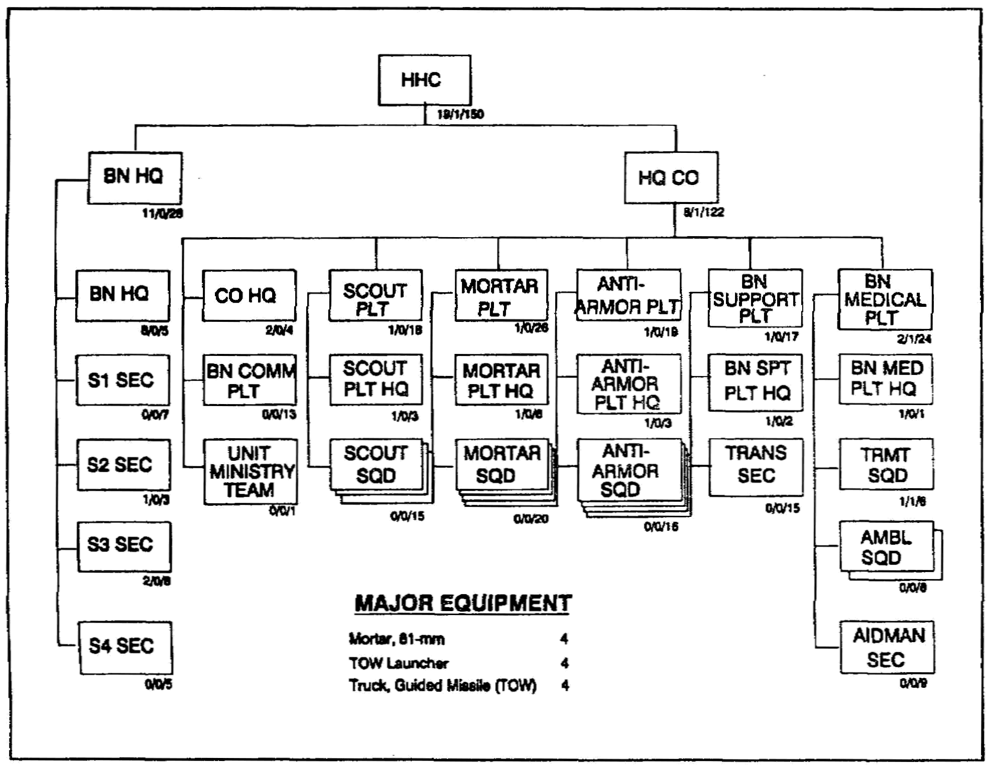

Figure 1-4. Organization of the HHC

(1) The battalion HQ commands, controls, plans, supervises, and supports the training and operations of the battalion.

(2) The company HQ provides administrative and logistical support to the battalion.

(3) The section provides all personnel-related functions in the battalion.

(4) The S2 section collects and processes battlefield information.

(5) The S3 section is responsible for the battalion's operations, plans, and training.

(6) The S4 section plans, coordinates, and effects logistical support for the battalion.

1-7 SS0120

(7) The battalion communications platoon installs, operates, and maintains the communications system for battalion command and control and support elements.

(8) The scout platoon is responsible for training and operating the three scout squads.

(9) The mortar platoon provides the battalion with close and immediate indirect fire support.

(10) The antiarmor platoon provides long-range antiarmor fires in support of the battalion.

(11) The battalion support platoon consists of a platoon HQ and a transportation section that delivers supplies to the battalion's companies.

(12) The battalion medical platoon sorts, treats, and evacuates the sick and wounded.

(13) The unit ministry team, supervised by the battalion chaplain, provides for the religious needs of the battalion's soldiers.

b. The three rifle companies close with the enemy by means of fire and maneuver to destroy or capture him, or to repel his assault by fire, close combat, and counterattack. There are 130 soldiers (5 officers and 125 enlisted) in each rifle company (Figure 1-5).

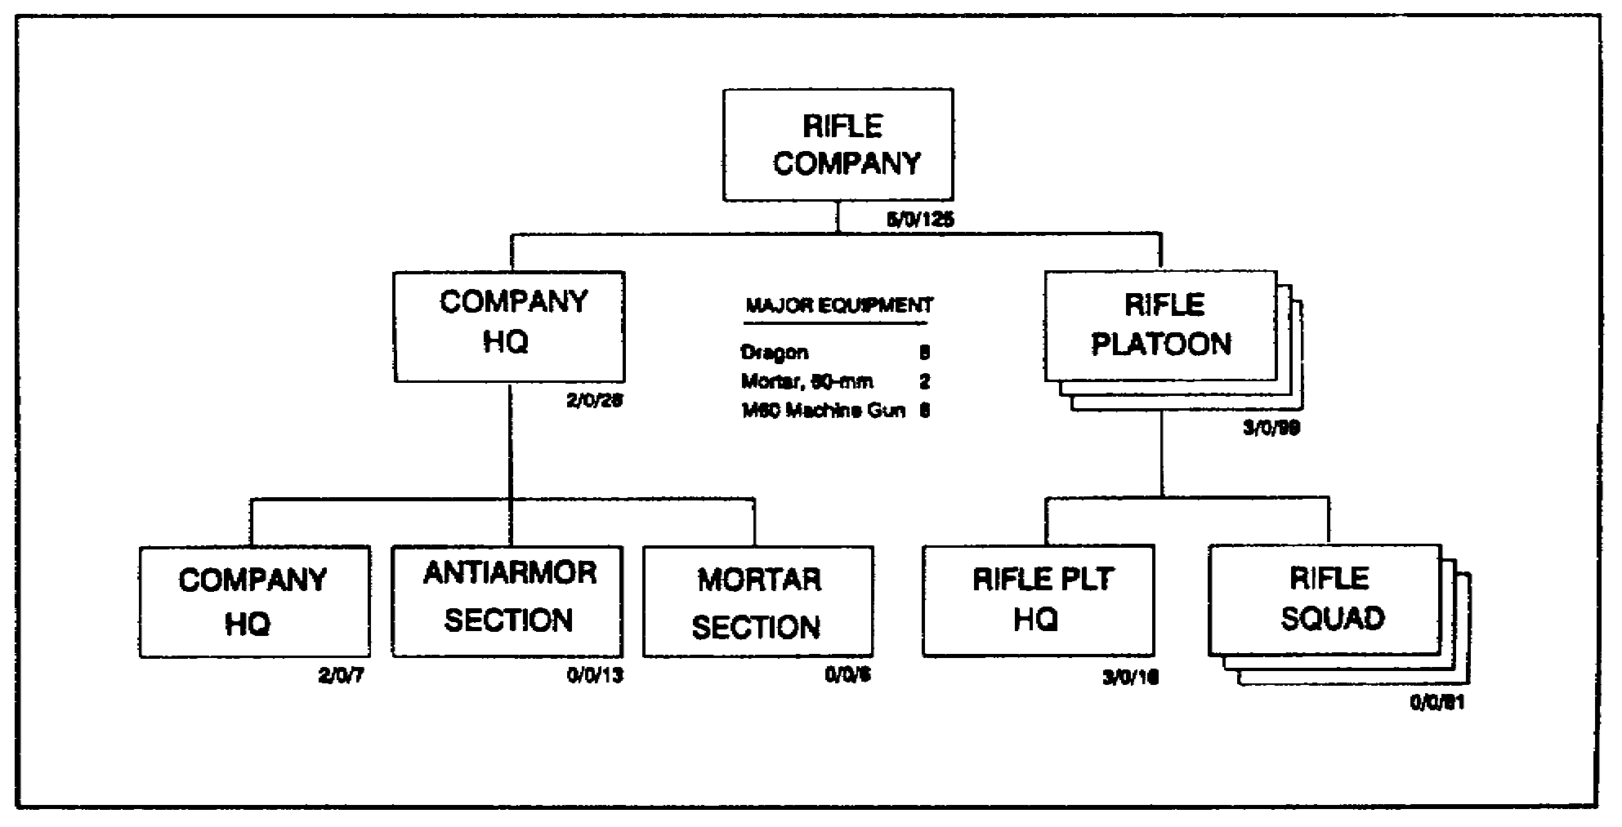

Figure 1-5. Organization of a rifle company

SS0120 1-8

(1) The company HQ provides the command and control and logistical support required for unit operations.

(2) The antiarmor section provides medium antiarmor support to the company.

(3) The mortar section has two 60mm mortar squads, each consisting of one 60mm mortar.

(4) The three rifle platoons each have three squads of riflemen, grenadiers, and automatic riflemen.

6. Mechanized Infantry Maneuver Brigade. This brigade is organized to fight successful battles on any part of the battlefield in conventional, nuclear, or chemical environments (Figure 1-6, page 1-10). The key to victory is the brigade's ability to synchronize subordinate maneuver battalions and integrate CS and CSS combat multipliers in support of its effort. When organized for combat, the brigade has between two and five maneuver battalions and supporting CS and CSS elements. Each of these elements has a certain relationship to the brigade; they are not organic to the brigade, but are assigned to it or under its OPCON.

a. The brigade HHC is the only unit permanently assigned to the brigade. It provides command, control, and supervision of all operations in the brigade and its attached units.

b. The three infantry battalions close with the enemy by means of fire and maneuver to destroy or capture him or to repel his assault by fire, close combat, and counterattack.

c. A 155mm self-propelled howitzer FA battalion provides direct support to the brigade. The FA battalion commander serves as the brigade FSCOORD.

d. An battery from the division's air defense battalion provides air defense coverage.

e. An engineer company from the division's engineer battalion plans and coordinates mobility, countermobility, and survivability tasks to support the mission.

f. A MP platoon from the division's MP company conducts route reconnaissance, performs area security operations, processes enemy prisoners of war, and maintains law and order.

g. Two MSE extension nodes from a platoon in the area signal company of the division's signal battalion provide the brigade access to the area common user system.

h. An IEW section establishes GSRs to detect the presence of any enemy ground activity beyond the established perimeter defense.

1-9 SS0120

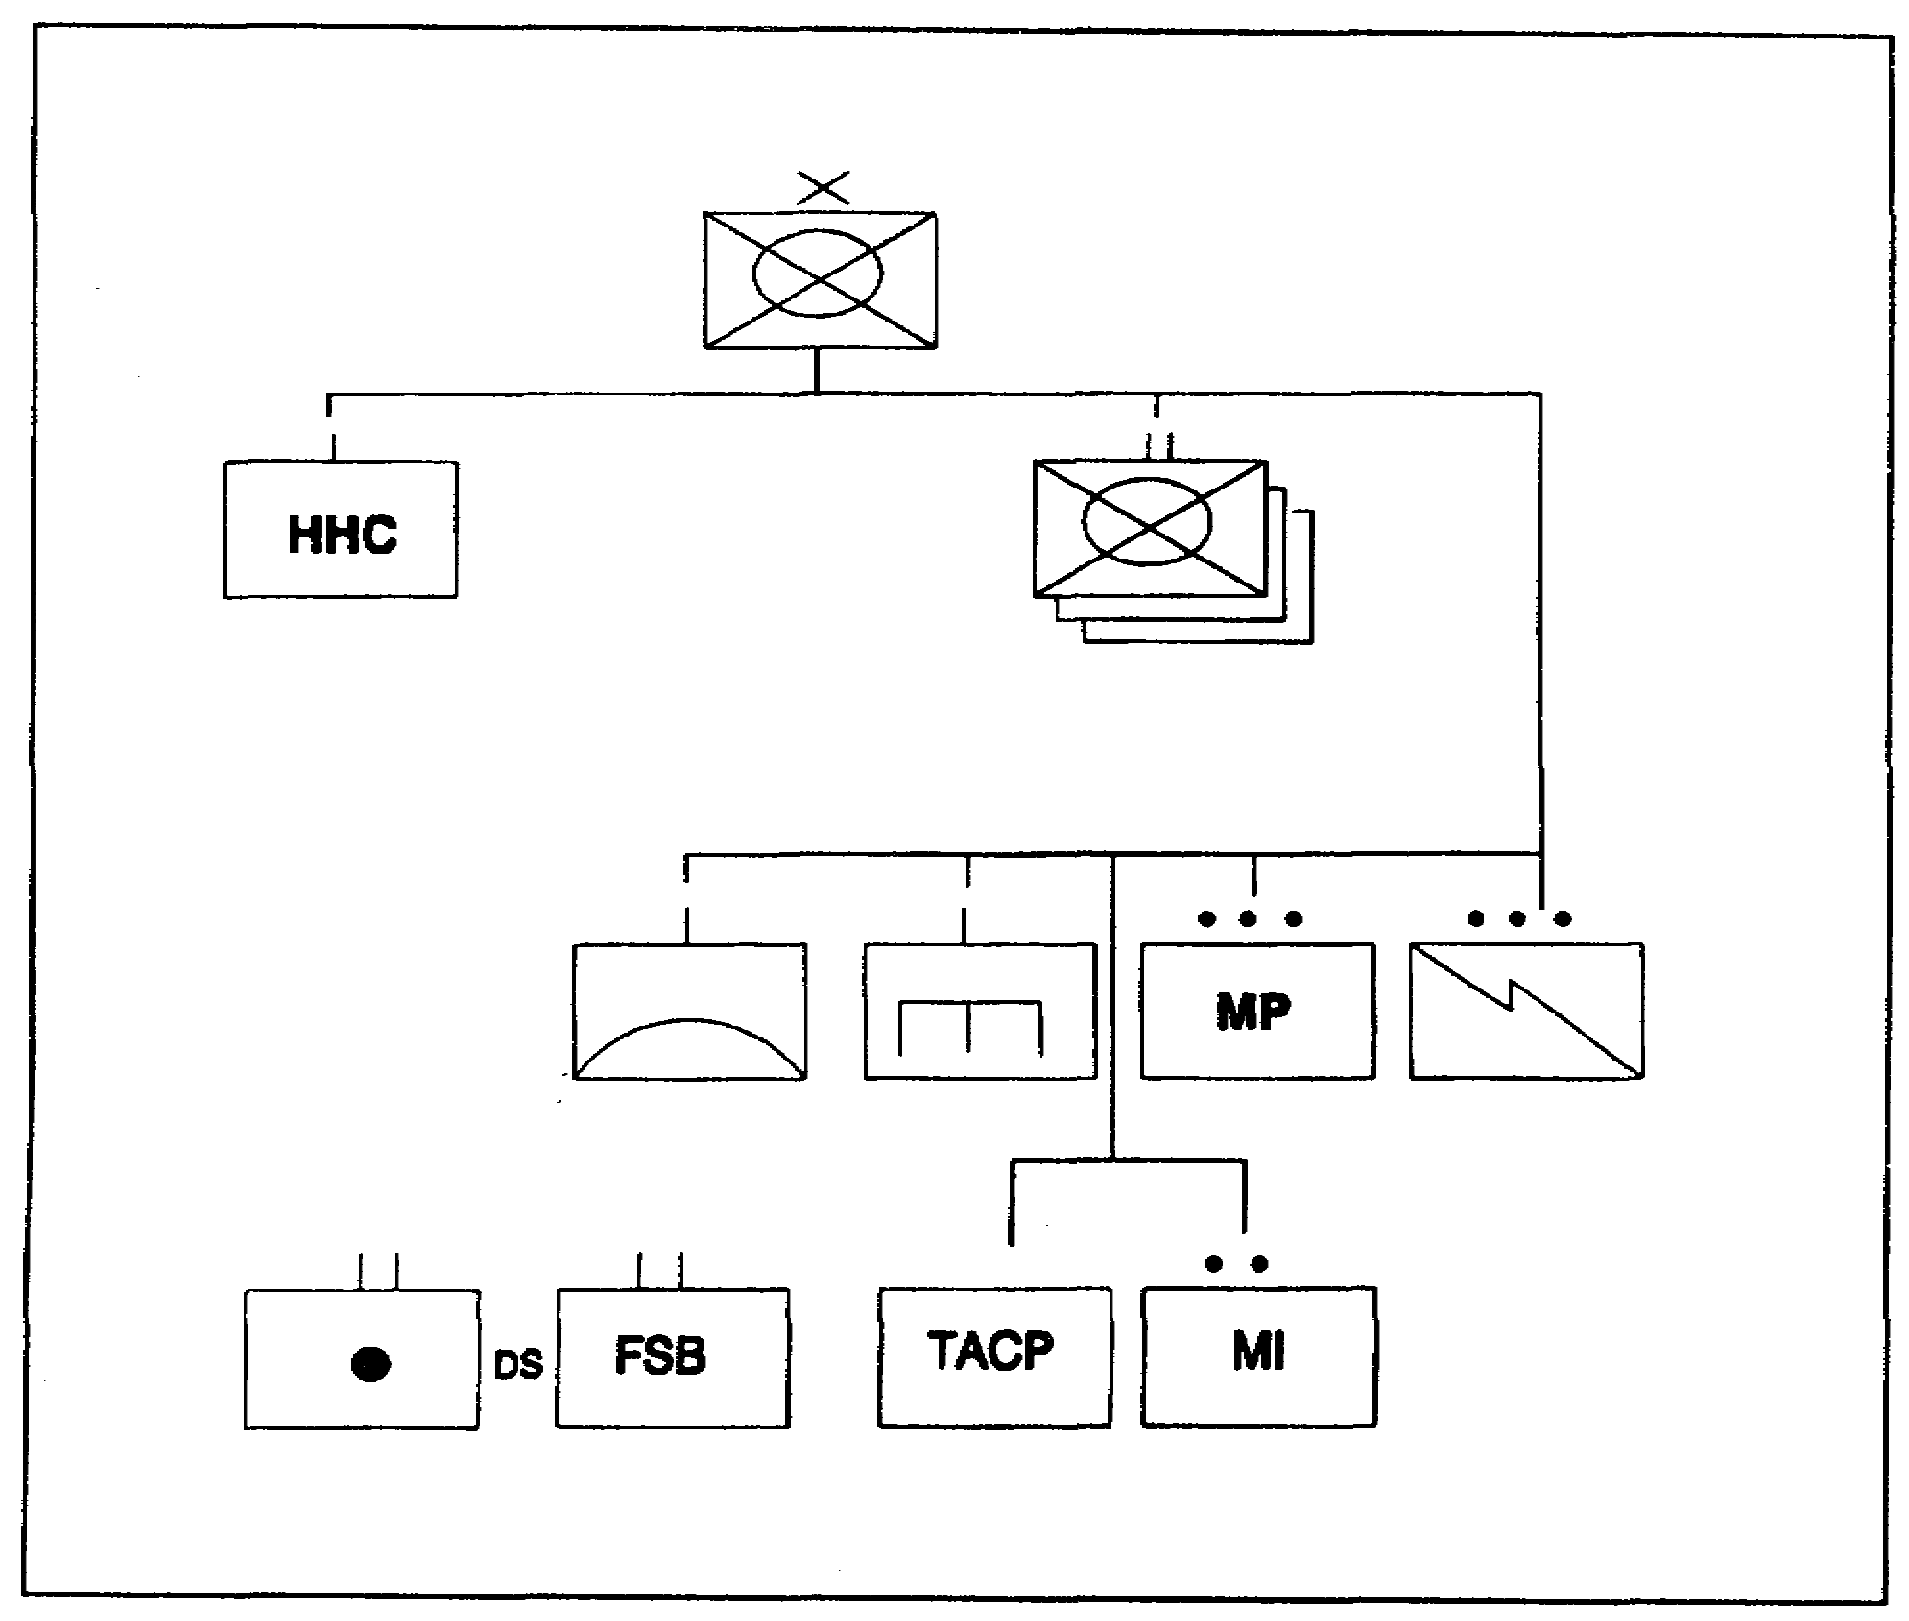

Figure 1-6. Mechanized infantry maneuver brigade

i. A tactical air control party (TACP), provided by the Air Force, provides liaison to the brigade to coordinate close air support (CAS) missions.

j. A forward support battalion (FSB) provides the logistics to support the maneuver brigade's tactical plan.

7. Mechanized Infantry Maneuver Battalion. The battalion's mission is to close with the enemy by means of fire and maneuver to destroy, capture, or repel his assault by fire, close combat, and counterattack. There are 813 soldiers (45 officers, 2 warrants and 766 enlisted) in the mechanized infantry battalion (Figure 1-7).

SS0120 1-10

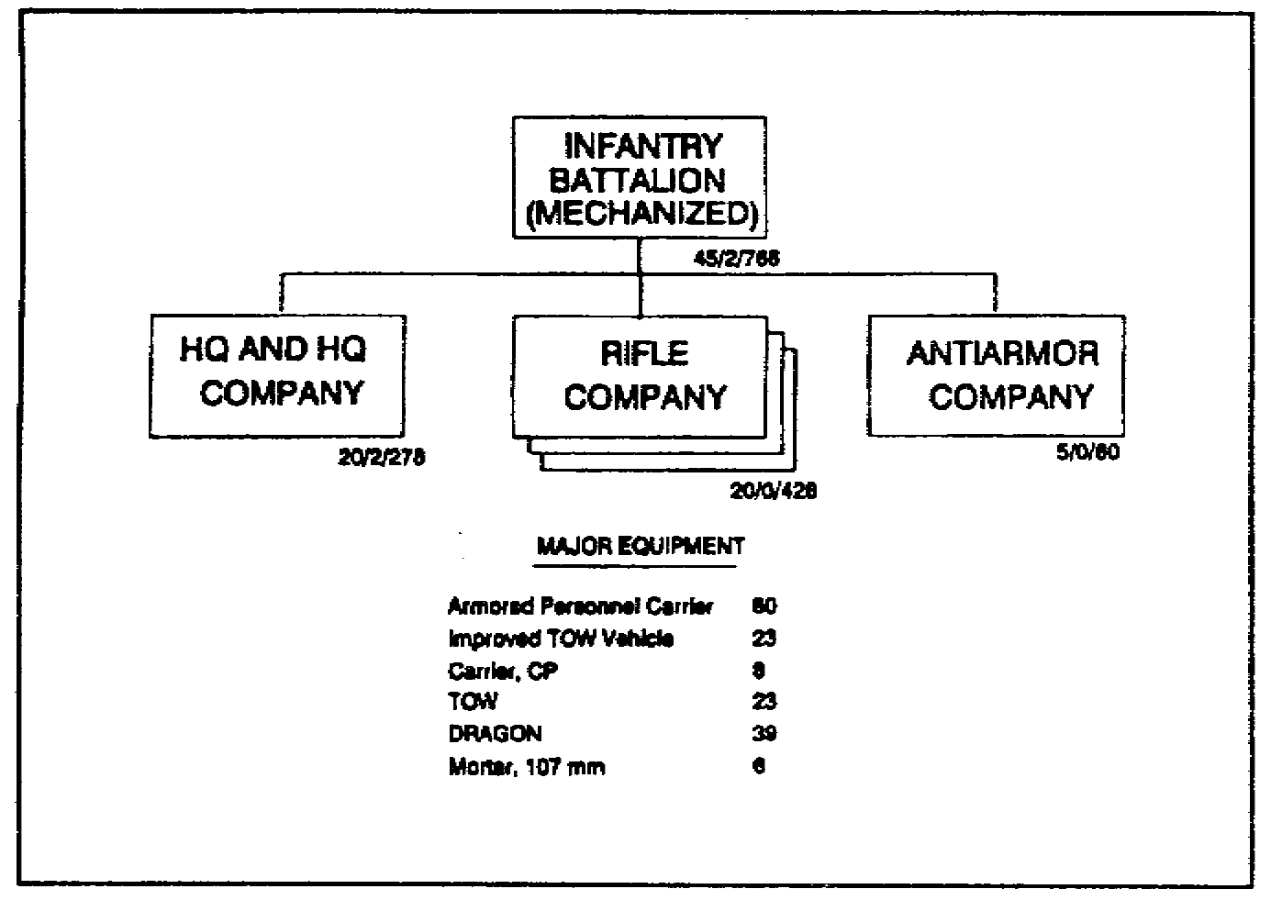

Figure 1-7. Mechanized infantry maneuver battalion

a. The HHC is depicted in Figure 1-8, page 1-12. The battalion HQ provides the battalion units with the command, control, planning, supervision, unit administration, and logistical support required to conduct operations. The HQ company provides unit administration and logistical support for the battalion staff sections. The HQ company also provides mortar fine support, reconnaissance, unit administration, and logistical support to the HHC.

(1) The command section provides command, control, and supervision of the operations of the infantry battalion (mechanized) and attached units.

(2) The S1 section accomplishes personnel functions and administrative matters.

(3) The S2 section is responsible for combat intelligence and intelligence training.

(4) The S3 section is responsible for matters pertaining to the organization, training, and operations of the battalion and attached units.

(5) The S4 section is responsible for maintenance, transportation, facilities, food service, and other logistics.

1-11 SS0120

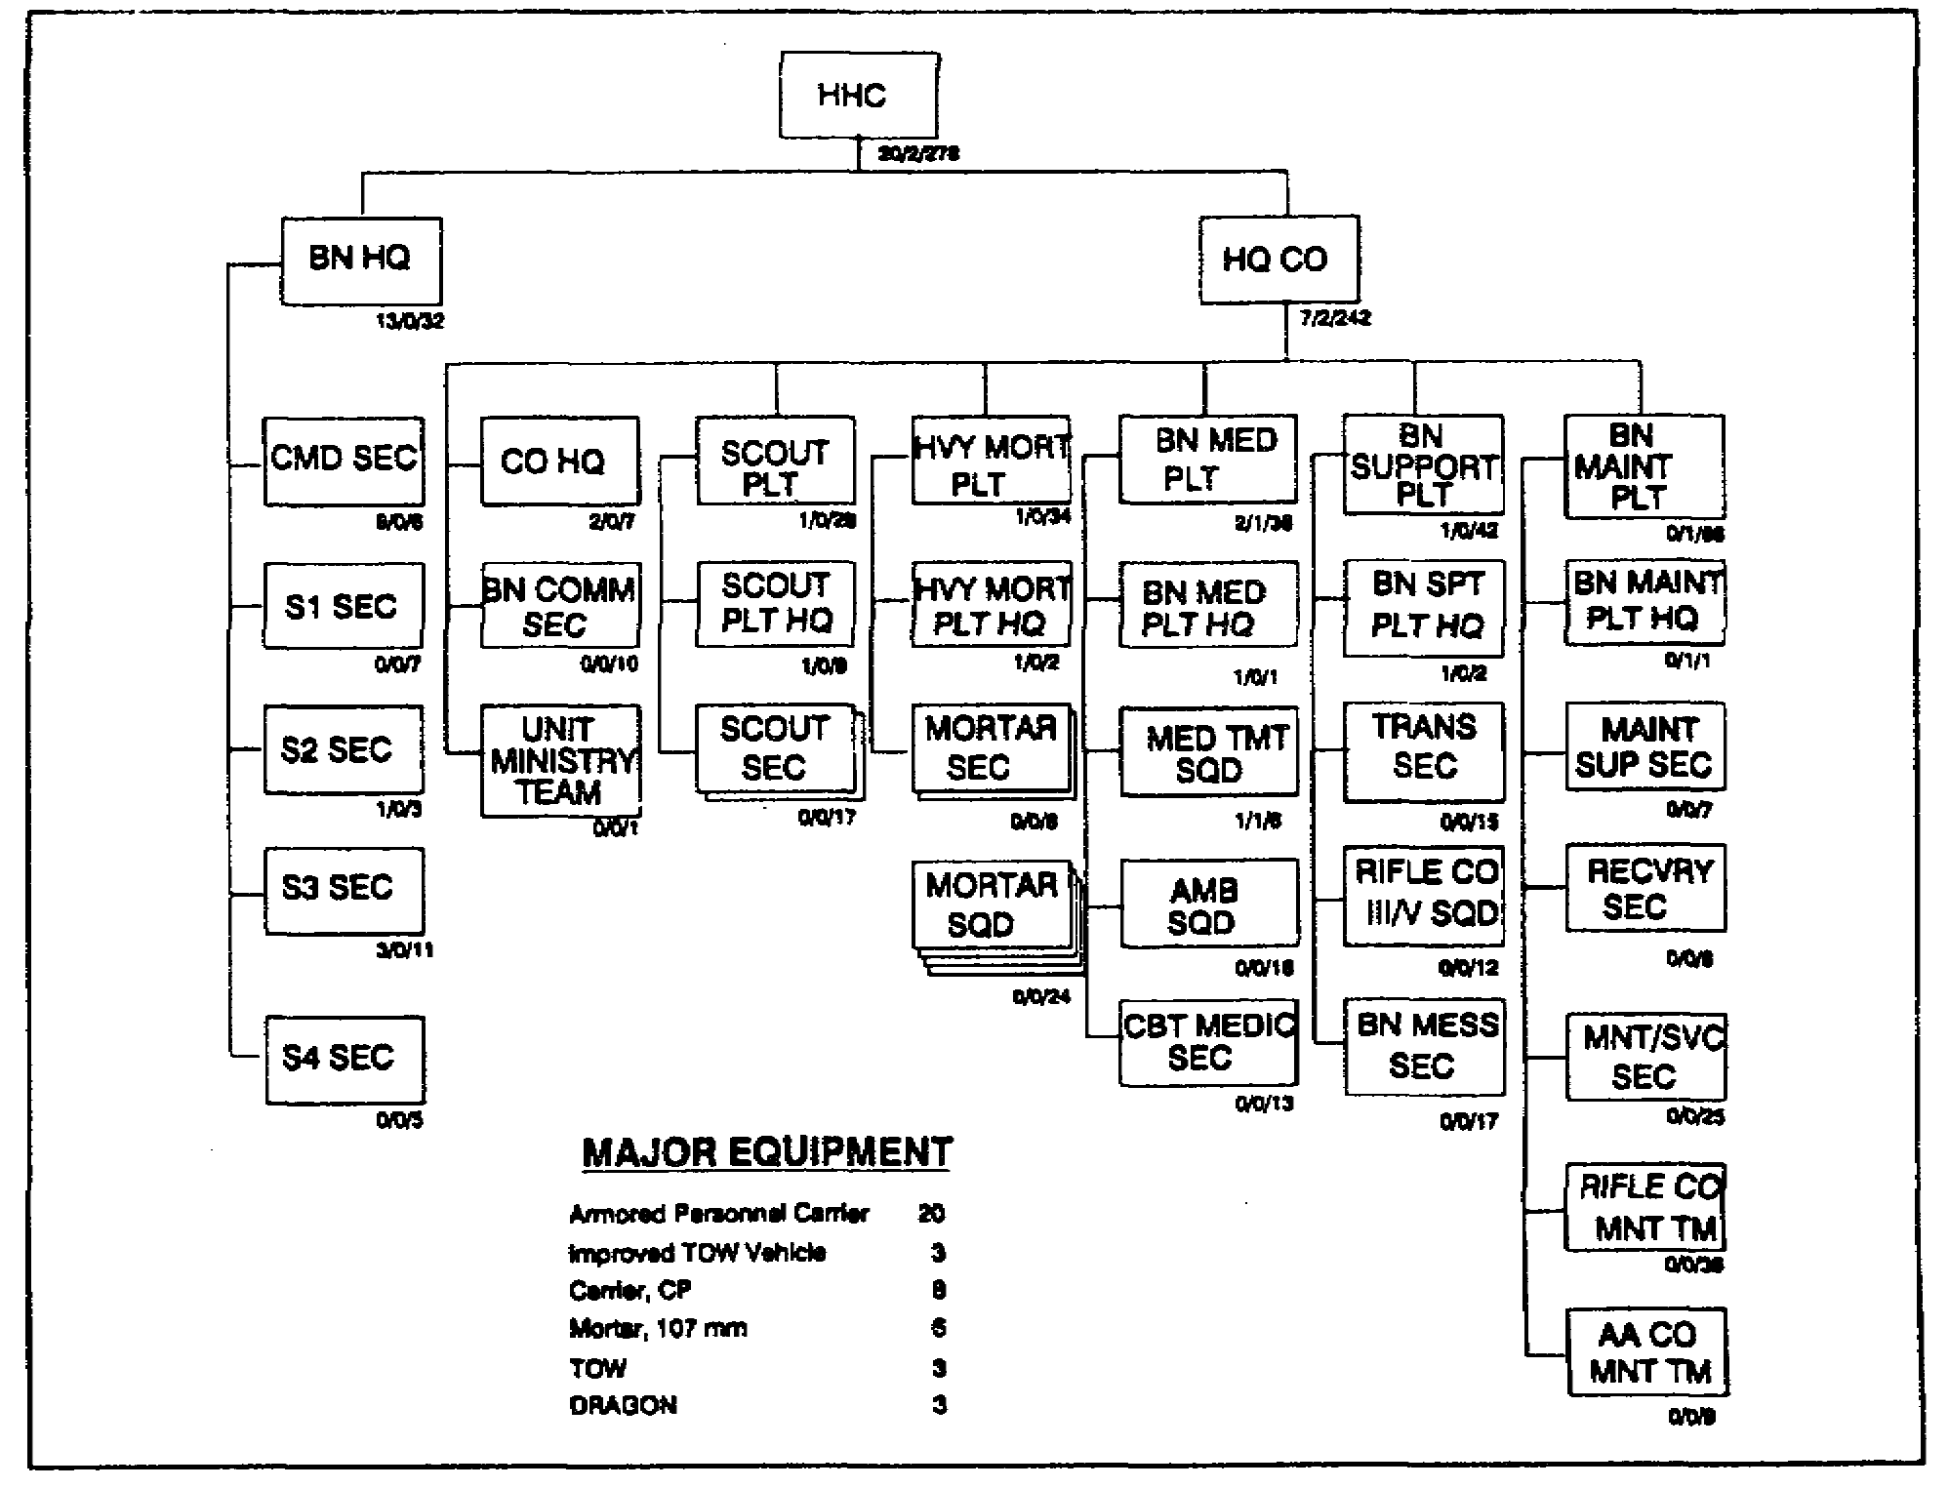

Figure 1-8. Organization of the HHC

(6) The company HQ provides administrative and logistical support for all personnel.

(7) The battalion communications section installs, operates, and maintains the communications systems for battalion command and control and support elements.

(8) The scout platoon conducts reconnaissance and security operations. This platoon consists of a platoon HQ and two scout sections.

(9) The heavy mortar platoon provides close and immediate indirect fire support to the battalion. This platoon consists of a platoon HQ and two mortar sections.

(10) The battalion medical platoon provides medical support to the battalion's assigned and attached personnel. This platoon consists of a platoon HQ, a medical treatment squad, an ambulance squad, and a combat medical squad.

SS0120 1-12

(11) The battalion support platoon transports ammunition, POL, and supplies to the battalion's units, and to prepare and issue meals to battalion personnel.

(12) The battalion maintenance platoon provides maintenance activities which include inspecting, testing, servicing, repairing, parts requisitioning, and recovering and evacuating disabled vehicles.

(13) The unit ministry team provides religious services to the battalion assigned and attached soldiers.

b. The battalion's four rifle companies close with the enemy by means of fire and maneuver to destroy or capture him or to repel his assault by fire, close combat, and counterattack. There are 112 soldiers (5 officers and 107 enlisted) in each rifle company (Figure 1-9).

(1) Company HQ. The company HQ provides the company with the command, control, administration, and logistical support required to conduct unit operations.

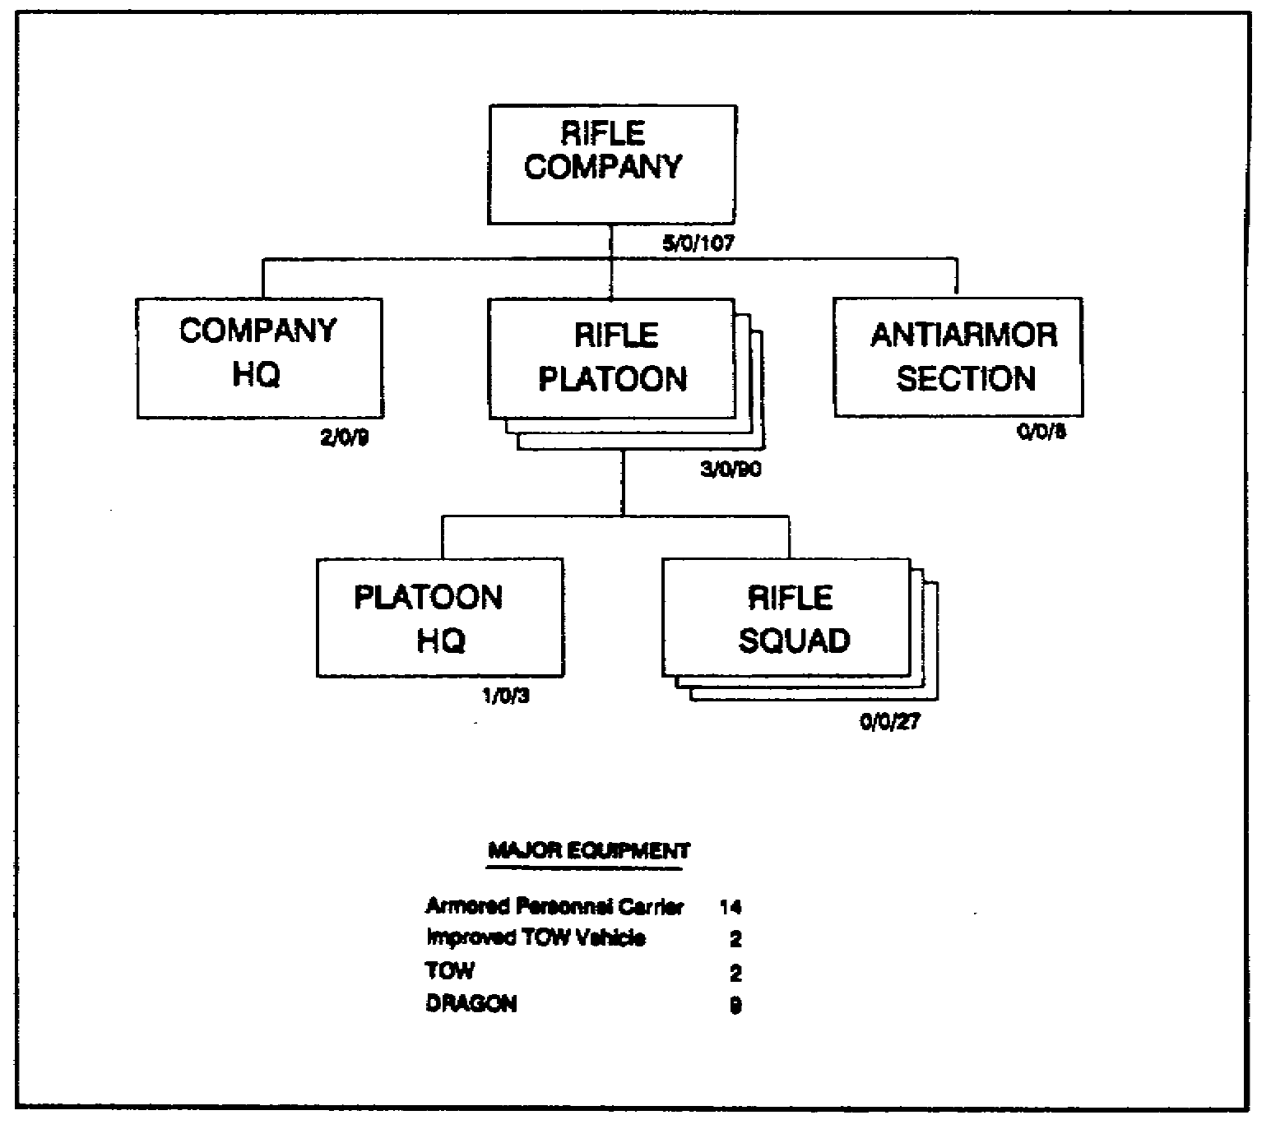

Figure 1-9. Organization of the rifle company

1-13 SS0120

(2) Rifle platoon. The platoon HQ provides leadership and directs the training, maintenance, and tactical employment of the rifle squads.

(3) Antiarmor section. This section provides long-range, direct antiarmor fire in support of the rifle company.

c. Antiarmor company. This company's mission is to reinforce the direct antiarmor fire of the rifle companies. There are 65 soldiers (5 officers and 60 enlisted) in this company. Figure 1-10 shows the organization of the antiarmor company.

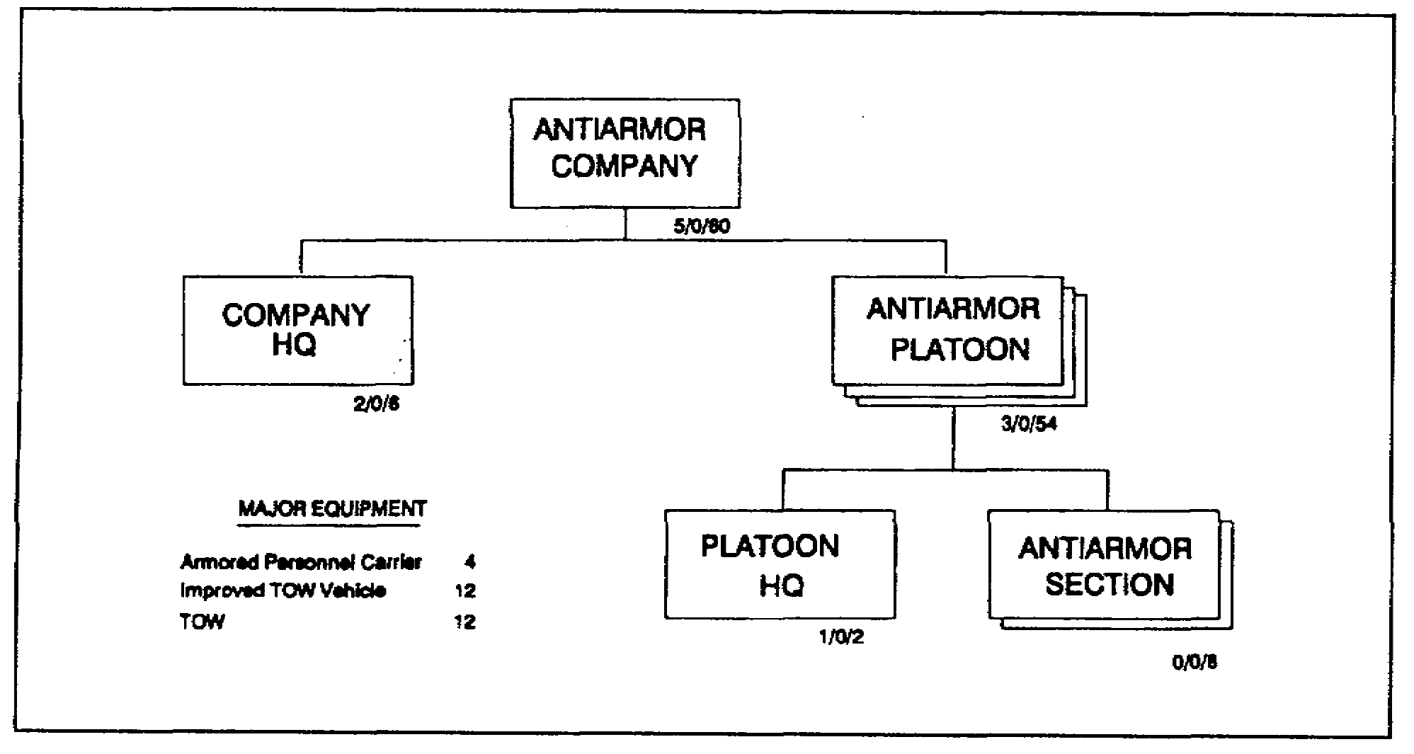

Figure 1-10. Organization of the anti-armor company

(1) Company HQ. The company HQ provides the command, control, administration, and logistical support required for unit operations.

(2) Antiarmor platoon. Each antiarmor platoon has two sections that provide long-range direct antiarmor fire again tanks, antiarmor vehicles, and other point targets.

8. Task Organization. The capability of the tank and mechanized infantry battalions is increased through task organization. Based on his estimate of the situation, the brigade commander task-organizes armor and mechanized infantry battalions by cross-attaching companies between these units. As a rule, cross-attachment is done at battalion, because the battalion has the necessary command and control and support capabilities to employ

SS0120 1-14

combined arms formations. The brigade commander determines the mix of companies in a task force. Similarly, the task force commander's estimate may require cross-attaching platoons to form one or more company teams for specific missions.

9. Heavy and Light Force Mix.

a. Heavy forces (armor and mechanized infantry) and light forces (infantry, light infantry, airborne, and air assault units) can operate together effectively, provided the commander tailors his force to the factors of METT-T. The employment of heavy-light forces permits the commander to maximize his combat power by offsetting the inherent weaknesses of one type unit with the inherent strengths of another type unit. In this sense, heavy-light operations are merely an extension of the combined arms concept.

b. As you may know, not all situations are suitable for heavy-light operations. In fact, organizing heavy and light force battalions into heavy-light or light-heavy task forces is by exception. Why? Because each type of force (heavy or light) best operates in those environments which use their strength, i.e., heavy units operate best where they can use their mobility and firepower unrestricted, and light units operate best in restricted terrain, built up areas, or during hours of limited visibility where the stealth qualities of individual soldiers can be exploited.

c. Heavy and light forces must not be considered interchangeable simply because they find themselves on the same battlefield. The heavy-light force must be matched to the current METT-T factors. The terrain and weather must be analyzed in terms of their effect on mobility and weapon systems. In particular, the unique capabilities of the light force (s) should be exploited to accomplish missions not suitable for heavy forces, and vice versa.

d. As you may recall, the maneuver brigade HQ is organized to provide the command and control facilities necessary to employ attached and supporting units. Maneuver battalions and additional units are placed in a command relationship by the brigade in order to accomplish the brigade mission in an anticipated operational environment. A battalion task force (TF) is one of these command relationships, which is a temporary grouping of battalion-sized units of the combat arms consisting of a battalion control HQ, with at least one of its major subordinate elements (a company), and the attachment of at least one company-sized element of another combat or combat support arm.

10. Heavy-Light Battalion Task Force.

a. A heavy-light task force is organized by combining armor or mechanized infantry battalions (the heavy units) with a battalion from a light force (infantry, light infantry, airborne, or air assault forces). Figure 1-11, page 1-16, depicts a heavy-light battalion task force comprised of an armor battalion HQ and three of its four organic tank companies. In this example, an infantry company from an infantry battalion is attached to the armor

1-15 SS0120

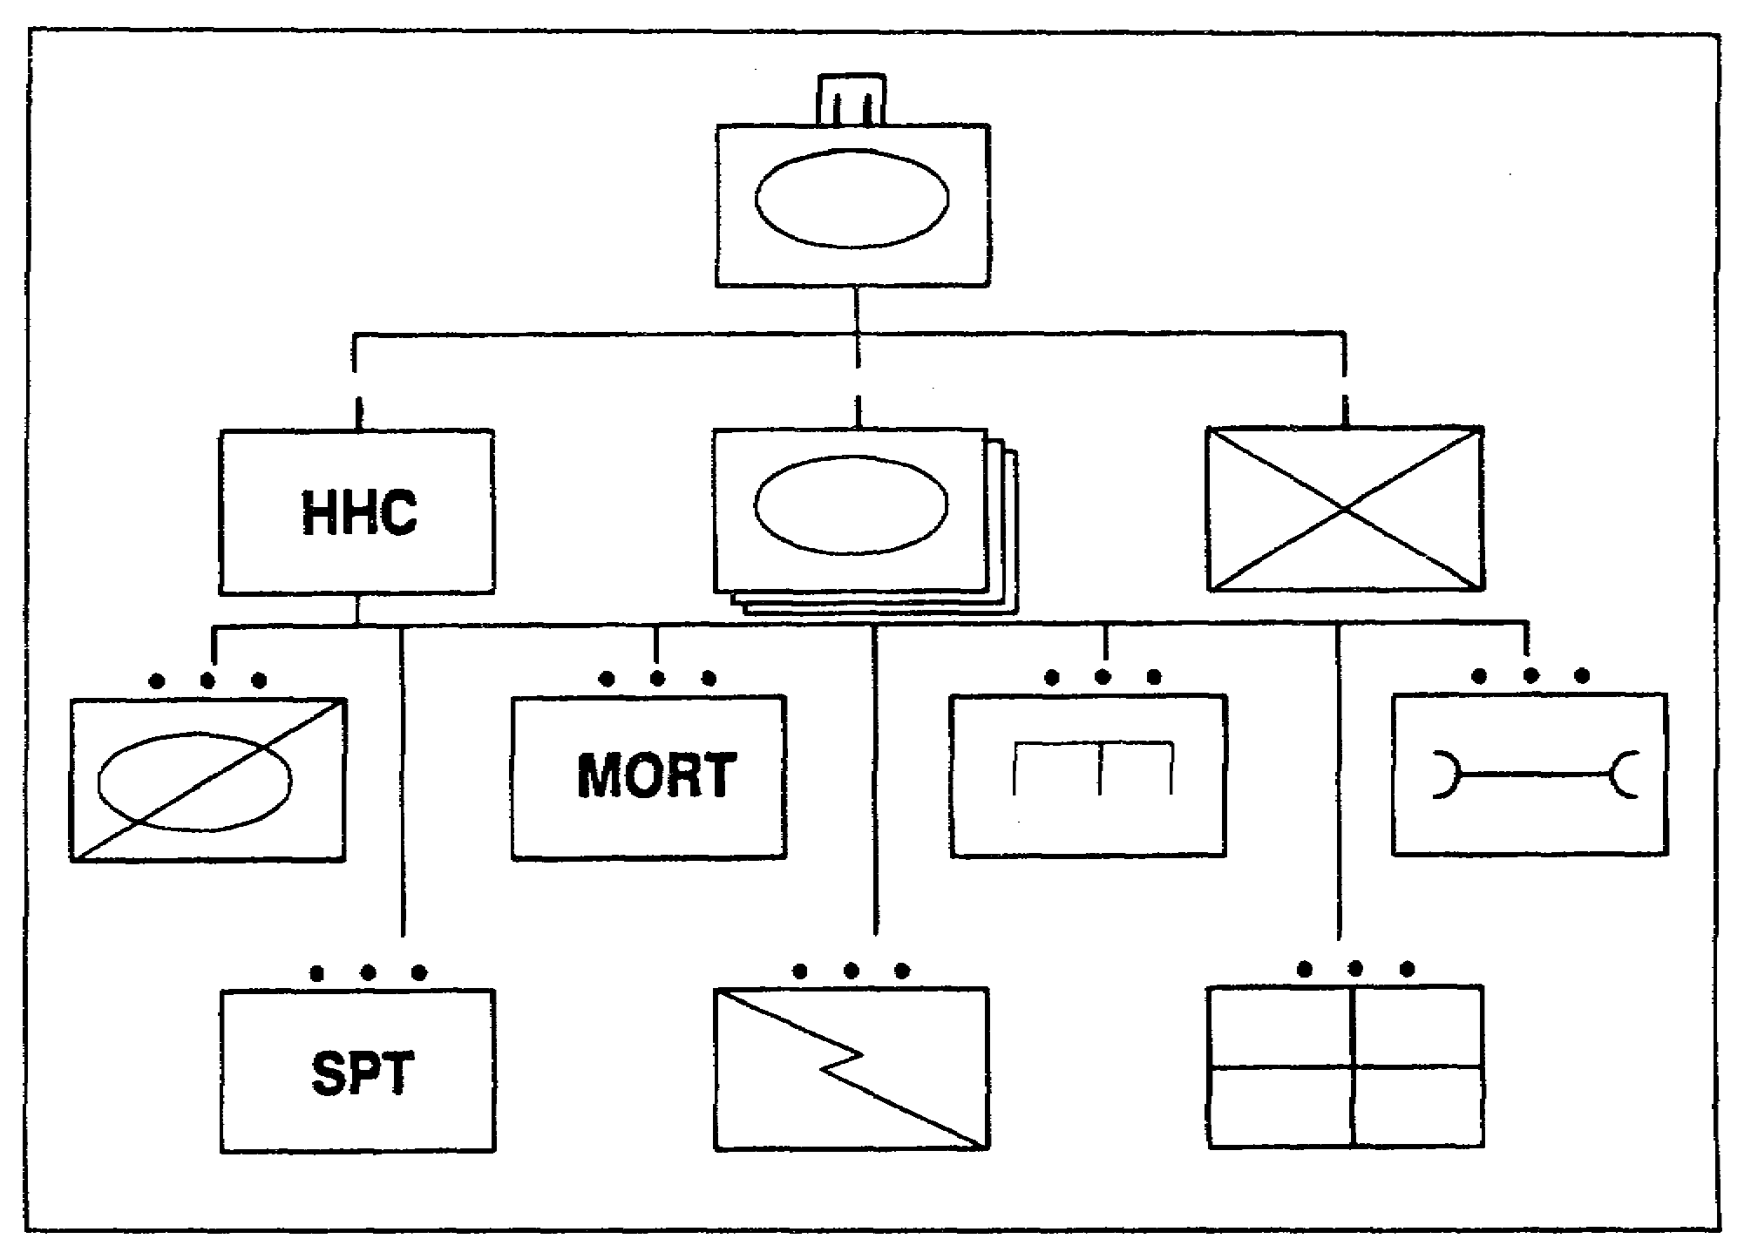

Figure 1-11. Heavy-Light TF (armored battalion HQ)

battalion. This TF is referred to as heavy-light because the heavy battalion HQ is the command HQ.

b. In addition to the armored and infantry units, Figure 1-11 shows the combat support, scout platoon (the battalion's eyes and ears), mortar platoon (the battalion's own indirect fire support) and combat service support units (maintenance platoon for organizational maintenance, support platoon for organic logistics support, communications platoon, and medical platoon for immediate treatment and evacuation capability) which are organic to the armored battalion. The engineer platoon is not organic to the battalion; rather, it is an asset that may be attached or OPCON from the brigade. Whether the battalion receives engineers is strictly dependent upon the factors of METT-T as seen by the brigade commander.

11. Light-Heavy Battalion Task Force. A light-heavy TF is simply a TF that has a light battalion HQ as the command HQ, one or more light maneuver companies, and the attachment of a tank or mechanized infantry company. Figure 1-12 shows a light-heavy TF organized under the command of a battalion HQ from an airborne infantry battalion, two of

SS0120 1-16

its three organic infantry companies, and a tank company. Figure 1-12 also shows the CS and CSS units organic to the light force battalion. These units have the same function as discussed previously. Like the heavy battalion, engineers are assets that may or may not be a part of the TF. Again, whether they are provided depends upon the brigade commander's analysis of METT-T.

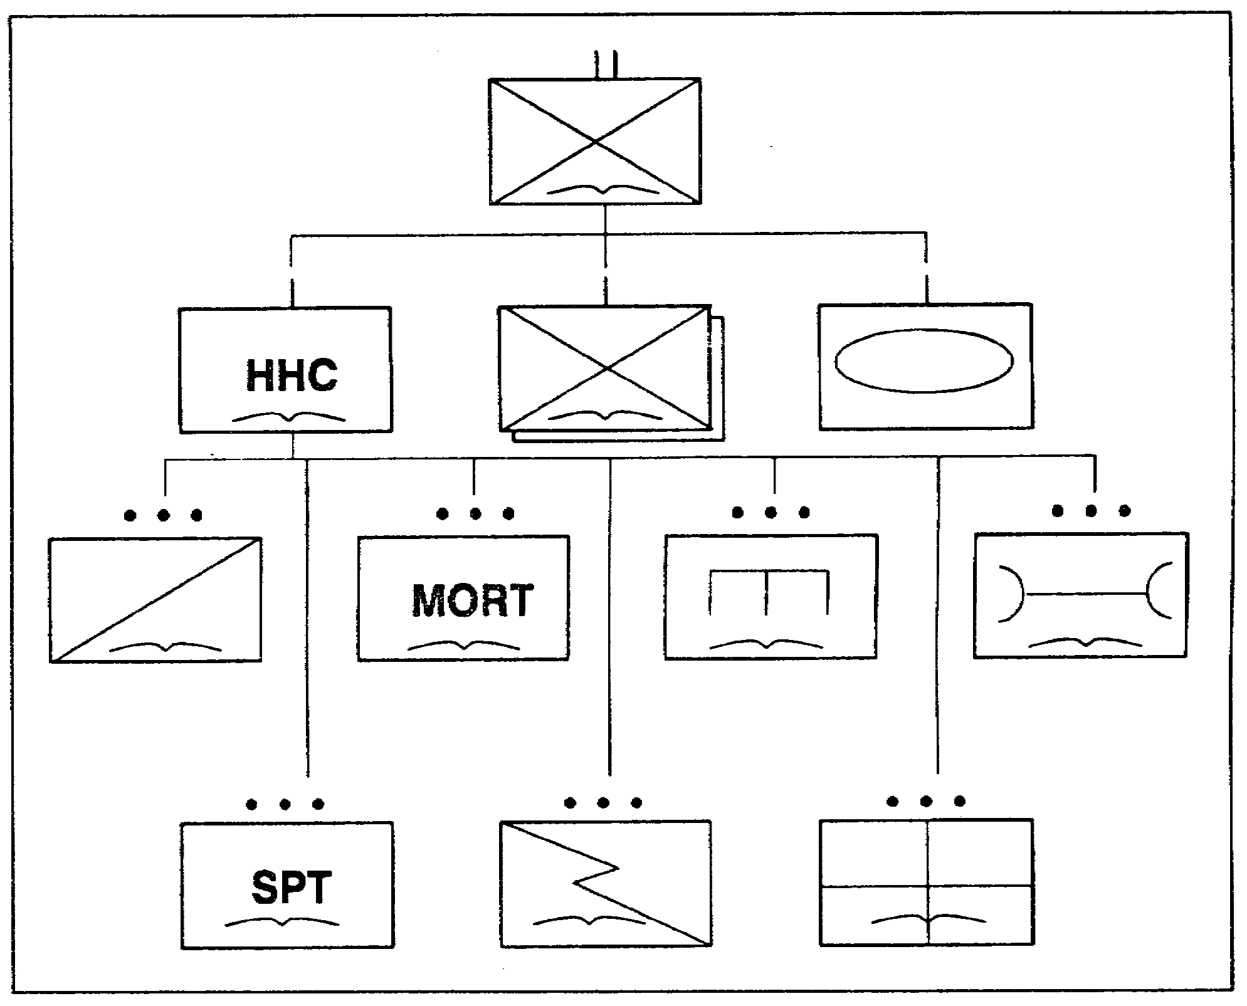

Figure 1-12. Light-Heavy TF (airborne infantry HQ)

12. Summary. In this lesson, you have-learned about the types of Army divisions, the light infantry maneuver brigade and battalion, the heavy maneuver brigade and battalion, and task force organization.

a. The infantry division is a dismounted, ground-gaining combined arms force that can be employed in most terrain and environmental conditions, especially urban areas.

1-17 SS0120

b. The light infantry division differs from other divisions in both design and concept of employment. It is rapidly deployable and is organized to fight as part of a larger force, in conventional conflicts, or independently in a low intensity conflict (LIC). The ability of its command and control structure to readily accept augmentation forces permits task organizing for any situation from low to high-intensity conflicts.

c. The airborne division conducts combined arms parachute assaults to seize and secure objectives in the enemy's rear. It is ideally suited to seize, secure, and repair airfields to provide a forward operating base for follow-on air-landed forces.

d. The air assault division conducts combat operations to strike over extended distances and terrain obstacles to attack the enemy. These operations involve insertions and extractions under hostile conditions.

e. The light infantry brigade is organized with three infantry battalions and the required CS and CSS to effectively operate in a LIC scenario, or as part of a larger conventional force.

f. The light infantry maneuver battalion is organized with three rifle companies and the required CS and CSS to support brigade operations.

g. The mechanized infantry maneuver brigade is organized with three mechanized infantry battalions and the required CS and CSS to fight successful battles on the battlefield in conventional, nuclear, or chemical environments.

h. The mechanized infantry maneuver battalion is organized with four mechanized infantry rifle companies and the required CS and CSS to support brigade operations.

i. The heavy and light force mix allows the commander to maximize his combat power by offsetting the inherent weaknesses of one type unit with the inherent strengths of another type unit.

SS0120 1-18

LESSON 1

PRACTICE EXERCISE

The following items will test your grasp of the material covered in this lesson. There is only one correct answer for each item. When you complete the exercise, check your answer with the answer key that follows. If you answer any item incorrectly, study again that part of the lesson which contains the portion involved.

1. Heavy divisions operate best in which terrain environment?

A. Urban Areas.
B. Jungle.
C. Open Terrain.
D. Mountainous Areas.

2. The light infantry division's method of operation is to disperse widely throughout a large area and conduct synchronized but decentralized operations.

A. True.
B. False.

3. The preferred division to send into the enemy's rear to seize airfields and provide a forward operating base is _________.

A. Infantry.
B. Light Infantry.
C. Mechanized infantry.
D. Airborne.

4. The infantry division is best employed in isolated areas where it achieves mass through the concentration of forces on the battlefield.

A. True.
B. False.

5. The brigade headquarters and headquarters company (HHC) is the only unit permanently assigned to the brigade.

A. True.
B. False.

1-19 SS0120

6. Which type of field artillery normally provides direct support to the light infantry brigade?

A. 155mm (towed).
B. 155mm (self-propelled).
C. 105mm (self-propelled).
D. 105mm (towed).

7. In the HHC of a light infantry maneuver battalion, the HQ company provides reconnaissance, mortar, and antitank fire support for the battalion and attached units.

A. True.
B. False.

8. A __________ provides direct support to a mechanized maneuver brigade.

A. 105mm self-propelled FA battery.
B. 155mm self-propelled FA battery.
C. 105mm self-propelled FA battalion.
D. 155mm self-propelled FA battalion.

9. The most important issue a commander considers when tailoring a mix of forces is _________.

A. Overwhelming combat power.
B. METT-T.
C. Command and control measures.
D. Combat support requirements.

10. The engineer platoon is organic to the heavy-light or light-heavy task force.

A. True.
B. False.

SS0120 1-20

LESSON 1

PRACTICE EXERCISE

ANSWER KEY AND FEEDBACK

Item Correct Answer and Feedback

1. C. Open Terrain.

Heavy divisions operate best in basically open terrain where they can use their mobility and long range, direct fire weapons to the best advantage.
(page 1-2, para 1a)

2. A. True.

Although employed as an entity, the light infantry division's method of operation is to disperse widely throughout a large area and conduct synchronized but decentralized operations which exploit the advantages of restricted terrain and limited visibility. (page 1-2, para 1c)

3. D. Airborne.

The airborne division is ideally suited to seize, secure, and repair airfields to provide a forward operating base for follow-on air-landed forces.
(page 1-4, para 1d(1))

4. B. False.

The infantry division is best employed in terrain favoring dismounted operations, such as urban areas. (page 1-2, para 1b)

5. A. True.

The only unit permanently assigned to the brigade is the brigade headquarters and headquarters company (HHC). (page 1-4, para 3)

1-21 SS0120

6. D. 105mm (towed).

A 105mm towed howitzer field artillery battalion provides direct support to the light infantry brigade. (page 1-5, para 4c)

7. A. True.

The HQ company provides reconnaissance, mortar and antitank fire support, unit administration and logistical and unit-level health services support for the battalion and attached units. (page 1-6, para 5a)

8. B. 155mm self-propelled FA battalion.

A 155mm self-propelled howitzer FA battalion provides direct support to a mechanized maneuver brigade. (page 1-9, para 6c)

9. B. METT-T.

Heavy and light forces can operate together effectively, provided the commander tailors his force to the factors of METT-T (mission, enemy, terrain, troops and time available). (page 1-14, para 9a)

10. B. False.

The engineer platoon is not organic to the battalion; rather, it is an asset that may be attached or OPCON from the brigade. (page 1-15, para 10b)

SS0120 1-22

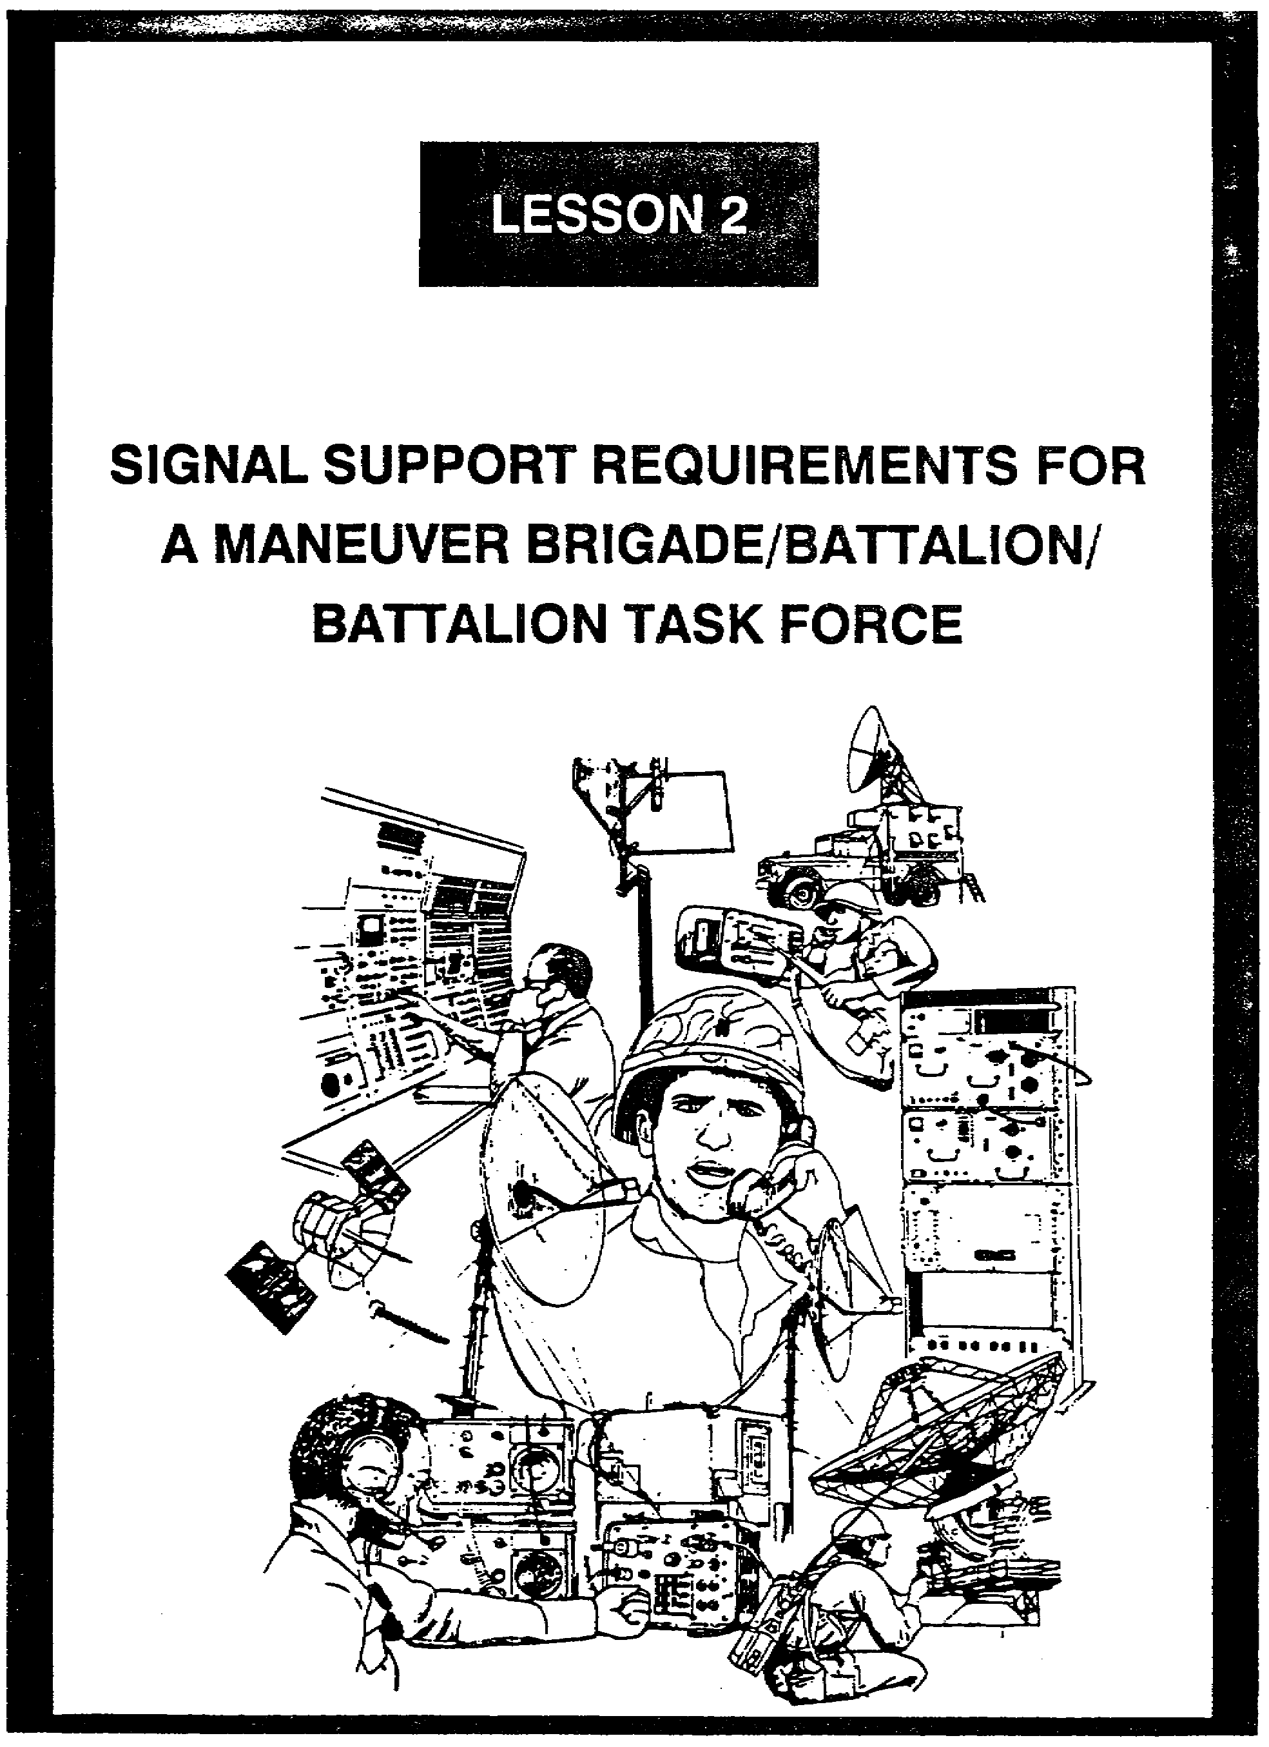

LESSON 2

SIGNAL SUPPORT REQUIREMENTS FOR
A MANEUVER BRIGADE/BATTALION/BATTALION TASK FORCE

Critical Tasks: 01-5840.07-0002
01-5841.07-0001

OVERVIEW

LESSON DESCRIPTION:

In this lesson, you will learn about the signal support requirements of a maneuver brigade, battalion, and battalion task force, to include wire, switchboards, and radio networks.

TERMINAL LEARNING OBJECTIVE:

ACTION: Explain the signal support requirements of a maneuver brigade/battalion/battalion task force.

CONDITION: You will have this lesson.

STANDARD: To demonstrate competency, you must achieve a minimum of 70% on the subcourse examination.

REFERENCES: The material in this lesson was derived from the following publications:
FM 7-20, FM 7-30, FM 11-50, FM 24-18, FM 71-2, FM 71-3, FM 71-100, FM 101-5-1, TC 24-20, TOE Handbook 070152-CTH, and TOE Handbook 072452-CTH.

INTRODUCTION

The communications requirements of the maneuver brigade are based on the needs of the maneuver battalions. To support fast-paced operations, the signal support must be simple, mobile and dependable. Single-channel radios and wire communications are the mainstay of the battalion's command and control. As a signal officer serving in these units, you will have to ensure the communications support meets the needs of the commander. This lesson covers the radio and wire communications which the maneuver brigade and battalion use, and what the signal officer should do to provide good communications.

2-1 SS0120

PART A - SINGLE-CHANNEL RADIO AND WIRE COMMUNICATIONS

1. Overview. As the signal officer providing signal support in a brigade or battalion, you must be very familiar with the different means of communications. The following description of the employment of single-channel radio, its capabilities and limitations, and its tactical applications is based on FM 24-18, Tactical Single-Channel Radio Communications Techniques.

a. Employment. Mobility is one of the keys to success on the modern battlefield. All communications must be geared to support a combat force that must repeatedly move to survive and fight the enemy. The single-channel radio is the primary means of communication for command, fire control, exchange of information, administration, and liaison between and within units. The versatility of radio makes it readily adaptable to rapidly changing tactical situations. Radio is essential for communicating over large bodies of water, territory controlled by enemy forces, and terrain where the construction of wire lines is impossible or impractical. It is also required for air assault operations.

b. The capabilities of single-channel radio make it flexible, securable, mobile, and reliable.

(1) Radio communications facilities usually can be installed more quickly than wire communications. Thus, radio can be used as a primary means of communications during the initial stages of combat operations.

(2) Once installed in a vehicle, aircraft, or ship, the equipment is ready for use and does not require reinstallation. Wire communications require reinstallation with each move.

(3) Radio equipment is designed to meet mobility requirements and is used by airmobile, amphibious, mechanized, and dismounted units.

(4) Radio lends itself to many modes of operation, such as radiotelephone, radiotelegraph, radio teletypewriter (RATT), visual presentation, and data.

(5) All of the modes of operation are securable when the required security equipment is available.

(6) Natural obstacles, mine fields, and terrain under enemy control or fire do not limit radio to the same extent that they limit other means of communications.

(7) By using special techniques, radio can interface with other communications means (net radio interface), be separated from the immediate vicinity of the user (remoting), and operate over extended distances (retransmission).

SS0120 2-2

c. The limitations of single-channel radio must be considered.

(1) Radio is the most detectable means of electronic communications and is subject to intentional and unintentional electronic interference.

(2) To be capable of operating together, radios must have common, or at least some overlapping frequencies. They must transmit and receive the same type signal and must be located within operating range of each other with a clear transmission path.

(3) Radio is the least secure means of communications, and interception can occur every time a transmitter is placed in operation.

d. Tactical applications. The extent to which radio is used in combat operations depends on secrecy and surprise requirements, balanced against the urgency of communications. When surprise is important, radio operations are limited initially to units in contact with the enemy. Higher headquarters (HQ) may direct the operation of dummy stations to increase deception and surprise. A unit moving into an area just prior to attack may maintain listening silence until the attack is launched. When a unit is already occupying a sector from which it is to launch an attack, and its radio stations are in operation, it may be directed to maintain normal radio operations without substantial change in traffic load until the attack is launched. A unit moving to another sector or being relieved by another unit may have to provide dummy radio stations to continue operations until the attack is fully underway. Once the attack is launched, special restrictions on radio operations are generally removed.

2. Single-Channel Radio Nets. These nets provide initial command, control, and communications at the brigade HQ and throughout the brigade. Threat electronic warfare (EW) capabilities determine our use of single-channel radio. Single-channel radio requires special considerations, especially when operated from static locations such as a command post (CP) area. Radio transmissions should be limited to information of an immediate operational nature. The basic single-channel radio nets are the command and operations net, the intelligence net, the administrative/logistics net, the fire direction net, the HF voice net (AM), and the general purpose (GP) radio teletypewriter (RATT) net. The following description of these nets is based on FM 11-50, Combat Communications Within the Division (Heavy and Light).

a. The command and operations net (FM) is used to pass orders and immediate command and operational information (tactical control, combat coordination, and tactical data reporting). This net is given the highest installation priority.

b. The intelligence net is used to pass intelligence information and spot reports. This net is the backup for the command and operations net and is given the second highest installation priority. In addition, operations and intelligence nets are often combined at brigade and battalion levels.

2-3 SS0120

c. The administrative/logistics net is used to pass personnel and supply information. The traffic on this net does not have the same immediate tactical importance as that on the command and operations net and the intelligence net used at brigade and battalion levels.

d. The fire direction net is the highest priority net in the field artillery firing units. The net is used for exchanging technical or firing data.

e. The HF voice net (AM) is used as a backup to the command and operations (FM) and the intelligence nets.

f. The GP RATT net passes hard copy radio teletypewriter traffic between HQ elements. It is not used to send lengthy or time-sensitive information due to the slow processing and handling time required to send messages.

3. Wire Communications.

a. Wire, one of the most dependable communications means, can be used in most terrain and tactical situations. Wire includes the use of field wire, wire-laying and recovery equipment, cable, battery-operated and sound-powered telephones, switchboards, teletypewriters, multiplexes, and other associated or terminating equipment. It affords person-to-person conversation, with break-in operation (capability of interrupting the conversation). Wire is more secure than radio, but the security of classified information is never assured when it is transmitted over wire circuits; classified information should be discussed only over security-approved wire systems. The decision to establish wire communications depends on the need, the time required and available to install and use, and the capability to maintain. The supply of wire on hand, the expected resupply, and future needs must also be considered.

b. The range of wire communications varies, depending on the weather and the condition of the wire (for example, wet weather, poor splices, and damaged insulation). The range of wire circuits may be extended by the use of attended or unattended repeaters. For planning purposes, the range of field wire circuits using the battery-operated telephone is 22.2 to 35.4 kilometers (14 to 22 miles). The range is reduced to 6.4 kilometers (4 miles) using sound-powered telephones.

c. It takes longer to install wire than any other means of communications. The time required depends mainly on the length of wire line and the method of laying it (ground vehicle, air vehicle, or manpack). In estimating the time required, the number of personnel available, their training, the type terrain, routes, weather, and visibility must be considered.

d. Wire is tactically employed to connect closely located activities, such as within command posts and between radio relay terminals and switching centrals. Long-haul wire circuits (trunks) between signal nodes and HQ are installed to backup radio and radio lay

SS0120 2-4

systems when time, personnel, and equipment are available. The use of various multiplexing devices allows the simultaneous transmission of more than one message over a single circuit. In combat, use existing commercial wire circuits when feasible. Wire communications are especially reliable and desirable in defensive operations where movement is limited and time is available for installation and maintenance.

PART B - RADIO AND WIRE DIAGRAMS IN THE MANEUVER BRIGADE

1. Overview. You can better understand the signal support requirements of a maneuver brigade and battalion if you know the radio net structure. At the brigade level, command and control is exercised through division, brigade, and battalion nets.

2. Radio and Wire Nets. Command and control within the maneuver brigade is achieved through the use of a number of single-channel radio and wire networks. These nets will be illustrated through a series of diagrams. Three radio nets will be discussed (command/operations, intelligence, administrative/logistics), along with who in the brigade talks with whom. You need to remember that the training objective is to learn the various radio nets, not to reflect the actual type equipment currently in a unit. Keep in mind that the Army's modernization program is underway to replace older vehicles and radio equipment. Figure 2-1, page 2-6, shows the communications ancillary equipment legend.

3. Brigade HQ. Figures 2-2A and 2-2B, pages 2-8 and 2-9, show the brigade command and operations Net (FM voice) in a mechanized infantry brigade. Both the older and newer generation of adios and vehicles are shown.

a. The command section provides necessary supervision, control, and coordination for the brigade, and attached units.

b. The S1 section provides personnel and administrative support.

c. The S2 section collects, evaluates, and disseminates intelligence data.

d. The S3 section is responsible for operations and training within the brigade, and coordination among the maneuver battalions, the brigade HQ, and the division HQ.

e. The S4 section manages logistics support, resources, and requirements.

f. The company HQ is responsible for administrative, logistical, and supply support for brigade personnel.

2-5 SS0120

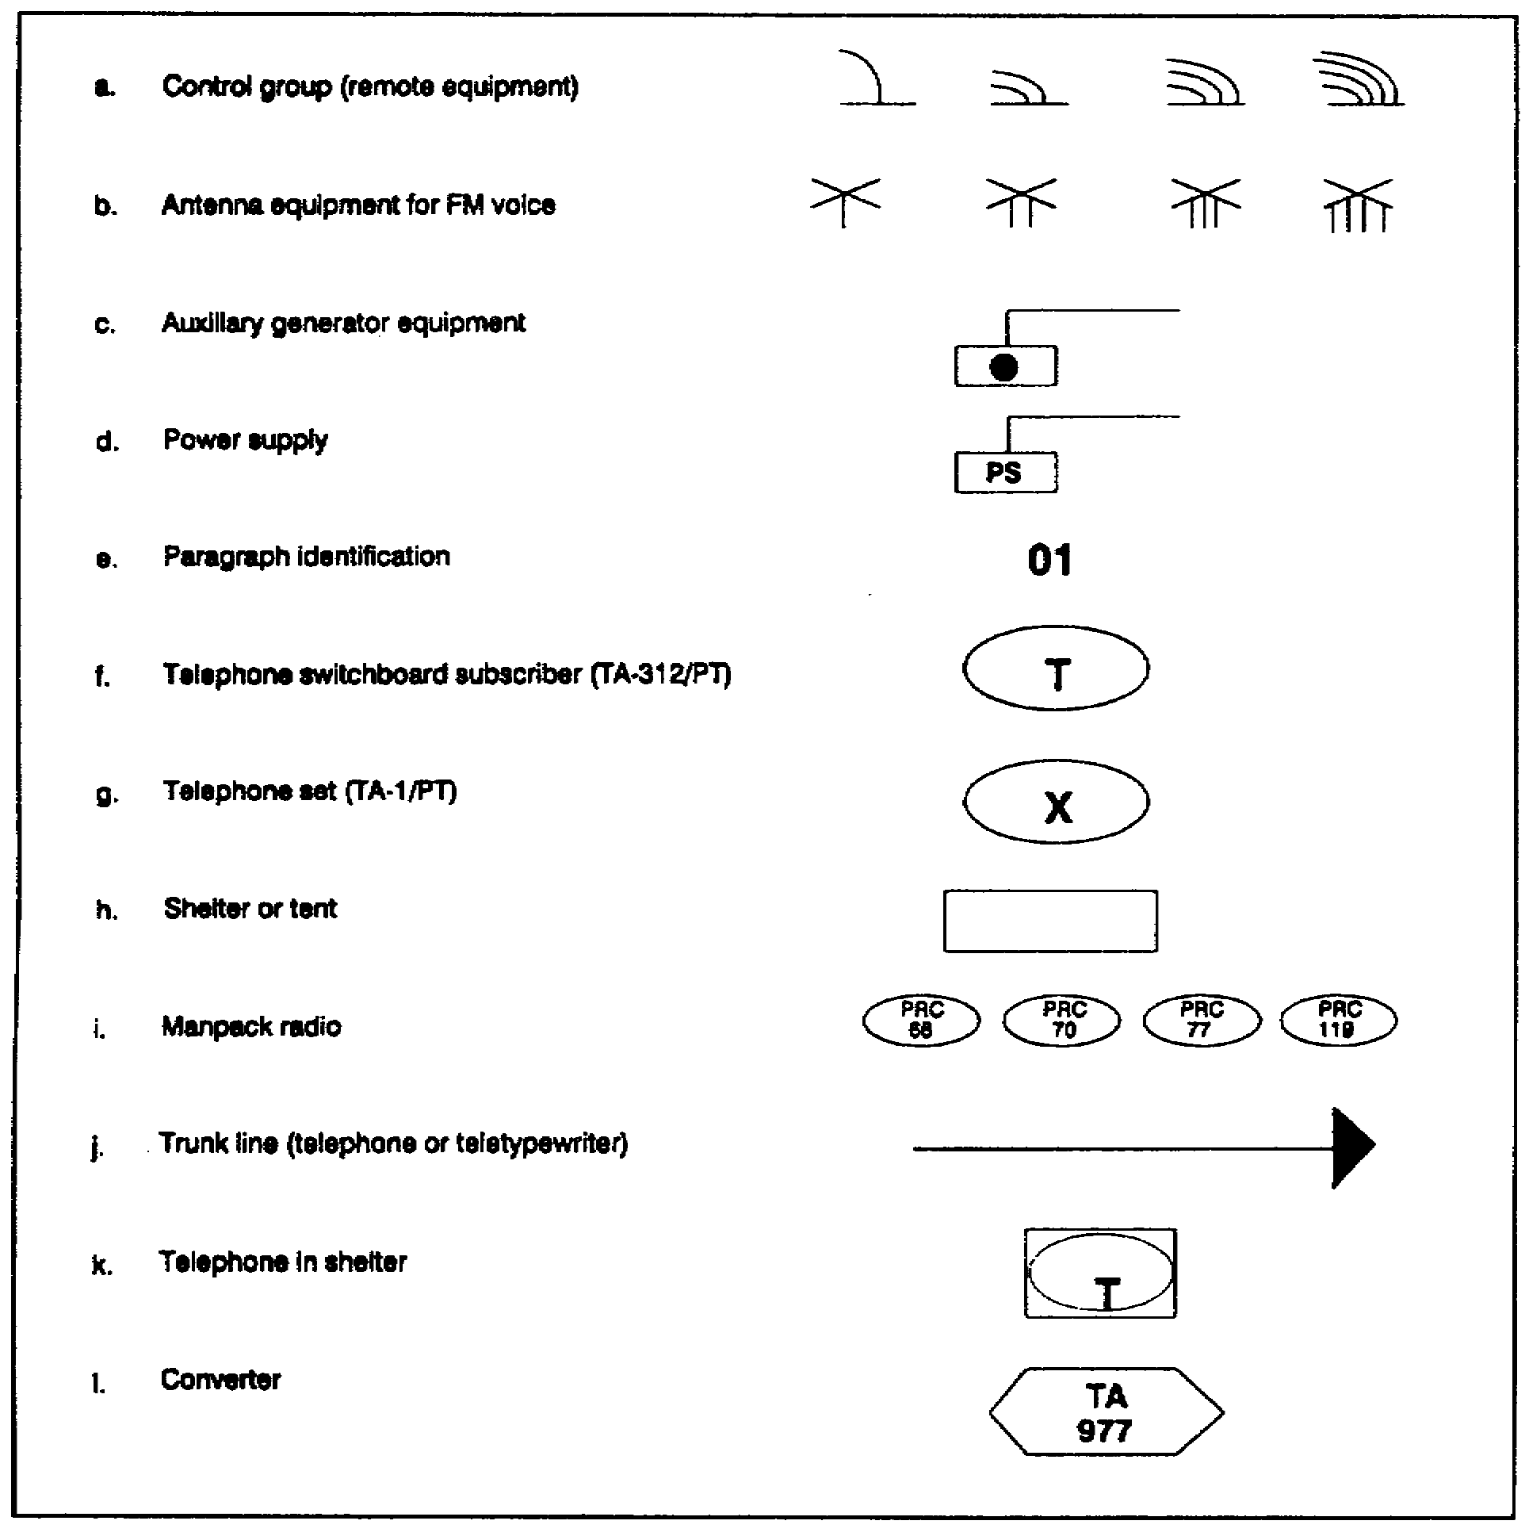

Figure 2-1. Communications ancillary equipment legend

g. The maintenance section provides unit maintenance to vehicles which are organic to the brigade HQ.

h. The communications section provides internal communications within the brigade and connection to the area signal center.

SS0120 2-6

4. Radio Communications Equipment.

a. Command section.

(1) The two VRC-46 radios installed in the brigade commander's personnel carrier operate in the brigade command/operations net and the division command/operations net (Figures 2-2A and 2-2B, pages 2-8 and 2-9).

(2) The two VRC-46 radios installed in the brigade commander's wheeled vehicle for command and control operate in the brigade command/operations net and the division command/
operations net (Figures 2-2A and 2-2B, pages 2-8 and 2-9).

(3) The two VRC-46 radios installed in the executive officer's vehicle operate in the brigade command/operations net and the brigade administrative/logistics net. The brigade administrative/
logistics net is shown in Figure 2-3, page 2-10.

b. S2 section.

(1) The VRC-47 radio in the S2 section's CP carrier operates in the brigade intelligence net, monitors the division intelligence net, and serves as the net control station (NCS) for the brigade intelligence net (Figure 2-4, page 2-11).

(2) The VRC-47 radio in the S2 section's 1 1/4-ton truck operates in the brigade intelligence net, monitors the brigade command/operations net, and serves as the alternate NCS in the brigade intelligence net.

c. S3 section.

(1) The two VRC-46 radios installed in the S3's vehicle operate in the brigade command/operations net and the brigade intelligence net (Figures 2-2A, 2-2B, and 2-4, pages 2-8, 2-9, and 2-11).

(2) The two VRC-46 radios installed in the CP carrier located at the tactical CP operate in the brigade command/operations net and the division command/operations net. They also serve as the NCS for the brigade command/operations net (Figures 2-2A and 2-2B, pages 2-8 and 2-9).

(3) The two VRC-46 radios installed in the CP carrier at the main CP operations cell operate in the brigade command/operations net and the supported maneuver battalion's net. They also serve as the alternate NCS for the command/operations net.

2-7 SS0120

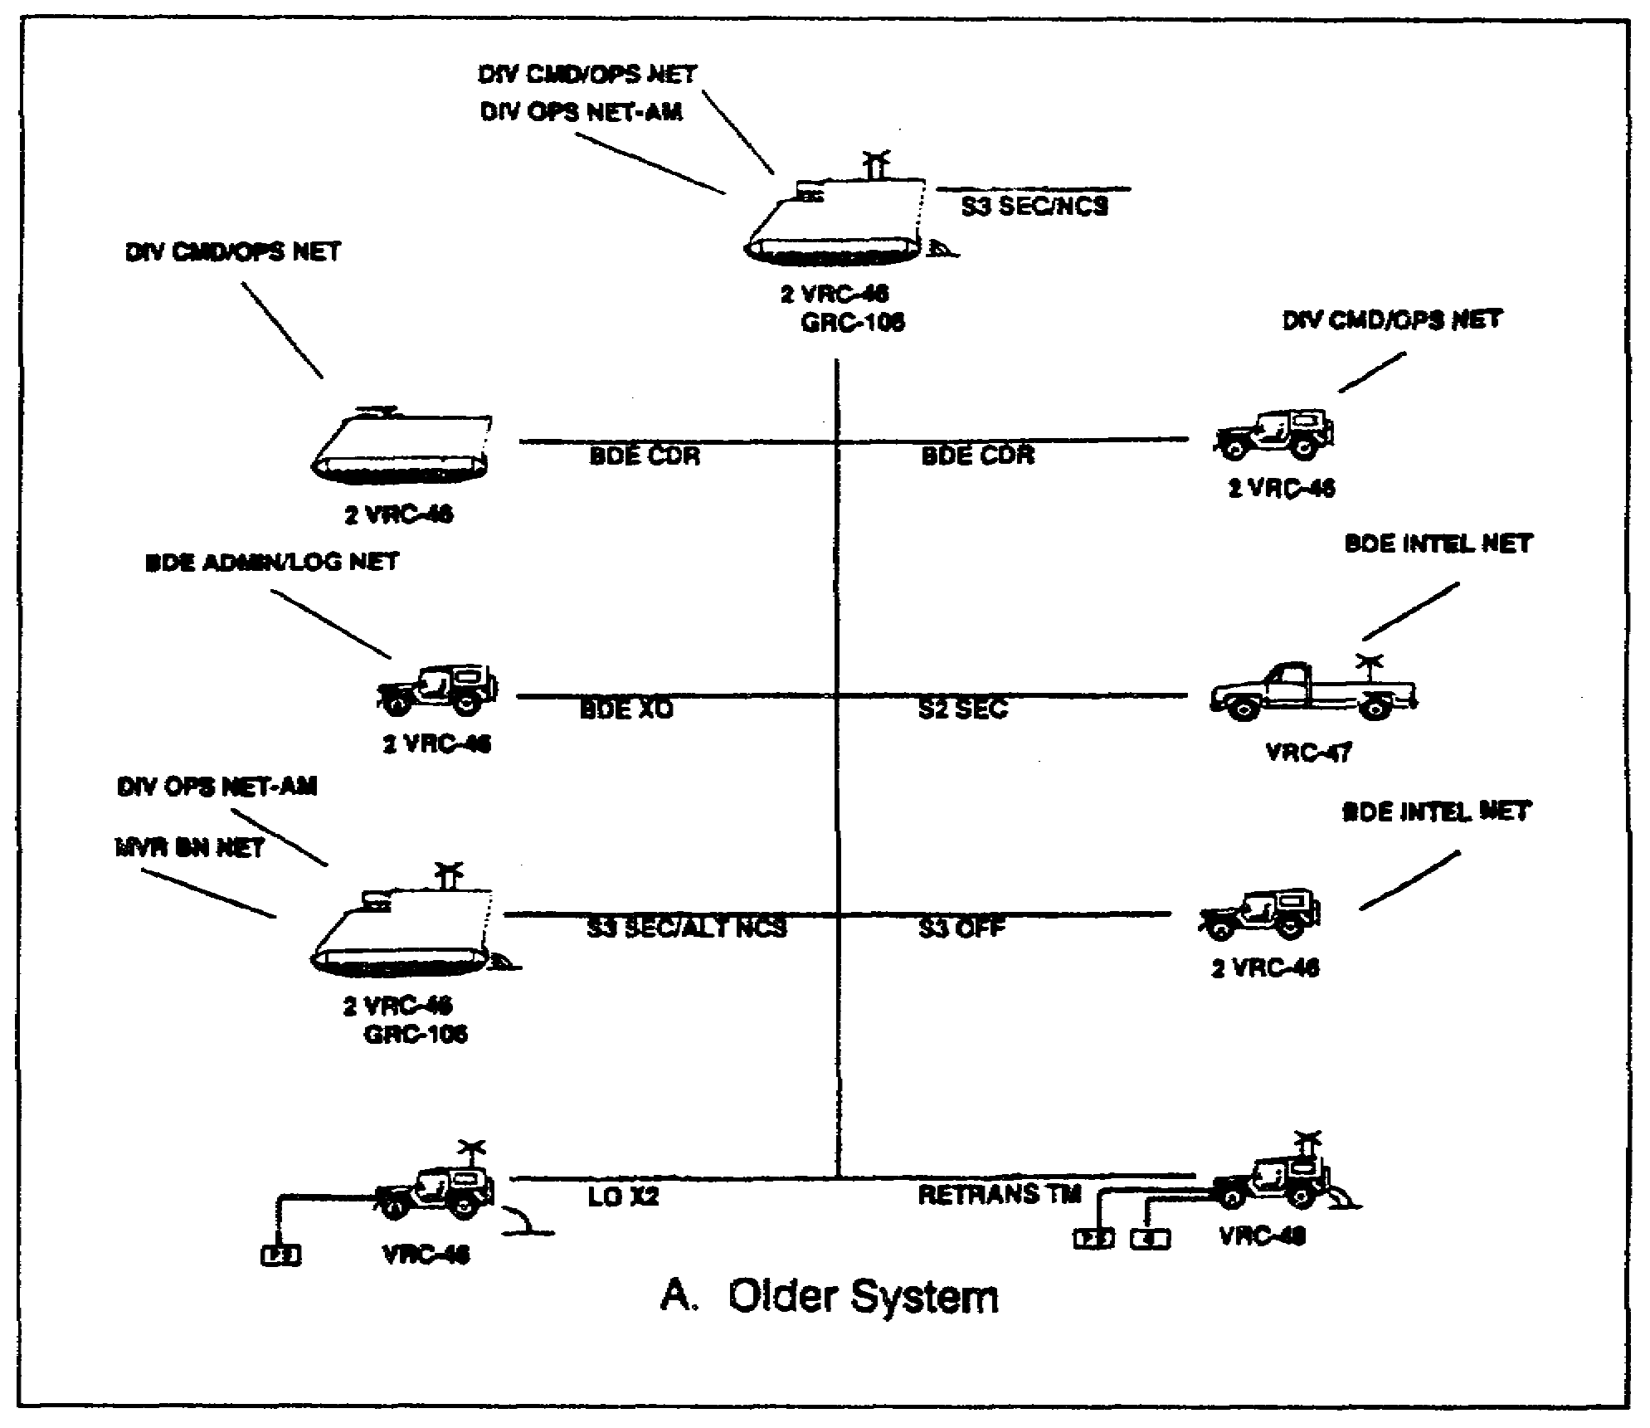

Figure 2-2A. Brigade command/operations net (FM voice)

SS0120 2-8

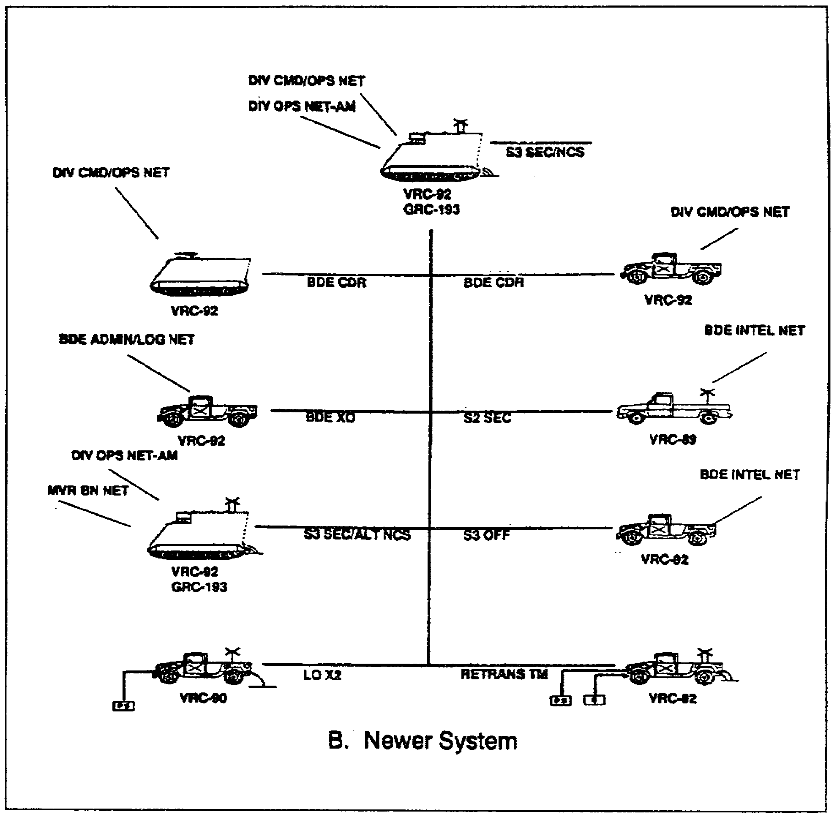

Figure 2-2B. Brigade command/operations net (FM voice)

2-9 SS0120

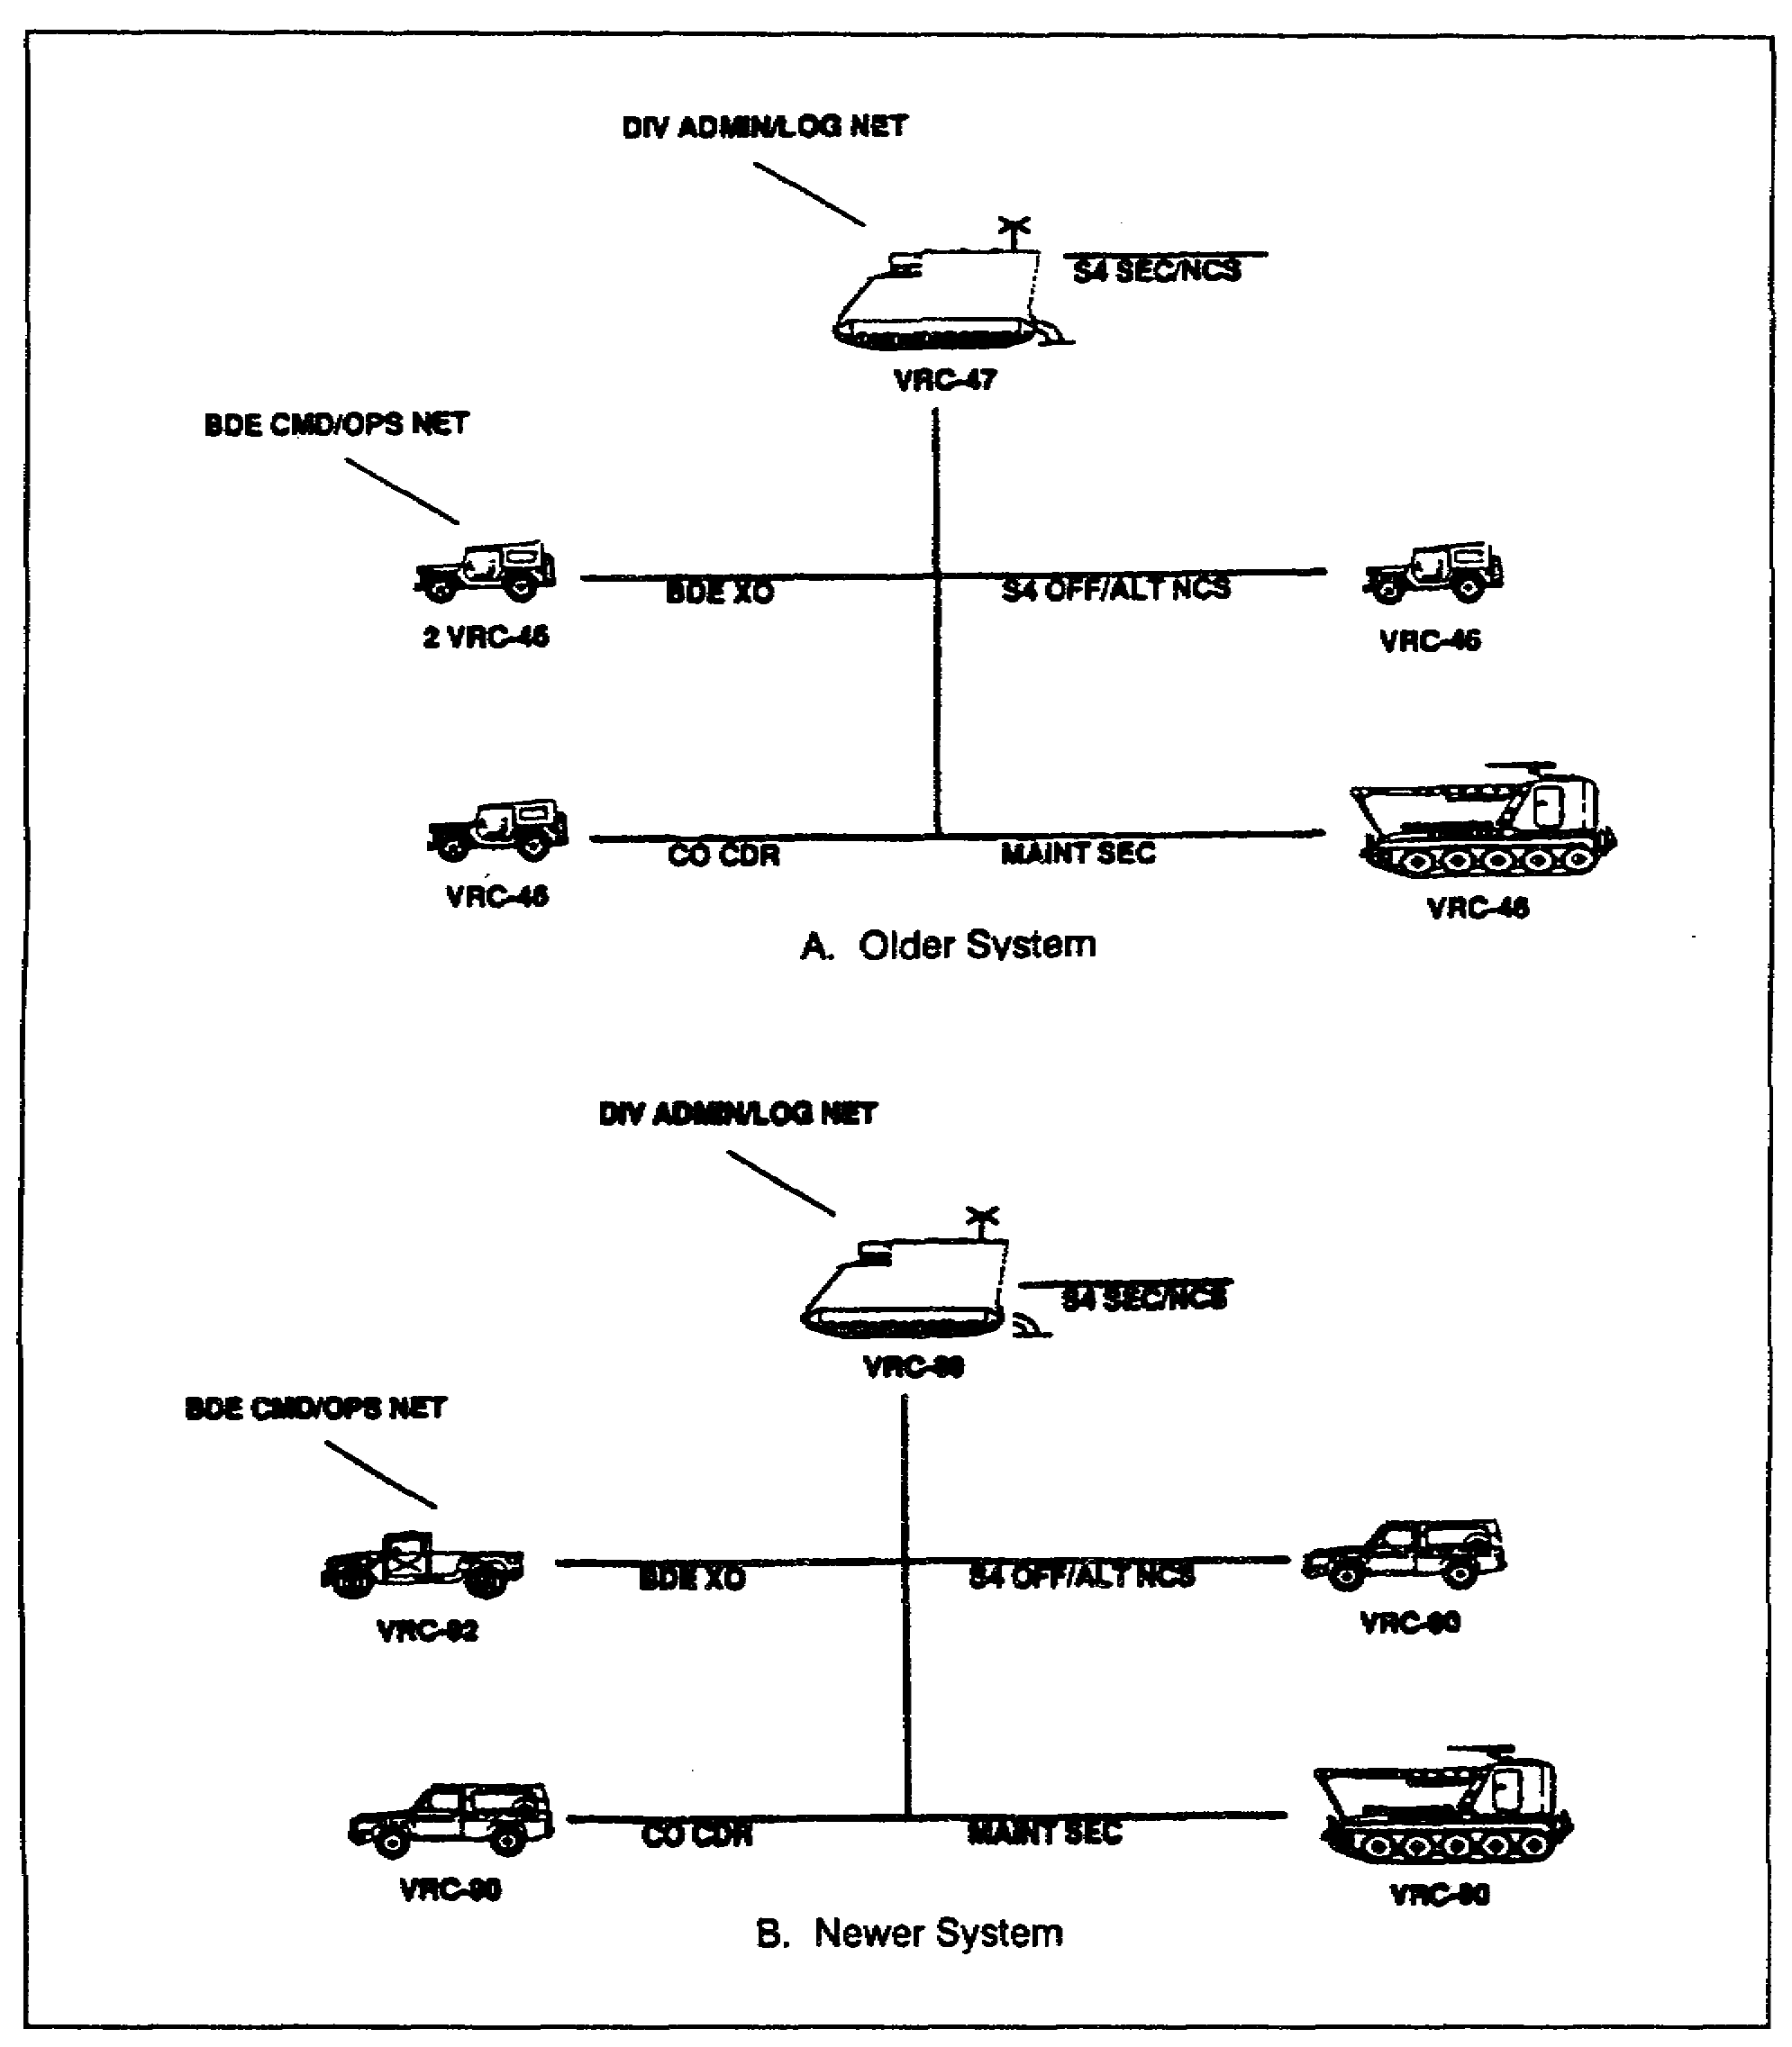

Figure 2-3. Brigade administrative/logistics net (FM voice)

SS0120 2-10

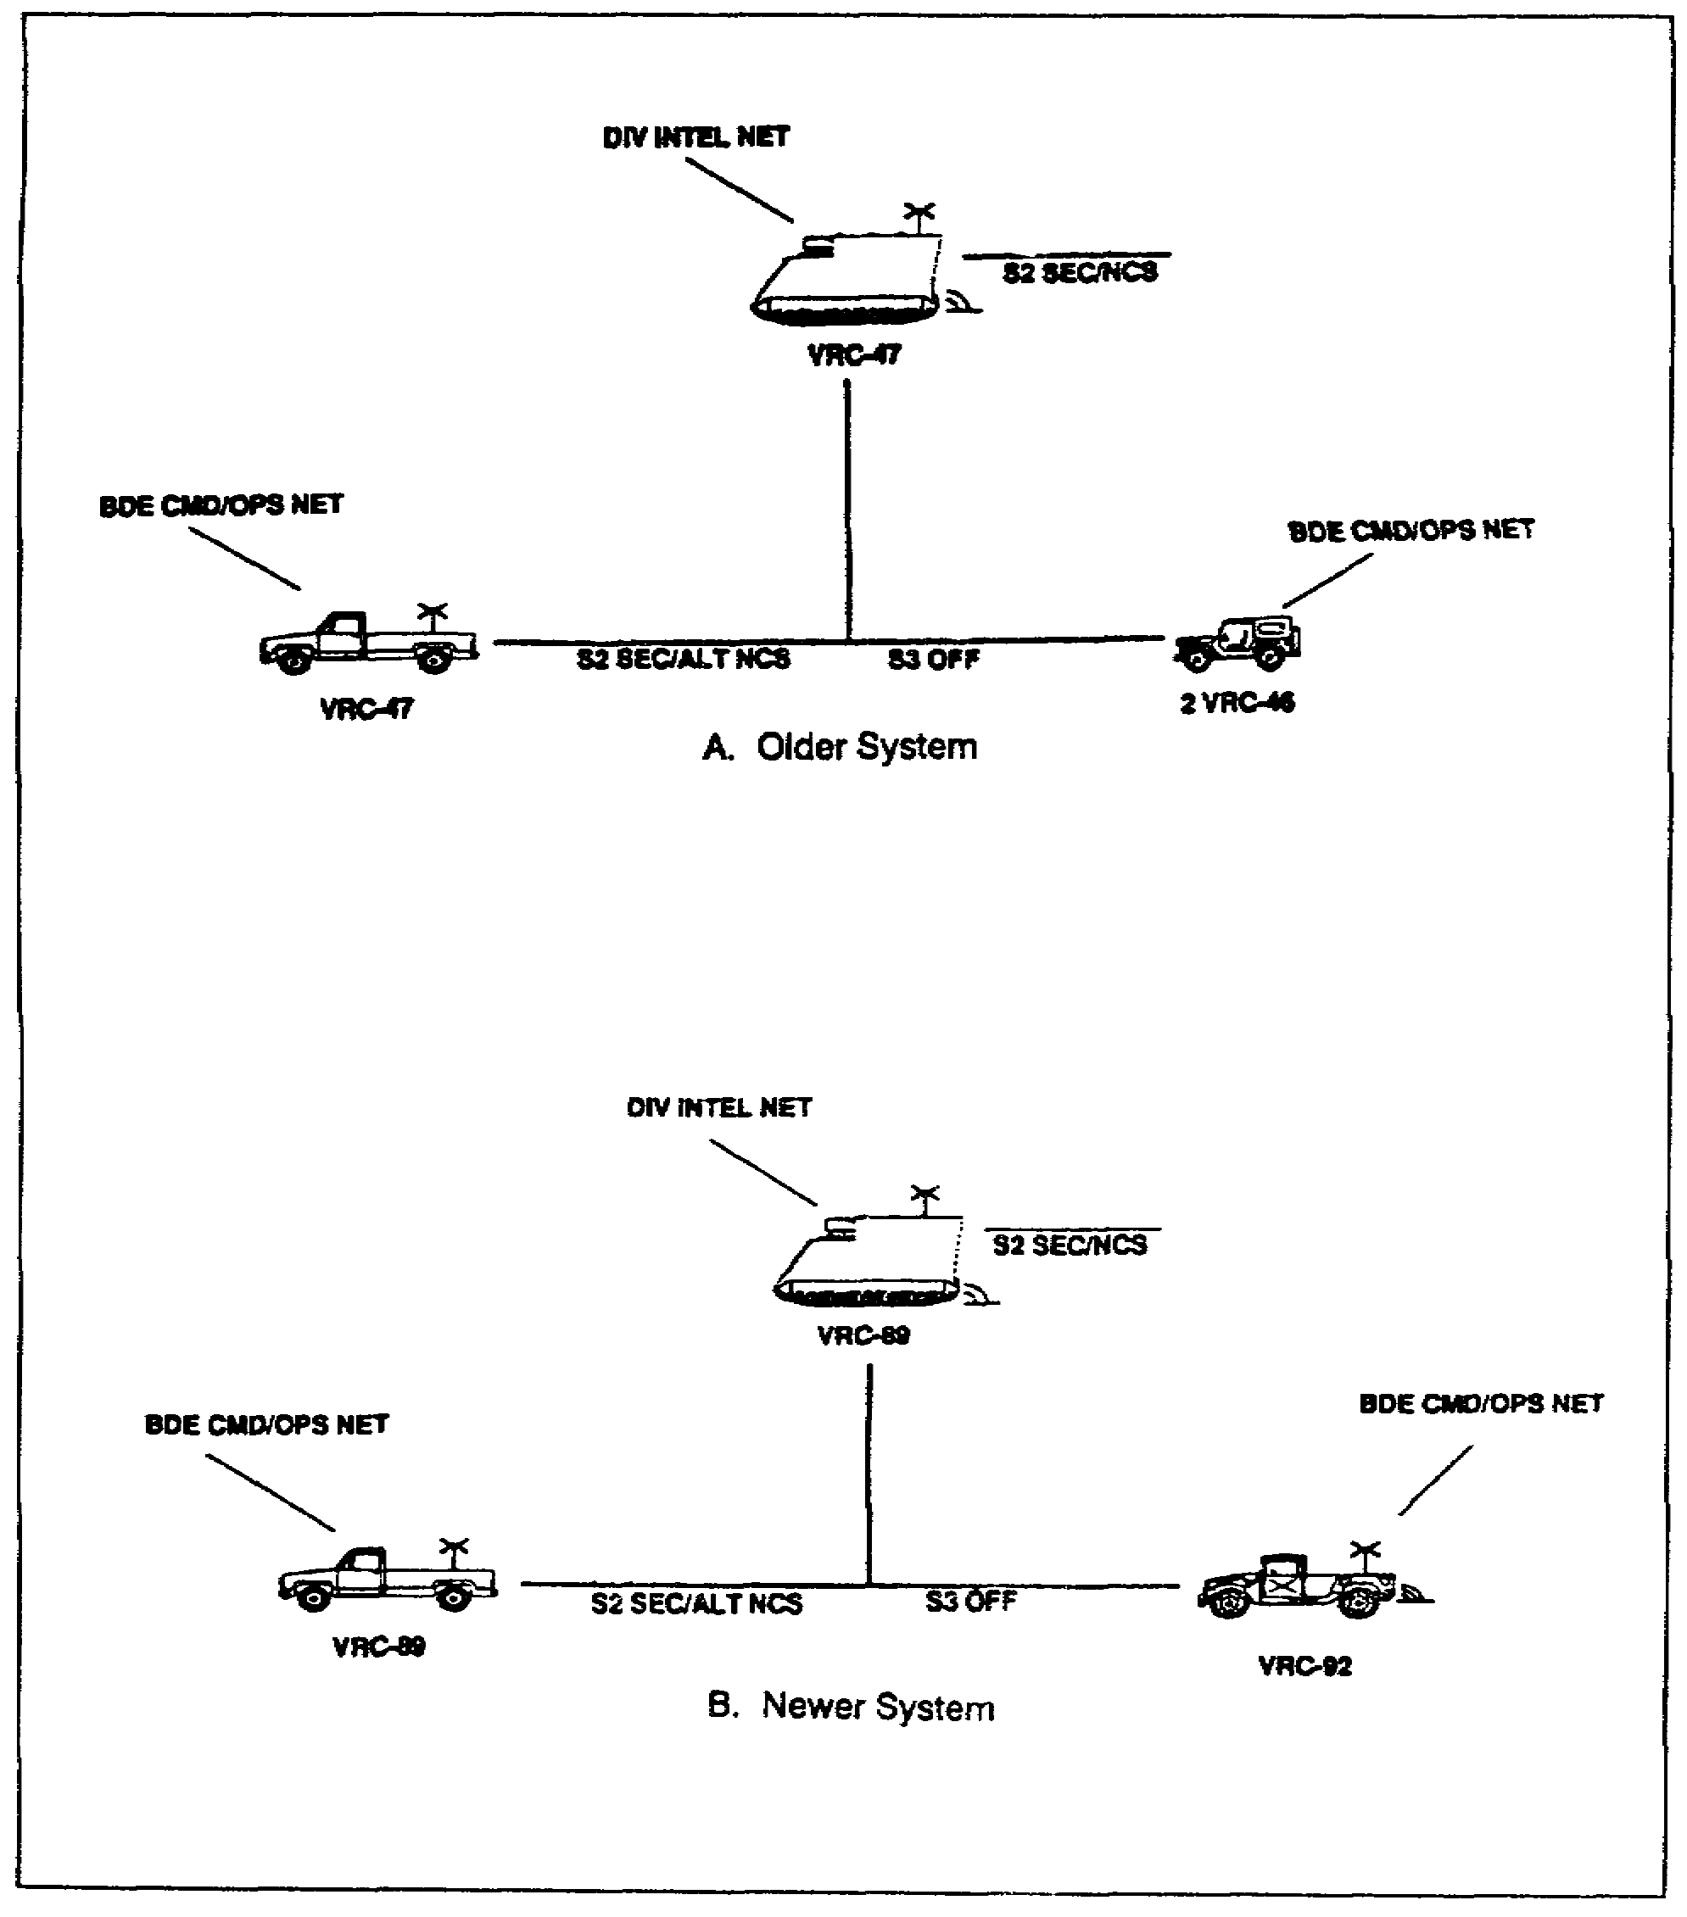

Figure 2-4. Brigade intelligence net (FM voice)

2-11 SS0120

(4) The two VRC-46 radios installed in each of the two vehicles which the liaison officers use operate in the brigade command/operations net (Figures 2-2A and 2-2B, pages 2-8 and 2-9).

(5) The GRC-106 radio installed in the CP carrier at the tactical CP operates in the division operational net (AM).

(6) The GRC-106 radio installed in the CP carrier located at the main CP operates in the division operational net (AM).

d. S4 section. The VRC-46 installed in the S4's vehicle operates in the brigade administrative/
logistics net (Figure 2-3, page 2-10). The VRC-47 radio installed in the S4's CP carrier operates in the brigade administrative/logistics net, monitors the division administrative/logistics net, and serves as the NCS in the brigade administrative/logistics net.

e. Company HQ. The VRC-46 radio installed in the company commander's vehicle operates in the brigade administrative/logistics net (Figure 2-3, page 2-10).

f. Maintenance section. The VRC-46 radio installed in the recovery vehicle operates in the brigade administrative/logistics net (Figure 2-3, page 2-10).

g. Communications section. The VRC-49 radio installed in the section's wheeled vehicle provides retransmission capability for the brigade command/operations net (Figures 2-2A and 2-2B, pages 2-8 and 2-9). The VSC-3 installed in the CP carrier operates in the division operations/intelligence net (RATT).

5. Brigade CP Communications.

a. The brigade CP requires rapid, continuous, dependable, and flexible communications. The brigade uses vehicular-mounted and manpack radios. In addition to voice nets, it establishes a RATT net with subordinate battalions to facilitate transmission of most hard copy traffic between HQs. The brigade also operates in external radio nets. Its single-channel voice stations are provided from organic assets. However, the division signal battalion provides RATT stations for external nets.

b. The brigade has no organic means to enter the division multichannel communications system. The area signal company of the division signal battalion provides multichannel terminal teams to each brigade. The terminal teams establish a site near the HQ of each brigade to terminate multichannel systems. Other teams are set up as a part of extension network located near the brigade support area (BSA). A typical wire distribution system for the brigade HQ is shown in Figure 2-5.

SS0120 2-12

c. The brigade communications platoon and other brigade personnel install internal CP wire lines. The two lengths of 26-pair cables between the multichannel terminals and the brigade CP switchboards the responsibility of the forward communications company of the division signal battalion. The brigade communications platoon is often needed to help signal battalion personnel install the cable from the multichannel site.

(1) Tailgate circuits may be installed as the first priority link to allow circuits between the brigade and the division to be activated during displacement. This long local circuit (telephone and field wire) is extended from the binding posts of the AN/TRC-145 to the brigade tactical operations center (TOC). These circuits are transferred to the local switchboard when cable systems are completed on site or maintained as a back up to the switchboard trunk. Reduction of the single-channel radio signature-the immediate goal-is realized.

(2) Installation priorities for other cables and wire lines will vary between brigades. Telephones serving the commander and key staff elements are usually installed first. Field fortifications and wire systems should be expanded and refined continuously.

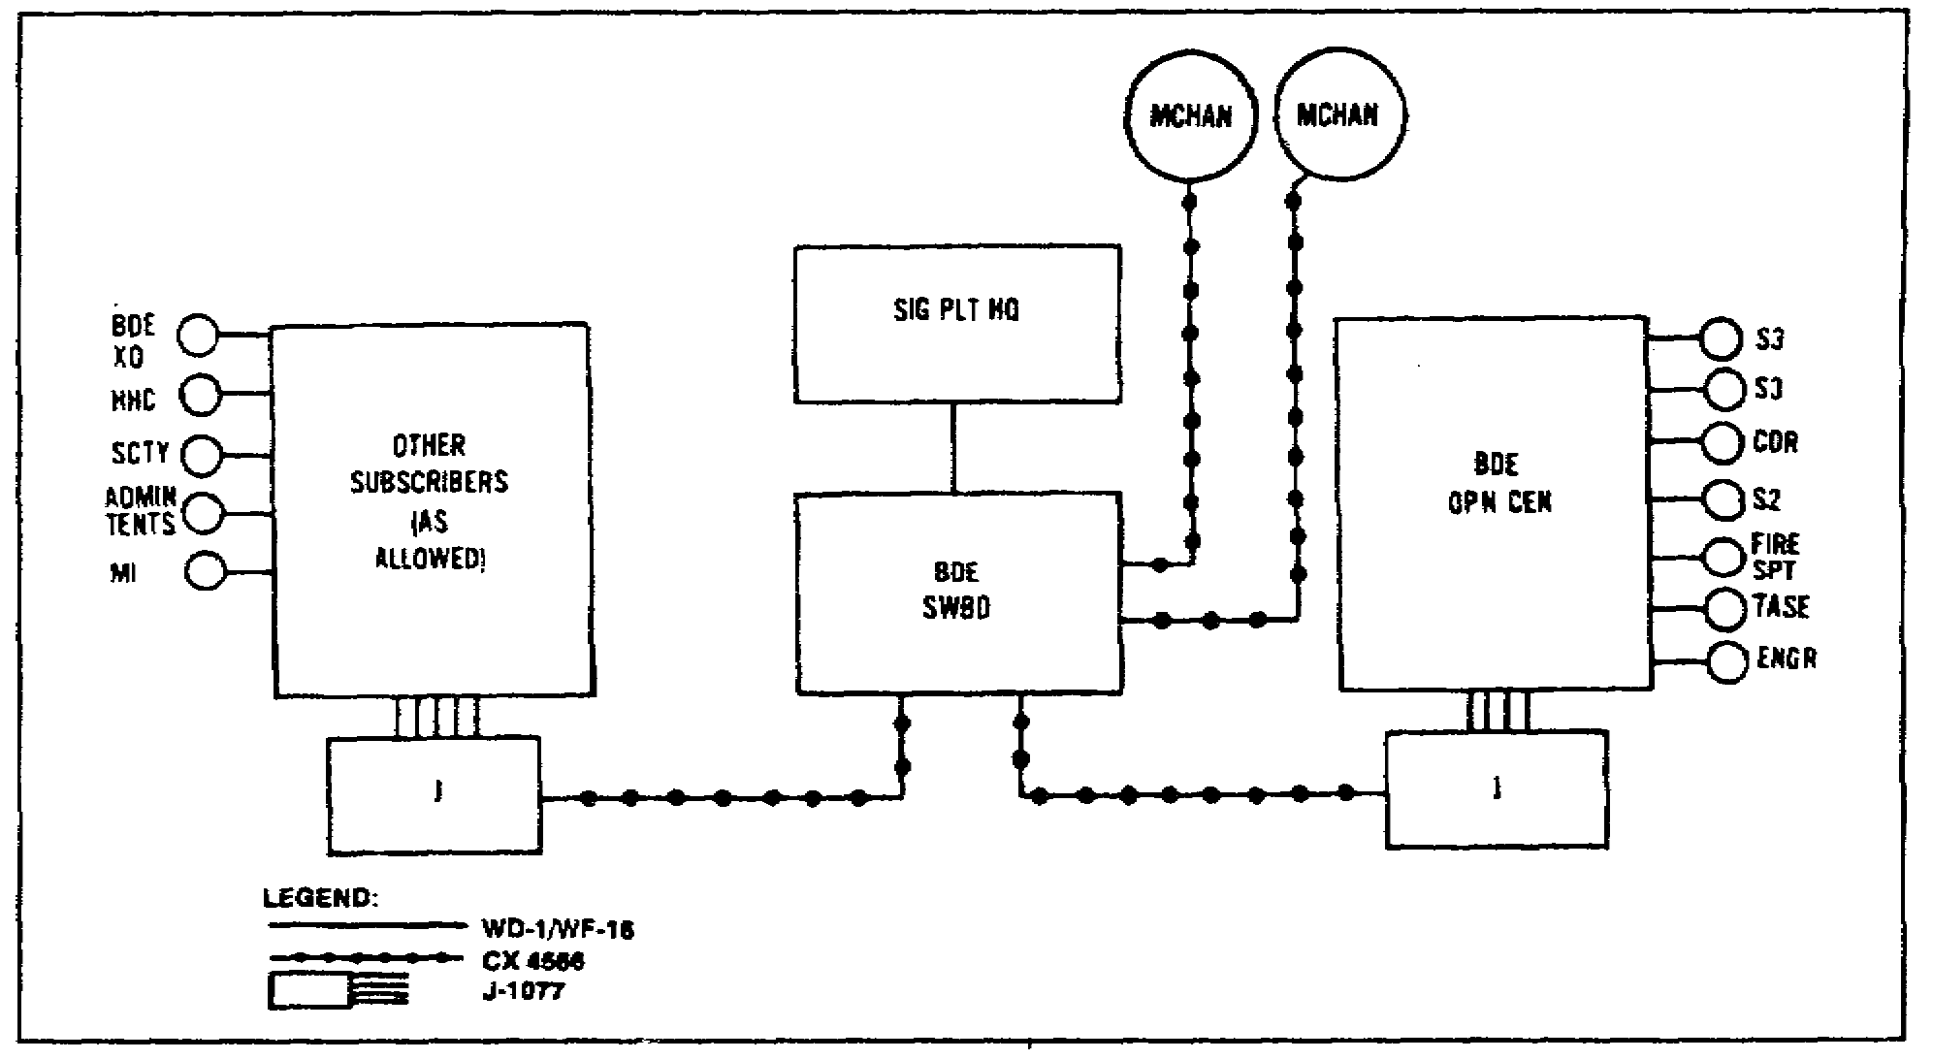

Figure 2-5. Brigade headquarters wire distribution system.

2-13 SS0120

PART C - RADIO AND WIRE DIAGRAMS IN THE MANEUVER BATTALION

1. Overview. At battalion level, command and control is exercised through brigade, battalion, and company nets. At this point, you should know how command and control is achieved through which net and for what purpose.

2. Radio Net Structure. The single-channel radio is used for a mobile battalion. The battalion uses FM radio equipment on all radio nets except the battalion station in the brigade RATT net. This station uses an HF radio (AM) for teletypewriter or voice transmissions. Figure 2-6 shows the battalion radio net structure.

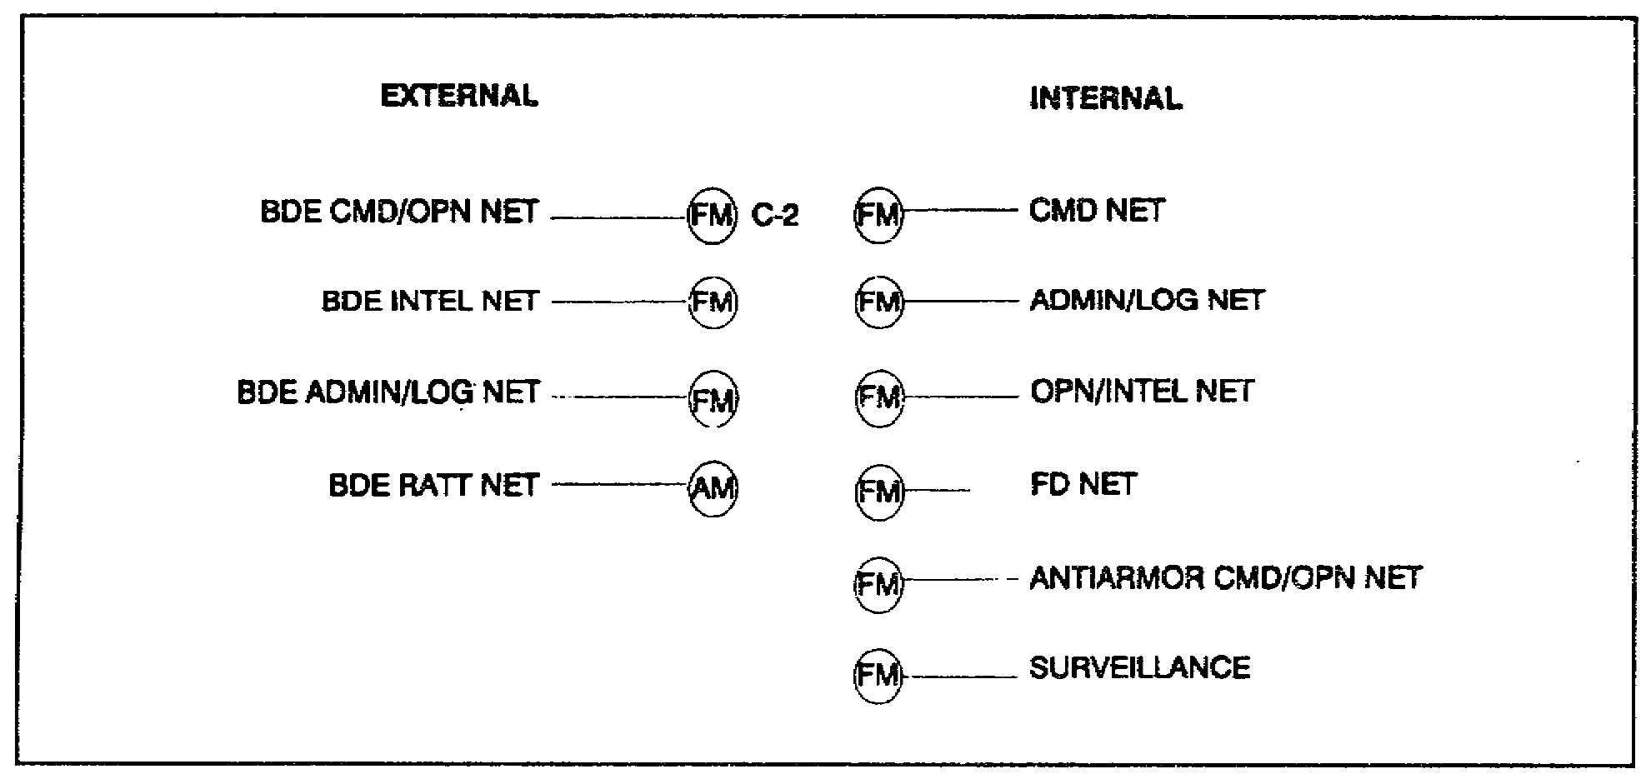

Figure 2-6. Battalion radio net structure

3. Wire Structure. The battalion uses its radio nets extensively while it is moving. However, field wire lines should become the primary means of communications when the battalion halts. The battalion wire system may be as big as time and wire assets allow (Figure 2-7). The basic wire system should link the battalion TOC with each company CP. Other wire links may be installed as necessary and as time permits. The units and personnel shown in Figure 2-7 may be at the TOC, at the combat trains, or at the field trains. Units designate where their switchboards are used to support the mission. Extreme care should be used when installing wire lines to protect them from being damaged or destroyed by tracked and wheeled vehicles. In addition, the laying and retrieval of wire takes manpower and time.

SS0120 2-14

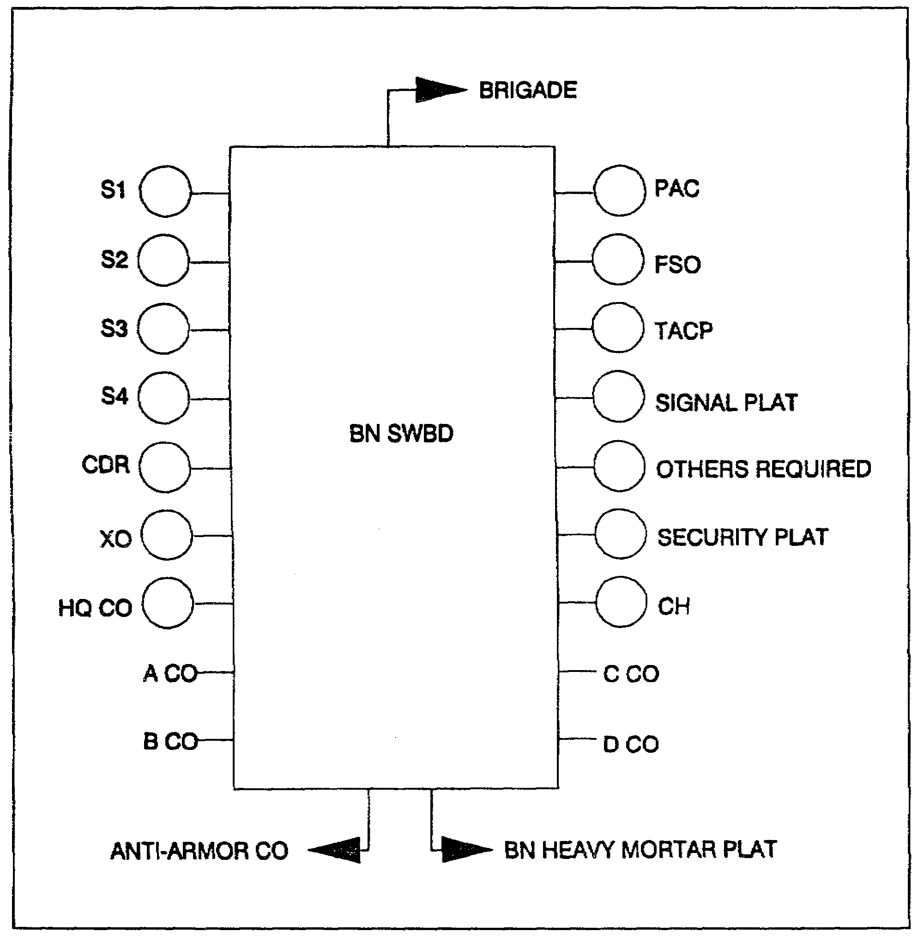

Figure 2-7. Battalion wire structure

2-15 SS0120

PART D - MANEUVER BATTALION (HEAVY AND LIGHT) SIGNAL SUPPORT SYSTEM

1. Overview. This lesson now examines the communications systems found in a heavy force battalion (armored and mechanized infantry) and a light force battalion (infantry, light infantry, airborne, and air assault).

2. Heavy Battalion Signal System.

a. The communications platoon (Figure 2-8) is organic to the heavy battalion's headquarters and headquarters company (HHC). The signal officer is assisted by a battalion communication chief, a radio team chief, two combat signaler team chiefs, two radio teletypewriter operators, two radio operators, and two switchboard operators.

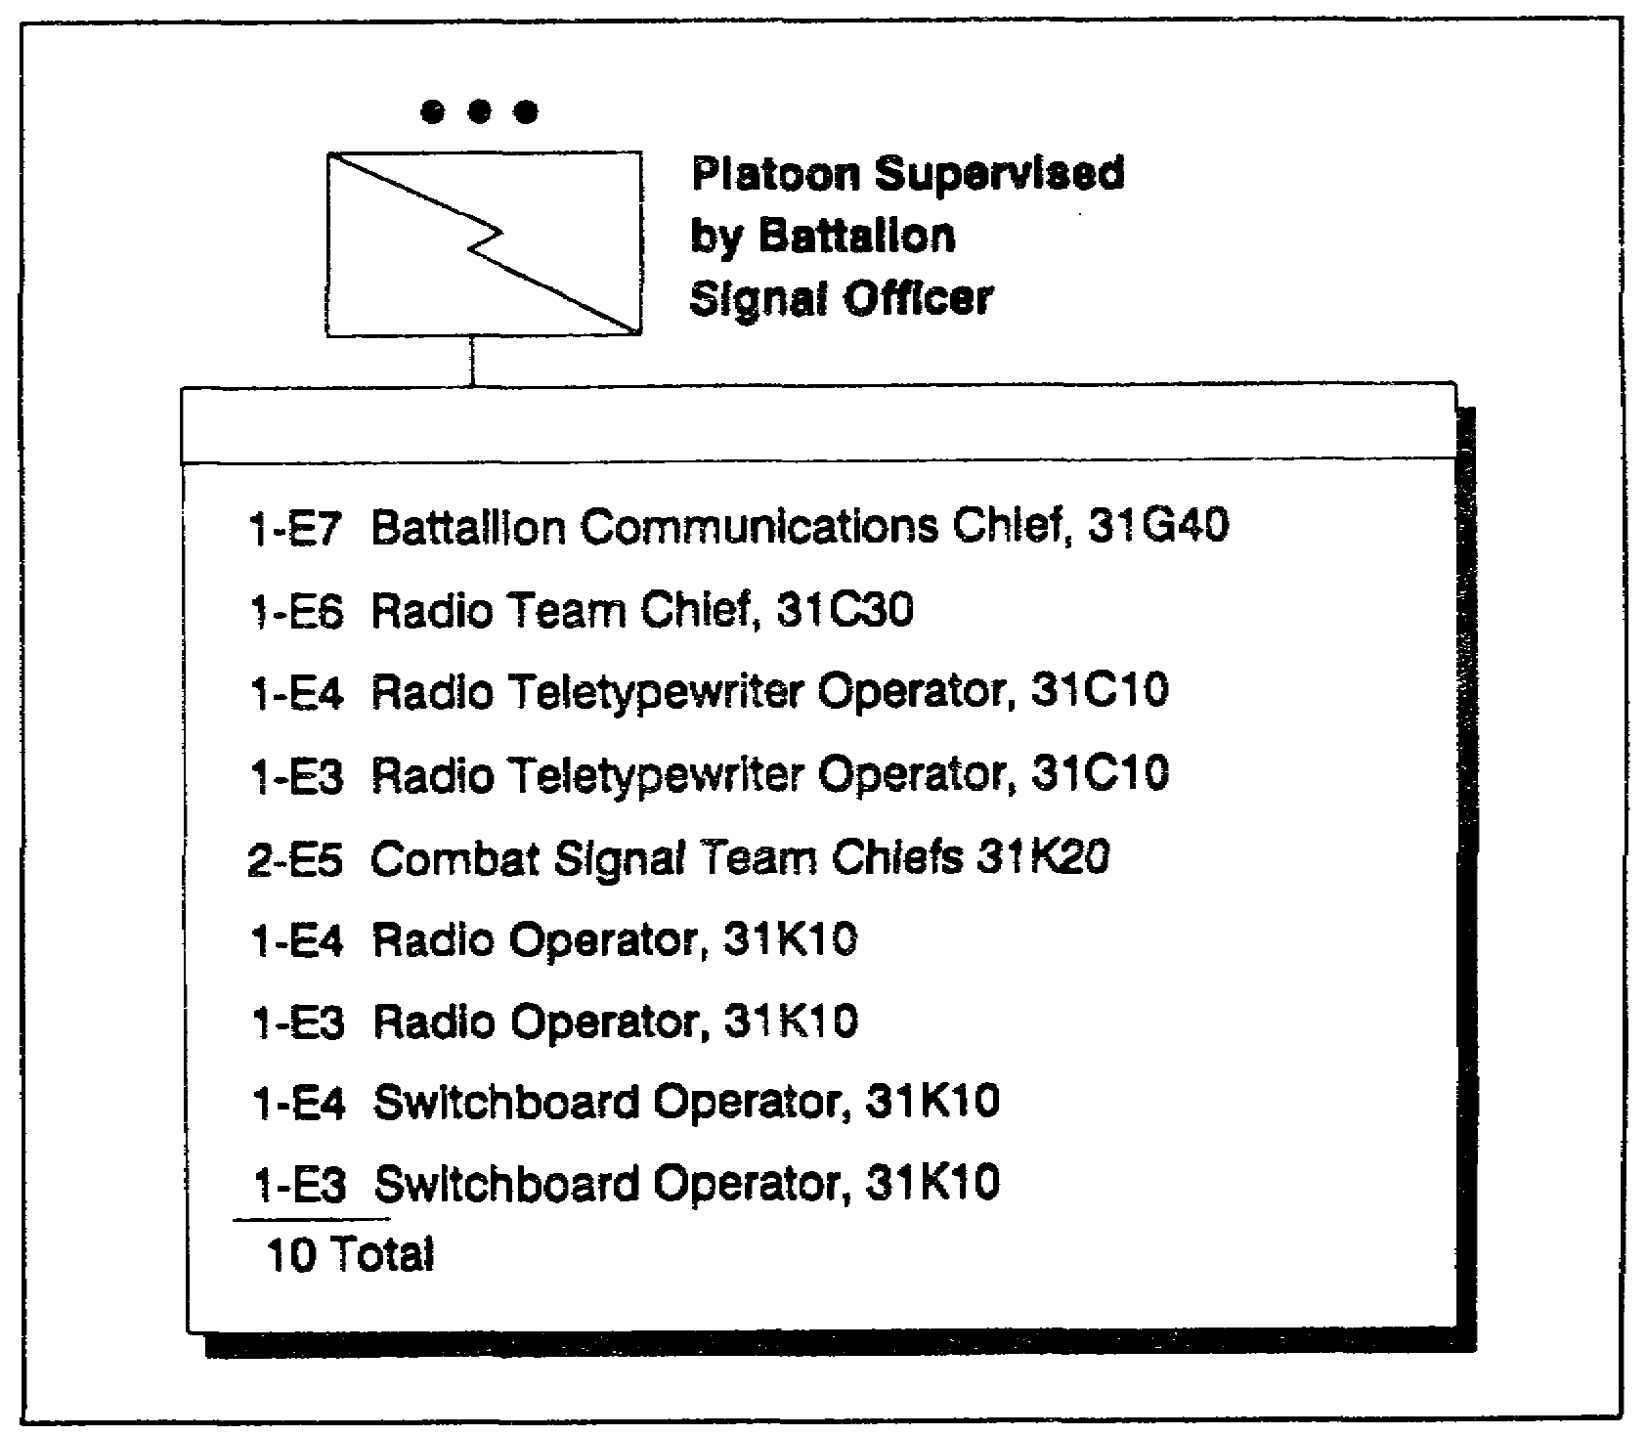

Figure 2-8. Communications platoon

SS0120 2-16

b. The vehicles and communications equipment found in a typical communications section of a heavy battalion are shown in Table 2-1. In units which are not equipped with SINCGARS, the vehicles may be different and equipped with the VRC-12 series of radios. However, the basic equipment and radio allocation remain as shown.

Table 2-1. Communications Section Vehicles and Equipment

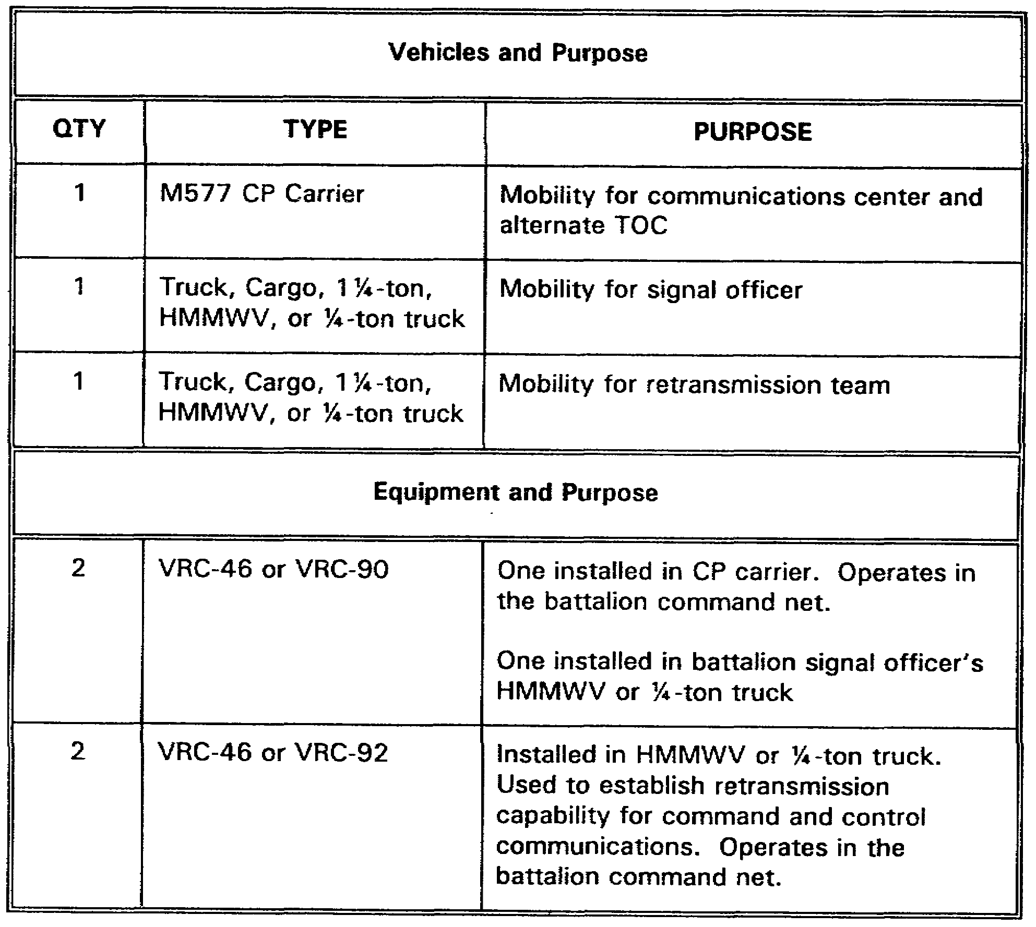

2-17 SS0120

c. The M577 command post carrier is the communication operations center for the battalion, and may be located forward or in the field trains area. The platoon also has a retransmission capability.

d. Radio Net Structure and Wire System.

(1) Command Net.

(a) The command net is a secure net used for command and control of the battalion.

(b) All organic and attached units, to include the fire support officer (FSO), the forward air controller (AC), and leaders of supporting elements, enter the battalion command net. Only commanders transmit during the execution of the mission; others monitor and transmit only essential information.

(c) The battalion main CP controls the command net. The command net is shown in Figures 2-9A and 2-9B, pages 2-20 and 2-21. The type of communications equipment (VRC-12 series or SINCGARS) may vary from one battalion to another.

(d) In a heavy battalion, the battalion commander and his staff will have vehicular-mounted radios.

(e) In a mechanized infantry battalion, the commander, the S3, the company commanders, and their subordinate leaders will have manpacked radio equipment for conducting dismounted operations. An armored battalion has a very limited capability to operate dismounted.

(2) Connectivity. The battalion maintains connectivity with its higher HQ (the brigade). Since the battalion is a combat asset of the brigade, the battalion maintains contact with the brigade through the brigade command/operations net (BDE CMD/OP NET), the intelligence net (BDE INTELNET), the brigade radio RATT (BDE RATT), and the brigade administrative/logistics net (BDE A/L NET). This connectivity is essential for the brigade's command and control and its logistics support operations.

(3) Wire system. The same basic structure of communications is maintained through the battalion's wire system. When the battalion stops moving and establishes a position, field wire should be used for internal communications as much as possible. The battalion's wire system is depicted in Figure 2-10, page 2-22.

(4) Operations and intelligence (O&I) net.

(a) The O&I net is shown in Figure 2-11, page 2-22.

SS0120 2-18

(b) The O&I net is a secure net. It provides a mechanism for the battalion to accept routine information concerning operations and intelligence reporting, without cluttering or interfering with the battalion command net.

(c) The S2 monitors and controls the O&I net. Others enter the net to transmit and receive information.

(d) The O&I net may be combined with the command net in some battalions.

(5) Administrative/logistics net.

(a) The battalion administrative/logistics net is a tactical net.

(b) The combat trains CP controls this net, which is shown in Figures 2-12A and 2-12B, pages 2-23 and 2-24.

(c) The battalion administrative/logistics net is operated from the battalion 54's M577 CP vehicle.

(d) The administrative/logistics net is used to communicate the administrative and logistical requirements of the battalion. All organic and attached units operate in this net.

(e) The administrative/logistics net connects all of the battalion's combat service support (CSS) elements and each subordinate company into the brigade administrative/logistics net.

(f) The administrative/logistics net also serves as the backup for the battalion command net.

e. The nets just reviewed are the primary nets in the heavy battalion (armored or mechanized infantry). The following discussion will focus on the communications support found in a light battalion (infantry, light infantry, airborne, and air assault). You will learn from this discussion that although the basic net structures are the same, the type and numbers of radios differ.

2-19 SS0120

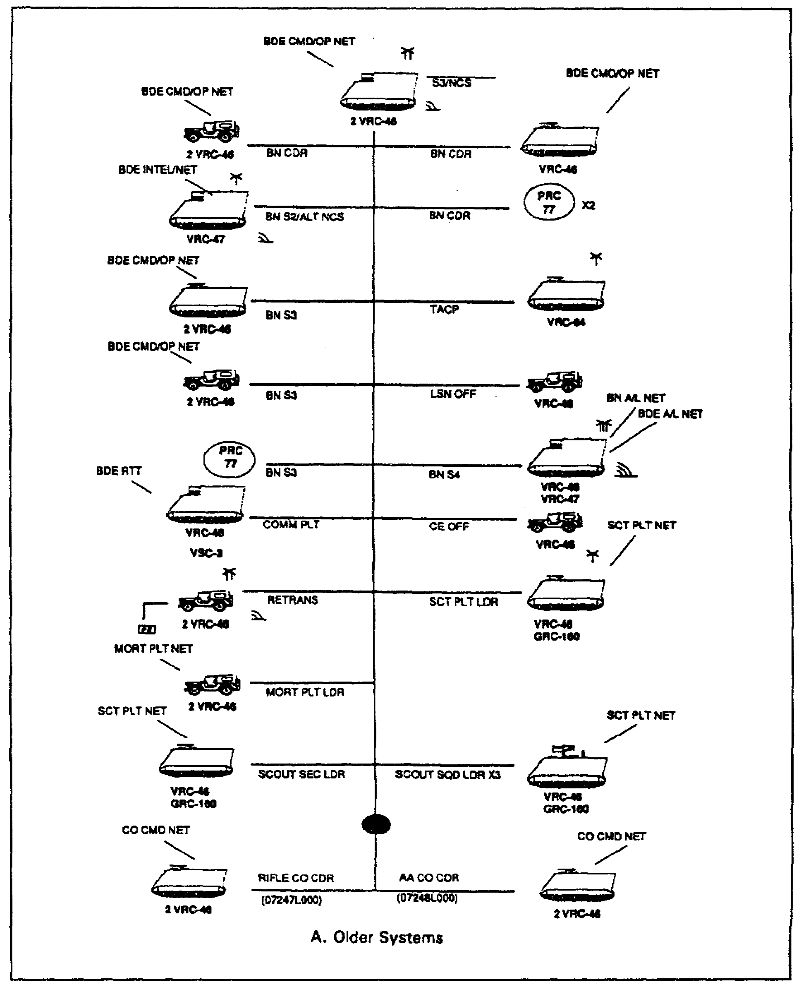

Figure 2-9A. Mechanized battalion command net

SS0120 2-20

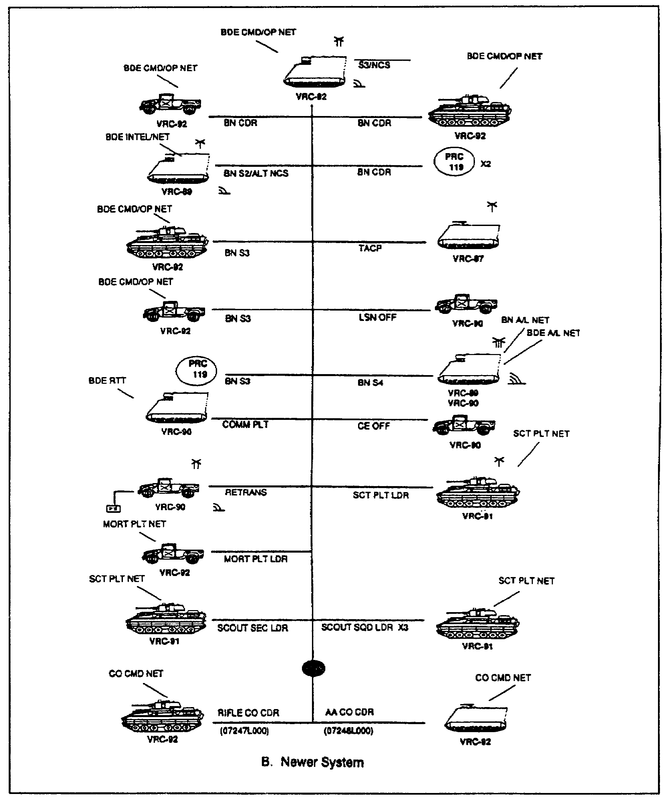

Figure 2-9B. Mechanized battalion command net

2-21 SS0120

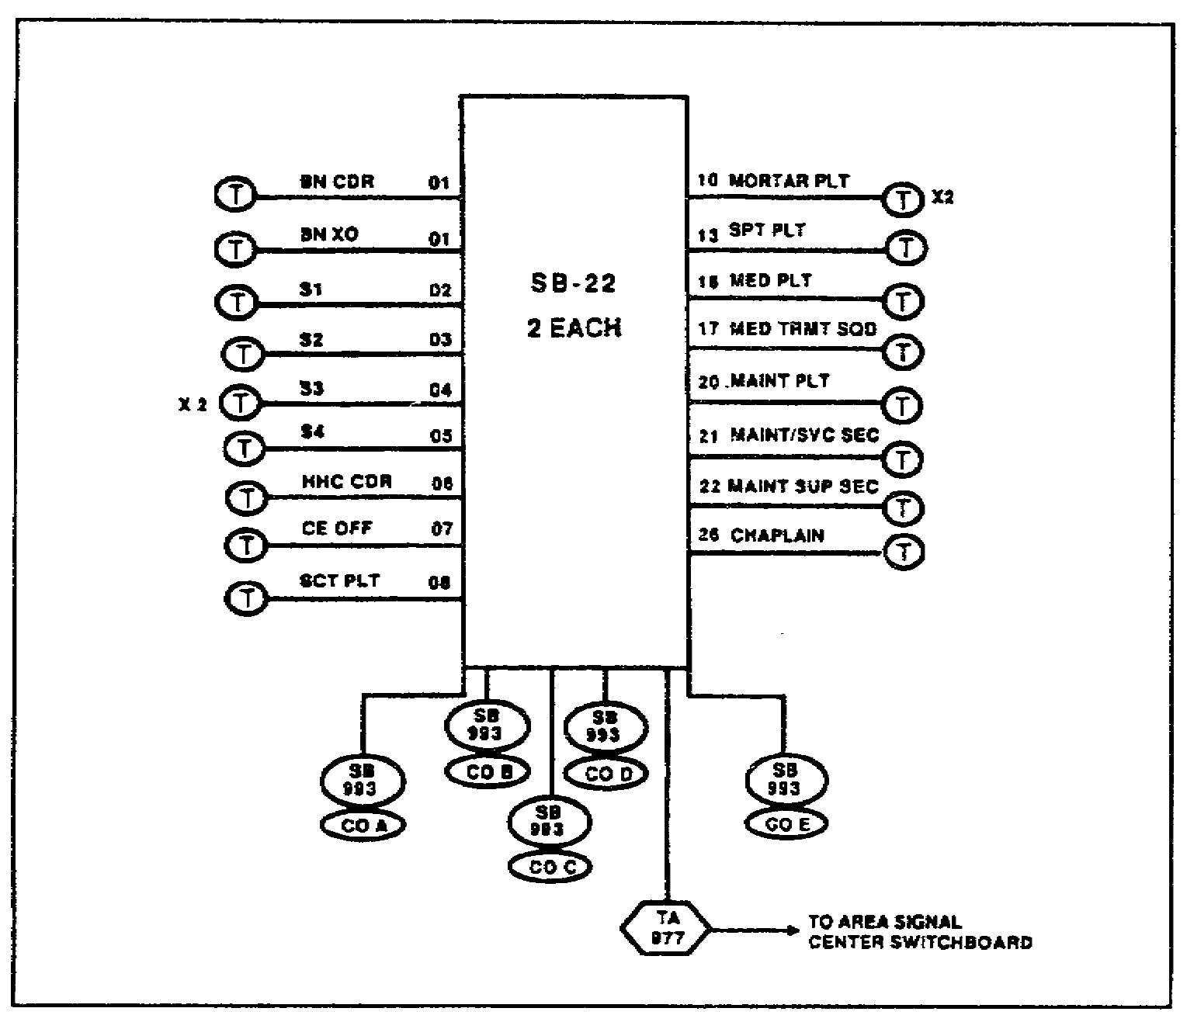

Figure 2-10. Battalion wire system

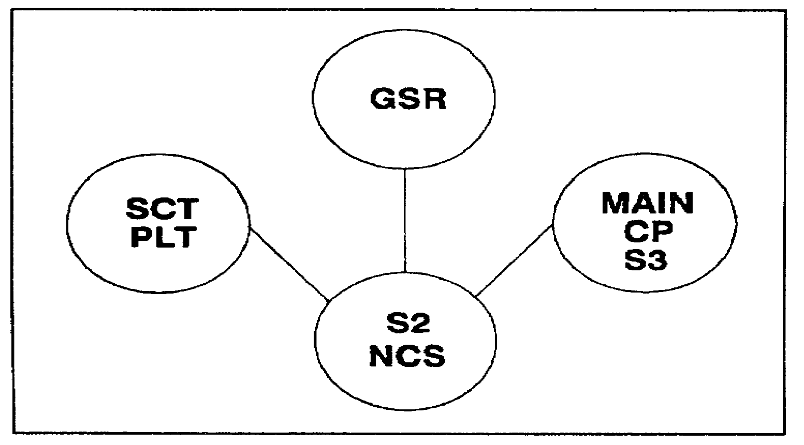

Figure 2-11. Battalion operations and intelligence net

SS0120 2-22

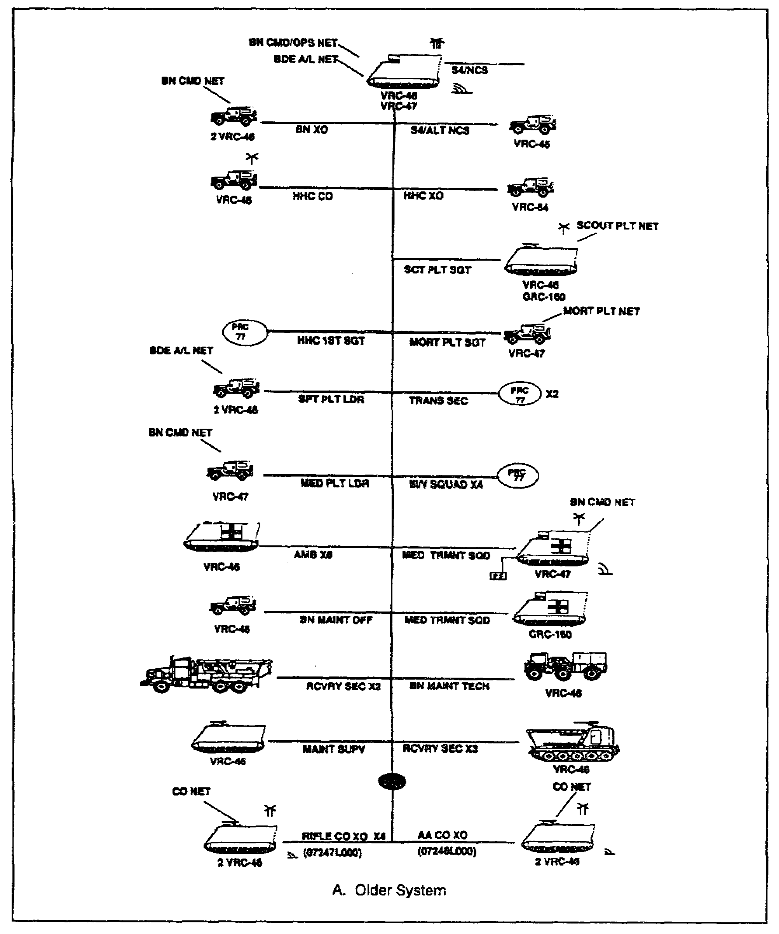

Figure 2-12A. Battalion administrative/logistics net

2-23 SS0120

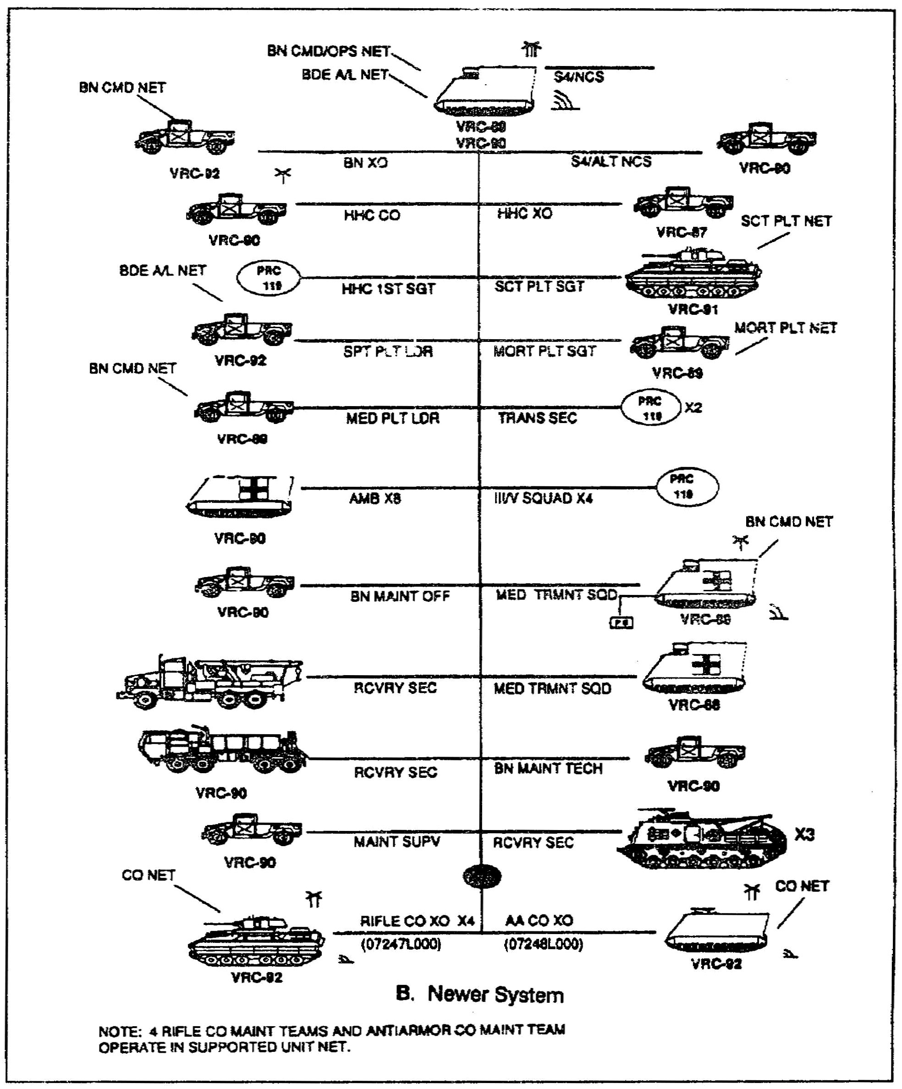

Figure 2-12B. Battalion administrative/logistics net

SS0120 2-24

3. Light Battalion Signal System.

a. The light battalion communications platoon is organic to the battalion's HHC, just as it is for a heavy battalion.

b. The communications platoon (Figure 2-13) has the same mission as the communications platoon in a heavy battalion-to install, operate, and maintain the communications system for battalion command and control elements. The platoon is supervised by the signal officer, and consists of a battalion communications chief who is in charge of the daily operation of the platoon, a communications maintenance supervisor who supervises the maintenance performed by a senior unit level communications maintainer and two unit level maintainers, a combat signaler team chief who leads the wire team consisting of two wire installers and two switchboard operators, and a combat signaler radio team chief who supervises two radio operators.

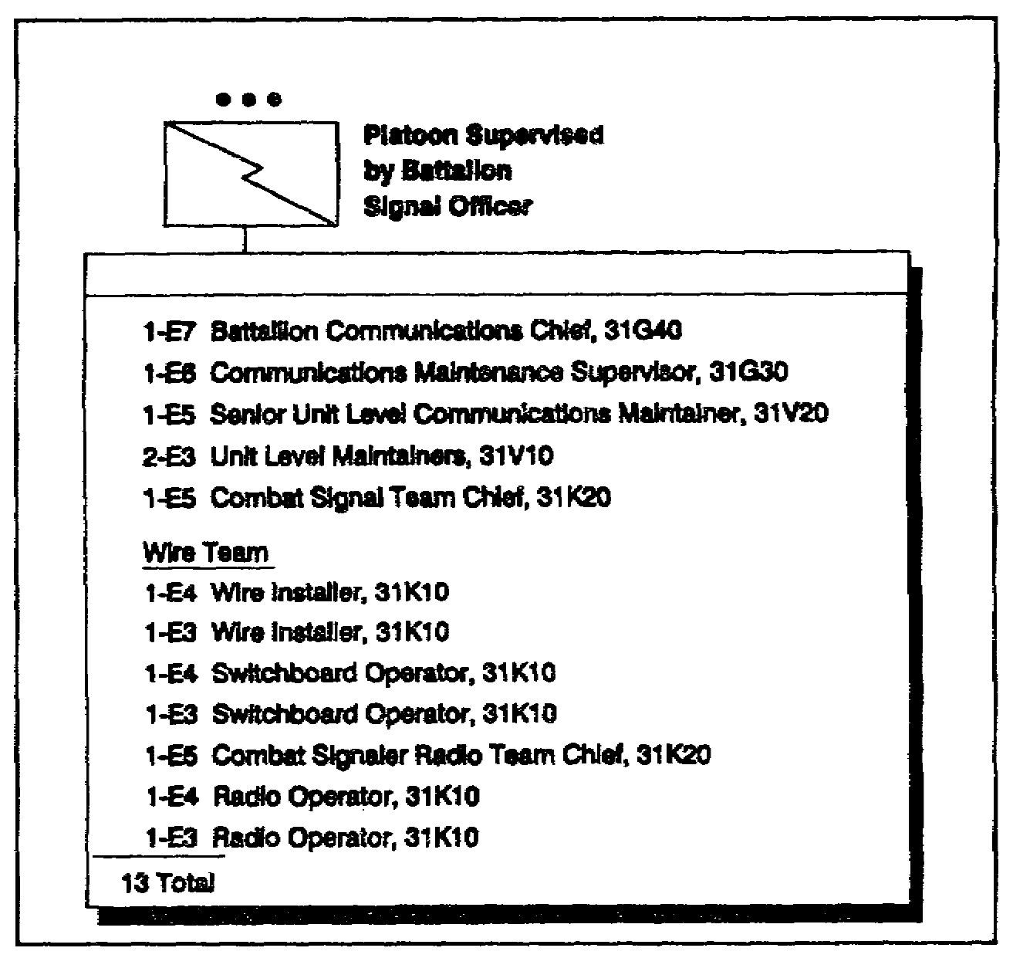

Figure 2-13. Light battalion communications platoon

c. The vehicles and communications equipment found in a typical communications section of a light battalion is shown in Table 2-2, page 2-26. Not all units axe SINCGARS-equipped. In those units, the vehicles may be different and equipped with the VRC-12 series of radios; however, the basic equipment and radio allocation remain as shown.

2-25 SS0120

Table 2-2. Communications Section Vehicles and Equipment

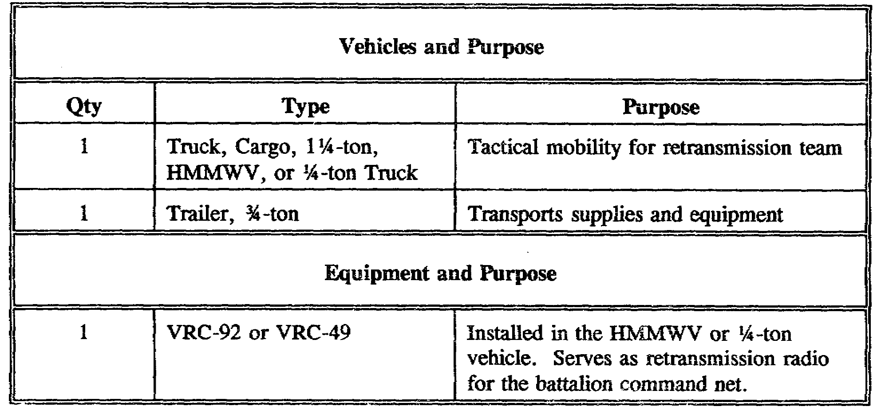

d. The communication systems found in light battalions are presented in the following figures. The battalion uses these radio nets extensively while it is moving. The light force is organized and equipped to fight dismounted. That means that when the FM voice radios are vehicular-mounted, the operating capabilities are similar to mounted radios in the heavy battalion. However, the operating range is drastically reduced when the radios are used dismounted.

(1) Command net.

(a) This net is used by the commander to command and control subordinate units. The command net is controlled by the battalion main CP. As in the heavy battalion, the signal officer uses the battalion communications support system to assist the commander in accomplishing the mission.

(b) Like the heavy battalion, all organic and attached units, to include the FSO, the FAC, and the leaders of supporting elements, enter the command net. During the execution of the mission, only commanders transmit; others monitor and transmit only essential information.

(c) A light battalion command net is depicted in Figures 2-14A and 2-14B, pages 2-28 and 2-29. The type of communications equipment (VRC-12 series or SINCGARS) may vary from one battalion to another.

SS0120 2-26

(2) Operations and intelligence (O&I) net.

(a) Like the heavy force battalion, the light fore battalion has an O&I net (Figure 2-15, page 2-30).

(b) The purpose of the O&I net is the same as it was for the heavy force -- to provide a means for the light force commander to accept routine items of information concerning O&I reporting, without cluttering or interfering with the command net.

(c) The S2 monitors and controls this net. Others enter the net to pass information.

(3) Administrative/logistics net.

(a) The battalion net is shown in Figures 2-16A and 2-16B, pages 2-31 and 2-32. This net handles the administrative and logistics requirements of the force. This net is also the backup command net.

(b) The connectivity for the light force battalion administrative/logistics net is the same as that of the heavy force. All CSS elements are connected into the net from company through battalion. As you can see, the battalion administrative/ logistics net connects with the brigade administrative/
logistics net.

4. Communications in Heavy-Light and Light-Heavy Task Forces.

a. As you may recall from lesson 1, there are times when light forces and heavy forces are cross-attached. The brigade commander makes the decision to cross attach company level units to his subordinate battalions. This decision is based upon his analysis of the factors of METT-T.

b. The organization and capabilities of the communications platoon organic to a heavy or light force were discussed in the preceding paragraphs. Although the communications platoons are similar, they differ in ways that reflect the missions of their battalions.

(1) The heavy force relies on its mobility to move and fight on the battlefield. The commander, his staff, and subordinate commanders fight mounted. The mechanized infantry is also equipped to fight dismounted. The armored battalion does not fight dismounted, and it is not equipped with the communications equipment to do so.

(2) The light force is organized and equipped to fight and communicate dismounted. It is not equipped to fight mounted. The light force has only a limited number of mounted radios.

2-27 SS0120

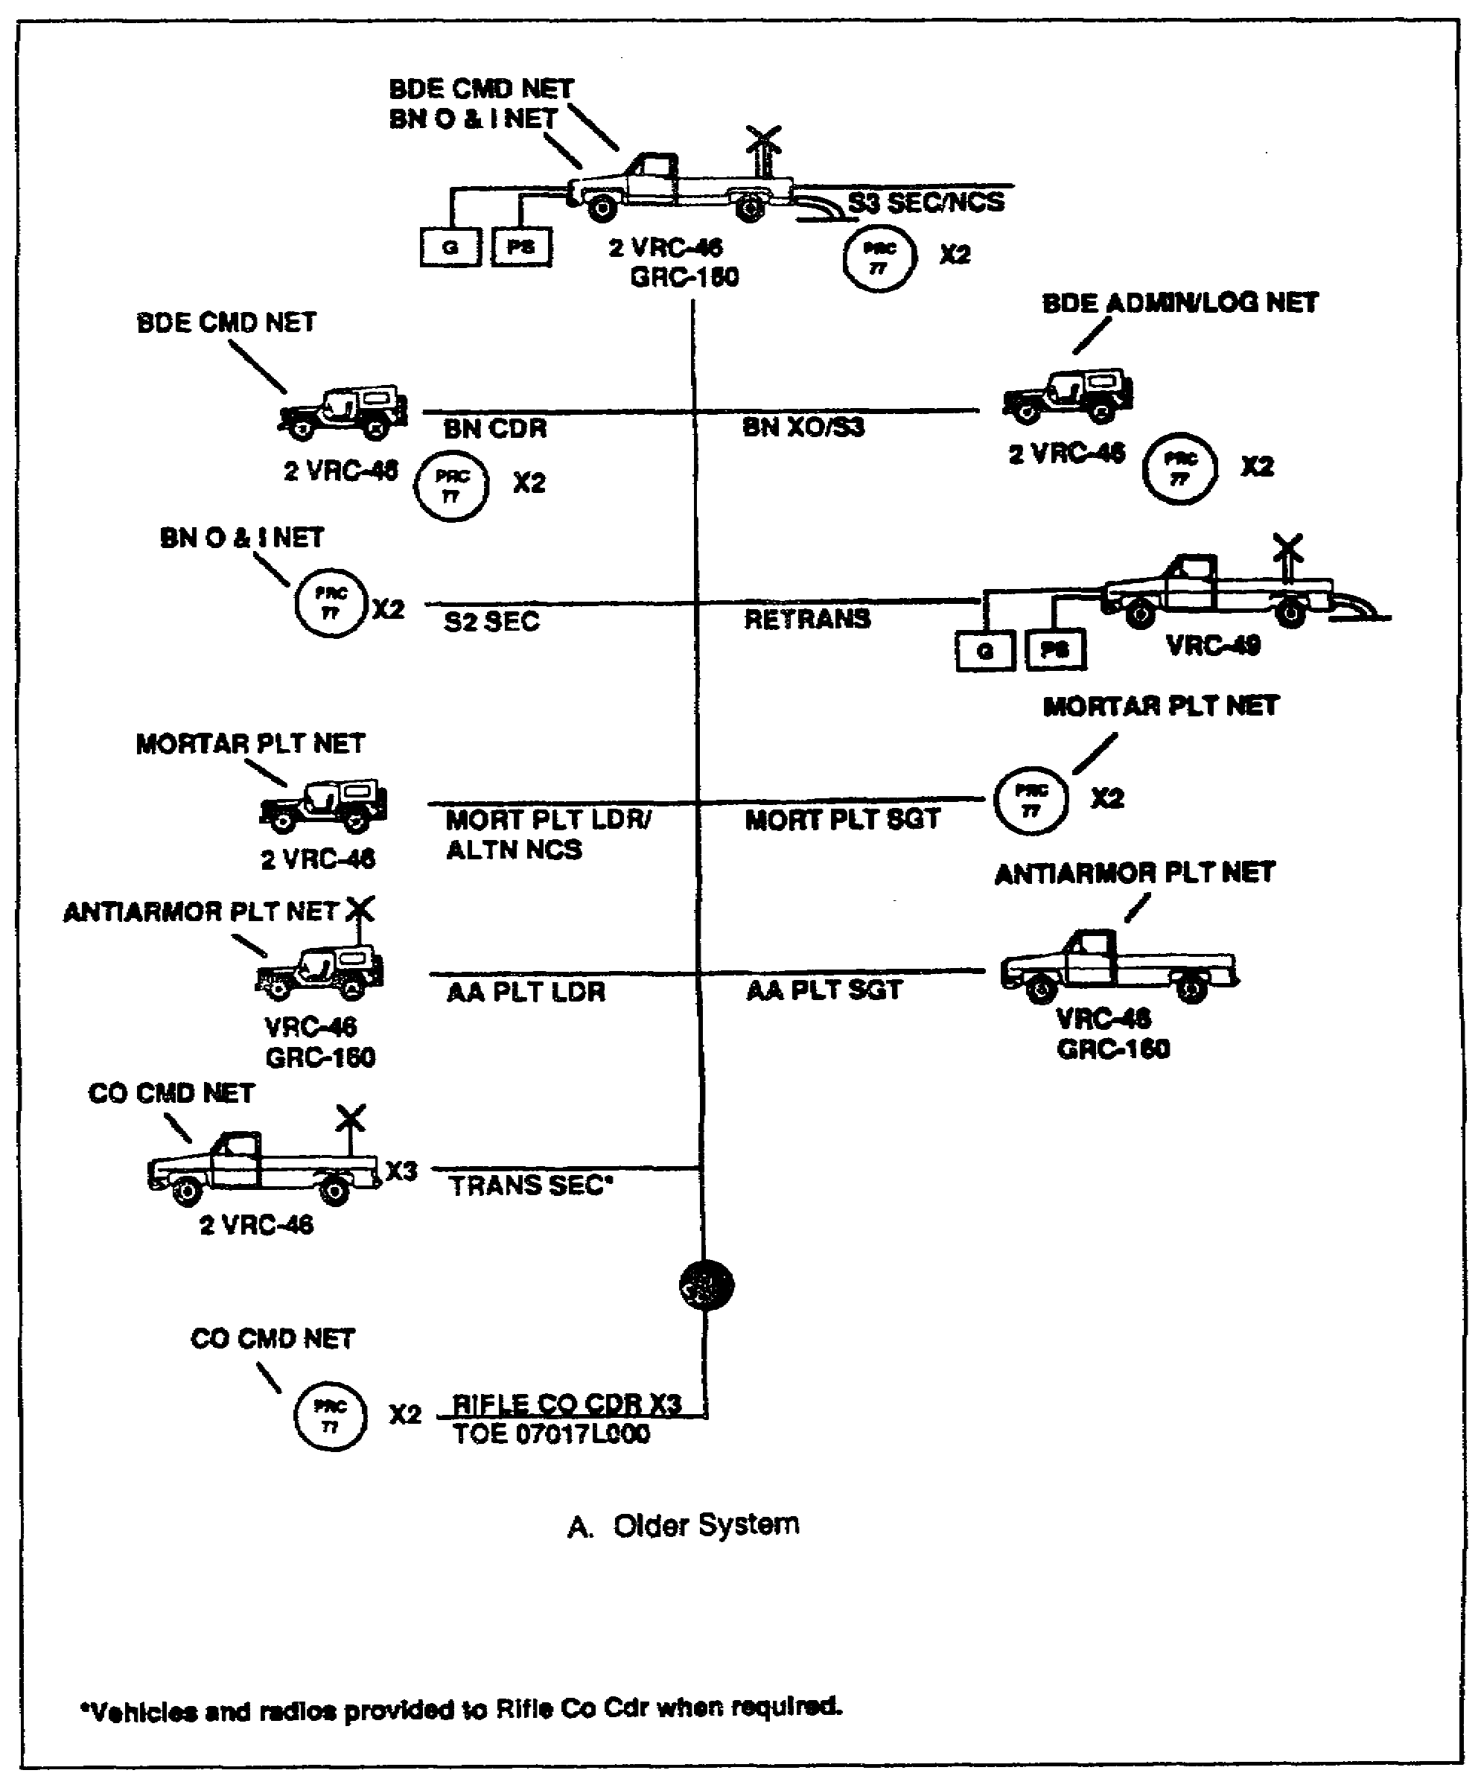

Figure 2-14A. Light battalion command net

SS0120 2-28

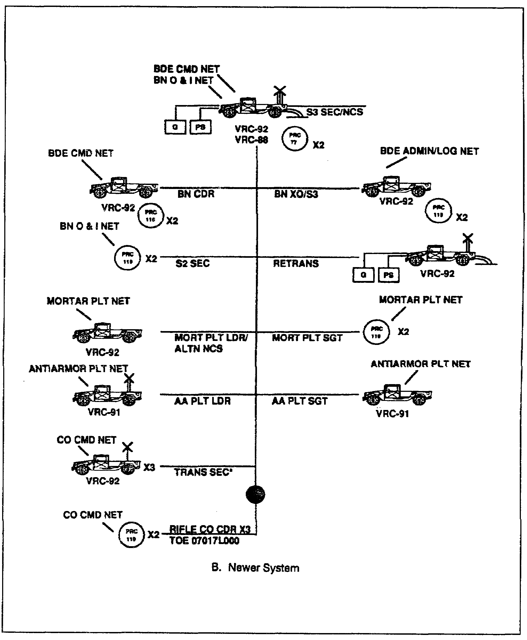

Figure 2-14B. Light battalion command net

2-29 SS0120

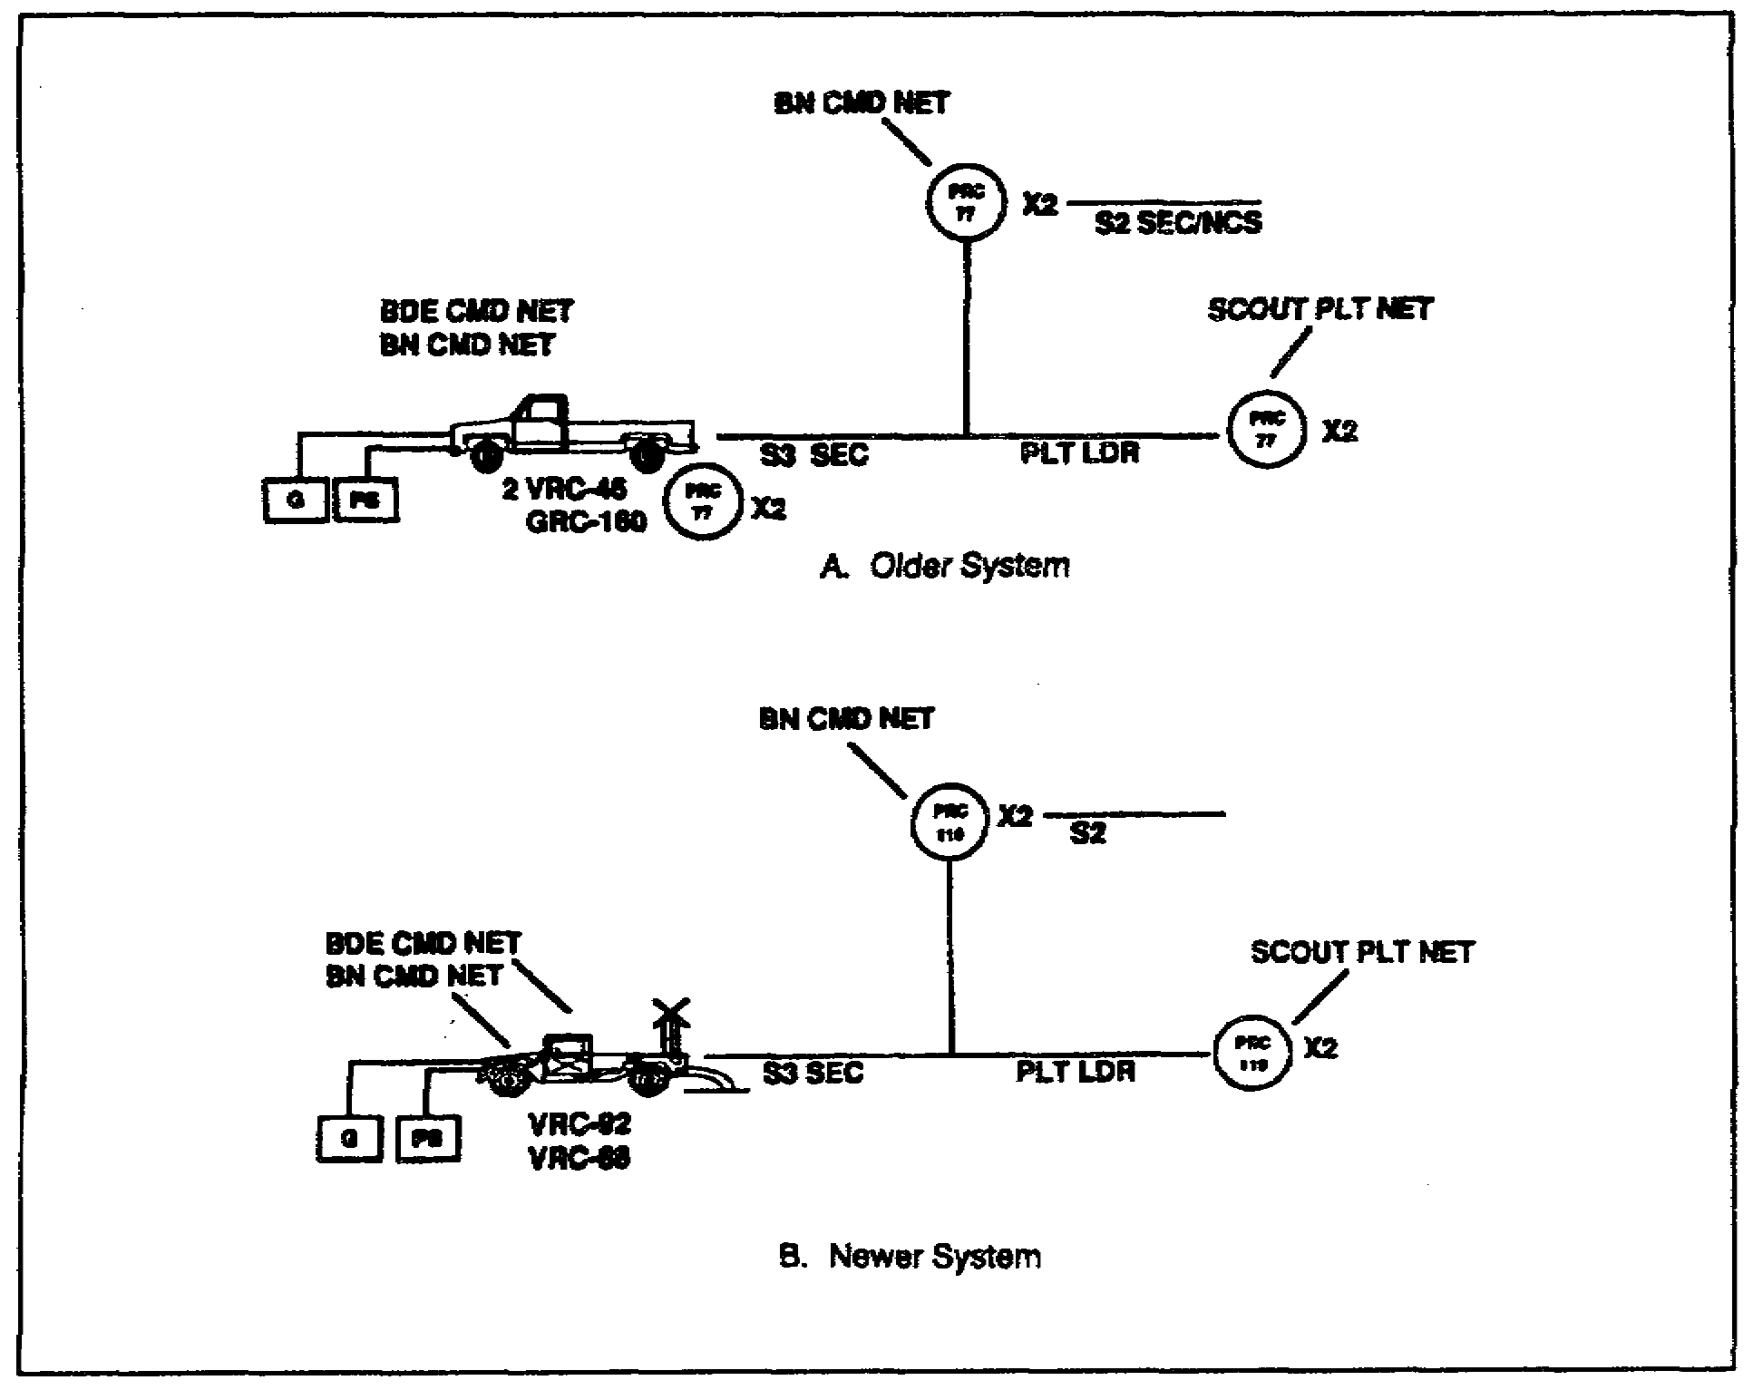

Figure 2-15. Light battalion operations and intelligence net

c. Upon attachment of a unit, the communications platoon of the gaining unit usually remains intact. Therefore, all of the capabilities and limitations remain unchanged. The gaining unit, however, inherits the capabilities and limitations of the attached unit. For example, the signal officer of a heavy battalion gaining a light force company, inherits the limited operating range of the dismounted radios. If the signal officer is in a mechanized infantry unit, he knows that his unit understands the limitations of operating radios dismounted, since his unit also has the capability and missions to operate dismounted. This is not so if his unit were an armored battalion. As the signal officer in an armored battalion, he will need to ensure the capabilities and limitations of fighting with a light force are understood by all. If he were the signal officer of a light force unit, and a heavy unit is attached, he will need to ensure that the attached unit understands the communications capabilities and limitations of his unit.

SS0120 2-30

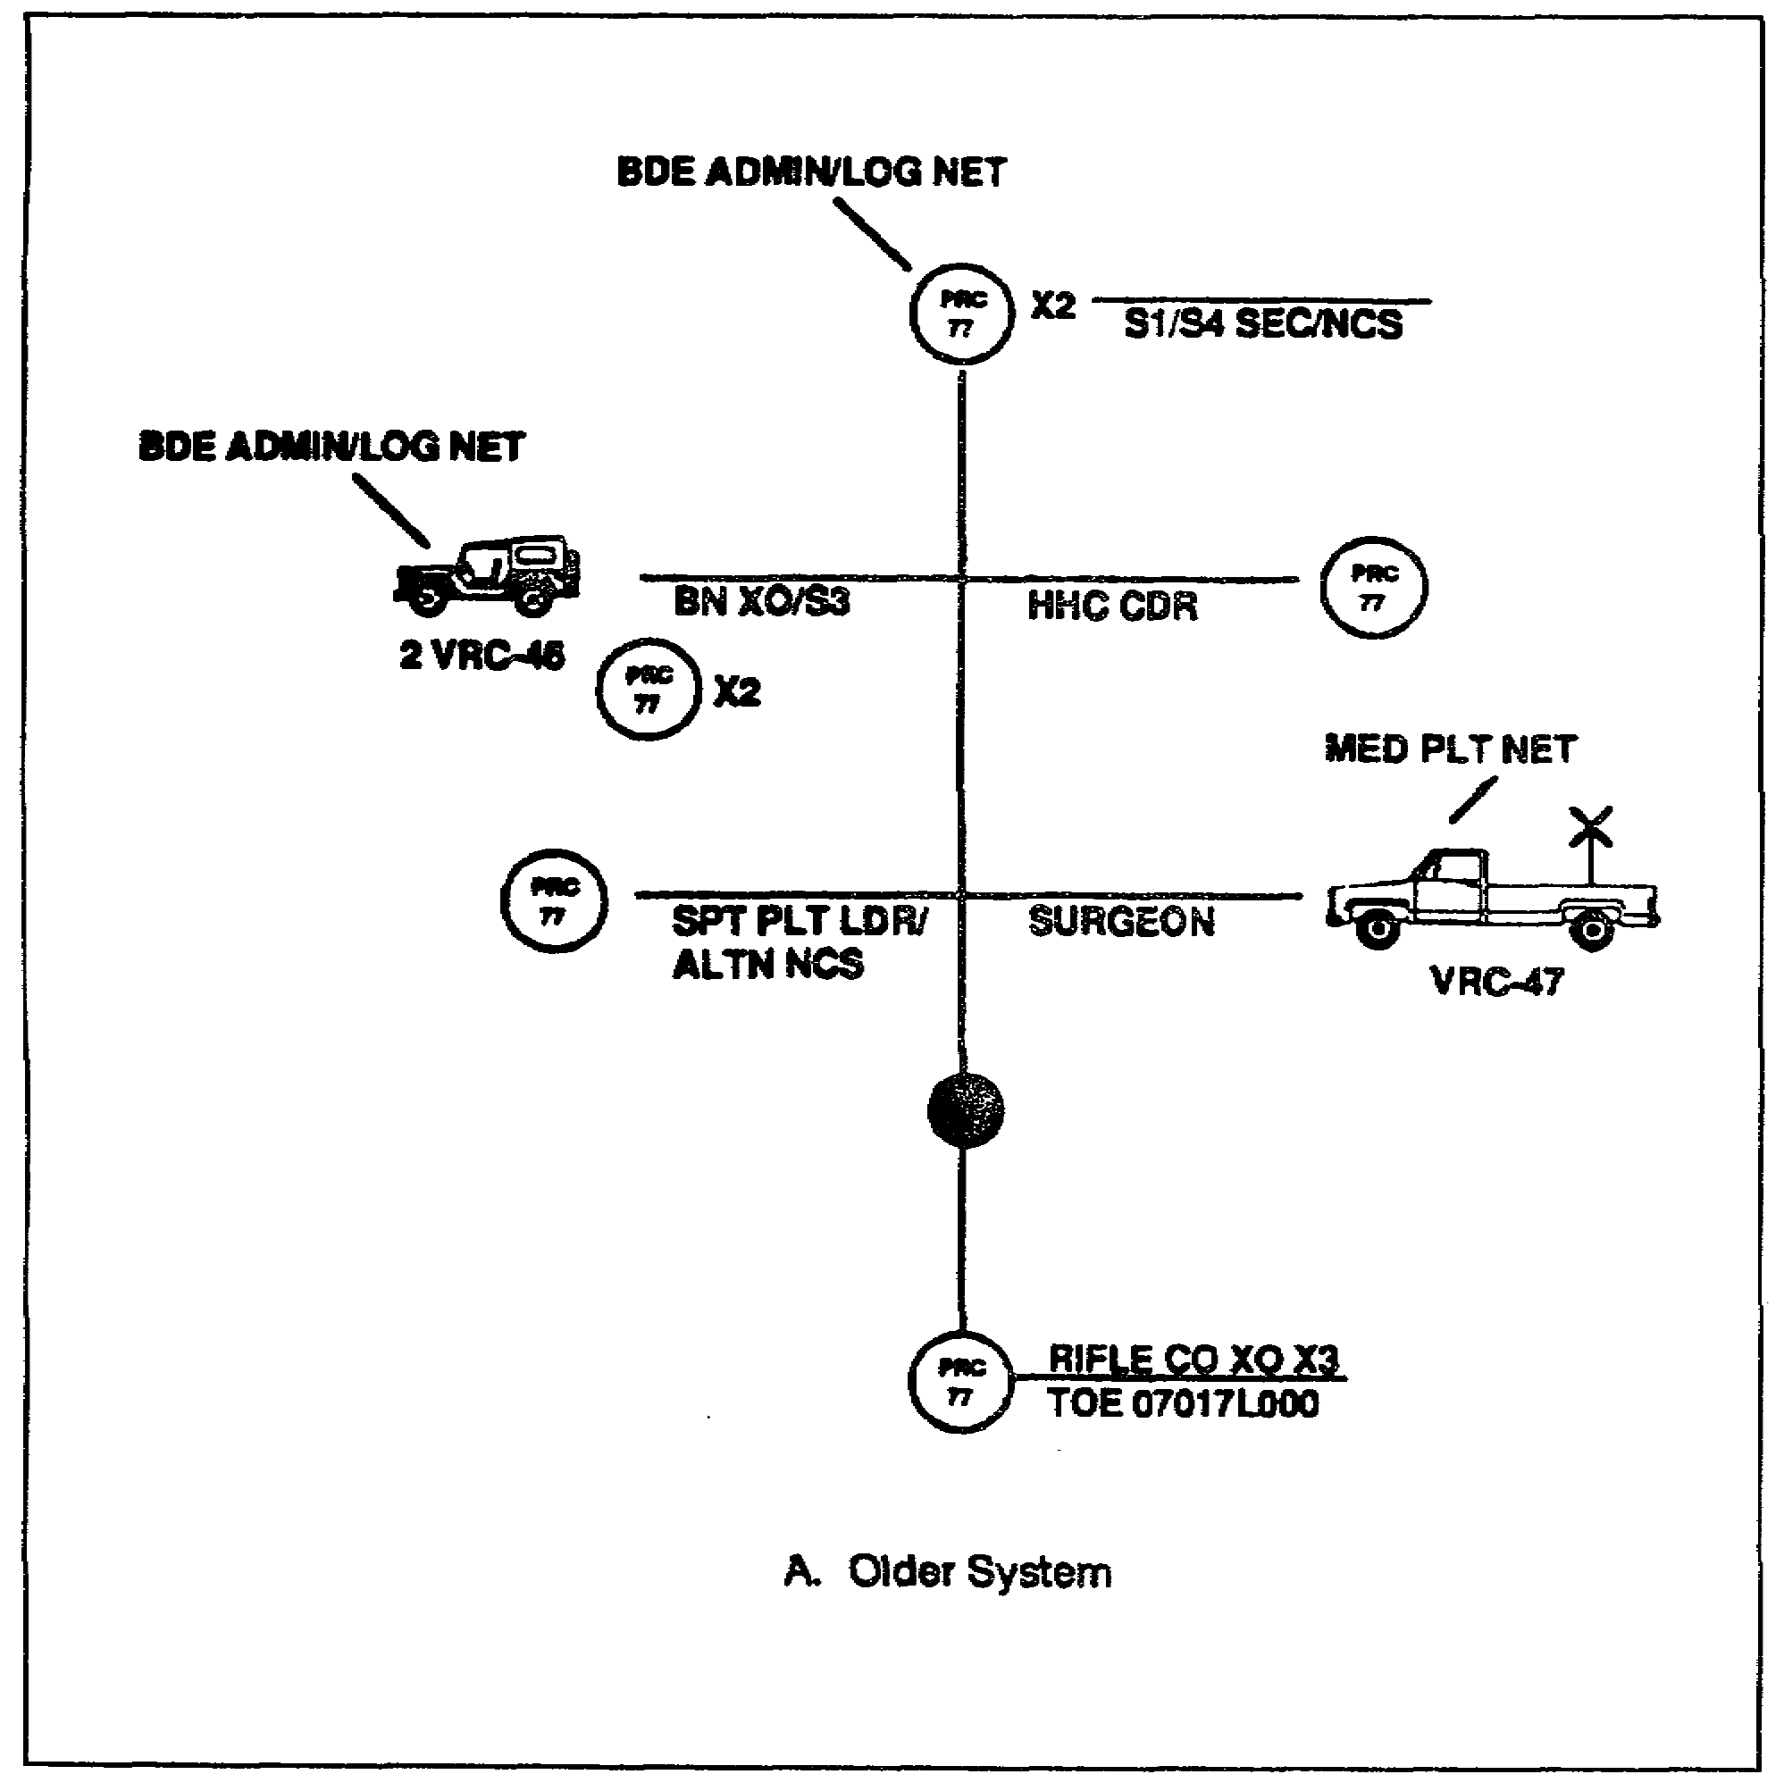

Figure 2-16A. Light battalion administrative/logistics net

2-31 SS0120

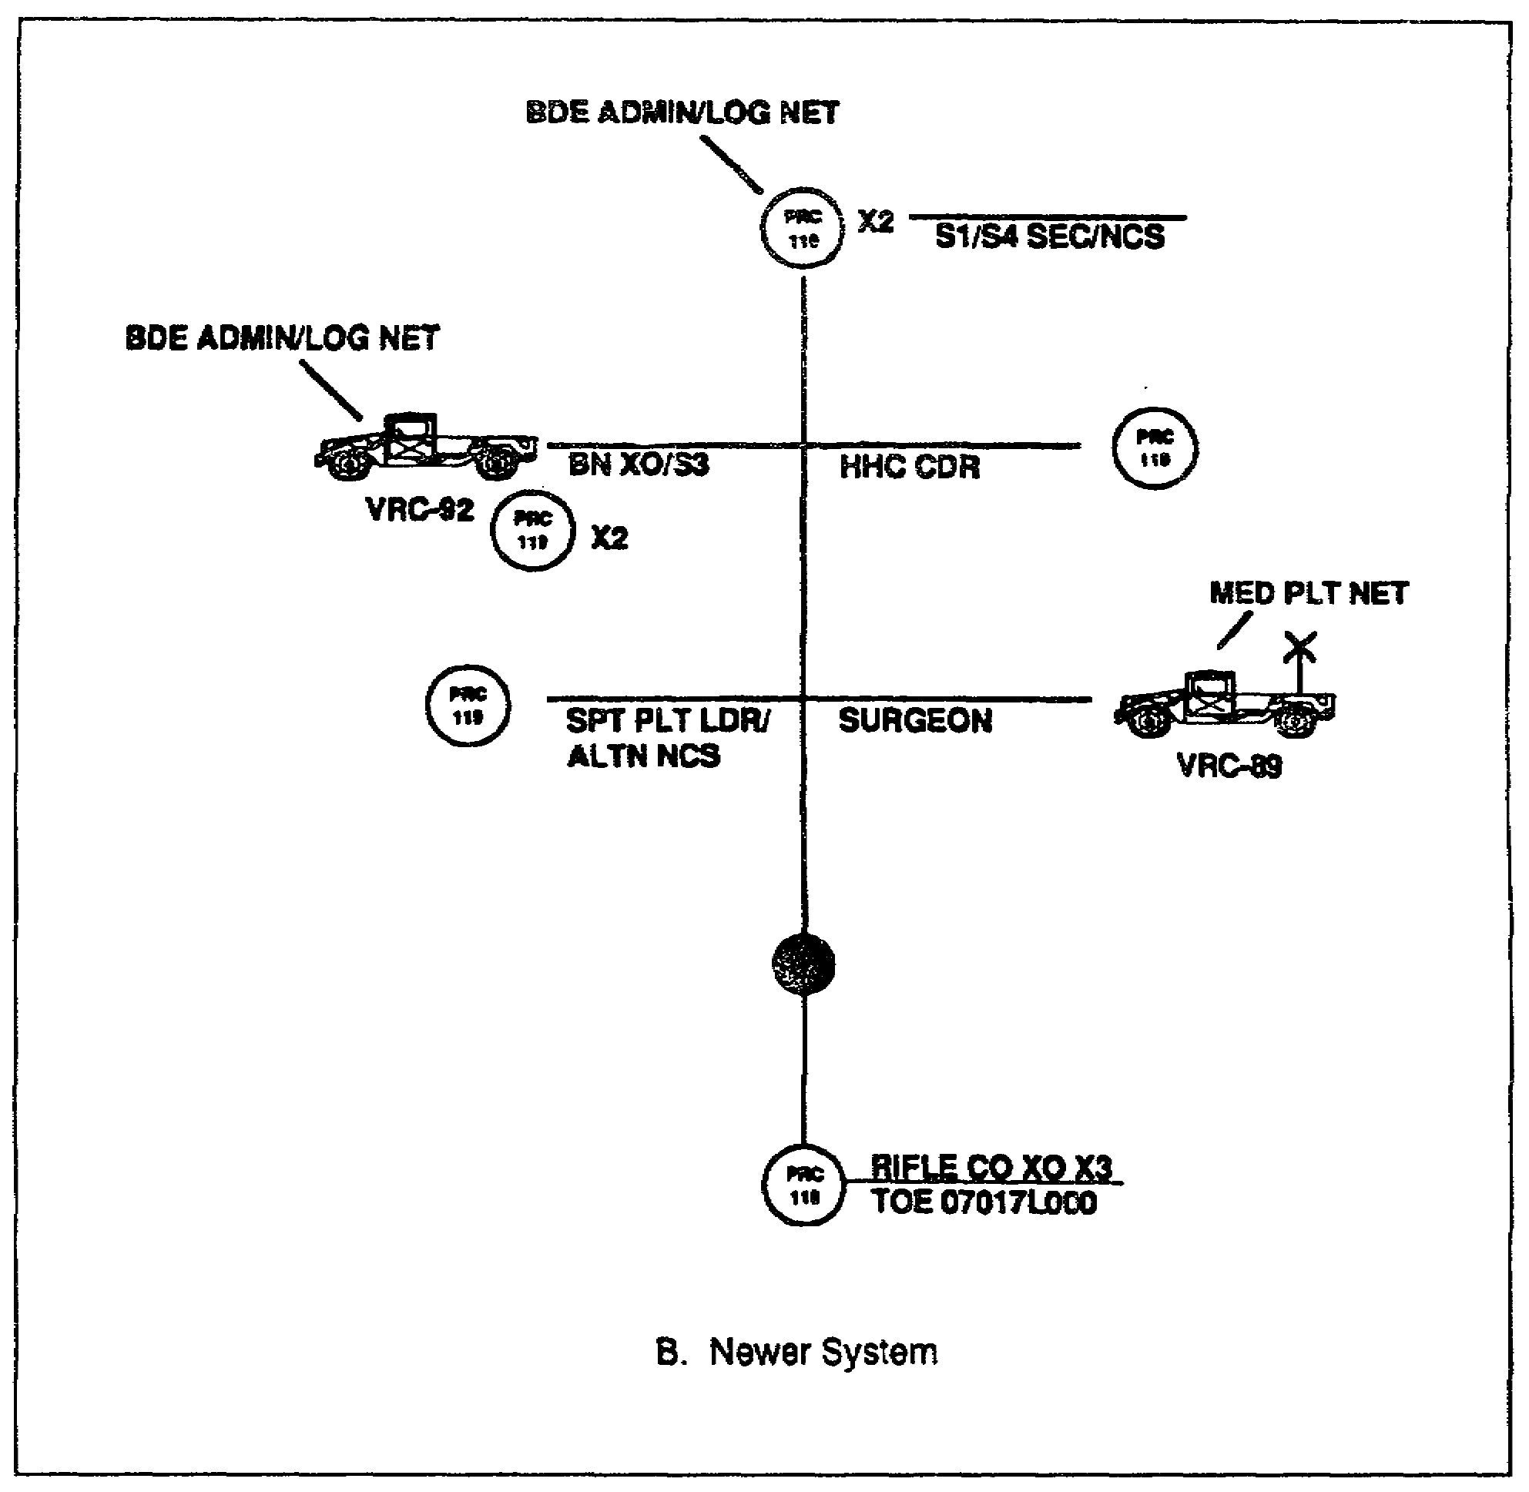

Figure 2-16B. Light battalion administrative/logistics net

SS0120 2-32

PART E - SUMMARY

1. In this lesson, you learned about the signal support requirements for a maneuver brigade, battalion, and battalion task force. Command and control (C²) within the maneuver brigade is achieved through the use of single-channel radio and wire networks.

2. Radio can interface with wire systems, operate over extended distances (retransmission), be remoted, and meet mobility requirements. Radio is the means least limited by terrain and it can be installed more quickly than wire. Conversely, radio is subject to interference, is the most detectable means, and is the least secure means of communications.

3. Wire is one of the most secure and dependable means of communications. Wire is best used in defensive operations. With multiplexing equipment, one wire circuit can serve multiple subscribers. However, wire takes longer to install than any other means. Its system quality decreases with range and it is subject to destruction from vehicles and the enemy.

4. Single-channel radio nets provide initial command, control, and communications at the brigade HQ and throughout the brigade.

a. The command and operations net is used to pass orders and immediate C² information. It has the highest installation priority.

b. The intelligence net is used to pass intelligence information and spot reports. It is also the backup for the command and operations net.

c. The administrative/logistics net passes personnel and supply information.

d. The fire direction net is used to exchange technical and field artillery firing data.

e. The HF voice net backs up the command and operations net and the intelligence net.

f. The general purpose RATT net passes hard copy radio teletypewriter traffic between HQ elements.

2-33 SS0120

THIS PAGE INTENTIONALLY LEFT BLANK

SS0120 2-34

LESSON 2

PRACTICE EXERCISE

The following items will test your grasp of the material covered in this lesson. There is only one correct answer for each item. When you complete the exercise, check your answer with the answer key that follows. If you answer any item incorrectly, study again that part of the lesson which contains the portion involved.

1. The primary means of communications at maneuver brigade/battalion used for command, fire control, and exchange of information is __________.

A. Multichannel radio.
B. Wire systems.
C. Single-channel radio.
D. Radio teletypewriter (RATT).

2. The single-channel radio net with the highest installation priority is the __________.

A. Intelligence net.
B. Command and operations net.
C. HF voice net (AM).
D. Administrative/logistics net.

3. The net which serves as backup for the maneuver brigade command and operations net is the _________.

A. Intelligence net.
B. Administrative/logistics net.
C. HF voice net (AM).
D. RATT net.

4. Using a sound-powered telephone in a wire circuit will reduce the range (distance) of the system.

A. True.
B. False.

2-35 SS0120

5. Wire systems are best used during defensive operations.

A. True.
B. False.

6. The brigade commander has two VRC-46 FM radios in his wheeled vehicle and operates in which nets?

A. Brigade command/operations and division command/operations.
B. Brigade command/operations and division intelligence.
C. Division command/operations and division intelligence.
D. Brigade intelligence and division intelligence.

7. The brigade executive officer normally operates in which nets?

A. Brigade command/operations and division command/operations.
B. Brigade intelligence and brigade administrative/logistics.
C. Division administrative/logistics and brigade administrative/logistics.
D. Brigade command/operations and brigade administrative/logistics.

8. The brigade uses its organic equipment to enter the division multichannel communications system.

A. True.
B. False.

9. The 26-pair cables installed between the multichannel terminals and the brigade CP switchboard are primarily the responsibility of the _________.

A. Forward communications company.
B. Brigade communications platoon.
C. Brigade TOC personnel.
D. Division signal office.

10. When the battalion stops moving and establishes a position, field wire should be used for internal communications as much as possible.

A. True
B. False

SS0120 2-36

11. The commander of a light battalion primarily uses which net to command and control subordinate units?

A. Operations and intelligence net.
B. Command net.
C. HF voice net (AM).
D. Administrative/logistics net.

12. The communications platoons of armor and light infantry battalions are the same.

A. True
B. False

13. The battalion __________ net is the backup battalion command net.

A. Administrative/logistics.
B. Operations and intelligence.
C. Intelligence.
D. None of the above.

2-37 SS0120

THIS PAGE INTENTIONALLY LEFT BLANK

SS0120 2-38

LESSON 2

PRACTICE EXERCISE

ANSWER KEY AND FEEDBACK

Item Correct Answer and Feedback

1. C. Single-channel radio.

Single-channel radio is the primary means of communication for command, fire control, exchange of information, administration, and liaison between and within units. (page 2-2, para 1a)

2. B. Command and operations net.

The command and operations net is given the highest installation priority (page
2-3, para 2a)

3. A. Intelligence net.

The intelligence net is the backup for the command and operations net and is given the second highest priority. (page 2-3, para 2b)

4. A. True.

For planning, the range of field wire circuits using the battery-operated telephone is 14 to 22 miles. The range is four miles using sound-powered telephones.
(page 2-4, para 3b)

5. A. True.

Wire communications are especially reliable and desirable in defensive operations where movement is limited and time is available for installation and maintenance.
(page 2-5, para 3d)

6. A. Brigade command/operations and division command/operations.

Two VRC-46 radios are installed in the brigade commander's vehicle for command and control. They operate in the brigade command/operations net and the division command/operations net. (page 2-7, para 4a(2))

2-39 SS0120

7. D. Brigade command/operations and brigade administrative/logistics.

Two VRC-46 radios are installed in the executive officer's vehicle. They operate in the brigade command/operations net and the brigade administrative/logistics net. (page 2-7, para 4a(3))

8. B. False.

The brigade has no organic means to enter the division multichannel communications system. The forward communications company of the division signal battalion provides multichannel terminal teams to each brigade.
(page 2-12, para 5b)

9. A. Forward communications company.

The two lengths of 26-pair cables between the multichannel terminals and the brigade CP switchboard are the responsibility of the forward communications company of the division signal battalion. (page 2-13, para 5c)

10. A. True.

When the battalion stops moving and establishes a position, field wire should be used for internal communications as much as possible. (page 2-18, para 2d(3))

11. B. Command net.

The command net is established for the commander to command and control subordinate units. (page 2-26, para 3d(1)(a))

12. B. False.

The platoons are not the same. (pages 2-16 and 2-25, Figures 2-8 and 2-13)

13. A. Administrative/logistics.

The battalion administrative/logistics net is the backup battalion command net.
(page 2-27, para 3d(3))

SS0120 2-40

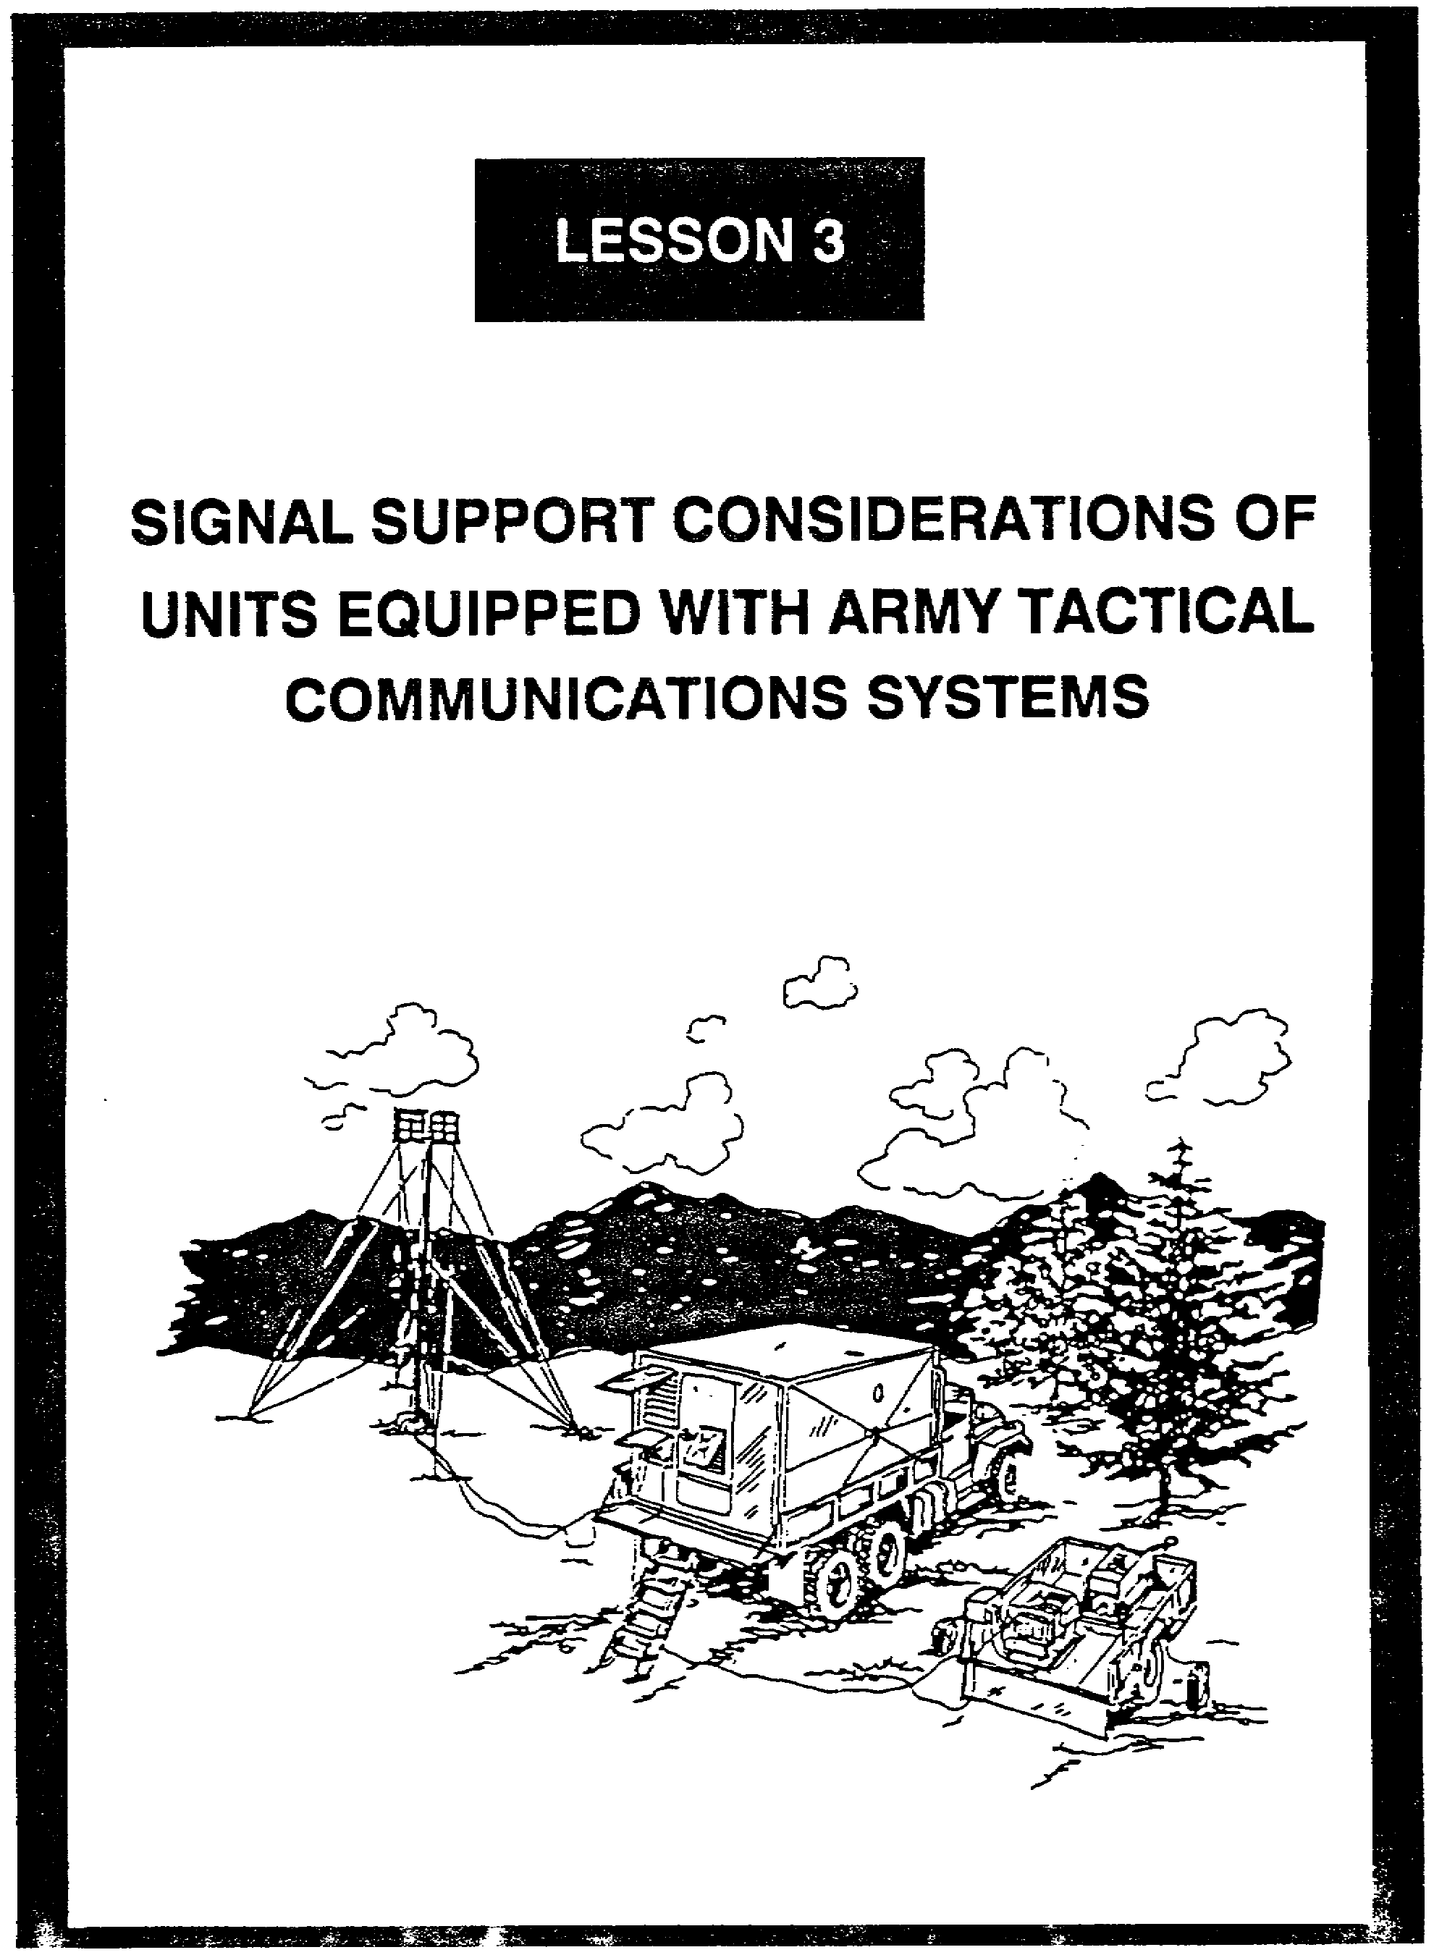

LESSON 3

SIGNAL SUPPORT CONSIDERATIONS OF UNITS
EQUIPPED WITH ARMY TACTICAL COMMUNICATIONS SYSTEMS

Critical Tasks: 01-5840.07-0002
01-5841.07-0001

OVERVIEW

LESSON DESCRIPTION:

In this lesson, you will learn about the signal planning considerations for signal units equipped with Army Tactical Communications Systems (ATACS), to include identifying external signal support resources. You will also learn about the need, function, and location of automated systems to support brigade and battalion missions.

TERMINAL LEARNING OBJECTIVE:

ACTION: Explain signal support considerations of units equipped with ATACS.

CONDITION: You will have this lesson.

STANDARD: To demonstrate competency, you must achieve a minimum of 70% on the subcourse examination.

REFERENCES: The material in this lesson was derived from the following publications:
FM 11-50, FM 24-16, and The Army Command and Control Master Plan, Volume 1, October, 1987.

INTRODUCTION

Effective command and control (C²) demands reliable signal support. To provide the communications the commander needs, the signal officer must plan accordingly. Many units have their go-to-war general defense plan (GDP) which details where and how they will fight. A significant element of the GDP is the signal support to be provided, which is reflected in a designated operations plan (OPLAN). When an OPLAN is put into effect, it becomes an operations order (OPORD). As a signal officer, you must thoroughly understand the who, what, when, and where of the supported unit and its mission.

3-1 SS0120

1. Tactical Communications Planning. Tactical communications planning must be detailed and continuous. It is during planning that the signal support principles and the essential signal support tasks are first addressed. When planning signal support, you need to consider:

a. The type of operations, the units involved, the support requirements, the physical characteristics of the area of operations, and the probable weather conditions.

b. The signal doctrine for the various echelons of command and for varying tactical situations, to include electronic warfare (EW) tactics of defense.

c. The availability, characteristics, capabilities, and limitations of signal units, personnel, and equipment.

d. The proper maintenance requirements and needed logistics support.

e. Other important items, to include:

(1) Knowing the commander's intent and ensuring close staff coordination among staff members of your unit and other units you are working with.

(2) Planning a complete communications system and using all communications media available. Consider effective cover and concealment (camouflage). Also consider already-installed communications, but use only what is needed.

(3) Not relying solely on a single means of communications. Have an alternate route or plan and keep something in reserve.

(4) Making full use of the unit's standing operating procedures (SOP) and signal operation instructions (SOI).

(5) Considering electromagnetic interference, electronic countermeasures, and counter-countermeasures.

(6) Considering your signal security (SIGSEC) program and revising it where necessary.

(7) Having a signal deception plan ready for implementation.

(8) Remember that time and execution are the keys to success.

SS0120 3-2

2. ATACS Signal Support Considerations. Units that have not received the improved high frequency radio (IHFR), Single-Channel Ground and Radio System (SINCGARS), and Mobile Subscriber Equipment (MSE) use the older communications assemblages, AM radios, and FM radios. This equipment is dependable although it takes a good signal planner to ensure superior signal support is provided. The following discussion of ATACS signal support considerations is based on FM 24-16, Communications-Electronics Operations, Orders, Records, and Reports.

3. Single-Channel Radio Communications Planning.

a. Single-channel net planning, like multichannel systems planning, is a logical analysis of the capabilities and requirements needed to develop a plan for single-channel radio communications. To plan properly, you must know doctrinal concepts governing single-channel radio and radio nets; know the number and types of radios available for the operation; and understand the technical characteristics and capabilities of available radio equipment. You must know which radios are compatible. You need to understand single sideband (SSB), radio teletypewriter (RATT), very high frequency (VHF), etc. Further, you need to know antennas and their characteristics. You also must know what communications security (COMSEC) equipment will work with each type of radio, and how it operates.

b. Single-channel radio has advantages and disadvantages which you must consider throughout your planning phase. The advantages allow radio to be used where other communications are impossible. The disadvantages might make it necessary for you to rule out radio communications, or alter your plan under conditions of stringent security, adverse frequency conditions, or equipment dissimilarities.

c. In radio net planning, you must consider all aspects pertaining to single-channel radio operations and usage to provide the best communications support possible. In considering single-channel radios in your plan, you need to know:

(1) The signal support mission and the physical characteristics of the area of operation.

(2) The purpose, characteristics, and use of available single-channel radios available, to include their advantages, disadvantages, operational functions, and electromagnetic compatibility (EMC).

(3) The communications doctrine pertaining to single-channel radio communications.

(4) Single-channel radio net organizations, scope of operations and procedures, employment, displacement, etc.

(5) Frequency management and control as it applies to single-channel radios.

3-3 SS0120

(6) Physical and communications security requirements and security equipment for single-channel radio operation.

(7) The EW threat as it pertains to single-channel radio operations, and counter-countermeasures for continuance of operation.

(8) Cover and concealment (camouflage) requirements.

d. Specific planning considerations for single-channel radio operations are listed in Table 3-1 and discussed below. Additional information is in Chapter 4 of FM 24-16, Communications-Electronics Operations Orders, Records and Reports, and Chapter 4 of FM 24-18, Tactical Single Channel Radio Communications Techniques.

Table 3-1. Single-Channel Radio Planning Considerations

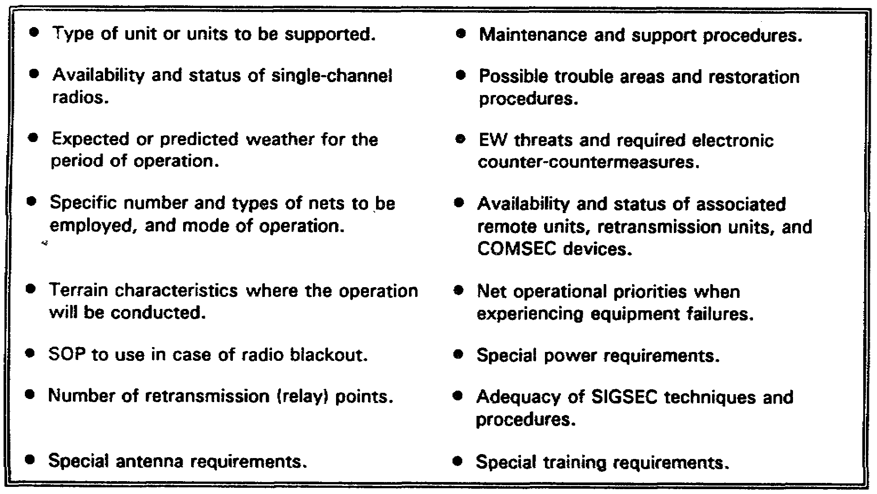

(1) The signal officer must know the availability and status of single-channel radios and associated remote units, retransmission units, and COMSEC devices to ensure adequate communications are provided on the fluid battlefield.

(2) Frequency management is critical to single-channeled radio operations. The signal officer must continually coordinate with the division signal battalion to ensure the optimum frequencies are assigned.

SS0120 3-4

(3) COMSEC is especially critical to single-channel radio communications. Radio, the least secure means of communication, can be intercepted any time a transmitter is placed in operation. Signal officers must ensure that proper radiotelephone procedures and COMSEC devices are continually used.

(4) Radio communications reliability depends to a major degree on selecting a good radio site. High hills or elevated terrain which provide good line-of-sight (LOS) and level, moist ground which provides good grounding and conductivity are excellent sites for radio communications. Valleys, underpasses, and areas with high tension lines are poor radio communication sites.

4. Multichannel Communications Planning.

a. Multichannel communications system planning is a logical analysis of your unit's resources, capabilities, and user requirements to develop a plan. To develop an effective plan, you must understand the characteristics and capabilities of the equipment and systems, and the accepted doctrine and standards which govern the installation and operation of the equipment and systems.

b. Multichannel communications systems are either radio (LOS and troposcatter) or wire and cable systems, plus associated terminal equipment, that provide two or more channels of communications simultaneously. Multichannel systems are a primary means of communications for combat operations and are used for interconnecting signal centers (SIGCEN) and tying units into the area systems.

c. Multichannel radio systems are more widely used than wire and cable multichannel systems because they can be installed quicker to cover long distances. Also, multichannel radio systems are less vulnerable than wire and cable systems in the forward area. Thus, signal doctrine dictates that wire and cable is used where radio equipment cannot be used, in rear areas where wire and cable are secure, and to free multichannel radio equipment.

d. Multichannel systems are the primary means to provide common user and dedicated telephone circuits, secure teletypewriter, data, and facsimile circuits between major headquarters (HQ) and other units of the area systems. The multichannel system will vary in size, configuration, and composition, depending on the support unit mission, organization for combat, location and disposition of the units, characteristics of the area of operation, enemy capabilities, attachment of forces by higher HQ, time, and tactical situation.

e. In planning the best way to support the assigned mission, you must consider all means of signal facilities available to provide the best support possible. In considering the use of multichannel communications, you need to know the following:

(1) The signal support mission.

3-5 SS0120

(2) As much about the location as possible. Accessibility is a major consideration. Does the road network support the volume of vehicular traffic in your mission? You must consider the width of the roads. If a vehicle breaks down, is there room for other vehicles to pass? What about the slopes of hills and the angles of turns? A 2 1/2-ton truck with shelter, pulling a 30-kw generator up a steep hill may lose a clutch, or there may not be enough space to round a turn. This is especially dangerous during periods of rain, darkness, or both. Will the road turn to mud? Is there an alternate access road to your site? Is there room to maneuver your rigs in the area of operation? Can vehicles be easily backed into position to hasten a tactical exit? Can you easily ground your systems, or is the area too rocky? Are the trees too tall and too dense to allow good transmission and reception? Can you get your antennas up high enough? Are there high voltage lines nearby that may cause interference? A good signal officer will consider these matters as he reconnoiters the area in support of the assigned mission.

(3) The purpose and use of multichannel systems, both radio (LOS and troposcatter) and wire, to include their advantages and disadvantages.

(4) Communications doctrine pertaining to systems communications and the operational characteristics of the systems and equipment.

(5) Frequency management and control techniques pertaining to multichannel radio systems.

(6) EMC and the electronic warfare threat and possible effects on multichannel operations, and counter-countermeasure for continuance of operation.

(7) Physical and COMSEC requirements.

(8) System design requirements and employment, displacement, and siting techniques. You must be especially careful when siting antennas, both for safety and for ensuring quality communications.

(a) To avoid interference, do not shoot a radio signal across a power line, a generator, or a SIGCEN.

(b) When erecting an antenna, ensure it is at least twice its height from all power lines; e.g., an antenna twenty-five feet high should be no closer than fifty feet from power lines. This protects soldiers from electrocution and precludes magnetic-induced interference from the power lines, many of which carry very high voltage. Figure 3-1 shows soldiers siting an antenna too close to high-tension lines, which can do more than shock; it can kill!

(9) The skills and the number of personnel needed to operate the equipment and systems.

SS0120 3-6

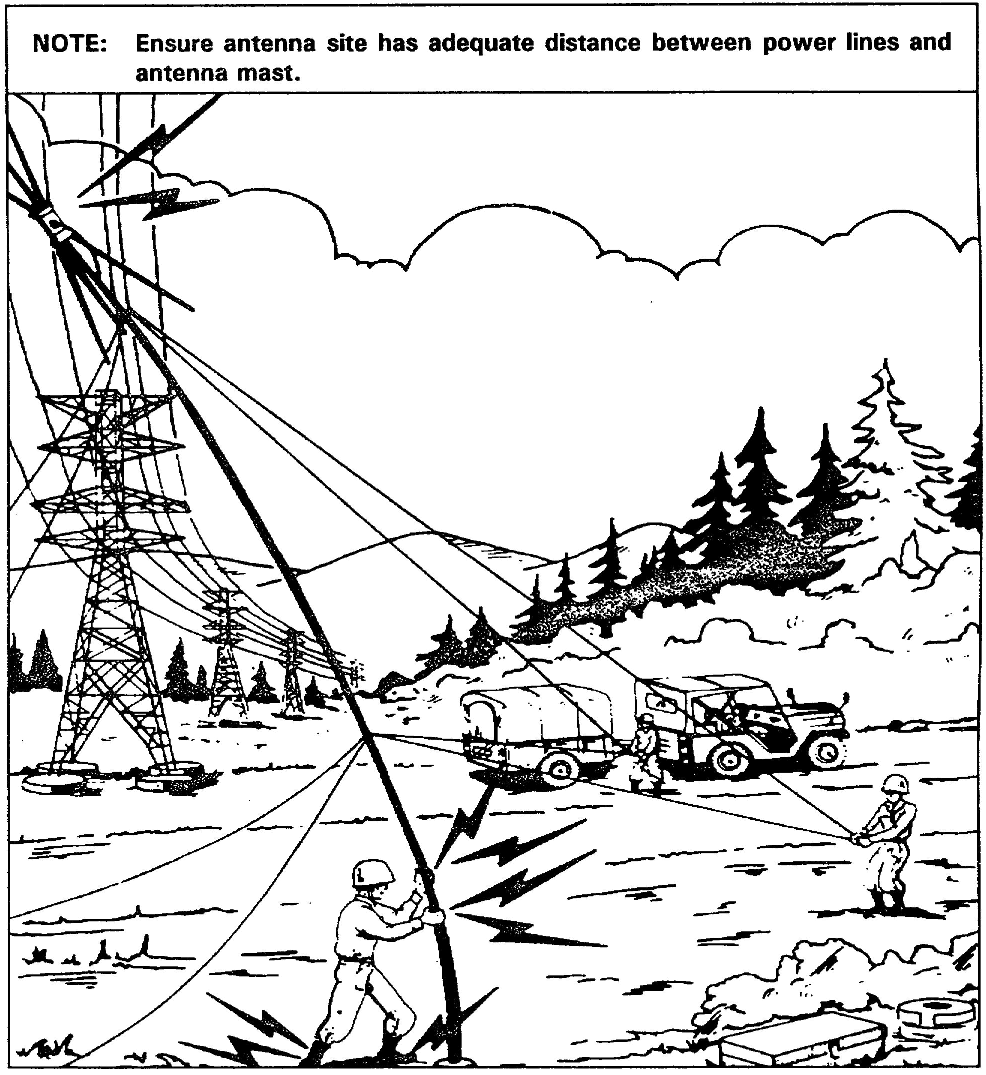

Figure 3-1. Antenna site inadequate distance between power lines and antenna mast

3-7 SS0120

(10) Getting the antennas up over trees if possible. Foliage on trees attenuates (weakens) the radio signal. Figure 3-2 shows some good and bad locations for siting antennas.

(11) Cover and concealment (camouflage) requirements. Coordinate with higher, lower, and adjacent units.

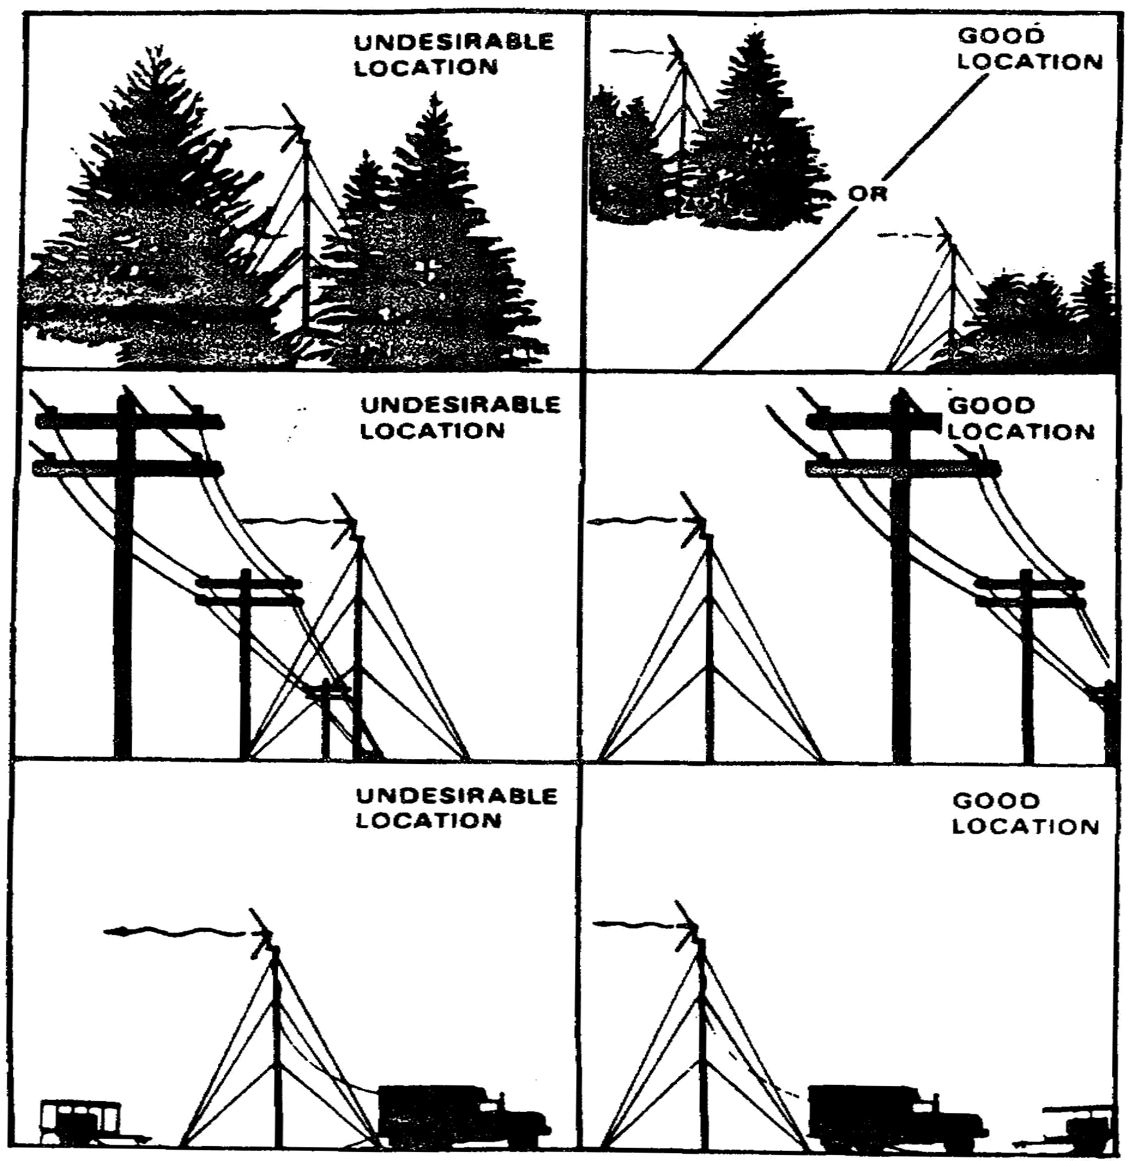

Figure 3-2. Antenna siting

SS0120 3-8

5. SIGCEN and Telecommunications Center (TCC) Planning.

a. A good place to start in discussing the planning of SIGCENs and TCCs is with the definitions. A SIGCEN is a combination of signal facilities operated by the Army in the field, consisting of a TCC, telephone switching central, and other appropriate means of signal communications. An area SIGCEN provides communications support, within its geographical area of responsibility, to all units requiring SIGCEN facilities to supplement their organic means for external communication to higher, subordinate, and adjacent units. SIGCENs are sometimes referred to as signal nodes.

b. A TCC is a facility responsible for the reception, transmission, delivery, reproduction, recording, and pickup and delivery of messages. Its normal elements are a message center section, messenger section, a cryptographic section, and means (sending and receiving) section which uses electronic communications devices. Some TCCs have facsimile and tape relay facilities.

c. SIGCEN planning. The ground rules for establishing SIGCENs are well established by doctrine. If you plan well in establishing your multichannel, single-channel radio, wire communications, and TCCs, then you are well set with your SIGCENs. SIGCEN planning considerations include:

(1) The number and types of units to be supported.

(2) Special requirements.

(3) SOP review and update when needed.

(4) Special training requirements.

(5) Required additional records and reports.

(6) Coordination with other staff sections and higher, subordinate, and adjacent units.

d. TCC Planning. Planning TCCs and TCC service for the various phases of a tactical operation requires close coordination with commanders and their staffs, other users, and with signal facilities at higher, lower, and adjacent echelons. The extent of the TCC service provided will depend on the mission of the units to be supported, authorized personnel and equipment, and the volume of message traffic. You must coordinate with the signal staff and study the probable message traffic load to ensure the best possible employment of the available signal resources. Your plan should be flexible to allow for changes in the traffic loads. The following important factors should be considered:

(1) The tactical situation as it affects the possible requirement for TCC facilities.

3-9 SS0120

(2) The availability of communications personnel, equipment, and the logistical support needed for TCC operation.

(3) The location of TCC facilities in the command post area and the internal arrangement and employment of TCC facilities.

(4) Provision for continuity of operations during and after displacement.

(5) COMSEC and messenger service requirements.

(6) Geographical factors (climate, topography, transportation, and road network) and local facilities (commercial communications facilities, power resources, and utilities).

6. Signal Systems Management and Control Planning. Signal officers determine the communications requirements and design signal systems to meet these needs. To ensure the systems will continue meeting the specific requirements of the situation, effective communications control must exist.

a. The battlefield is a dynamic environment, and the tactical requirements on the communications network constantly change. Signal officers must know how to manage these systems to reduce the number of delays and outages. Four levels of the signal management system provide this control.

(1) Communications systems planning element (CSPE). Staff and operations planners at each element perform all long-range planning. At the division level, this is the division signal staff element.

(2) Communications system control element (CSCE). This is the actual focal point for dynamic control. The CSCE acts as the operations center for command and control for the signal systems and equipment of the signal battalion, and maintains a data base for these systems.

(3) Communications nodal control element (CNCE). This is a circuit terminal patch which provides technical control for circuits in and through the patch panel. The CNCE is also the management office-shelter for the unit or site. It provides the management and control of signal functions within the node (SIGCEN).

(4) Communications equipment support element (CESE). This is an individual element of the signal system (radio, switch, multiplex, wire team, maintenance section, etc.). The CESE provides equipment support and information feedback to the CNCE.

SS0120 3-10

b. Signal management systems planning considerations include:

(1) The unit SOP covering the signal management system is an important document used in planning. It addresses those features of operations that lend themselves to standardized procedures. Responsibilities are delineated. The SOP should be periodically reviewed to ensure it reflects actual conditions.

(2) Special or additional procedures needed, including records and reports, are generally a part of the planning process. These should be covered in detail during the operations briefing to ensure those responsible know what is expected.

(3) A review of the signal management data of previous operations is a must. After each operation, an after action review should be conducted by unit personnel to capture the lessons learned while it is still fresh in their minds. Reinforce and build on the positive aspects of previous missions, and learn from mistakes.

c. Records and reports used include the trouble report, the traffic status report, the system and circuit status report, the circuit routing list, the operational resource report, the systems performance (status) report, and the personnel and equipment status report.

7. Automation at the Maneuver Brigade. The modern battlefield is an incredibly complex environment. So much information is acquired, processed, and acted upon that manual systems cannot keep pace. The Army recognizes the need for battlefield automation, and many systems have been built. As technology improves, older automated systems are replaced by the newer systems. The maneuver brigade uses automated systems to effectively command and control subordinate units to do the mission.

a. The Maneuver Control System (MCS) assists the brigade commander, his staff, and subordinate commanders by providing information on their own forces, enemy forces, and the characteristics of the battlefield. The MCS provides battlefield information by collecting, processing, and displaying data generated in the area of operations. The commander's decisions are made based on the latest and best information available.

b. The Advanced Field Artillery Tactical Data System (AFATDS) is replacing the current Tactical Fire Direction System (TACFIRE) and the Battery Computer System (BCS). Used by the fire support element (FSE) at brigade, the AFATDS provides automated support for the planning coordination, control, and execution of close support, counterfire, interdiction, deep operations, and suppression of enemy air defense.

c. The Combat Service Support Control System (CSSCS) provides timely and reliable logistics, medical, and personal information essential for planning and decision making by the brigade commander and his staff. Through the use of Army Tactical Command and

3-11 SS0120

Control System (ATCCS) common hardware, the brigade is linked to the division support command (DISCOM) to rapidly exchange combat service support data.

8. Liaison Elements at the Brigade Tactical Operations Center (TOC).

a. Signal support. The brigade TOC is a highly mobile element that places high demands on the signal support unit. The brigade receives communication support from one of the extension platoons from the forward communications company of the signal battalion. This platoon has a platoon HQ (signal site operations), a telephone and switchboard section, a single-channel radio section, a cable and wire installation section, and a multichannel communications LOS section. The platoon leader and his platoon sergeant supervise operations. The platoon leader spends most of his time at the brigade HQ, but must also travel to the brigade trains area, as well as be liaison to the forward support battalion, where the platoon operates an extension node. The extension node established at the brigade HQ connects into the division area common user system (ACUS). At the brigade HQ and the brigade support area (BSA), the forward communications platoon provides:

(1) Multichannel LOS communications terminals. These terminals terminate the division multichannel systems at each brigade location and provide “jump” capability.

(2) Automatic telephone and switching facilities for trunk and local telephone subscriber circuits (at the BSA only; the AN/TTC-41(V)2 at the brigade HQ is provided by the brigade communications platoon).

(3) Cable and wire installation teams to install cable and local telephone circuits (at the BSA only).

(4) Net radio interface (NRI) facility for single-channel voice radio access to the division telephone system (at the BSA only).

(5) Signal site operations.

(6) RATT for operation in the division general purpose net.

b. Other liaison. The maneuver brigade may be structured (task organized) to ensure the proper combination of elements are brought together to accomplish the mission. The following represent some of the liaison teams that may be located at brigade HQ. However, the mission determines what outside cooperation will occur.

(1) An Air Force liaison team may be sent to the brigade to interface during joint missions that call for close coordination between the two services. This team may be comprised of Air Force weather section personnel (who advise the brigade commander on

SS0120 3-12

weather-related matters) or a liaison officer and NCO (who coordinate for close air support). Generally, the team provides its own single-channel voice secure radio equipment.

(2) Special operations teams may be found at brigade HQ during missions that require their form of warfare. Special operations forces, as well as rangers and long range surveillance units, may be inserted deep behind enemy lines. These units use the IHFR and tactical satellite radio sets.

(3) An aviation liaison officer from the aviation brigade may be found at the maneuver brigade. He will coordinate for required aviation support; e.g., assault helicopter needs or heavy lift missions. As with other teams, the aviation representative will bring his own communications package with him.

9. Summary. In this lesson you learned about signal support considerations of units equipped with ATACS. You learned about single-channel radio communications planning-the need to know the doctrinal concepts of operation, the technical characteristics, and the general and specific considerations before establishing a net.

a. Multichannel planning considerations include understanding the mission, using camouflage effectively, and knowing the terrain, the equipment, siting techniques, the skill levels of your soldiers, frequency management, and COMSEC.

b. SIGCEN and TCC planning involves knowing the mission; reviewing the SOP; implementing special training (if needed); coordinating with staff sections and higher, subordinate, and adjacent units; positioning SIGCEN facilities; and COMSEC requirements.

c. Signal systems management and control planning are conducted at four levels. The communications systems planning element (CSPE) performs long-range planning. The communications systems control element (CSCE) is the operations center for C² for the signal systems. The communications nodal control element (CNCE) provides technical control for circuits in and through the patch panel, and provides the management and control of signal functions within the SIGCEN. The communications equipment support element (CESE) provides equipment support to the CNCE.

d. C² at the maneuver brigade is enhanced through the use of automated systems, such as the Maneuver Control System (MCS), the Advanced Field Artillery Tactical Data System (AFATDS), and the Combat Service Support Control System (CSSCS).

e. Liaison at the brigade TOC includes the signal extension platoon that ties brigade into the ACUS. Depending on the mission, other liaison teams (who bring their own communications packages) may be Air Force (weather, close air support), Special Operations Forces, and aviation brigade personnel.

3-13 SS0120

THIS PAGE INTENTIONALLY LEFT BLANK

SS0120 3-14

LESSON 3

PRACTICE EXERCISE

The following items will test your gasp of the material covered in this lesson. There is only one correct answer for each item. When you complete the exercise, check your answer with the answer key that follows. If you answer any item incorrectly, study again that part of the lesson which contains the portion involved.

1. Multichannel radio systems are less vulnerable than wire and cable systems.

A. True
B. False

2. Wire and cable multichannel systems are more widely used than multichannel radio systems.

A. True
B. False

3. The communications equipment support element (CESE) is an individual element of the signal system that provides equipment support and information feedback to the communications system control element (CSCE).

A. True
B. False

4. An aviation liaison officer from the aviation brigade may be found at the maneuver brigade. He will bring his own communications package with him.

A. True
B. False

5. The circuit terminal-patch which provides technical control for circuits in and through the patch is the __________.

A. Communications systems planning element.
B. Communications system control element.
C. Communications nodal control element.
D. Communications equipment support element.

3-15 SS0120

6. The document that focuses on the signal management system, addressing those features of operations that lend themselves to standardized procedures is the __________.

A. Signal records and reports.
B. After action review.
C. Unit SOP.
D. Traffic status report.

7. The automated system that assists the brigade commander, his staff, and subordinate commanders by providing battlefield information is __________.

A. AFATDS
B. MCS
C. CSSCS
D. BCS

8. TACFIRE and BCS are being replaced by __________.

A. MCS
B. CSSCS
C. AFATDS
D. ASAS

9. An extension platoon from the forward communications company establishes extension nodes at both brigade HQ and at the forward support battalion.

A. True
B. False

10. The operations center for command and control for signal systems and equipment of the signal battalion is the _________.

A. Communications systems planning element.
B. Communications system control element.
C. Communications nodal control element.
D. Communications equipment support element.

SS0120 3-16

11. An antenna must never be erected any closer than __________ its height from any power lines.

A. One time.
B. Two times.
C. Three times.
D. Four times.

12. Shooting a radio shot across a signal center (SIGCEN) or through power lines will result in interference.

A. True.
B. False.

3-17 SS0120

THIS PAGE INTENTIONALLY LEFT BLANK

SS0120 3-18

LESSON 3

PRACTICE EXERCISE

ANSWER KEY AND FEEDBACK

Item Correct Answer and Feedback

1. A. True.

Multichannel radio systems are less vulnerable than wire and cable systems.
(page 3-5, para 4c)

2. B. False.

Multichannel radio systems are more widely used than wire and cable multichannel systems because they can be installed quicker to cover long distances. (page 3-5, para 4c)

3. B. False.

The communications equipment support element (CESE) is an individual element of the signal system that provides equipment support and information feedback to the communications nodal control element (CNCE). (page 3-10, para 6a(4))

4. A. True.

An aviation liaison officer from the aviation brigade will bring his own communications package with him. (page 3-13, para 8b(3))

5. C. Communications nodal control element.

The communications nodal control element (CNCE) is a circuit terminal-patch which provides technical control for circuits in and through the patch.
(page 3-10, para 6a(3))

6. C. Unit SOP.

The unit SOP addresses those features of operations that lend themselves to standardized procedures. (page 3-11, para 6b(1))

3-19 SS0120

7. B. MCS.

The Maneuver Control System (MCS) assists the brigade commander, his staff, and subordinate commanders by providing information on their own forces, enemy forces, and the characteristics of the battlefield (page 3-11, para 7a).

8. C. AFATDS.

The Advanced Field Artillery Tactical Data System (APATDS) is replacing the Tactical Fire Direction System (TACFIRE) and the Battery Computer System (BCS). (page 3-11, para 7b)

9. A. True.

An extension platoon from the forward communications company establishes extension nodes at both brigade HQ and at the forward support battalion.
(page 3-12, para 8a)

10. B. Communications system control element.

The communications system control element (CSCE) acts as the operations center for command and control for the signal systems and equipment of the signal battalion. (page 3-10, para 6a(2))

11. B. Two times.

When erecting an antenna, ensure the antenna is at least twice its height from any power lines. (page 3-6, para 4e(8))

12. A. True.

To avoid interference, do not shoot a radio signal across a power line, a generator, or a signal center (SIGCEN). (page 3-6, para 4e(8))

SS0120 3-20

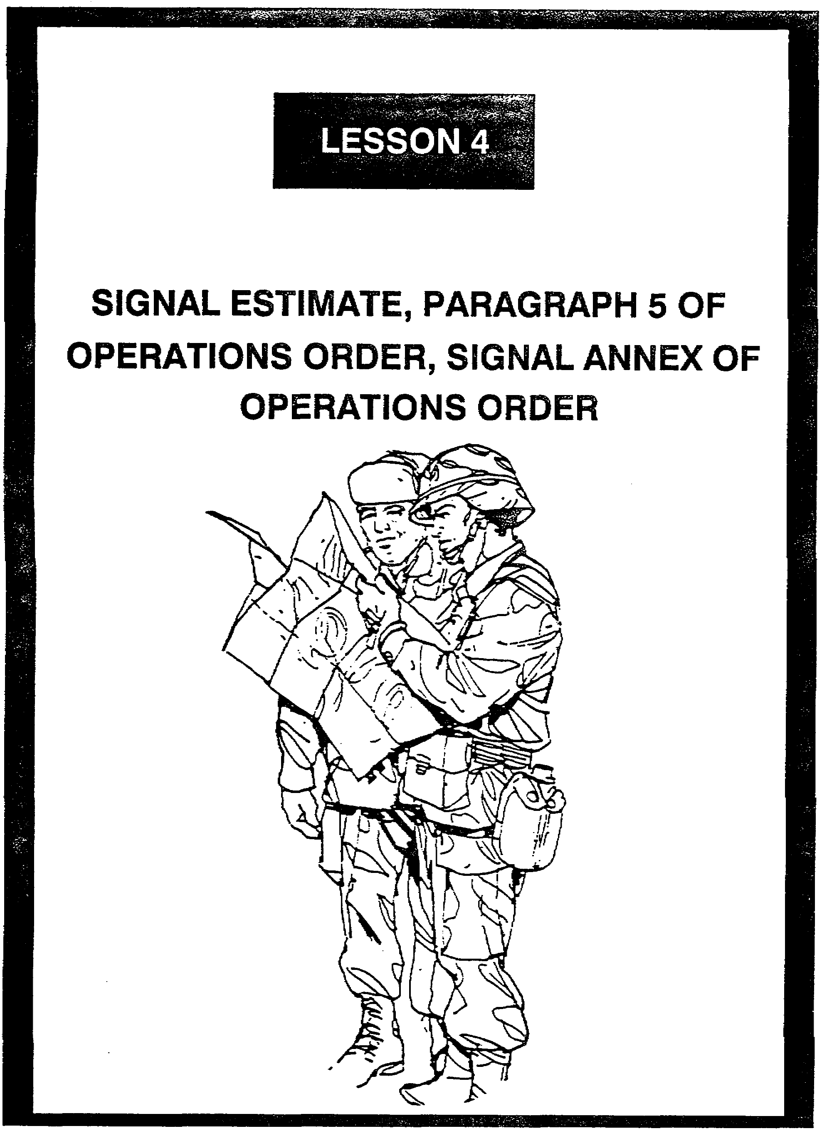

LESSON 4

SIGNAL ESTIMATE, PARAGRAPH 5 OF OPERATIONS
ORDER, SIGNAL ANNEX OF OPERATIONS ORDER

Critical Tasks: 01-5840.07-0002
01-5841.07-0001

OVERVIEW

LESSON DESCRIPTION:

In this lesson, you will learn about developing the signal estimate based on the commander's intent. You will also learn about preparing paragraph 5 of an operations order (OPORD) and writing a signal annex for an OPORD.

TERMINAL LEARNING OBJECTIVE:

ACTION: Explain signal plans and orders.

CONDITION: You will have this lesson.

STANDARD: To demonstrate competency, you must achieve a minimum of 70% on the subcourse examination.

REFERENCES: The material in this lesson was derived from the following publications: FM 24-16 and FM 101-5.

INTRODUCTION

The commander and staff use the military decision-making process to make and execute tactical decisions. It is a logical, systematic approach to determine the situation and how to best carry out the mission. Its elements include estimates of the situation, plans, and orders. As a signal officer, you must know this process. Communications systems are the medium by which command and control (C²) is exercised, and the degree of C² determines the outcome of the battle.

4-1 SS0120

1. The Military Decision-Making Process. The process through which the commander and his staff interact and execute decisions is termed the military decision-making process. This is illustrated in Figure 4-1. The process refers to commander and staff actions used to reach and execute tactical decisions; however, it can be applied to other military activities as well. The commander and staff constantly face situations which involve uncertainties, questionable or incomplete data, and several possible alternatives. They must not only decide what action to take, but also recognize when a decision is needed. How a commander or staff officer arrives at a decision is a matter of personal determination; however, sound conclusions, recommendations, and decisions only result from relating to the situation. A systematic approach to problem-solving assists in applying thoroughness, clarity, judgment, logic, and professional knowledge to the task.

a. Solutions to problems result from a logical and orderly process. This process consists of:

(1) Recognizing and defining the problem.

(2) Gathering the facts and making assumptions needed to determine the scope of and solution to the problem.

(3) Developing possible solutions to the problem.

(4) Analyzing and comparing possible solutions.

(5) Selecting the best solution to the problem.

b. The decision-making process is continuous. Although some actions occur in sequence while others take place concurrently, as indicated in Figure 4-1. Time available, urgency of the situation, and the judgment of the commander all affect this approach to decision-making.

c. Time is often the most critical factor to the commander and staff in the decision-making process. When time does not allow formal adherence to procedure, the commander takes the action needed to ensure timely decisions. The notes on Figure 4-1 indicate points at which the commander may have to proceed through the decision-making process and issue oral orders based on his own knowledge of the situation without taking the time required to formally include his staff in the process.

d. In short, the procedures designed to assist decision making are not ends in themselves, but means to ends.

SS0120 4-2

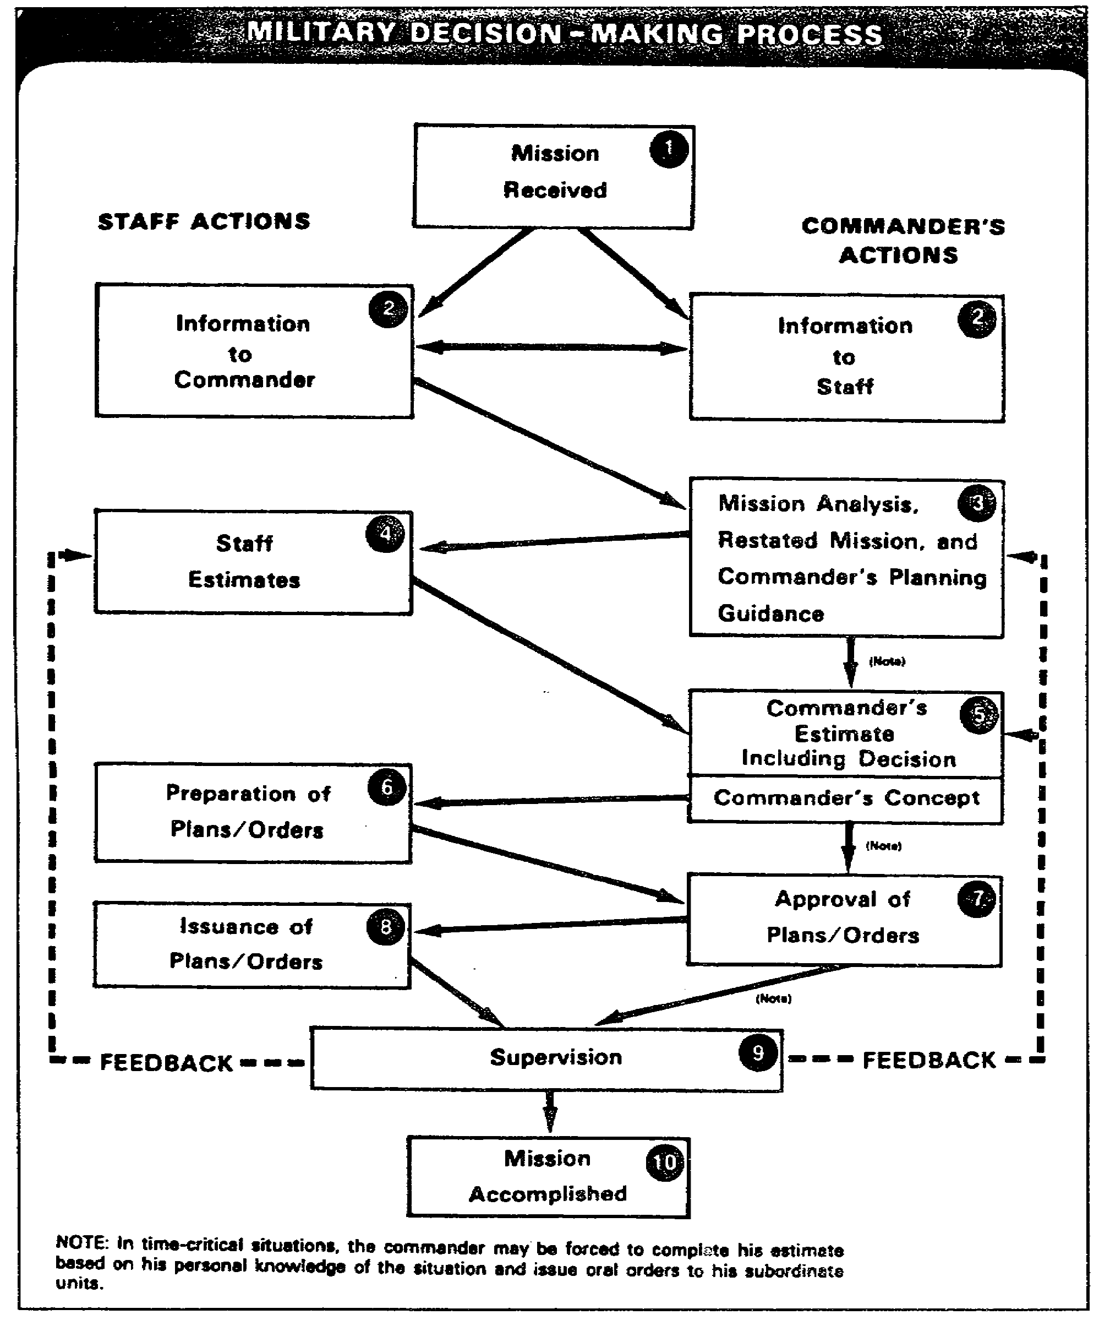

Figure 4-1. Military decision-making process

4-3 SS0120

2. Staff Estimate Overview.

a. The staff assists the commander in reaching a decision by making estimates in their assigned areas of responsibility. The purpose of the estimate of the situation is to collect and analyze relevant information for developing the most effective solution to a problem, within the time limits and available information. Estimates also identify factors that affect formulation, analysis, and comparison of feasible courses of action. The staff estimate concludes and recommends feasible courses of action. In making an estimate, the staff officer consults with other staff officers and agencies.

b. Staff officers prepare estimates on a variety of areas. Coordinating and special staff officers may prepare estimates covering the entire area of their staff responsibilities, or some subarea or activity.

c. Staff estimates may be prepared mentally, orally, or in writing. Often, only the staff officer's conclusions or recommendations are presented to the commander.

3. The Estimate Format. The staff estimate is a five-paragraph document that shows an analysis of the situation, courses of action, and recommendations. Figure 4-2 shows a format for the estimate of the situation. This format is used for both the commander's estimate and the staff estimate. The following is an analysis of each paragraph of the estimate based on FM 24-16, Communications-Electronics, Operations, Orders, Records, and Reports.

a. Paragraph 1- Mission.

(1) The signal support mission can be determined by a thorough analysis of the mission of the command, the concept of the operations, and the tasks for subordinate units as stated in the higher headquarters operations plan. In the signal operations estimate, the mission should include a reference to the SOP for normal signal support and any unusual or special signal support requirements. Whether prescribed or deduced, the mission will not usually identify all the tasks involved. The S3 provides information and assists the commander in determining additional tasks, such as establishing relay locations and making movements or “jumps.”

(2) Although the mission statement may include any one or a combination of the elements of who, what, when, where, how, and why, it does not normally specify the details to be accomplished. Therefore, the S3 is primarily concerned with determining those elements not included in the mission statement. At battalion level, this often includes selecting locations for signal installations and determining how battalion units will be used.

SS0120 4-4

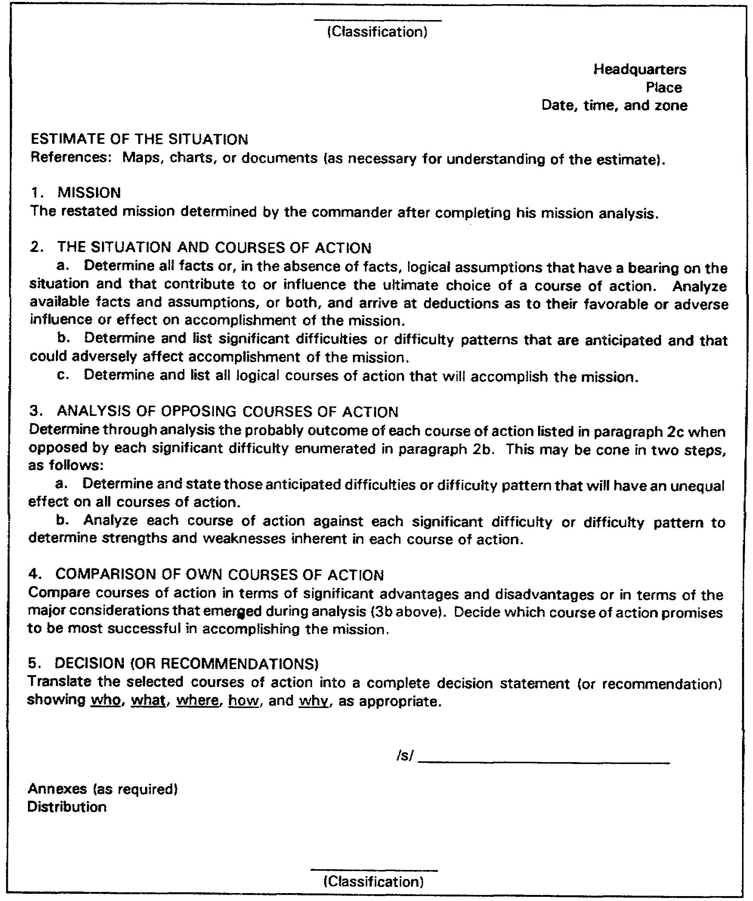

Figure 4-2. Format for the estimate of the situation

4-5 SS0120

(3) To give you a better understanding, look at the sample mission statement and the analysis of the statement in Figure 4-3.

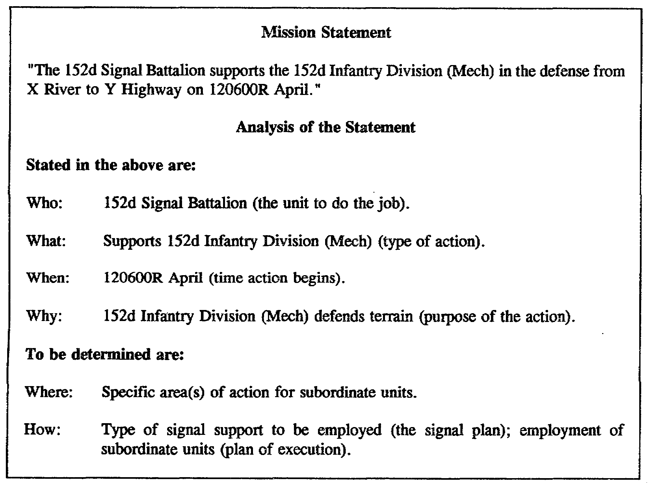

Figure 4-3. Mission Statement Analysis

b. Paragraph 2 - Situation and Courses of Action. The purpose of the operation estimate is to consider known and assumed factors and aspects of the situation which will affect signal operations; and, to develop feasible courses of action to do the signal support mission. For logical development, it is divided into four subparagraphs:

(1) Characteristics of the area of operations. In evaluating the characteristics of the area of operations for a signal estimate, consider:

(a) Predictable or assumed effects of the weather and atmospheric conditions on the employment of equipment.

(b) Frequency propagation predictions for critical periods of the operation.

SS0120 4-6

(c) Pertinent factors about the terrain that may have a bearing on the accomplishment of the signal mission in support of the operation.

(d) Existing signal systems and the political and security implications of employing the systems in support of military operations.

(2) Enemy situation. In evaluating the enemy situation, consider:

(a) The disposition of known or suspected enemy electronic warfare and communications intelligence (COMINT) units that could impede the success of the mission.

(b) Those portions of the frequency spectrum that are most congested by enemy electromagnetic radiating devices.

(c) The composition of enemy signal forces.

(d) Peculiarities and weaknesses that will affect the enemy signal effectiveness, either favorably or unfavorably.

(3) Your own situation. In evaluating your own situation, consider:

(a) Present commitment of own signal elements that are not committed and are available to support the mission.

(b) Morale and state of training of signal elements.

(c) Vulnerability of signal elements, systems, and equipment to enemy electronic warfare operations.

(d) The adequacy of the signal security (SIGSEC) program and practices.

(4) Courses of action. Determine all feasible courses of action that will accomplish the mission. Each course of action is a clear, concise, logical statement indicating what signal support will be provided when, where, and how to accomplish the mission. Each course of action must be within the capabilities of the signal troops assigned to the command. In determining the various courses of action, consider:

(a) Maintaining existing systems to prevent disclosure of the impending operation to the enemy.

(b) Phased displacement of signal facilities to provide for continuous operation.

4-7 SS0120

(c) Employment of signal deception to minimize the effectiveness of enemy intelligence activities.

(d) Special signal requirements that may arise during critical phases of the operation.

(e) Requirements for signal supply and maintenance support.

c. Paragraph 3 - Analysis of Opposing Courses of Action.

(1) The purpose of paragraph 3 of the estimate is to evaluate each course of action against those difficulties that may have a significant influence upon the success of the signal support mission. Difficulties that have equal effect on all courses of action, or have little or no effect on the choice of a course of action, are not considered in this analysis.

(2) Each course of action must be carefully analyzed to assure that it meets the requirements to ensure success of the signal support mission. Consider the following planning factors that may be used in analyzing the various courses of action:

(a) Mission. How effectively does the course of action accomplish the mission? Does the course of action provide timely support?

(b) Enemy. What are the critical points of the course of action that may be affected by enemy courses of action? What effect will the course of action have on enemy signal systems? Does the course of action consider good SIGSEC practices to counteract enemy signal intelligence (SIGINT) efforts?

(c) Troops. Does the course of action provide for effective use of signal troops? Are supporting troops capable of providing the required support? Does the course of action provide adequate time to support the movement of signal personnel to required locations? Does the course of action provide for a reserve capability to accomplish anticipated special requirements?

(d) Area. Does the course of action make optimum use of the characteristics of the area of operation? Does the course of action make optimum use of indigenous communications in this area? Are critical terrain features adequately considered? Does the area lend itself to meeting SIGSEC requirements?

(e) Logistics. Are adequate supplies available to support the mission? Is adequate maintenance provided to fulfill the critical requirements? Is adequate transportation available?

SS0120 4-8

d. Paragraph 4 - Comparison of Courses of Action. The purpose of paragraph 4 is to evaluate the importance of the critical factors indicated in the analysis of situation and courses of action. The primary consideration in comparing the various courses of action is that signal facilities will be deployed to provide command and control of the tactical operation. The following factors may be considered advantages and disadvantages:

(1) Advantages.

(a) Economy of personnel and facilities. The economical use of personnel and facilities may be considered a definite advantage if the tactical requirements are fulfilled and there are reserve resources. Such economy provides uncommitted personnel and facilities that may be committed to assure continuous operation over extended periods of time in a highly fluid situation.

(b) Location of signal facilities. The selection of sites that will meet the requirements of the tactical situation and minimize the effectiveness of enemy air, ground, and electronic warfare attack may be considered an advantage.

(c) Indigenous facilities. The capture and employment of indigenous facilities may be an advantage when such employment will reduce construction time, reduce facilities requirements, minimize effectiveness of enemy electronic warfare, or provide improved security facilities.

(2) Disadvantages.

(a) Commitment of all personnel and facilities. Any course of action that calls for the full commitment of personnel and facilities in the early phase of the operation would be a disadvantage, and such a commitment should be carefully evaluated. Such commitment of signal personnel and facilities may prevent the establishment of new facilities or the displacement of echelons of the command post as the tactical operation progresses. Further, the efficiency of personnel committed for long periods of time will decrease, and the system they operate will deteriorate.

(b) Systems highly vulnerable to electronic warfare. If the facilities of a signal system are located where they are highly susceptible to enemy electronic warfare, that may be disrupted and fail to provide command and control during critical phases of the operation. This type of situation would be a disadvantage.

(c) Failure to meet tactical requirements. Any course of action that fails to meet the tactical requirements would definitely be a disadvantage and should be disregarded. Signal facilities must be located so that they not only provide highly efficient signal systems, but also provide ready access to the tactical units and facilities. This will aid in the overall accomplishment of the mission of the command.

4-9 SS0120

e. Paragraph 5 - Recommendation. In your recommendation, select the course of action that has the greatest possibility of assuring the success of the signal support mission. Translate this course of action into a statement of what the command's signal elements as a whole are to do to assist the command in the doing its mission. State as much of the elements of who, what, when, where, how, and why as may be appropriate. The greater the emphasis placed on these elements prior to the decision's announcement, the more efficient the signal systems will function during the tactical operation. Assign tasks to the command's signal elements to ensure that facilities are established and operating when required. Do not overtax any single element, and provide adequate reserves to meet unforeseen requirements. Key points of your recommendations should be:

(1) Selecting the best course of action.

(2) Translating the course of action into a statement of signal element requirements.

(3) Stating and emphasizing the who, what, when, where, how, and why.

(4) Assigning the task.

(5) Not overtaxing

(6) Providing adequate reserves.

4. OPORD. The OPORD provides for coordinated action to carry out the decision of the commander in the conduct of an operation. For the purpose of this subcourse, you will learn the specific information required only in paragraph five, command and signal. FM 101-5, Staff Organization and Operations, contains an in-depth explanation of the OPORD and the operations plan (OPLAN). The format for an OPLAN/OPORD is illustrated in Figure 4-4. The following description is based on FM 101-5.

a. Purpose. An OPORD gives subordinate commanders the essential information they need to carry out an operation. This information includes the situation, the mission, the assignment of tasks, and the support and assistance to be provided.

(1) When an operation will be conducted immediately, the complete OPORD or a series of fragmentary orders (FRAGO) is prepared based on the commander's announced decision and concept (if given).

(2) When an operation is to be conducted at some future time, the OPORD may be an OPLAN that will be implemented by appropriate instructions. For example, “Execute OPLAN 16 as OPORD 8; D-day, H-hour is 151700 July 19--.” Changes to an OPORD normally are made by issuing a FRAGO. A new order is published whenever a significant change in the mission occurs or a new mission is received.

SS0120 4-10

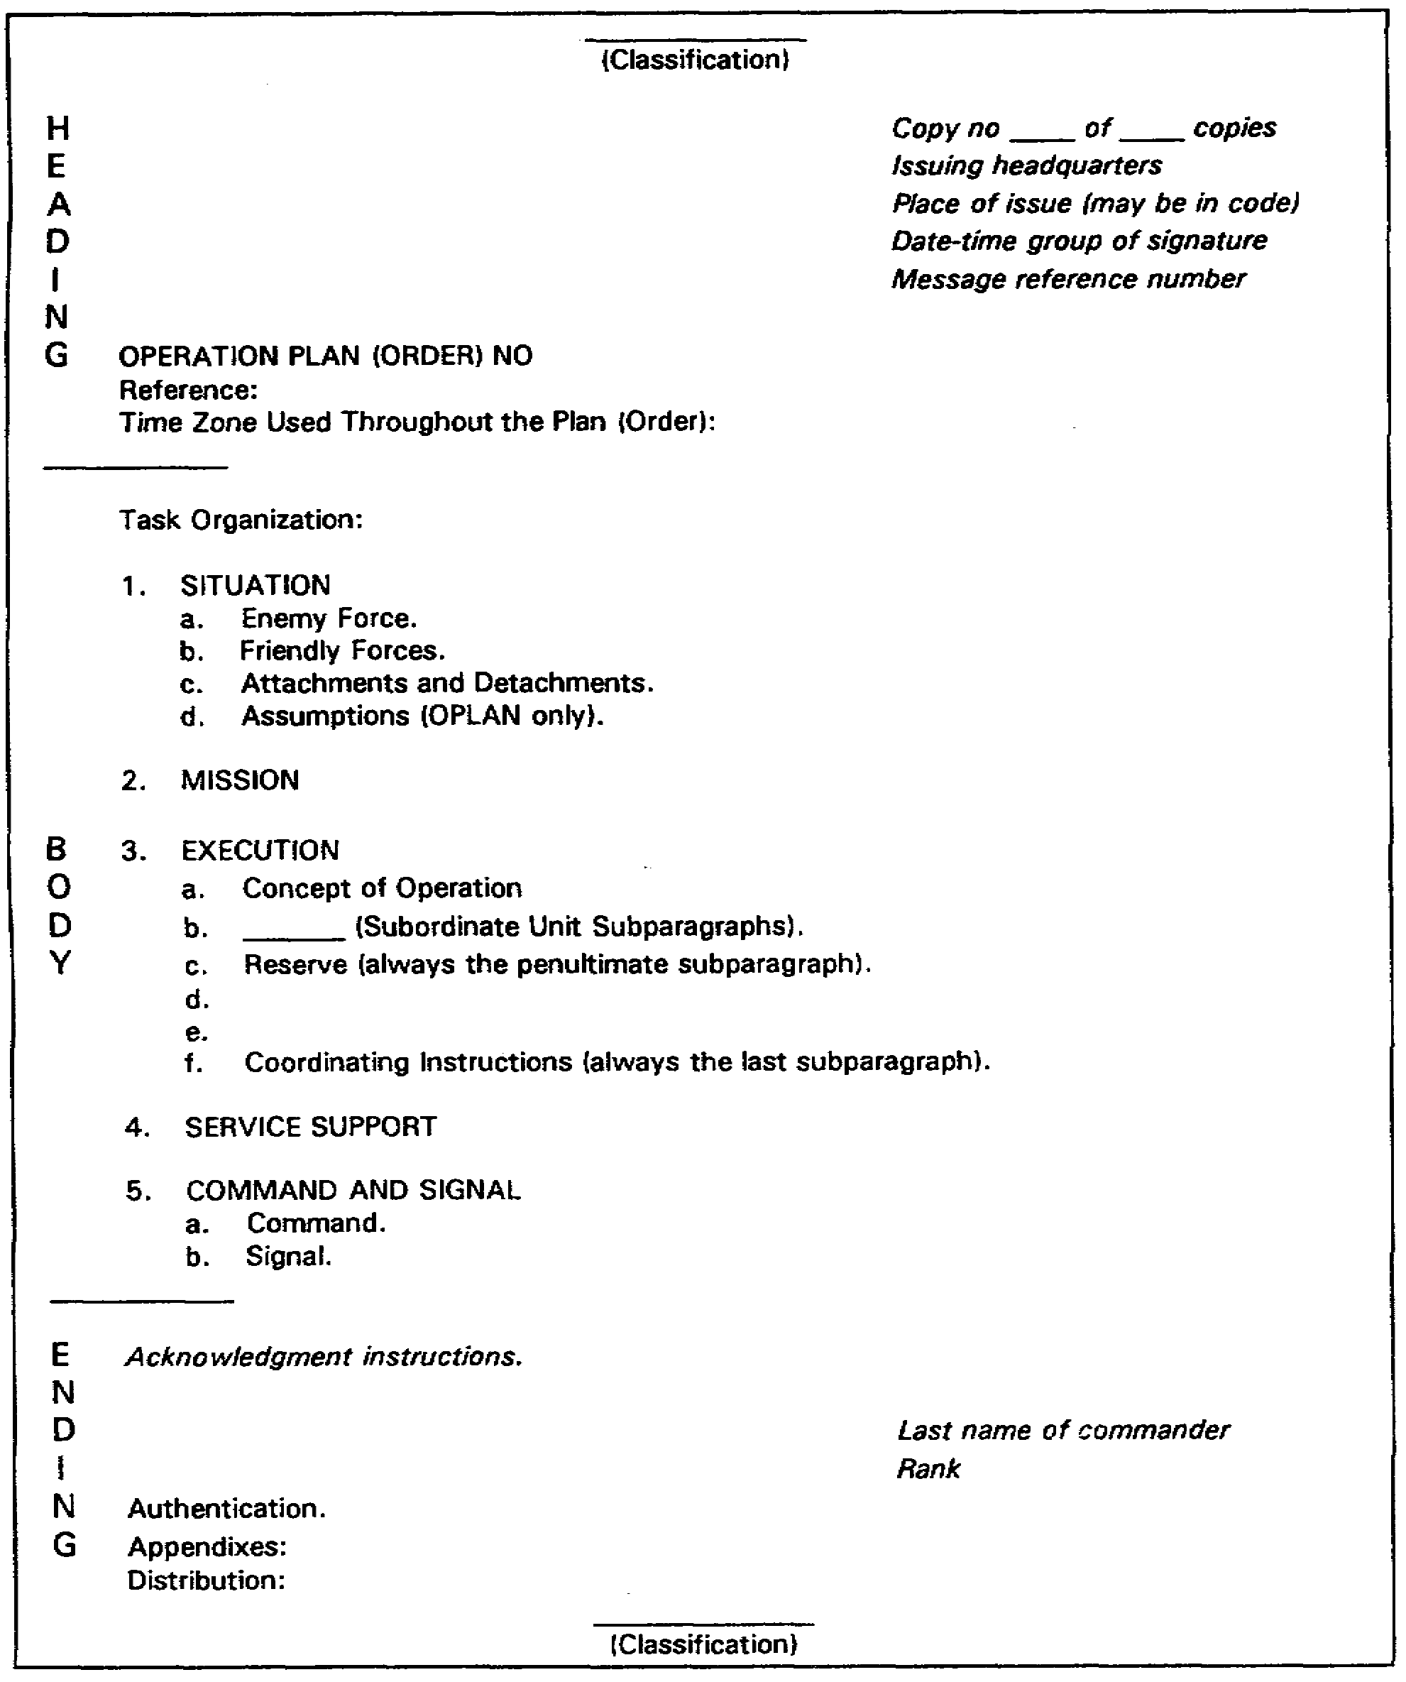

Figure 4-4. Format for an operations plan/order

4-11 SS0120

b. Content. An OPORD should include only the detail that commanders of subordinate units need to issue their own orders and to ensure coordination. The details of how supporting and specialist units are to carry out their tasks should be issued in their own orders, which will use the same format as an OPORD unless otherwise specified.

c. Staff activity. The chief of staff (division and higher) or the executive officer (brigade and lower) supervises the staff input during the preparation of the OPORD to ensure compliance with the commander's guidance (concept). G3/S3 operations has primary coordinating staff responsibility for preparing, publishing, and distributing the command's OPORD. Other staff officers will provide those portions of the order pertaining to their staff responsibilities. This contribution varies from a single sentence to a complete annex, depending on requirements and the staff officers concerned.

d. Paragraph five.

(1) Command instructions may include command post (CP) locations and axis of CP displacement, if not shown on an accompanying overlay. Liaison requirements, designation of alternate CP, and succession of command are included in this subparagraph if not adequately covered in the SOP.

(2) Signal instructions may include rules concerning the use of communications and other electronic equipment (e.g., radio silence). Signal instructions may refer to an annex, but, as a minimum, should list the current signal operation instructions (SOI) index.

5. Signal Annex.

a. The signal annex is one of many annexes in an OPORD. It addresses the specific aspects of signal support and serves to keep the basic text of an OPORD short. The sign annex should not include mattes covered in the SOP, although where appropriate, reference should be made to an SOP. The format for a signal annex is shown at Figure 4-5.

b. Signal annex subjects. Some suggested subjects for inclusion in the annex are detailed below and in FM 24-16, Communications-Electronics, Operations, Order, Records, and Reports. These subjects may also be included in the unit SOP. However, the signal annex should not address matters covered in the SOP.

(1) References. These may include field manuals, technical manuals, regulations, the SOP, and the SOI.

(2) Training of signal personnel. Training instruction for signal personnel are limited to general statements of responsibility. Detailed instructions are usually contained in training memorandums.

SS0120 4-12

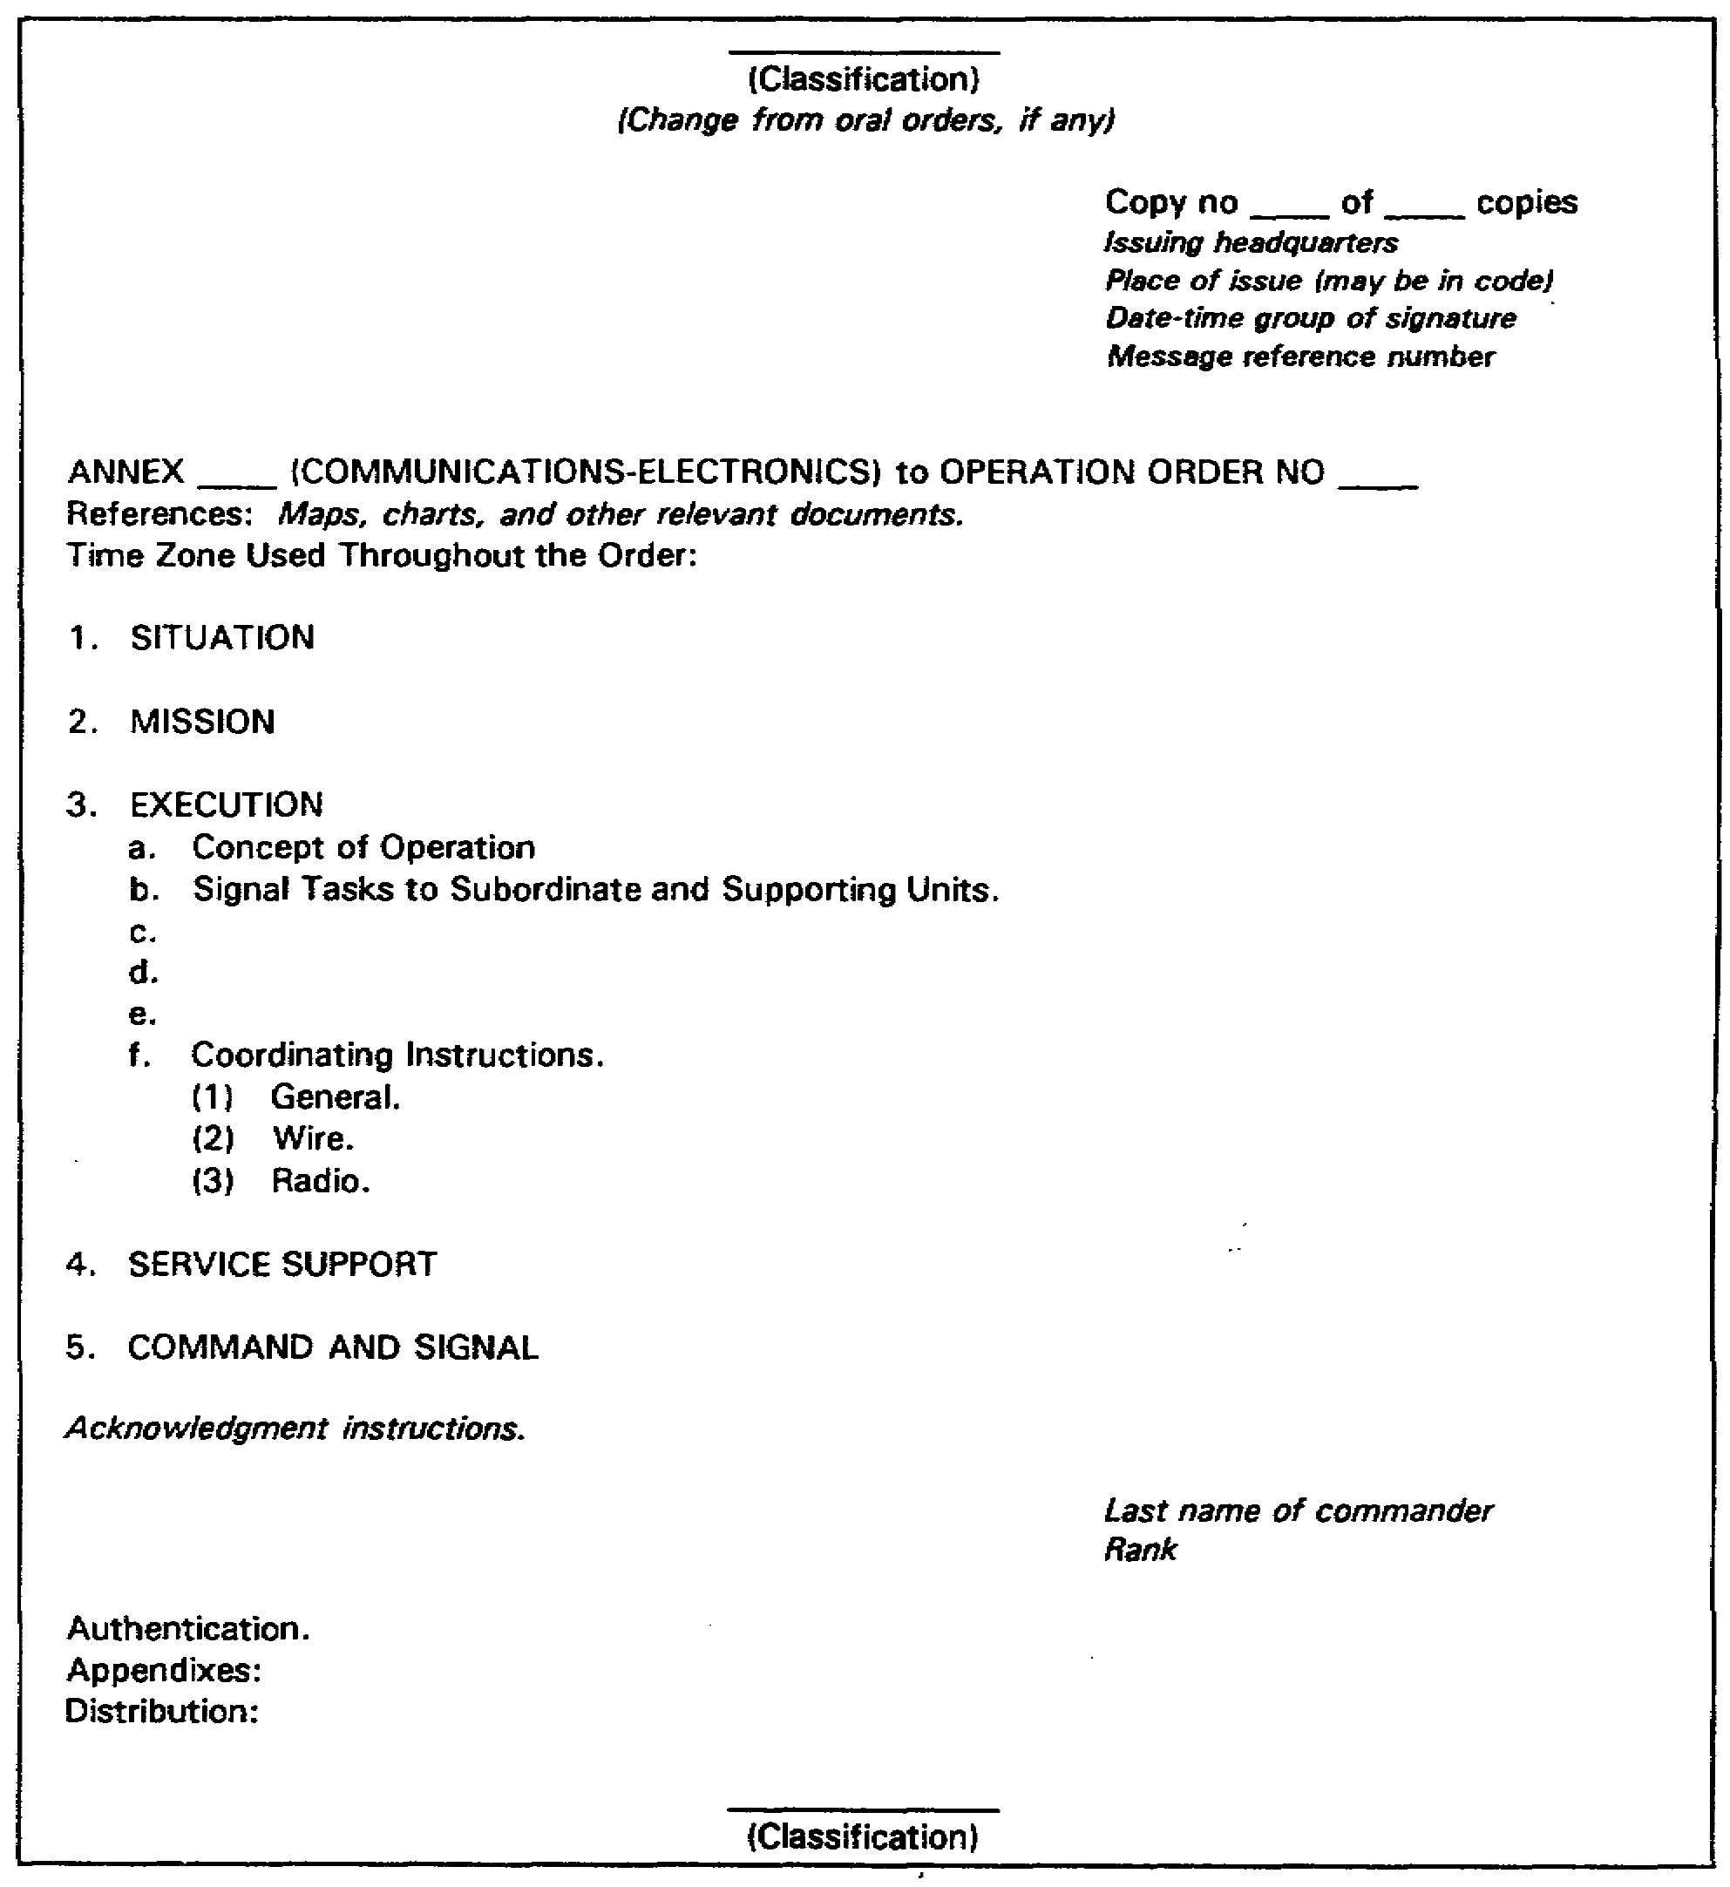

Figure 4-5. Signal annex format

4-13 SS0120

(3) Administration. A means of promulgating and standardizing administrative procedures throughout the unit.

(4) SIGSEC. The purpose of these instructions is to develop and maintain a SIGSEC awareness throughout the unit. They are limited to those instructions that apply to all elements of the command and that are not contained in the command's SOI.

(5) Physical security. The purpose of these procedures is to develop an awareness for physical security and to promulgate and standardize procedures throughout the unit.

(6) Signal centers. These instructions should include the number of signal centers to be established for routine operations, the services they are to provide, and general procedures governing the operation and displacement.

(7) Telecommunications centers. These instructions govern the locations and markings of telecommunications centers, establish procedures pertaining to the transmittal and receipt of documents, prescribe the records to be maintained, and give other information pertaining to telecommunications center operations.

(8) Messenger service. These instructions should indicate the extent of the command messenger service, including scheduled motor, air, and special messengers. They should indicate pickup and delivery points, prescribe methods of packaging and addressing, state security clearances required by messengers, and prescribe methods of marking messenger vehicles.

(9) Wire communications. These instructions include assignment of responsibility for normal wire lines, wire and cable construction practices, priority of installations, and tagging procedures; general guidance pertaining to locations of switchboards, patch panels, circuit/system control facilities, teletypewriter equipment, and other major terminal equipment; and instructions governing the placing of calls. These instructions may also include directory service, circuit/system control procedures, instructions for obtaining service, and care and maintenance of wire communications material. Refer to FM 24-20, Field Wire and Cable Techniques, for specific details.

(10) Single-channel radio communications. These instructions pertain to the installation, operation, and maintenance of single-channel radio communications equipment, and the composition and use of radio nets, to include those required for special purposes and emergency operation. These instructions also define actions to be taken in the event of jamming, and establish procedures for monitoring various frequencies on nets. Refer to FM 24-18, Tactical Single-Channel Radio Communications Techniques, for specific details.

(11) Multichannel communications. These instructions pertain to the installation, operation, and maintenance of those multichannel systems that apply to all elements of the

SS0120 4-14

command. Detailed instructions on operations should be in the SOP for the signal unit that provides the multichannel system. The signal annex should indicate those facilities to be provided for each major element of the command and prescribe the criteria for their displacement. Refer to FM 24-21, Tactical Multichannel Radio Communications Techniques, for specific details.

(12) Visual and sound communications. These instruction pertain to the general use and distribution of visual and sound signal devices (flags, lights, pyrotechnic, panels , arm-and-hand signals, whistles, sirens, bells, voice amplifiers, explosive devices, etc.). Specific instructions on visual and sound communications are in the SOI and OPORD, which cover the maintenance of equipment where applicable. Refer to FM 21-60, Visual Signals, and FM 23-30, Grenade and Pyrotechnic Signals, for specific details.

(13) Electronic warfare (EW). These instructions contain routine actions to be taken in an EW environment to include the reporting of hostile interference, jamming, and deception attempts, and the employment of standard procedures to minimize the occurrence and effects of electronic countermeasures. These instructions are normally defined in the SOP or SOI with elaborate instructions relevant to EW and electronic counter-countermeasures (ECCM) set forth in the EW annex. When an EW annex is not published, instructions must be in the signal annex. If both annexes are published, they should be cross-referenced. Refer to FM 32-30, Electronic Warfare Tactics, for specific details.

(14) Frequency control. These instructions pertain to frequency control which should include procedures to be followed to obtain frequencies, restrictions on the use of frequencies, procedures for reporting interference, and conditions under which radio silence or listening silence is required. The SOI should adequately cover this subject.

(15) Communication security (COMSEC) logistics. COMSEC logistics is the staff responsibility of the signal officer. Procedures for issuance, control, and turn-in of COMSEC material are contained in AR 380-41.

(16) Audiovisual support. These instructions prescribe audiovisual support to be provided for the various elements of the command to include still and motion picture photography, photographic laboratory operations, television, audio, graphics, procedures for requesting support, and locations of audiovisual facilities. Refer to FM 11-40, Tactical Audio Visual Doctrine, for specific details.

(17) Tactical Automatic Switching System (TASS). With the innovation of the tactical automatic switching system, numerous changes in procedures and doctrine are required to provide standardization without loss of effectiveness. Refer to FM 24-26, Tactical Automatic Switching, for specific details.

4-15 SS0120

(18) Systems and circuits identification. The instructions cover the proper identification of circuits and systems for installation and control purposes in accordance with the 7-character identification system. These instructions should also cover the tagging of wire circuits (wire tagging code). Refer to FM 24-22, Communications-Electronics Management System (C-EMS), for specific details.

(19) Communications systems. The communications system consists of two combined systems, the command and the area systems. These systems are designed and engineered to provide tactical support for the Army units in the field. The use of multi-media, multi-axis signal equipment provides sufficient high-capacity, quality-controlled facilities to meet response, flexibility, mobility, and disposition requirements. These communications systems combine the corps command and area communication systems, using area signal centers to provide tactical automatic switching, centralized control, and interconnected circuits/systems throughout the corps area. The interconnecting of two or more signal enters (nodes) provides for a wider distribution of traffic loads, primary and secondary routing over alternate systems, and enhances reliability of the communication media consistent with demands envisioned for newer data systems. Instructions in this signal annex pertaining to these systems should include the doctrinal procedures that apply to all elements of the command.

(20) Intelligence. The signal officer, together with the EW officer, should assist the G2 in preparing those portions of the command SOP which pertain to SIGINT. Information provided by the signal officer includes instructions on the types of documents and equipment to be processed through signal technical intelligence channels, methods for reporting the capture of such documents and equipment, and the provisions for security of signal communications installations. The signal officer also provides information pertaining to enemy signal operations required to assist in preparing the communications and EW plans.

(21) Communications for coordinating agencies. The communications required by the various coordinating agencies is a major portion of the special communications that has to be established within the command. The requirements of each agency are revaluated and necessary facilities provided. Coordinating agencies include those responsible for coordination and control of fire and maneuver, regulation and control of air space over the combat zone, control of the electromagnetic frequency spectrum, combat service support, and rear area security and area damage control.

(22) Miscellaneous. This includes information concerning the location of the signal officer, selection of command posts, instructions governing the preparation of the SOI, the SOP, and instructions pertaining to signal planning for future operations. FM 24-1, Combat Communications, FM 11-50, Combat Communications Within the Division, FM 11-92, Combat Communications Within the Corps, and the manuals referenced in the preceding paragraphs should provide you with a good understanding of the Army communications systems and their use.

SS0120 4-16

6. Summary. In this lesson, you learned about the military decision-making process, the signal estimate, paragraph 5 of the operations order (OPORD), and the signal annex.

a. The military decision-making process is followed by the commander and his staff as they interact and execute decisions. It is a logical, systematic approach to determine the situation, and best carry out the mission.

b. The signal estimate is an analysis of the influence of factors within the signal officer's particular field of interest on the accomplishment of the mission. The estimate identifies factors that affect formulation, analysis, and comparison of feasible courses of action, and concludes with recommended feasible courses of action. The estimate is comprised of five paragraphs.

(1) Paragraph 1 - Mission.

(2) Paragraph 2 - Situation and Courses of Action.

(3) Paragraph 3 - Analysis of Opposing Courses of Action.

(4) Paragraph 4 - Comparison of Courses of Action.

(5) Paragraph 5 - Recommendation.

c. An OPORD gives subordinate commanders the essential information needed to carry out an operation. This includes the situation, the assignment of tasks, and the support and assistance to be provided. An OPORD includes only the detail needed for commanders of subordinate units to issue their own orders and ensure coordination.

d. When an operation will be conducted immediately, the complete OPORD or a series of fragmentary orders (FRAGO) is prepared based on the commander's announced decision and concept (if given). When an operation is to be conducted at some future time, the OPORD may be an operations plan (OPLAN) that will be implemented by appropriate instructions.

e. The signal annex deals with the specific aspects of signal support as it relates to the OPORD. The purpose of the annex is to address signal matters in the necessary detail, thus keeping the basic text of an OPORD short.

4-17 SS0120

THIS PAGE INTENTIONALLY LEFT BLANK

SS0120 4-18

LESSON 4

PRACTICE EXERCISE

The following items will test your grasp of the material covered in this lesson. There is only one correct answer for each item. When you complete the exercise check your answer with the answer key that follows. If you answer any item incorrectly, study again that part of the lesson which contains the portion involved.

1. The commander uses the __________ to make and execute decisions.

A. Operations order.
B. Staff estimates.
C. Military decision-making process.
D. Decision briefing.

2. A commander would never make a decision without his staff’s formal input as part of the decision-making process.

A. True.
B. False.

3. The purpose of a staff estimate is to __________.

A. Give a subordinate commander the essential information needed to carry out an operation.
B. List the procedures that are unique to the organization and used habitually for accomplishing routine, recurring actions or maters.
C. Keep the basic text of an operations order short.
D. Collect and analyze relevant information for developing, within the time limits and available information, the most effective solution to a problem.

4. The staff estimate is a five-paragraph document that __________.

A. Is a means of presenting information to commanders, staffs, or other designated audiences.
B. Shows an analysis of the situation, courses of action, and recommendations.
C. Gives subordinate commanders the essential information needed to carry out an operation.
D. Lists procedures that are unique to the organization and used for accomplishing routine, recurring actions or matters.

4-19 SS0120

5. Paragraph 1 - Mission, will always identify all tasks involved.

A. True.
B. False.

6. The purpose of paragraph 3 of the staff estimate is to __________.

A. Evaluate each course of action against those difficulties that may have a significant influence upon the success of the mission.
B. Determine the characteristics of the area of operations, the enemy situation, your own situation, and courses of action.
C. Consider the advantages and disadvantages of each course of action.
D. Recommend a course of action to the commander.

7. In selecting a course of action to recommend to the commander, you should make your selection based primarily on __________.

A. Signal doctrinal considerations.
B. The course of action that has the greatest possibility of success.
C. How your unit has performed a similar mission in the past.
D. Ensuring that you have thoroughly investigated every aspect of the situation.

8. When an operation is to be conducted at some future time, the operations order (OPORD) may be a/an __________ that will be implemented by appropriate instructions.

A. SOP.
B. Staff estimate.
C. OPLAN.
D. Annex.

9. An OPORD should include only the detail that commanders of subordinate units need to issue their own orders and to ensure coordination.

A. True.
B. False.

10. Paragraph five of an OPORD addresses __________.

A. Mission statement.
B. Execution concept.
C. Service support requirements.
D. Command and signal instructions.

SS0120 4-20

11. CP locations and axis of CP displacement may be included in the _________.

A. Signal instructions, paragraph five.
B. Signal annex, paragraph two.
C. Command instructions, paragraph five.
D. SOI.

12. The _________ deals with one aspect of an operation (such as signal support).

A. SOP.
B. OPORD.
C. Annex.
D. OPLAN.

4-21 SS0120

THIS PAGE INTENTIONALLY LEFT BLANK

SS0120 4-22

LESSON 4

PRACTICE EXERCISE

ANSWER KEY AND FEEDBACK

Item Correct Answer and Feedback

1. C. Military decision-making process.

The commander and staff use the military decision-making process to make and execute tactical decisions. (page 4-1, Introduction)

2. B. False.

The commander may have to proceed through the decision-making process and issue oral orders based on his own knowledge of the situation without taking the time required to formally include his staff in the process. (page 4-2, pare 1c)

3. D. Collect and analyze relevant information for developing, within the time limits and available information, the most effective solution to a problem.

The purpose of the staff estimate is to collect and analyze relevant information for developing the most effective solution to a problem, within the time limits and available information. (page 4-4, para 2a)

4. B. Shows an analysis of the situation, courses of action, and recommendations.

The staff estimate is a five-paragraph document that shows an analysis of the situation, courses of action, and recommendations. (page 4-4, para 3)

5. B. False.

Whether prescribed or deduced, the mission will not usually identify all the tasks involved. (page 4-4, para 3a(1))

4-23 SS0120

6. A. Evaluate each course of action against those difficulties that may have a significant influence upon the success of the mission.

The purpose of paragraph 3 of the staff estimate is to evaluate each course of action against those difficulties that may have a significant influence upon the success of the mission. (page 4-8, para 3c(1))

7. B. The course of action that has the greatest possibility of success.

In your recommendation, select the course of action that has the greatest possibility of assuring the success of the signal support mission.
(page 4-10, para 3e)

8. C. OPLAN.

When an operation is to be conducted at some future time, the operations order (OPORD) may be an operations plan (OPLAN) that will be implemented by appropriate instructions. (page 4-12, para 4a(2))

9. A. True.

An OPORD should include only the detail commanders of subordinate units need to issue their own orders and to ensure coordination. (page 4-12, para 4b)

10. D. Command and signal instructions.

Paragraph five of an OPORD addresses command and signal instructions.
(page 4-12, para 4d(1)(2))

11. C. Command instructions, paragraph five.

Command instructions may include command post (CP) locations and axis of CP displacement, if not shown on an accompanying overlay. (page 4-12, para 4d(1))

12. C. Annex.

The signal annex is one of many annexes i an OPORD. It addresses the specific aspects of communications support and serves to keep the basic text of an OPORD short. (page 4-12, para 5a)

SS0120 4-24

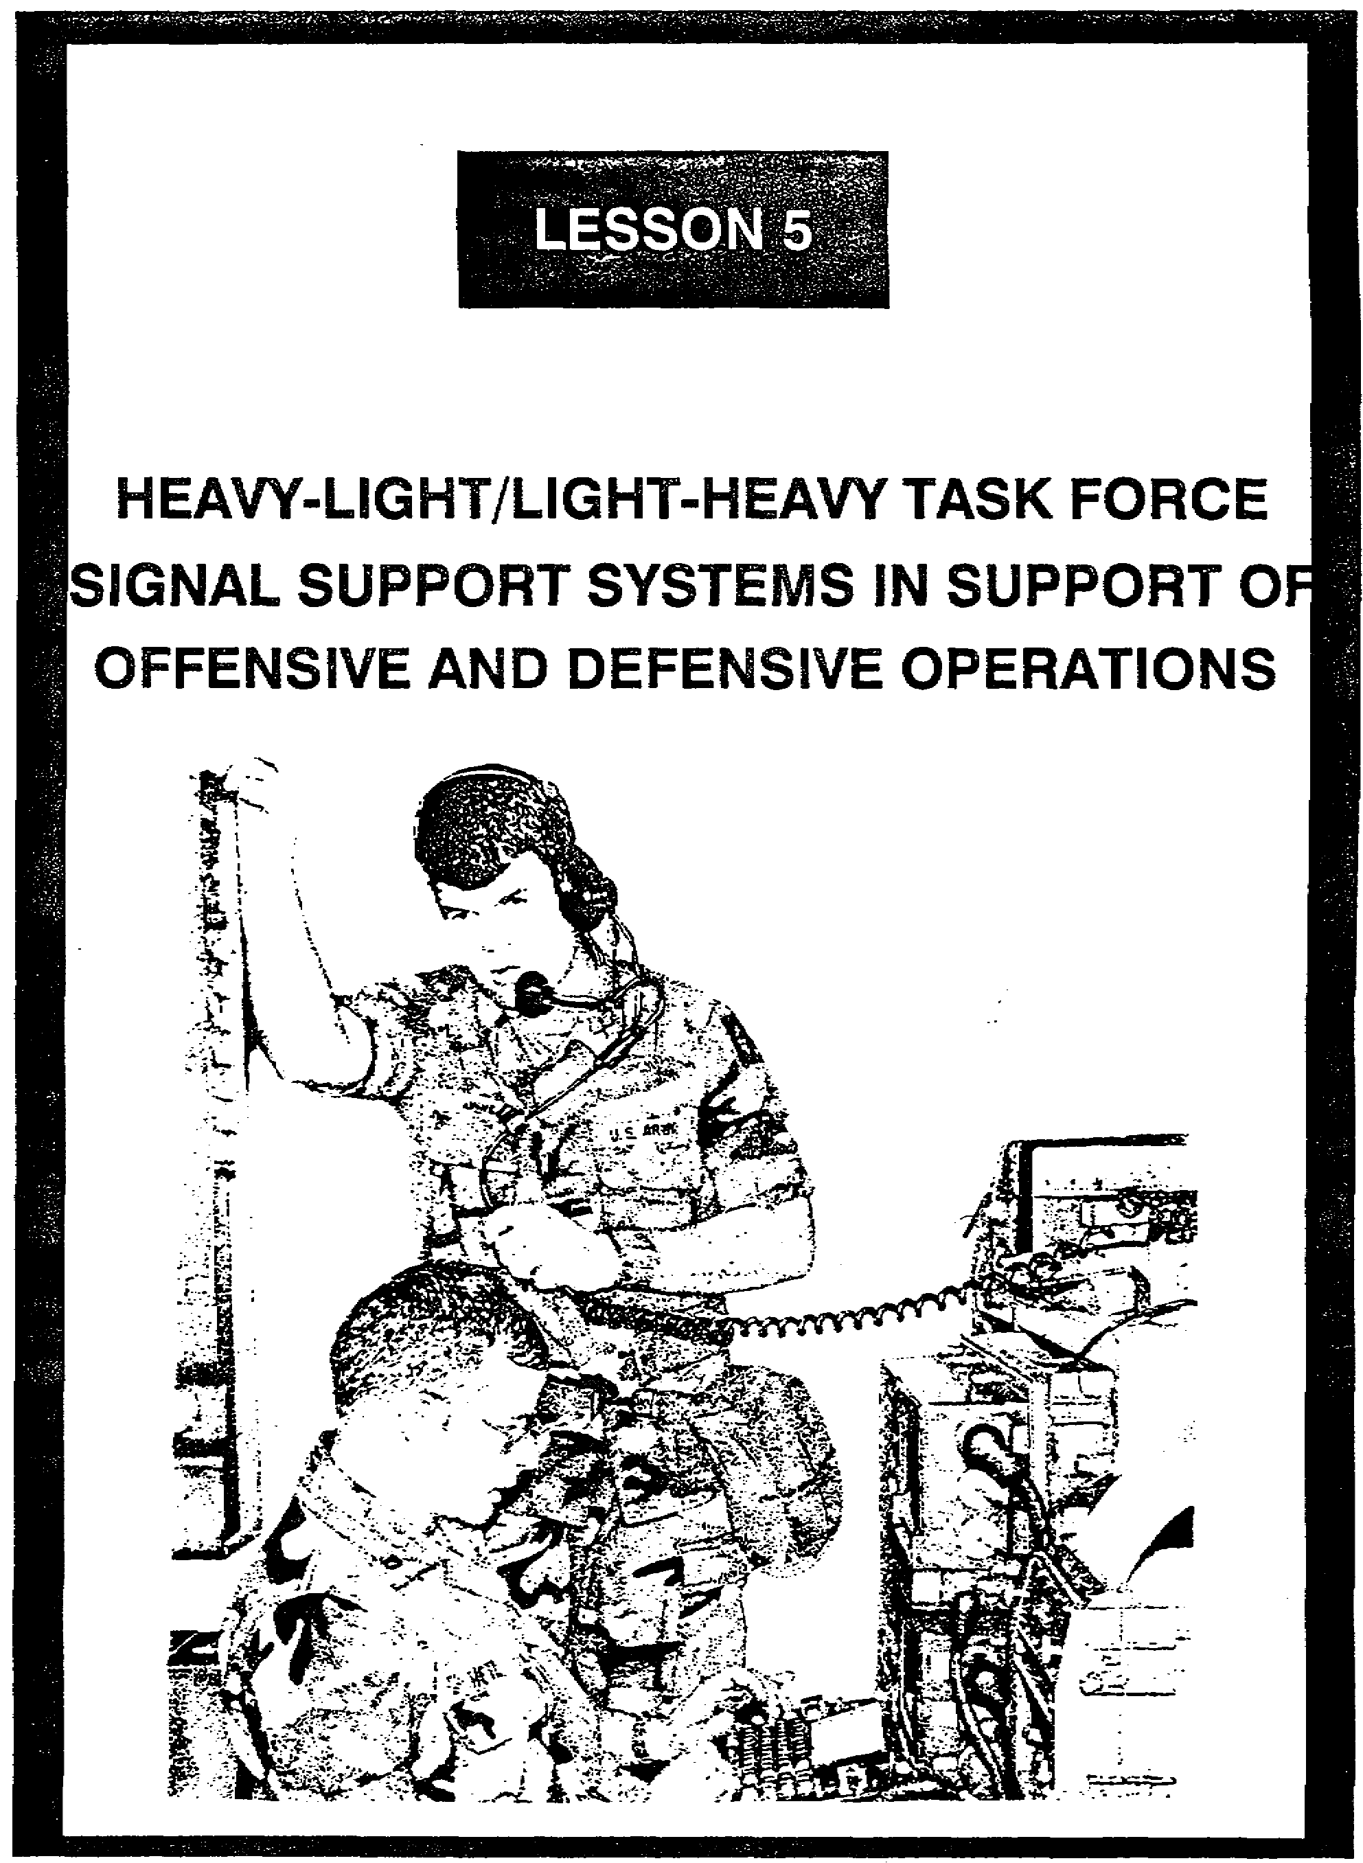

LESSON 5

HEAVY-LIGHT/LIGHT-HEAVY TASK FORCE
SIGNAL SUPPORT SYSTEMS IN SUPPORT OF
OFFENSIVE AND DEFENSIVE OPERATIONS

Critical Tasks: 01-5840.07-0002
01-5841.07-0001

OVERVIEW

LESSON DESCRIPTION:

In this lesson, you will learn about planning the signal support systems used in support of offensive and defensive operations conducted by heavy-light or light-heavy battalion task forces.

TERMINAL LEARNING OBJECTIVE:

ACTION: Explain the signal support systems used in support of the offensive and defensive operations conducted by heavy-light and light-heavy task forces.

CONDITION: You will have this lesson.

STANDARD: To demonstrate competency, you must achieve a minimum of 70% on the subcourse examination.

REFERENCES: The material in this lesson was derived from the following publications:
FM 7-20, FM 11-32, FM 11-50, FM 24-1, FM 24-18, FM 71-2, and FM 71-100.

INTRODUCTION

In lessons 1 and 2, you learned the organization of the heavy-light and light-heavy battalion task forces (TF) and the signal support systems available. This lesson discusses planning and employment considerations for using the communications assets available to the heavy-light/ light-heavy battalion TF during offensive and defensive operations.

5-1 SS0120

PART A - SIGNAL SYSTEMS PLANNING

1. Planning.

a. Good planning extends over considerable space and time. It may cover a single operation, or a series of operations to be carried out simultaneously or in succession. Plans are usually based on the commander's knowledge of an upcoming mission, or on higher headquarters’ mission forecasts issued to permit subordinate commanders time to prepare supporting plans and orders. Planning requires the careful application of common sense, a thorough knowledge of the supported unit's mission, and a thorough knowledge of your unit, its capabilities, and its limitations. As the signal officer, you must have a good handle on the situation to plan and render adequate signal support to the commander. You must thoroughly understand the who, what, when, and where of the supported elements and units, as well as their mission. With proper planning, you can decide how to effectively and efficiently provide the support.

b. Plans are the initial basis for action. However, TF commanders fight in a dynamic environment and must expect changes in the situation, resulting in changes in their plans. After an initial order, TFs are usually directed by a series of fragmentary orders (FRAGO), with the commander continually making decisions on how to fight the battle.

(1) In planning an operation, the TF commander focuses on developing a concept of the operation that best accomplishes the TF's mission. He assigns missions and tasks to subordinate elements and allocates forces and establishes priorities to make the concept work.

(2) Planning must be done rapidly to provide adequate time for preparation and coordination. Planning is continuous. Initial plans are updated and refined, but complete change is avoided, especially if changes negate subordinate planning and preparation time.

(3) Plans must be simple, yet must contain sufficient information for understanding and coordination to take place.

(4) Standing operating procedures (SOP) that are detailed, understood, and practiced allow for short concise plans. Orders do not repeat those SOP items which subordinates understand.

(5) Routinely, the TF will have limited time to plan and prepare to conduct an operation. For example, the commander receives an immediate mission while acting as a reserve or conducting a movement-to-contact. During such situations, the troop-leading procedures are the basis for planning and preparation. The commander does a rapid estimate with the other members of the tactical command post. Subordinates provide quick radio updates and the commander and staff pass other information needs to the main command post (CP) over radio. The commander gathers his leaders, quickly explains the concept, visually

SS0120 5-2

shows the concept on a map, hands out a few control graphics, and allows face-to-face coordination as shown in Figure 5-1. A FRAGO sent over the radio is far less desirable, but sometimes required.

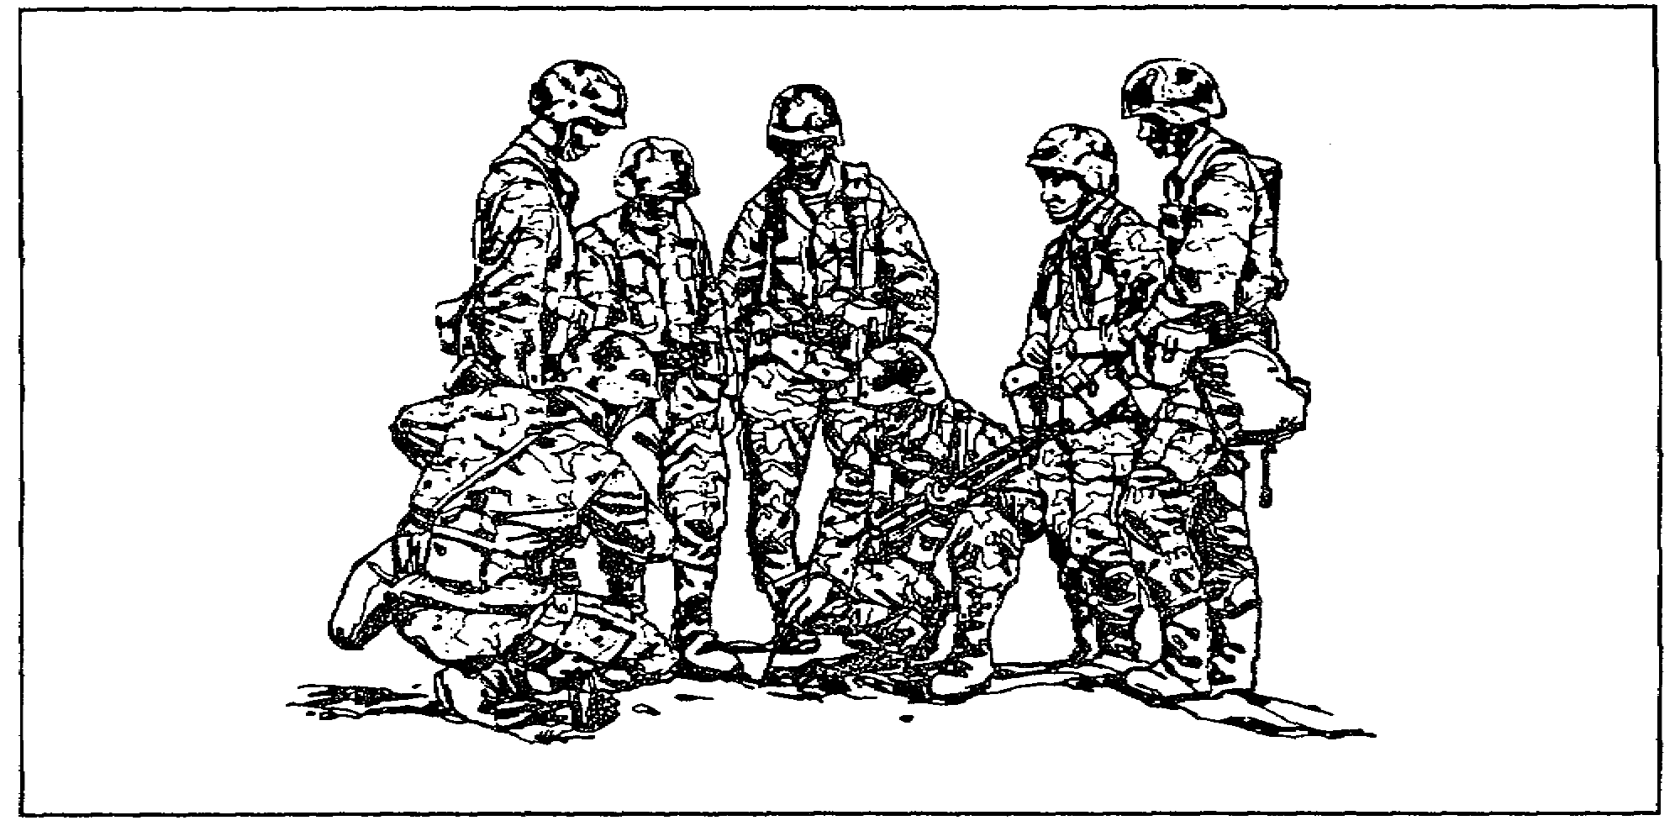

Figure 5-1. Face to face coordination

(6) Your signal plan should be as thorough as time and the situation allows. The estimate of the situation is the first step of your planning. The plan for signal support is based on and is an amplification of paragraph 5 of the estimate. After you have completed your estimate and made a decision as to how you will render the support, you can develop a detailed signal plan.

c. Generally, you must consider everything that can possibly have a bearing on your plan, to include the ever-present Murphy's Law. The TF commander's requirements must be anticipated if signal facilities are to be installed and operated when and where required. To maintain flexible and reliable communications, signal planning must be extensive and continuous. Basic signal doctrine and unit training habits lean toward fixed patterns for the installation and operation of signal systems. In tactical operations where the situation is dynamic, communications support requirements must be flexible and change accordingly.

(1) To plan property, you must know:

(a) The commander's special desires (requirements).

(b) The type of operation, the units involved, and the support requirements.

5-3 SS0120

(c) The physical characteristics of the area of operation and the probable weather conditions.

(d) Signal doctrine for the various echelons of command, and for varying tactical situations, to include electronic warfare (EW) tactics of defense.

(e) The availability, characteristics, capabilities, and limitations of signal units, personnel, and equipment.

(f) How to prepare plans and orders.

(g) Proper maintenance requirements and logistics support.

(2) You must also:

(a) Sustain close staff coordination with the S3 and other staff members.

(b) Plan a complete communications system, considering already-installed communications.

(c) Never rely solely on a single method of communications; have an alternate route or plan, and keep something in reserve (plan redundancy).

(d) Make full use of the unit SOP and signal operation instructions (SOI).

(e) Consider electromagnetic interference and plan accordingly.

(f) Plan for electronic countermeasures (ECM) and electronic counter-countermeasures (ECCM).

(g) Consider your signal security program and revise where necessary.

(h) Have a signal deception plan ready for implementation.

(i) Remember that time and execution are the keys to success.

2. Signal Responsibility. All levels of command must gain and maintain communications with the appropriate headquarters (HQ) and personnel during operations. A properly established communications system provides the commander with parallel means of communication for efficient command and control of his unit. The system provides the commander with the capability to control the actions of his units; to coordinate supporting fires; to receive and transmit orders and information; to maintain contact with higher, subordinate, attached, supporting, and adjacent units; and to coordinate combat support and

SS0120 5-4

combat service support matter. The following rules govern establishing and maintaining communication between units.

a. The higher unit is responsible for establishing and maintaining communications with subordinate elements, including attached and operational control (OPCON) units.

b. A supporting unit is responsible for establishing and maintaining communications with the supported unit.

c. Communications between adjacent units is established and maintained as directed. In the absence of specific instructions, the commander of the unit on the left establishes and maintains communications with the unit on his right. Lateral radio communications between battalions within a brigade is habitual.

d. Although one unit is specifically charged with establishing communications with another unit, all affected units attempt to regain lost communications immediately. The unit that was initially responsible for establishing communications retains that responsibility.

3. Signal Support Means. There are five means of signal support available to forces in AirLand Operations, but a TF will not necessarily use all of these means to the extent found in higher level units. The five categories of signal support means are radio, wire and cable, visual and sound, automation, and manual.

a. Radio support means.

(1) Radio nets particular to heavy and light battalion TFs were covered in Lesson 2. The TF uses the single-channel frequency modulated (FM) radio nets operating in the 30-300 MHz very high frequency (VHF) range as the primary means of communication. It is a fast means which allows the commander to command and control his subordinate unit as well as determine what is occurring on the battlefield. The commander's VHF FM voice net enables him to talk directly to his subordinates, his senior commander, air support, etc. In other words, the advantages of operating the radio are extensive. In the same vein, the disadvantages are just as real. The command net is subject to jamming, interception, direction finding and deception. Table 5-1, page 5-6, is a layout of the radio support means.

(2) Radio Nets. Lesson 2 discussed the battalion TF radio and wire communication systems. You may recall that the primary battalion communications nets include the command net, the operations and intelligence (O&I) net, and the administrative/logistics net.

5-5 SS0120

Table 5-1. Radio support means

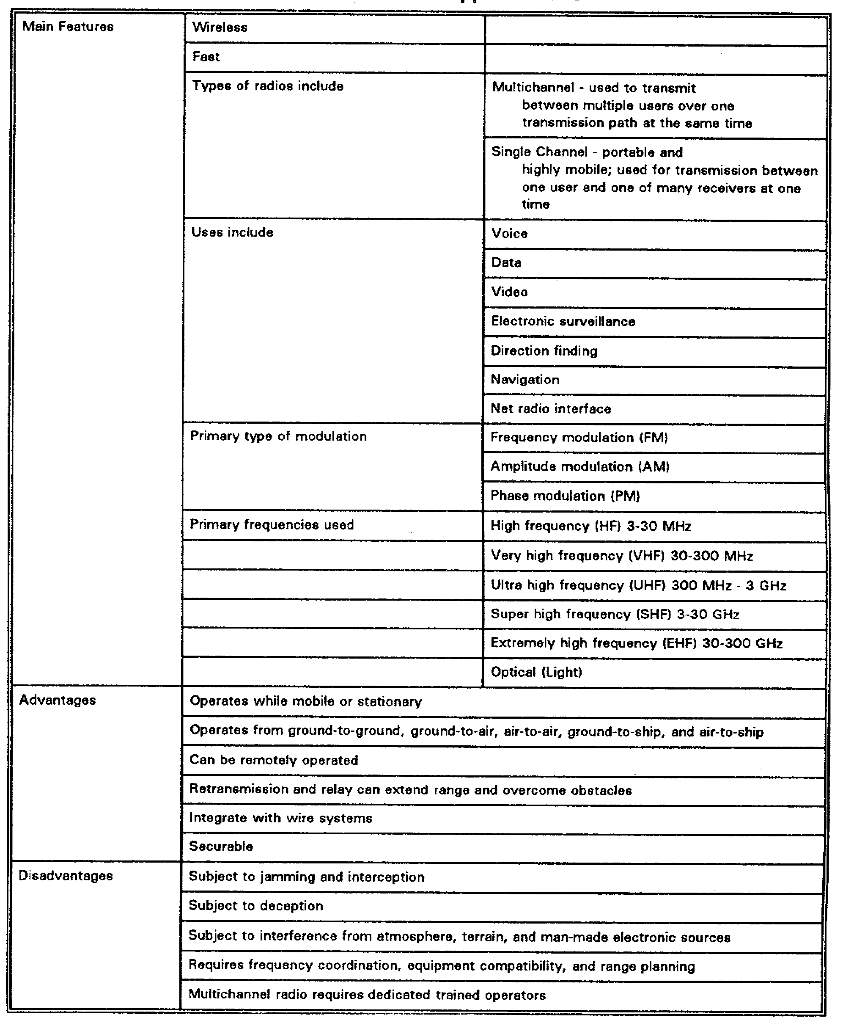

SS0120 5-6

(a) The command net (Figure 5-2) is a secure net used for command and control of the TF. All organic and attached units, including the fire support officer, and leaders of supporting elements, enter the TF command net. During the execution of the mission, only commanders transmit; all others monitor and transmit only essential information. The command net is controlled by the TF main CP.

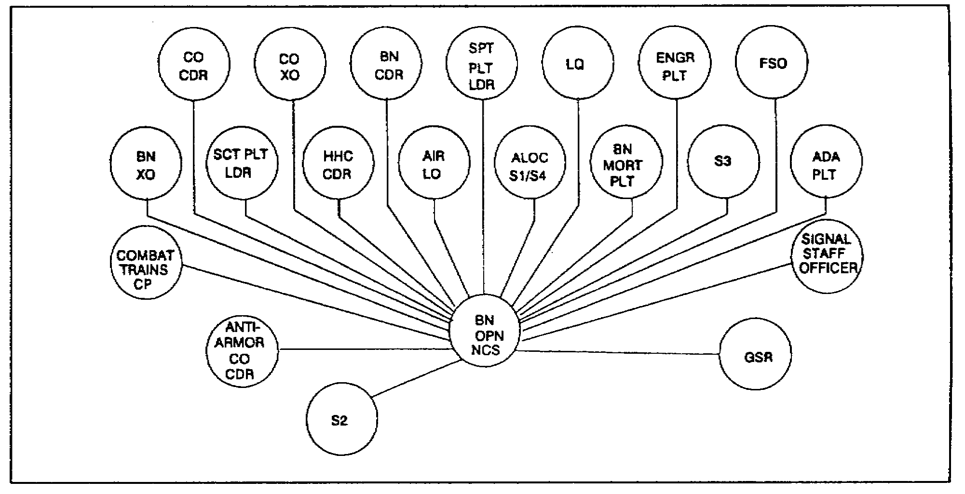

Figure 5-2. Battalion task force command net

(b) The O&I net is a secure net (Figure 5-3). The battalion TF uses the O&I net to accept routine items of information concerning operations and intelligence reporting.

(c) The administrative/logistics net is a tactical net controlled by the combat trains. Figure 5-4, page 5-8, depicts the net used to communicate the administrative and logistical requirements of the TF. All organic and attached units normally operate in this net.
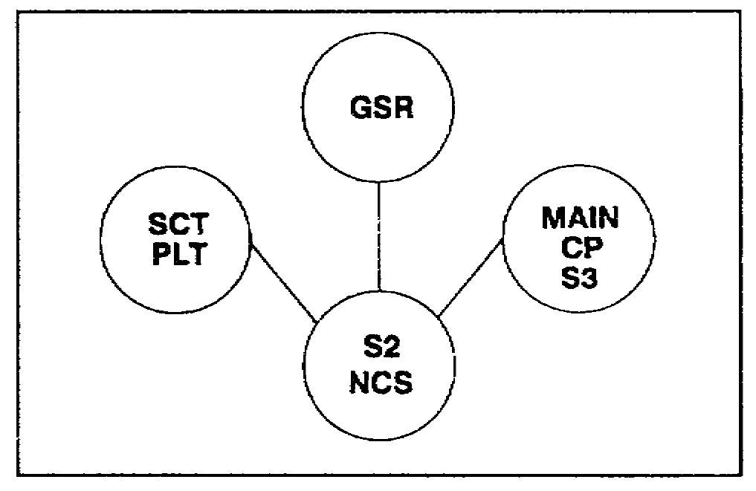

Figure 5-3. Battalion task force O&I net

5-7 SS0120

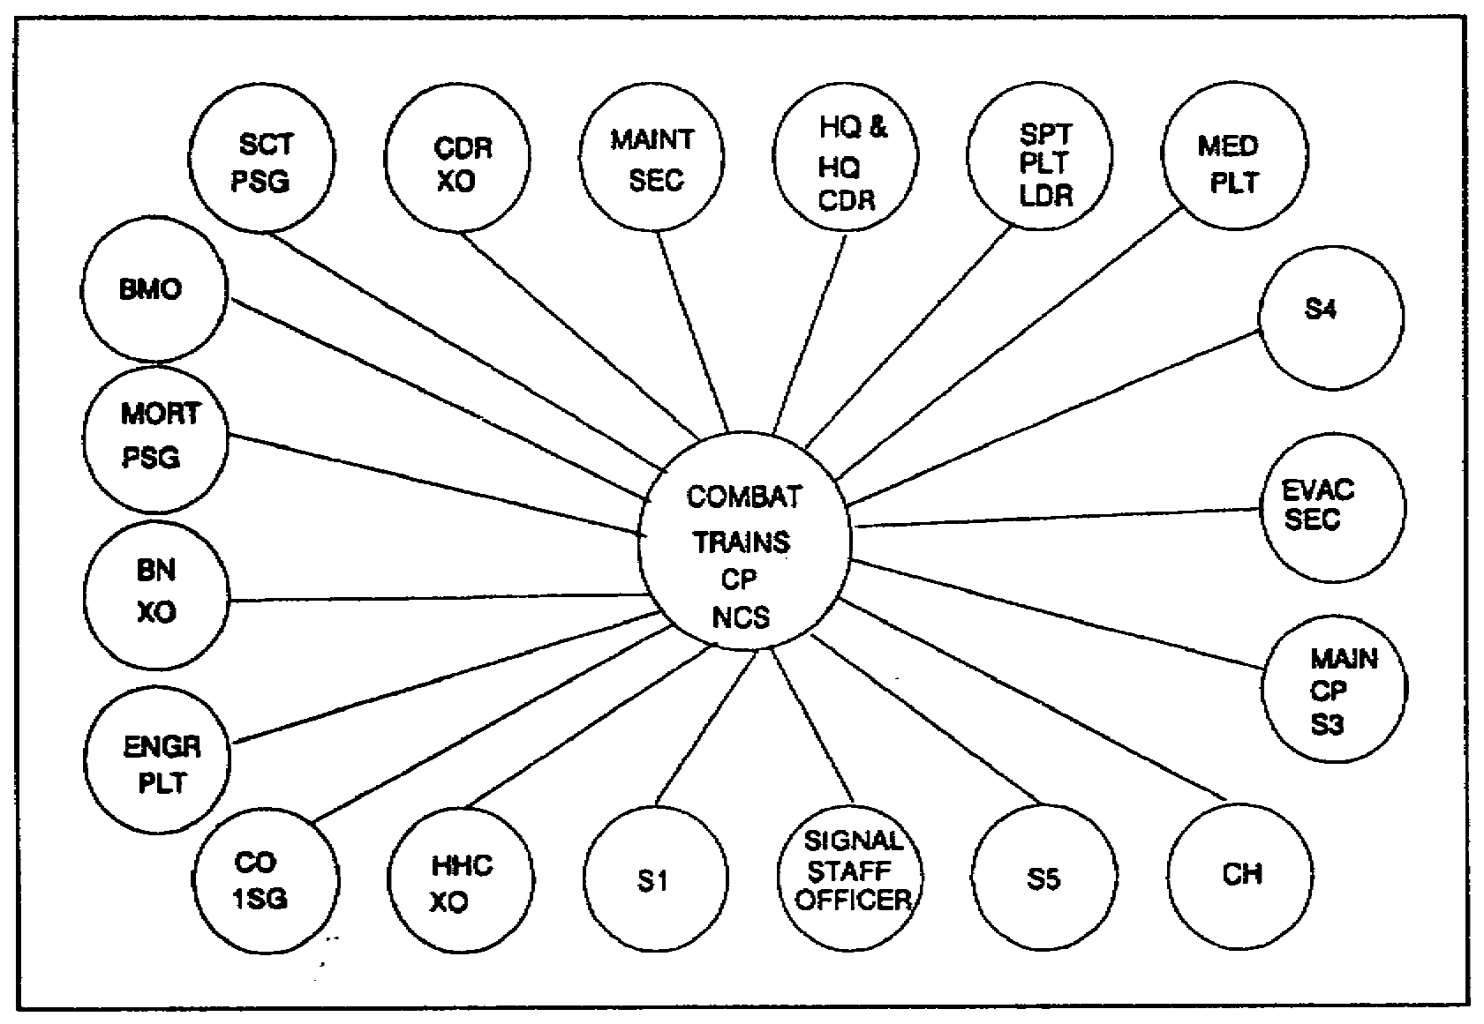

Figure 5-4. Battalion task force administrative/logistics net

b. Wire and cable support means.

(1) The wire and cable support means are listed in Table 5-2. The wire most often found in and around TFs is WD-1 or single pair wire. The TF uses wire as the primary means of communication when it is in a defensive posture. However, armored units do not employ wire as extensively as do infantry units, even in the defense. Therefore, when the heavy-light TF has an armored HQ, less wire will likely be used than if the heavy-light TF had a mechanized infantry HQ.

(2) The use of wire provides a more secure means of communications between units than radio, thereby reducing the probability of being intercepted by an enemy force. When using wire in and around tracked and wheeled vehicles, extra care must be taken to protect the wire from being damaged or destroyed by vehicles. In addition, the laying and retrieval of wire takes manpower and time.

c. Visual and sound support means.

(1) Visual and sound signals may be included in the SOI. Visual and sound signals not included in the SOI may be established for use within the battalion provided they are understood by all.

SS0120 5-8

Table 5-2. Wire and cable support means

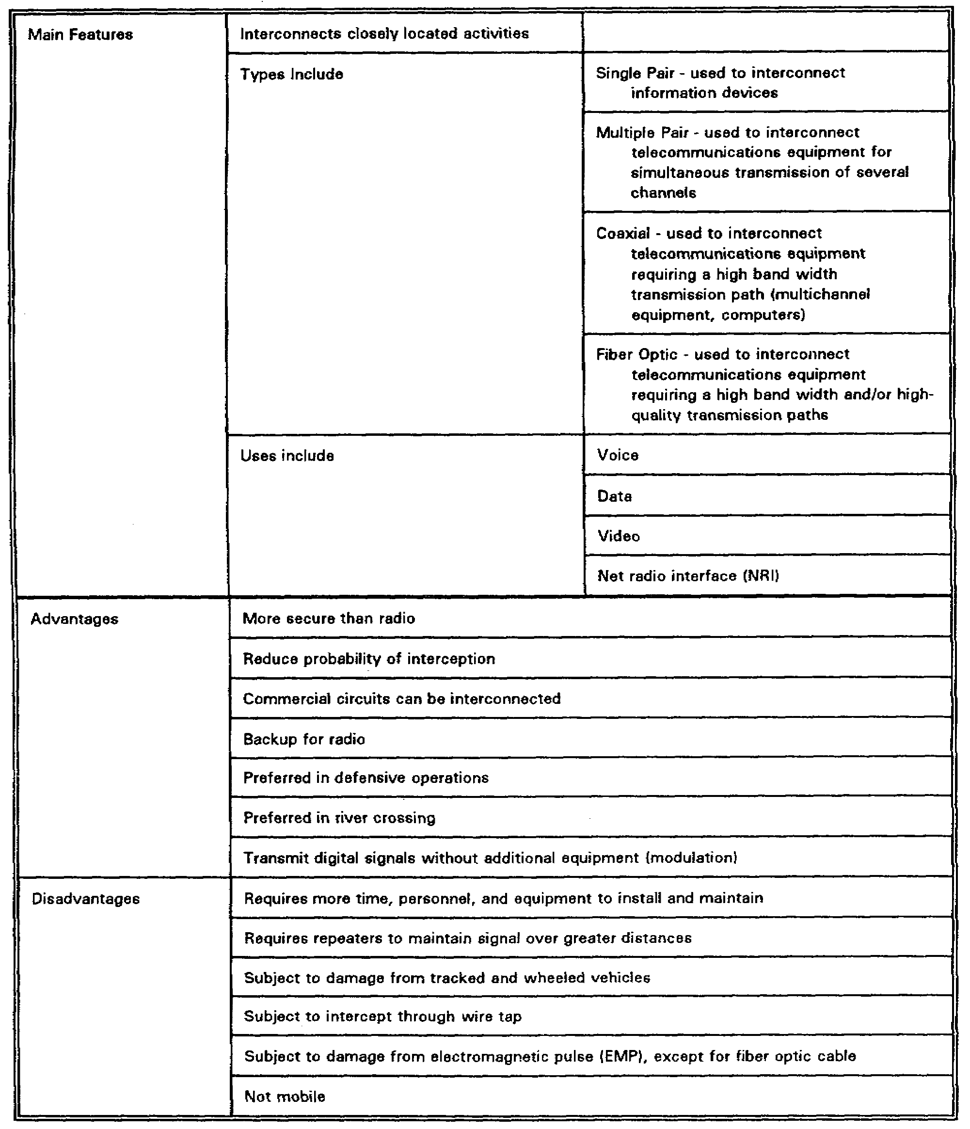

5-9 SS0120

(2) Visual communications include pyrotechnics such as flares and smoke grenades, flags, hand-and-arm signals, and light signals. Visual signals may be SOP or prearranged. They can be as simple as signals for parking a vehicle or as complex as sending extended messages by Morse Code or some other code using a flashlight or vehicle headlights. Sound communications include the use of voice commands, whistles, horns, and banging metal on metal.

(3) Because panels, flags and other visual markers are easily recognizable, you will find them extensively used in heavy units for identification. Extensive use is made of chemlights on vehicles and personnel for identification and navigation during periods of limited visibility.

(4) The disadvantage of visual and sound communications is that during battle, pyrotechnics, panels, flags and hand-and-arm signals all become obscured. Pyrotechnics can easily be used by enemy forces in efforts to deceive friendly forces. The ability to hear sound devices is reduced or impossible during battle. Table 5-3 lists the visual and sound support means.

Table 5-3. Visual and sound support means

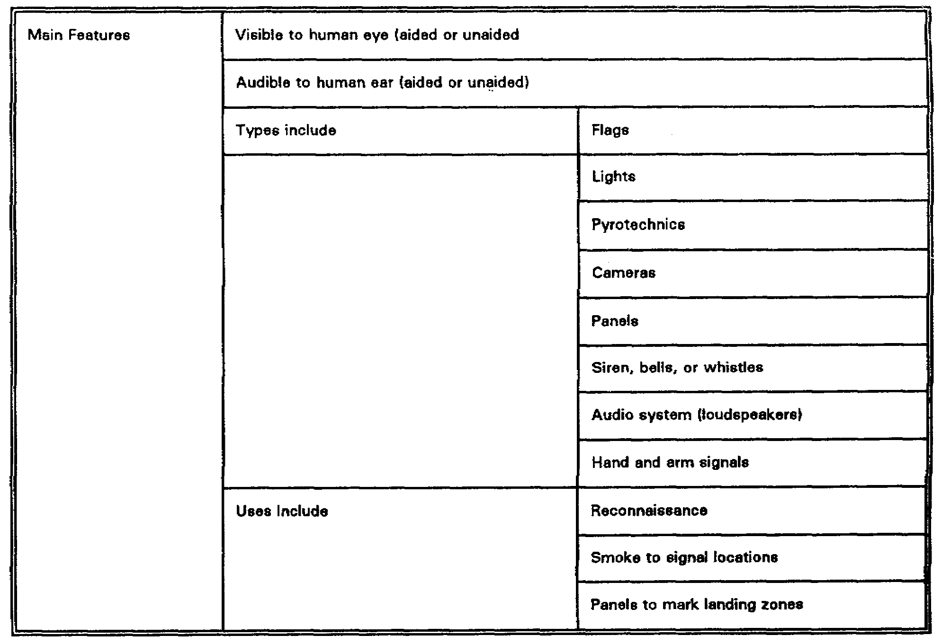

SS0120 5-10

Table 5-3. Visual and sound support means (continued)

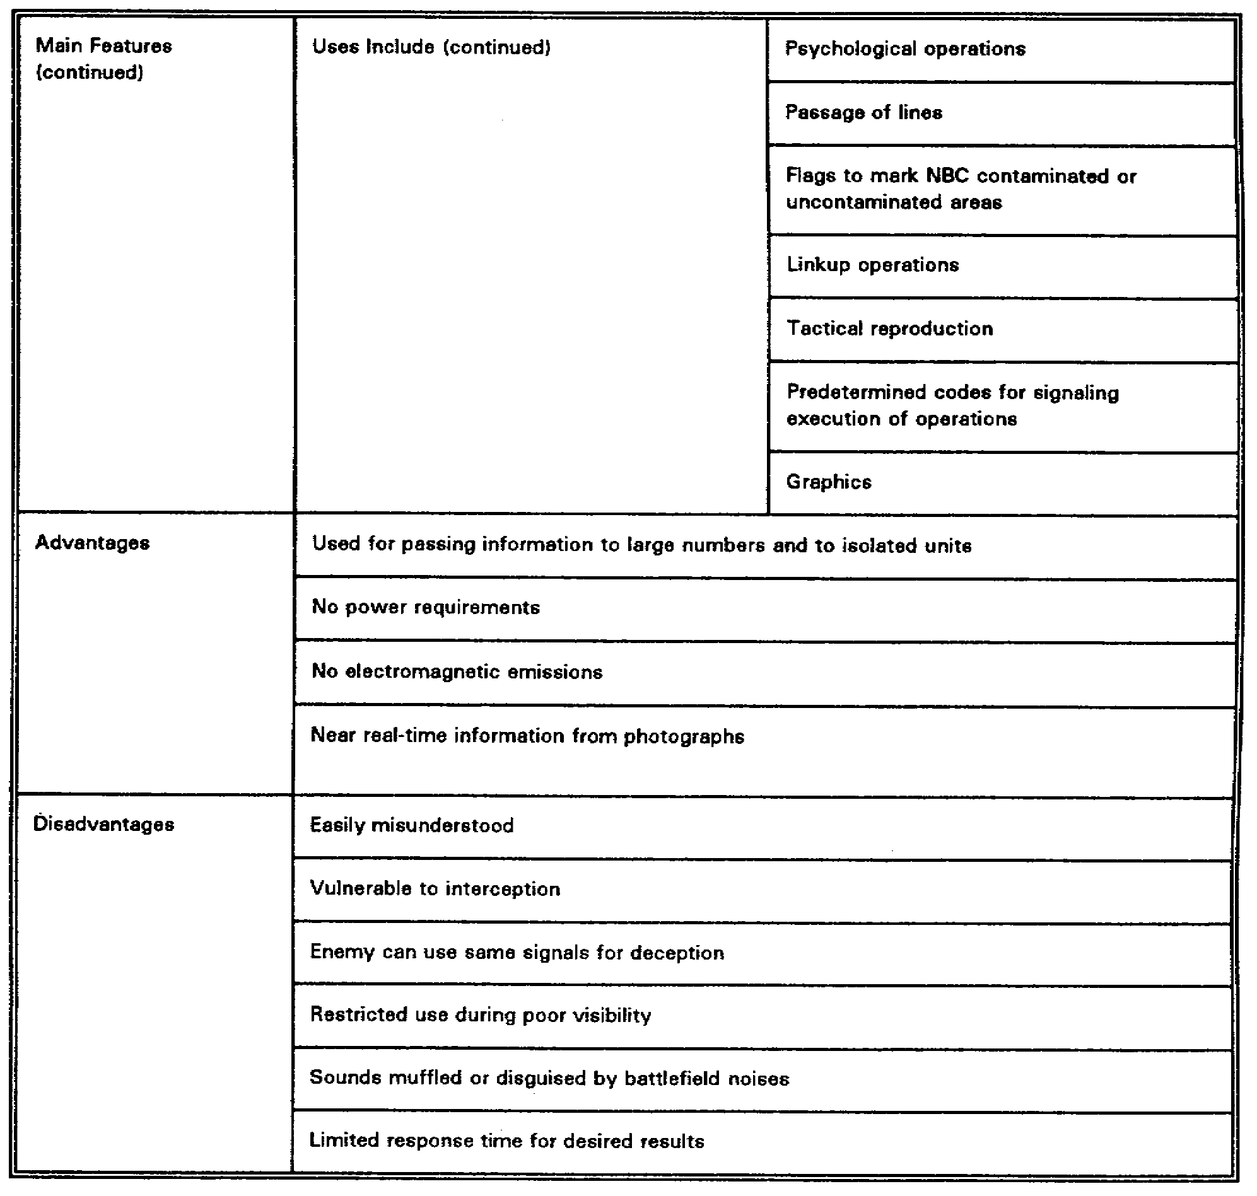

d. Automation support means. The heavy-light and light-heavy TFs are equipped with a limited amount of automation equipment. Battalions have or will have the Tactical Army CSS Computer System (TACCS). The TACCS is used in many light infantry battalions to process personnel Standard Installation/Division Personnel System (SIDPERS) data input. This system is maintained in the battalion field trains and is connected via electronic data link, or through the exchange of disk media, to the brigade S1 and the AG company. The system is instrumental in the automated maintenance of an S1 battle roster system. This

5-11 SS0120

roster allows the rapid collection of personnel data for casualty reporting, strength accounting, manifesting, and replacement operations. Table 5-4 lists the automation support means.

Table 5-4. Automation support means

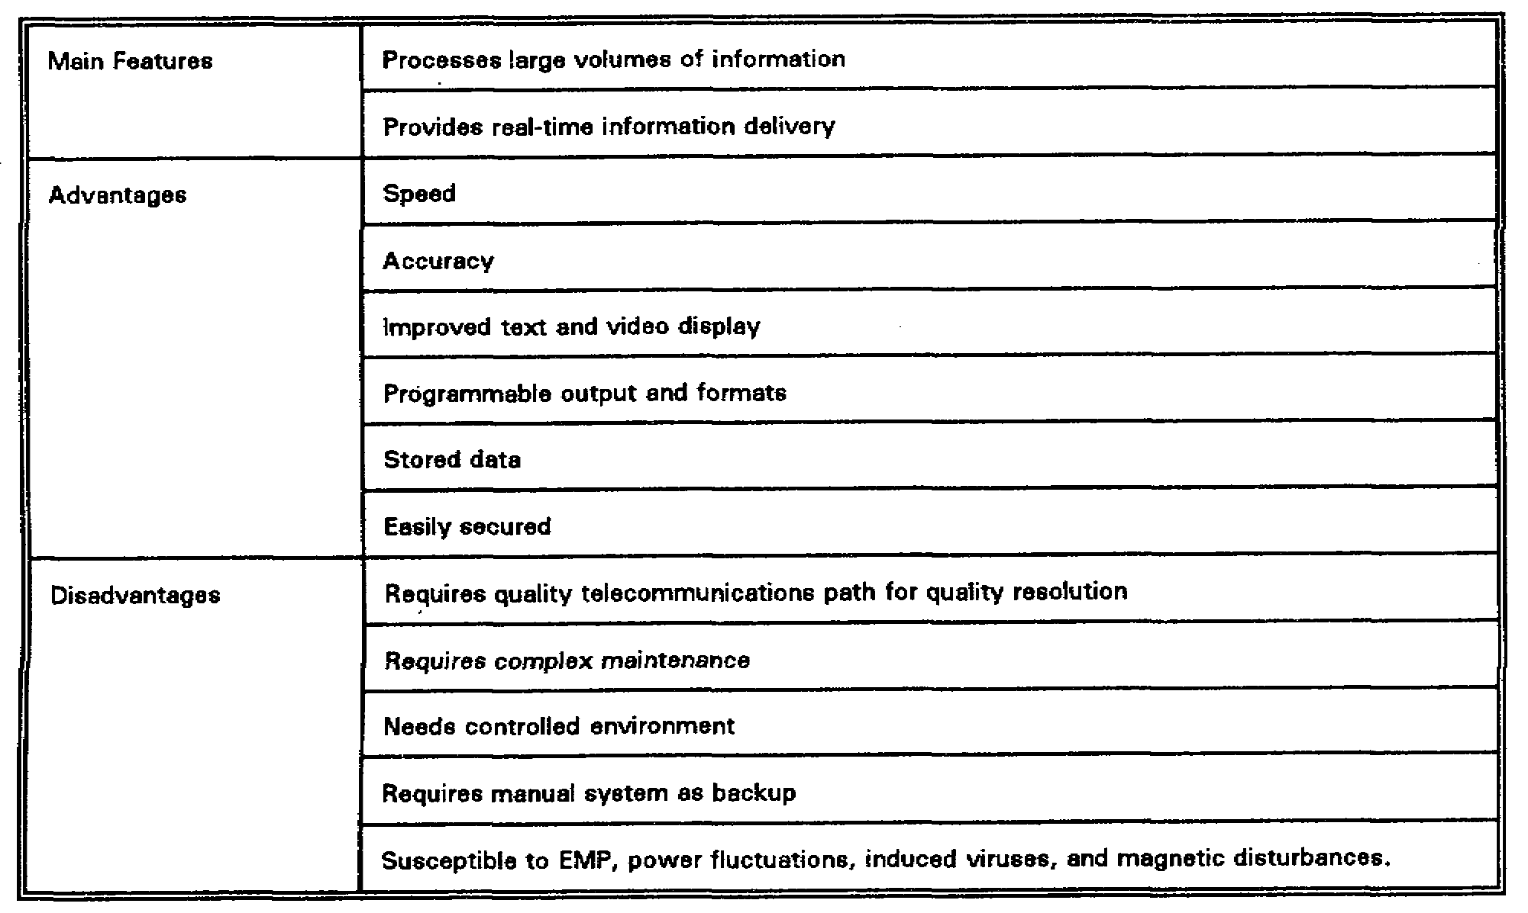

e. Manual support means. The main features of the manual support means are all apparent in a TF. Messenger assets are available in all units. Messengers are reliable, in that a commander can pass orders, maps, graphics etc., knowing the messenger will, in all probability, get through. Messengers can, however, only go so fast and carry so much, and are subject to enemy intervention, weather, terrain, and time constraints. For every messenger used, there is one less individual to operate equipment, or to fight the battle. Table 5-5 lists the manual support means.

4. TF Communications Support System.

a. The battalion signal officer.

(1) The battalion signal officer is the key individual for implementing the signal system in battalion. The signal officer is responsible to the battalion commander for signal

SS0120 5-12

Table 5-5. Manual support means

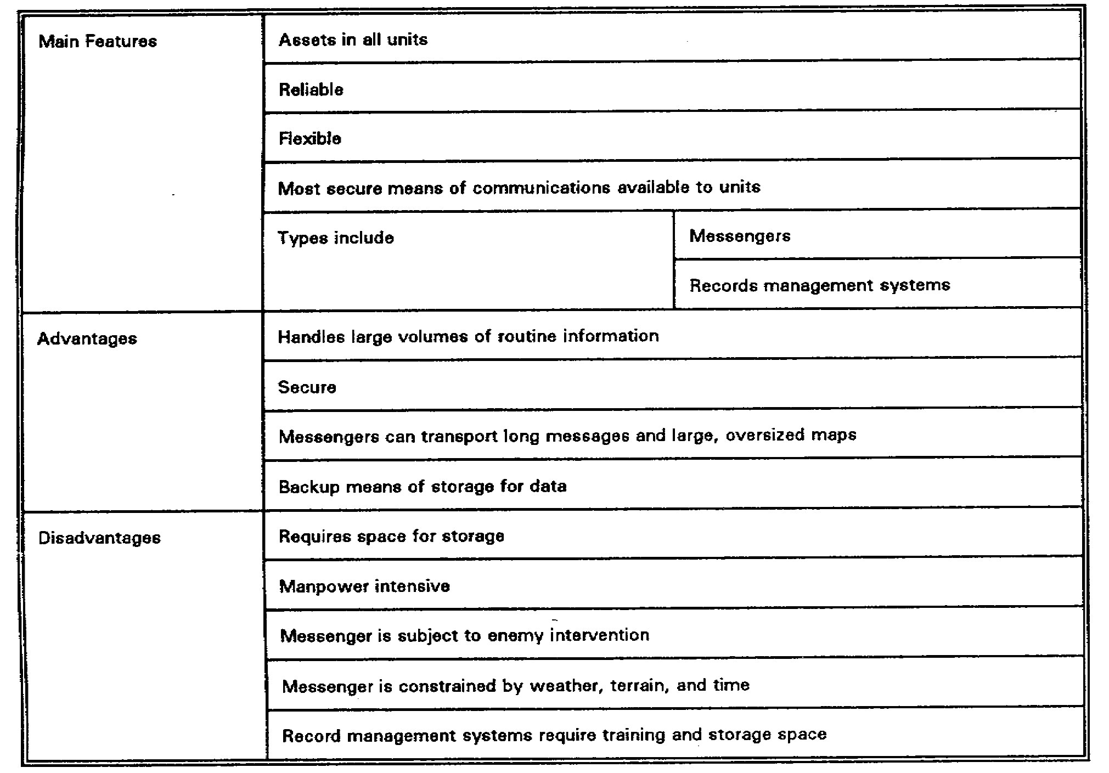

matters throughout the battalion, although his specific duties are assigned by the battalion operations officer (S3). The signal office's duties include:

(a) Reconnoitering possible sites for the battalion main, combat trains, and field train command posts (CP).

(b) Maintaining operational control of the battalion's organic communications platoon.

(c) Supervising the organizational maintenance of unit signal equipment and monitoring the status of unit and subordinate unit signal equipment in support maintenance.

(d) Recommending retransmission equipment employment.

(e) Establishing messenger services and schedules.

5-13 SS0120

(f) Monitoring communications security (COMSEC).

(g) Preparing the signal annex to unit plans and orders.

(2) When the scheme of maneuver has been developed by the TF commander, the signal officer makes a map reconnaissance and a ground reconnaissance (if possible) to determine any special communications requirements (Figure 5-5). Wire routes are planned when wire is to be used. The signal officer also looks for a suitable location for the battalion tactical operations center (TOC).

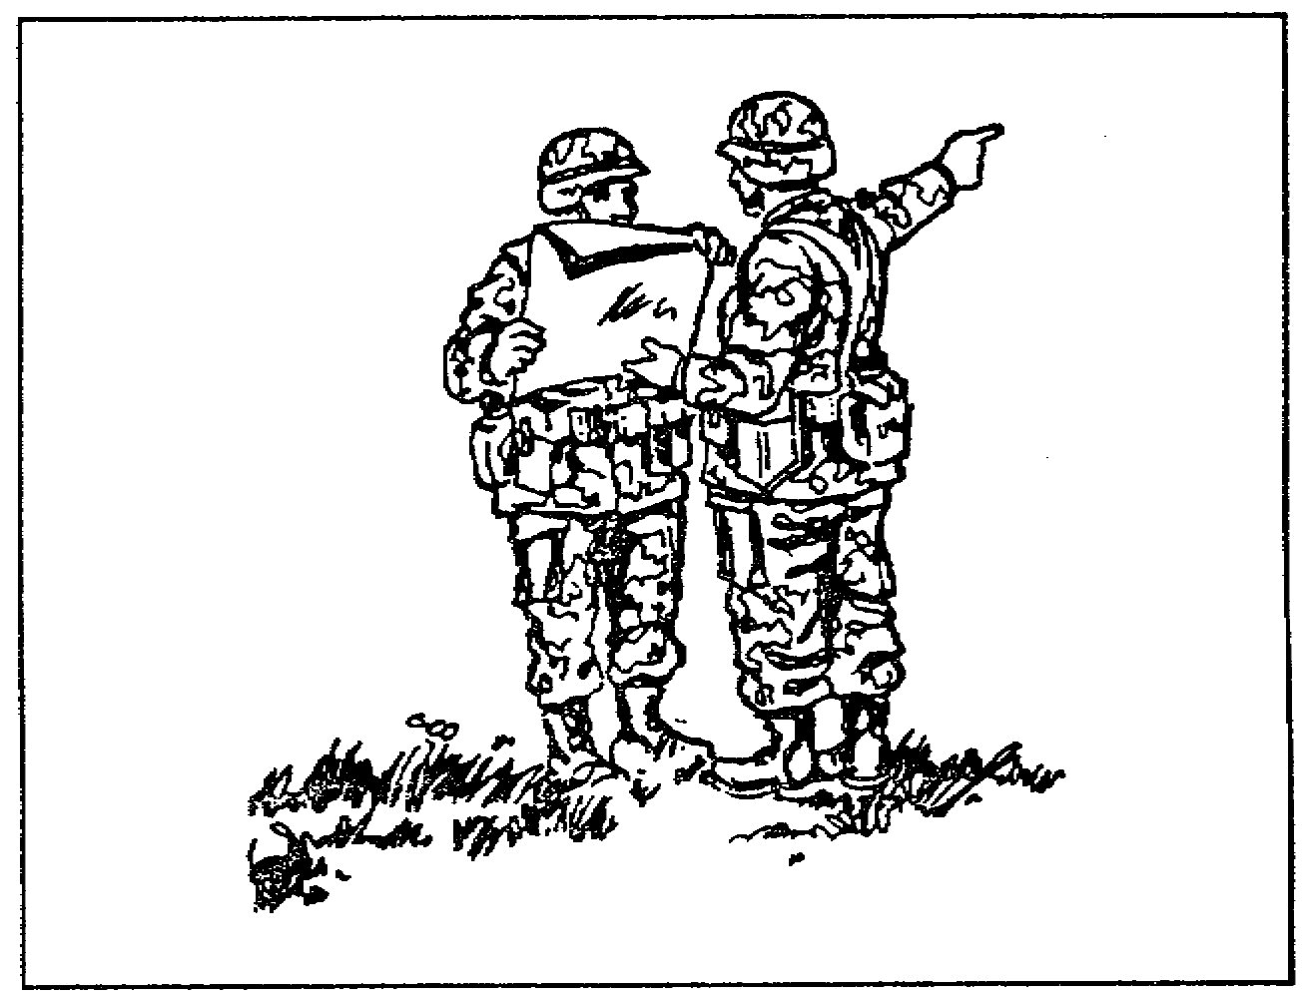

Figure 5-5. Map reconnaissance

(3) The signal officer has additional tasks when associated with the Battlefield Electronic Communications and Operating Instruction System (BECS) and frequency hopping (FP) systems of the Single-Channel Ground and Airborne Radio System (SINCGARS). The signal officer's responsibility as a communications manager has increased importance with the fielding of new automated systems. FH radios present challenges in operator preparation. The BECS computer gives the signal officer an automated system for real-time SOI data and network management. As the primary BECS operator, the signal officer determines network structures in coordination with the unit S3; coordinates with higher and adjacent HQ for SOI and FH variables when the unit must operate outside normal channels; and develops distribution schemes for users in the unit networks.

b. The battalion communications platoon is responsible for establishing and operating the battalion radio and wire communication systems. In addition, the platoon provides couriers

SS0120 5-14

to supplement the battalion liaison officers. Figure 5-6 depicts the structure of the platoons found in the light and heavy battalions, respectively.

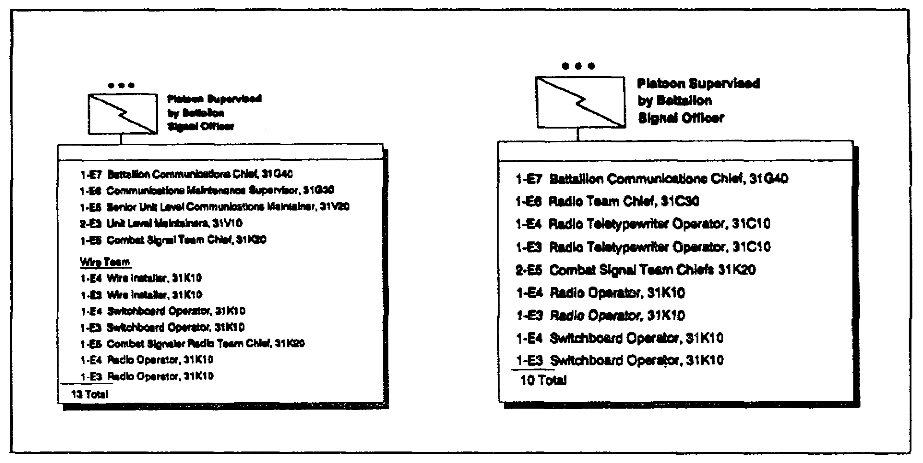

Figure 5-6. Light and heavy battalion communications platoons

(1) The communications platoon has the capability to:

(a) Install, operate, and maintain internal battalion wire and telephone systems connecting the battalion TOC to each company CP. A reduction in strength reduces the platoon's ability to do this task.

(b) Install and operate a station in the brigade radio teletypewriter (RATT) net and provide a retransmission station.

(c) Provide a consolidation point for all battalion signal equipment evacuated to direct support maintenance.

(d) Account for, store, and distribute SOI material within the battalion HQ and to subordinate units.

(e) Provide all subordinate units with assistance and training on installing, using, and performing unit-level maintenance on signal equipment, plus assistance and training on ECCM.

5-15 SS0120

(2) Functions which the communications platoon performs include:

(a) Unit level maintainers of the light battalion perform organizational maintenance on signal equipment organic to the battalion HQ company. They also provide some backup organizational maintenance for subordinate companies. Signal equipment in need of repair from battalion elements is evacuated through the communications platoon.

(b) The message center functions as the battalion communication center. It includes all message-handling facilities. When possible, messengers are used between the TOC, trains, higher HQ, and companies. Although slower than other means of communication, messengers are the most reliable, especially in sending maps, overlays, and lengthy or detailed information.

(c) The wire section of the light battalion installs the wire system of the battalion. This system includes lines to the commander, staff, elements of the HQ company, subordinate companies, and attached units. Wire is normally used for internal communication in the CP area. It is the primary means of communication within the battalion whenever the situation permits.

(d) The communications platoon operates a station in the battalion administrative/logistics net as required, and provides a radio operator to assist the S3 in operating the battalion command net control station (NCS).

PART B - COMMUNICATIONS OPERATIONS IN SUPPORT OF TF OPERATIONS

1. Overview. The types of missions and operations to consider in your planning as the signal officer depends upon the type of mission and the commander's intent in accomplishing that mission. Tables 5-6 and 5-7, pages 5-17 and 5-18, illustrate the tasks that are performed by light battalions in support of heavy missions, and heavy tasks in support of light missions, respectively. Notice in Table 5-6 that during heavy-oriented missions such as attack, the light force is given the tasks that exploit their strength, such as infiltration at night. In the defense, the heavy unit conducts the main defense, while the light force conducts tasks that strengthen the defense, such as conducting ambushes. In the reverse role, as shown in Table 5-7, page 5-18, where the heavy unit supports the light unit in a defensive mission, the light unit conducts the defense and the heavy unit exploits its strengths by being assigned the tasks to counterattack, etc. When preparing for combat operations, messengers, visual signals, or wire are used to avoid detection by enemy direction-finding equipment. Prior to contact with the enemy, significant increases or decrease in radio traffic may compromise security. When radio is used, transmissions are kept short and secure means or operational numerical codes are used. Low-power transmissions, directional antennas, and the use of terrain to mask signals from enemy direction-finding equipment minimizes the risk of detection. Messengers and wire should be used for sending large volumes of information.

SS0120 5-16

Table 5-6. Heavy missions with light tanks

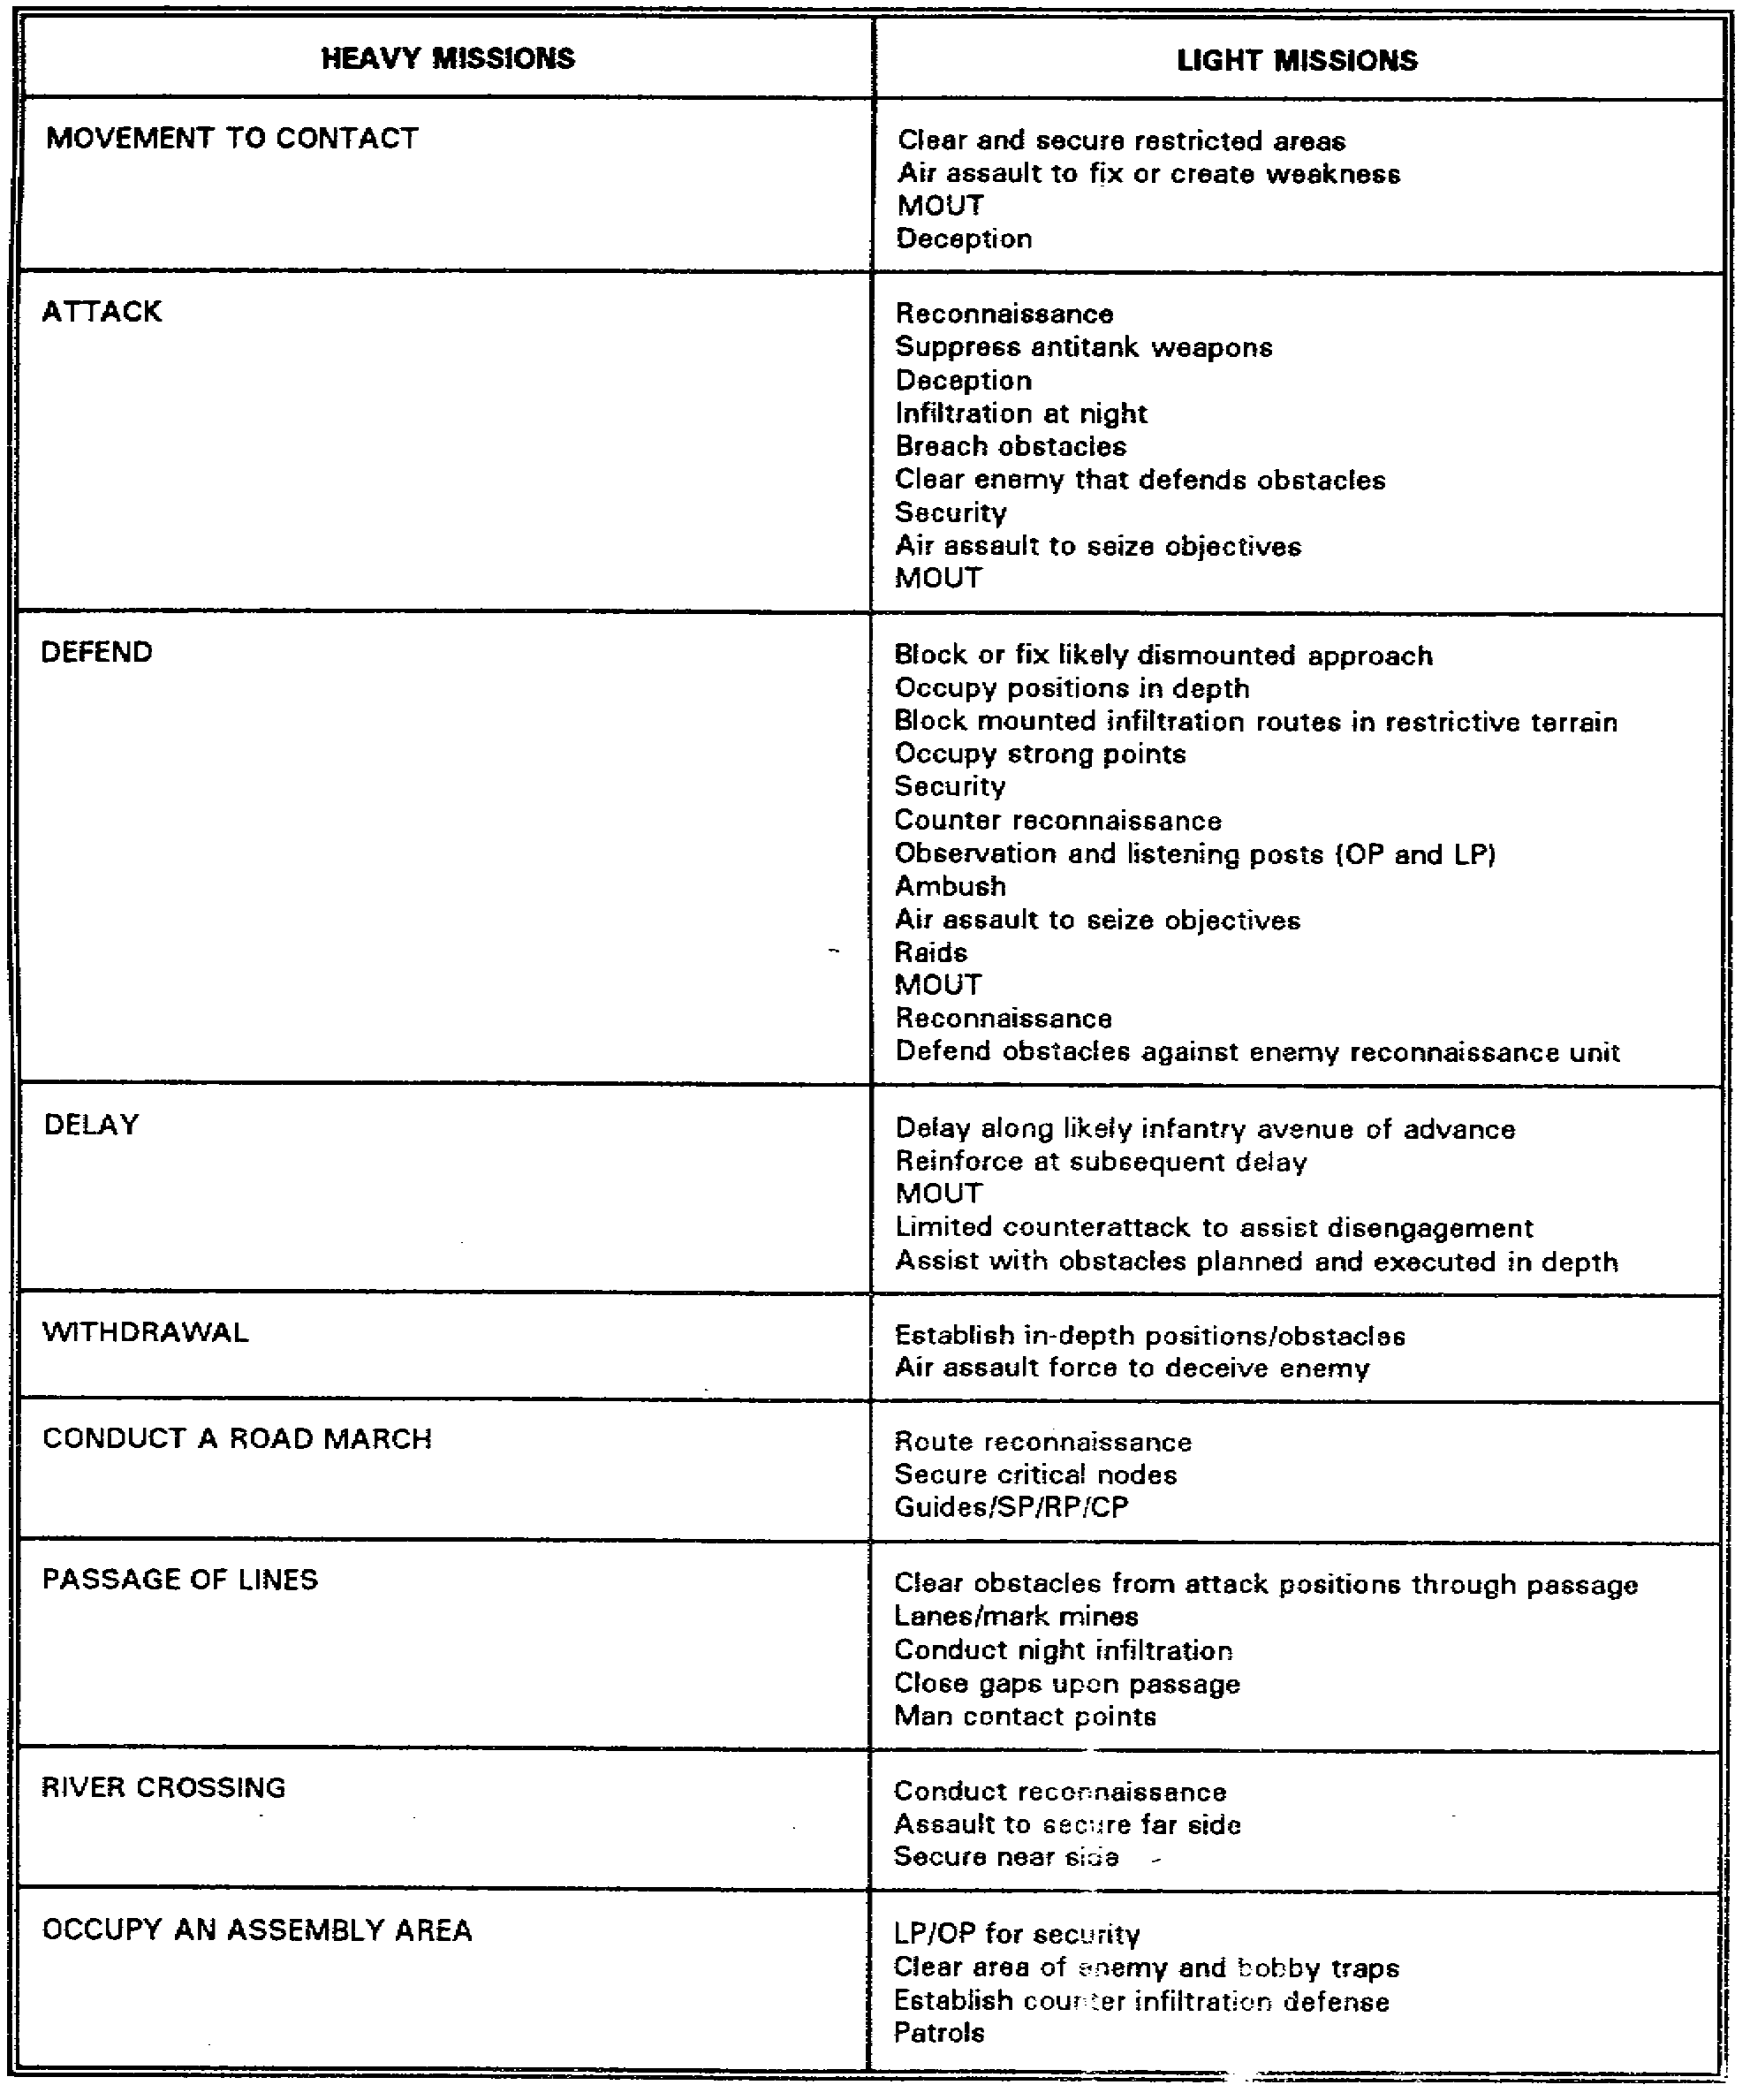

5-17 SS0120

Table 5-7. Light missions with heavy tasks

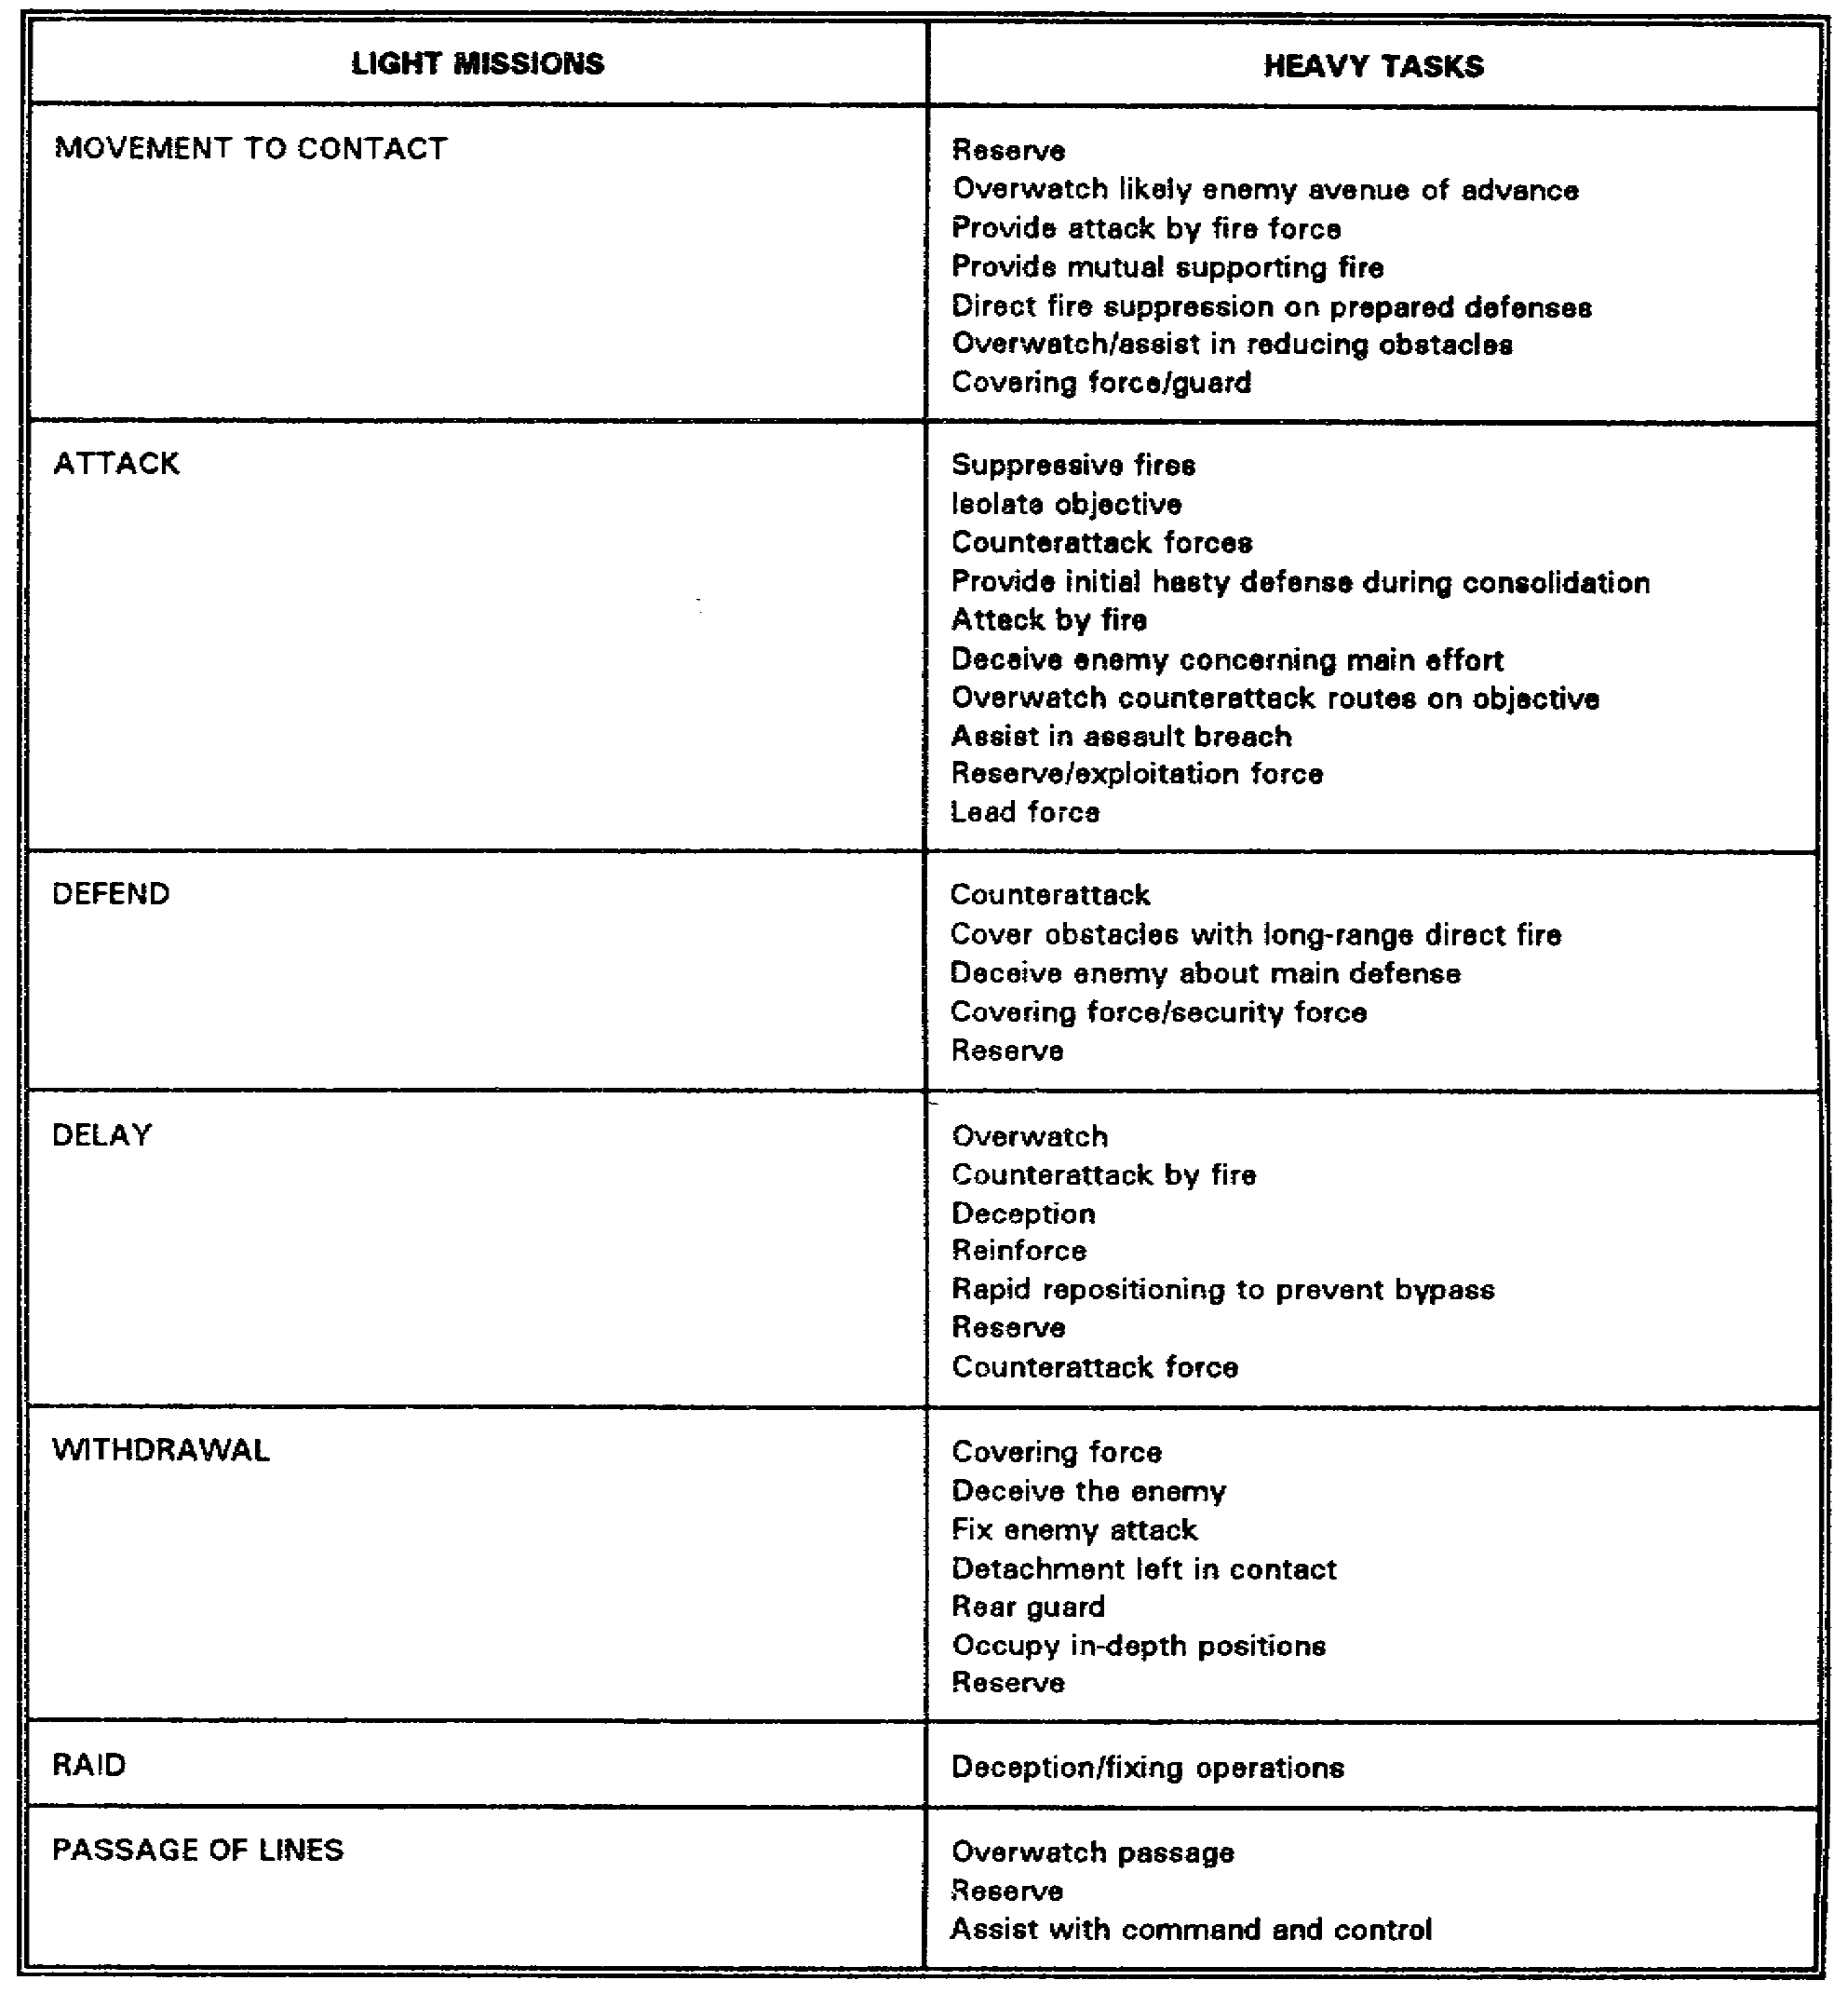

SS0120 5-18

2. Retransmission Operations.

a. When dismounted, as the light infantry is designed to fight, the capability for radio operating distance between and among mixed forces is greatly reduced. In heavy-light operations during training exercise REFORGER 88, it was found that the planning for and use of retransmission equipment was essential to maintain communications between light and heavy forces. The heavy-light force in REFORGER 88 discovered that the heavy force commander could talk to the light force commander, but the light force could not respond because its communications equipment did not have the same range as the radios of the heavy force.

b. Commanders who constantly fight mounted may tend to outrun, especially in the offense, their capability to communicate with the dismounted infantry. The signal officer must plan to support the TF commander's intent by selecting suitable signal retransmission sites. The signal officer must also keep the commander and the S3 informed about the need to move into or relocate retransmission operations.

3. Wire Operations.

a. Wire is seldom used during offensive operations and it cannot be used when conducting a movement to contact. Instead, messengers and visual signals should be used whenever possible. Wire can be installed only when the battalion is halted for extended periods, as in an assembly area.

b. Wire is installed as rapidly as possible during defensive operations. As a rule, the brigade communications platoon lays two or more wire lines from the brigade to the battalion TOC. The battalion communications platoon lays wire in the TOC and trains areas. Two or more lines over alternate routes are laid to subordinate units in accordance with priorities established by the battalion commander or the SOP.

c. Commercial lines may be used if permitted by the brigade HQ. If the battalion is forced to withdraw, wire lines (including commercial lines) are cut and sections removed to preclude their use by enemy forces. Once the defensive battle begins, new lines are laid as time allows. The battalion may be required to rely on radio, messenger, or visual signals.

4. Communications During the Offensive.

a. In the offense, we take the initiative and carry the fight to the enemy. We attack to destroy the enemy, or seize terrain, or both. The decision to go on the offensive must be carefully weighed, and the probability of winning must be very high. This means that we must have good intelligence to concentrate forces at the decisive time and place to defeat the enemy. During the offense, we must use the terrain and deny the enemy a lucrative target. We must suppress the firepower of his direct and indirect fire weapons. This is done with our weapons systems, as well as the use of EW against his communications and fire control systems.

5-19 SS0120

b. Communications for command and control have to be provided while on the battlefield during offensive operations. The commander must have responsive and reliable communications to take full advantage of mobility and to hit the enemy at his weakest point. To do this, the signal plan must be closely coordinated with the operations plan so it will directly support the mission.

(1) Quartering party. Before the main body leaves an assembly area, the march commander sends a reconnaissance party and a quartering party (or advance party) to the forward assembly area. The reconnaissance party and the quartering party do not travel as a part of the march column. They precede the main body and move by infiltration. The reconnaissance party, normally the scout platoon, checks the area for enemy units or observation post and for nuclear, biological, and chemical (NBC) contamination. The TF quartering party is normally composed of a security element, subordinate unit quartering parties, communications, medical personnel, and staff section representatives. The communicator notes the positions of the TOC, staff sections and subordinate units. This diagram or sketch will enable the communications platoon to establish wire nets, if applicable, or help position the signal center upon arrival.

(2) Communications during an attack. Signal centers are established by the signal unit supporting the major HQ of the attacking force. They provide the signal services signal centers should be located as far forward as possible. This will minimize the number of moves required as the battle progresses; however, these facilities must be capable of displacing as the need arises. COMSEC procedures are implemented and enforced. Messengers can be used to great advantage during the attack because of their inherent security and flexibility. Speed of communications, however, is important, and the critical nature of a message will determine if it is sent via messenger. Visual and sound communications can be employed during the attack to transmit prearranged messages in accordance with the current SOI. Secure radio is the primary means of communications during the attack. Prior to the attack, radio listening silence should be imposed to maintain surprise, however, once the attack is launched and the enemy has been engaged, this restriction can be removed. The use of the lowest possible power setting for our transmitters is stressed to prevent the enemy from locating us. When lead elements contact the enemy in the offense, the enemy knows where they are. In this situation, radios should be tuned to high power to ensure communications are maintained and that we will not get overpowered by the enemy's transmitters. During the attack, radio stations should maintain an even flow of traffic, so the enemy will not be alerted to new or imminent changes in attack plans. Wire communications in the attack are secondary to radio as a means of communications. The minimum essential circuits are installed first, and the system is expanded as rapidly as possible to satisfy requirements. The time available, the rapidly changing tactical situation, and the supply of wire and personnel on hand, will govern the extent that a wire system will be used.

(3) Communications during an envelopment. In the envelopment, we avoid the enemy's main defense and reach for objectives to his rear by way of his flanks. In the envelopment, we communicate over longer distances. The distances involved can greatly tax

SS0120 5-20

our communications equipment and may require additional repeaters in the communications system. Planning for this requirement should be done far in advance due to the rapidly changing situation. Because the need for speed and surprise is increased in an envelopment, radio listening silence will be required for a longer period of time. With this exception, communications are basically the same as in an attack.

5. Communications During the Defense.

a. Defensive positions are held until the next higher HQ approves a withdrawal or directs otherwise. Modern weapons give the defender sufficient combat power to inflict catastrophic losses on the attacker; losses so large that he cannot continue the offensive. The defender fights on ground that he has chosen-ground which is organized to maximize the effectiveness of his weapons and minimize their vulnerability to enemy weapons. To hamper enemy movement, natural barriers, strengthened with obstacles and mines, are used. Sufficient concentration of fire at the decisive time and place is employed to stop the enemy.

b. To be successful in the defense, as in any other operation, we must have reliable communications. Depending on the time available, we will normally find a more elaborate communications system in the defense. While holding specific terrain, primary communications will be wire. During fire and movement, primary emphasis will be placed on secure FM radio and messengers. When the defense is hastily adopted, the communications facilities that are available will be used. As time and the situation permit, these facilities can be changed and improved upon.

c. In the defense, our communications system interconnects all major command elements, and provides entry into the communications systems for covering forces, outposts, and reserves. They will not be required to displace as often as the offense, but at times they will displace, and personnel should be prepared to move on short notice. Messengers are effectively used in organizing and conducting defensive positions. They reduce the requirement for radio transmissions and provide a high degree of signal security. Visual signals can be used in the defense, as in other situations. This type of communication allows us to maintain radio silence, and provides security. In the defense, radio communications are not used as long as we have other communication means available. Radio nets can remain open, but on listening silence. Wire communications will be the primary means in the defense. High priority circuits should be established as quickly as possible to meet immediate requirements. More circuits can be installed, as needed, to meet requirements and increase communications traffic capacity and flexibility.

6. Communications During the Retrograde Movement.

a. A retrograde movement provides for organized movement of our force to the rear or away from the enemy. It may be voluntary, or caused by enemy action. Under either circumstance, it has to be approved by the corps or joint commander. The retrograde movement permits us to preserve our forces for use in another area, or to realign or shorten defensive lines. Retrograde operations include withdrawals and delaying actions. The

5-21 SS0120

retirement is a third type of retrograde operation which takes place when we are not in contact with the enemy. The withdrawal is a deliberate attempt to break contact and free units for new missions. Every effort is made to keep the enemy from knowing what we are doing, because the withdrawal, under pressure, is very difficult. A delaying action causes the attacker to deploy while exposed to fire, and then attempts to push the defender off his delay position. Generally, retrograde operations are a combination of the withdrawal and delaying action.

b. During preparation for a retrograde movement, our existing communications would continue their normal operations. At CP locations, which will soon be abandoned, new installations should be held to an absolute minimum, while maximum use is made of existing facilities. As we move and establish successive CP locations, we should establish the minimum essential communications for command and control, in anticipation of moving again.

c. The commander and his staff use special messengers during the rapidly changing situation. Messengers will be kept at the old CP location to ensure communications with forces left in contact with the enemy. Radio communications must be closely supervised and regulated during disengagement. For deception purposes, dummy stations are used to maintain the normal traffic level at old positions when a CP is moving. Listening silence will be enforced until a withdrawing unit reaches a designated position or has been committed in another location. Wire communications already in operation are used as much as possible in retrograde operations, and the installation of new wire lines is held to a minimum. Connecting wire to defensive or delay positions in the rear of the present positions may be necessary. As the retrograde action progresses, wire lines that are not required will be recovered. If recovery is not possible, the wire lines should be destroyed by removing random sections. March control points should be provided where necessary by tapping wire circuits that are toward the rear. When moving to the rear, wire routes will be selected with care to ensure dependable communications. Also, less maintenance time will be required if the routes are well selected. This means putting the wire where tracked vehicles cannot damage it. We must keep it away from roads, wherever possible. If it is necessary to cross a road or trail, the wire will be overheaded, buried, or run through culverts or under bridges.

d. Forces in contact with the enemy may be relieved to conserve fighting power, to bring a reserve unit into action, or to relieve a unit for another mission. During relief operations, congestion and confusion are always dangers. To avoid trouble, we must have detailed planning to reduce vulnerability and risk. Units involved in a relief operation should appear to be conducting normal activities. They should make maximum use of darkness and reduced visibility to avoid detection. Secrecy, deception, and speed of execution are necessary for a successful relief operation.

SS0120 5-22

7. Passage of Lines.

a. A passage of lines occurs when a moving unit passes through a stationary unit already deployed on an established line. As an example, an incoming unit attacks through a unit in contact with the enemy. The incoming unit is the passing unit, and the unit that remains in place is the passed unit. Passage of lines is one of the most difficult operations to accomplish on the battlefield. For a passage of lines to work correctly, the passed unit remains in position and supports the passing by all available means. This requires the utmost coordination and command and control. After the incoming unit engages the enemy, the other unit can be withdrawn or committed to some other action. A passage of lines must be done with the least amount of confusion and without enemy detection. To do this, communications must be carefully and closely coordinated. Communications for the unit passing through the line will be restricted as much as possible to avoid interference and confusion between the two units.

b. Messengers are used within and between the two units involved.

c. Visual signals should be limited to prearranged identification signals such as hand-and-arm signals, armbands, and panels. Care must be used with these because the enemy might also see them.

d. Radio silence and radio listening silence should be practiced to an absolute maximum to avoid enemy detection of our plans. For emergency use of radio, frequencies and call signs must be coordinated between the units involved to avoid confusion and interference. Multichannel radio communications of the unit conducting the passage should not be employed until the passage of lines is complete. The unit being passed through should maintain normal traffic during the passage.

e. Wire communications of the unit being passed should not be affected. The unit making the passage will use the existing circuits as much as possible.

8. Relief in Place. In this type of operation, the relieving unit takes over all responsibility for the combat mission and area of operations of the relieved unit. Execution of a relief in place is done while the unit being relieved is in the defense. It may be executed on a unit or area basis. During a relief in place, communications facilities of the relieved unit should remain in place until the relief is completed. Secrecy must be maintained to prevent enemy offensive action while we are vulnerable. Measures used for maintaining security are include the following:

a. Radio silence is one of the most important precautions, and provides the needed security to make the operation successful.

b. Only wire and messengers should be used for coordinating as the relieving unit moves up to the line and the relieved unit moves back.

5-23 SS0120

c. The relieving unit should take over the call signs, radio frequencies, codes, and ciphers of the unit relieved. The relief should take place at the time period for change of the day's SOI material to minimize the confusion of the changeover.

d. The relieving unit should take over the existing signal facilities to the extent possible, so the electronic signature of the unit does not change.

PART C - SUMMARY

1. In this lesson, you learned about signal support systems used in heavy-light and light-heavy TFs for both offensive and defensive operations. You also learned about planning considerations of the signal officer.

2. The signal officer has to thoroughly understand the who, what, when, and where of the supported unit and its mission. Signal support is planned as thoroughly as time and situation allow, basing the plan upon the signal officer's estimate. The signal officer is responsible for establishing and maintaining communications with subordinate, supported, and adjacent units.

3. The five means of signal support are radio, wire and cable, visual and sound, automation, and manual.

4. During the offense, secure radio is the primary means of communications and wire is a secondary means. Visual and sound are used to transmit prearranged messages.

5. During the defense, wire is the primary means although secure radio is used during movement. Messengers and visual signals are also used.

6. During a retrograde operation, secure radio and messenger are used during the transition. Dummy radio transmissions are used to deceive the enemy.

7. During a passage of lines, messengers are used between units, radio transmissions are restricted, and the passing unit does not use multichannel.

8. During a relief in place, the relieved unit leaves its signal systems in place until the relief is completed. Radio silence is employed as much as possible. The use of wire and messengers is maximized. Electronic signatures are kept the same so the enemy will not notice a change.

SS0120 5-24

LESSON 5

PRACTICE EXERCISE

The following items will test your grasp of the material covered in this lesson. There is only one correct answer for each item. When you complete the exercise, check your answer with the answer key that follows. If you answer any item incorrectly, study again that part of the lesson which contains the portion involved.

1. A supposing unit is responsible for establishing and maintaining communications with the supported unit.

A. True.
B. False.

2. Plans are as detailed as time permits. When working at the task force (TF) level in a constantly changing environment, the __________ is the basis for planning and preparation.

A. Fragmentary orders.
B. Troop leading procedures.
C. Rapid estimates of the situation.
D. Commander's guidance.

3. Which of the following is the primary means of communication when the TF is in a defensive posture?

A. Radio.
B. Wire and cable.
C. Visual and sound.
D. Automation.

4. Which of the following is not an advantage of using the radio?

A. Radio can be integrated with wire systems.
B. Securable.
C. Can be remotely operated.
D. Requires dedicated operators.

5-25 SS0120

5. Visual and sound signals may be included in the SOI.

A. True.
B. False.

6. The handling of large amounts of routine information is an advantages of the __________ means of signal support.

A. Radio.
B. Wire and Cable.
C. Automation.
D. Manual.

7. Which of the following is a secure net which is used to accept routine items of information concerning operations and intelligence reporting?

A. Administrative/logistics net.
B. Command net.
C. Operations & intelligence net.
D. Fire support net.

8. When dismounted, as the light infantry is designed to fight, the capability for radio operating distance between and among mixed forces is increased.

A. True.
B. False.

9. The infantry battalion may use commercial lines if permitted by the brigade HQ.

A. True.
B. False.

SS0120 5-26

LESSON S

PRACTICE EXERCISE

ANSWER KEY AND FEEDBACK

Item Correct Answer and Feedback

1. A. True.

A supporting unit is responsible for establishing and maintaining communications with the supported unit. (page 5-5, para 2b)

2. B. Troop leading procedures.

When the TF has limited time to plan and prepare, troop leading procedures are the basis for planning and preparation. (page 5-2, para 1b(5))

3. B. Wire and cable.

The TF uses wire as the primary means of communications when it is in a defensive posture. (page 5-8, para 3b(1))

4. D. Requires dedicated operators.

The requirement for a dedicated operator is a disadvantage of using radio.
(page 5-6, Table 5-1)

5-27 SS0120

5. B. False.

Visual and sound signals may be included in the SOI. Visual and sound signals not included in the SOI may be established for use within the battalion provided they are understood by all. (page 5-10, para 4c(1))

6. D. Manual.

The handling of large amounts of routine information is one of the advantages of the manual means of signal support. (page 5-12, Table 5-5)

7. C. Operations and intelligence net.

The operations & intelligence (O&I) net is a secure net. The battalion TF uses it to accept routine items of information concerning operations and intelligence reporting. (page 5-7, para 3a(2)(b))

8. B. False.

When dismounted, as the light infantry is designed to fight, the capability for radio operating distance between and among mixed forces is greatly reduced. In heavy-light operations, the planning for and use of retransmission equipment is essential to maintain communications between light and heavy forces.
(page 5-16, para 2a)

9. A. True.

Commercial lines may be used if permitted by the brigade HQ.
(page 5-19, para 3c)

SS0120 5-28

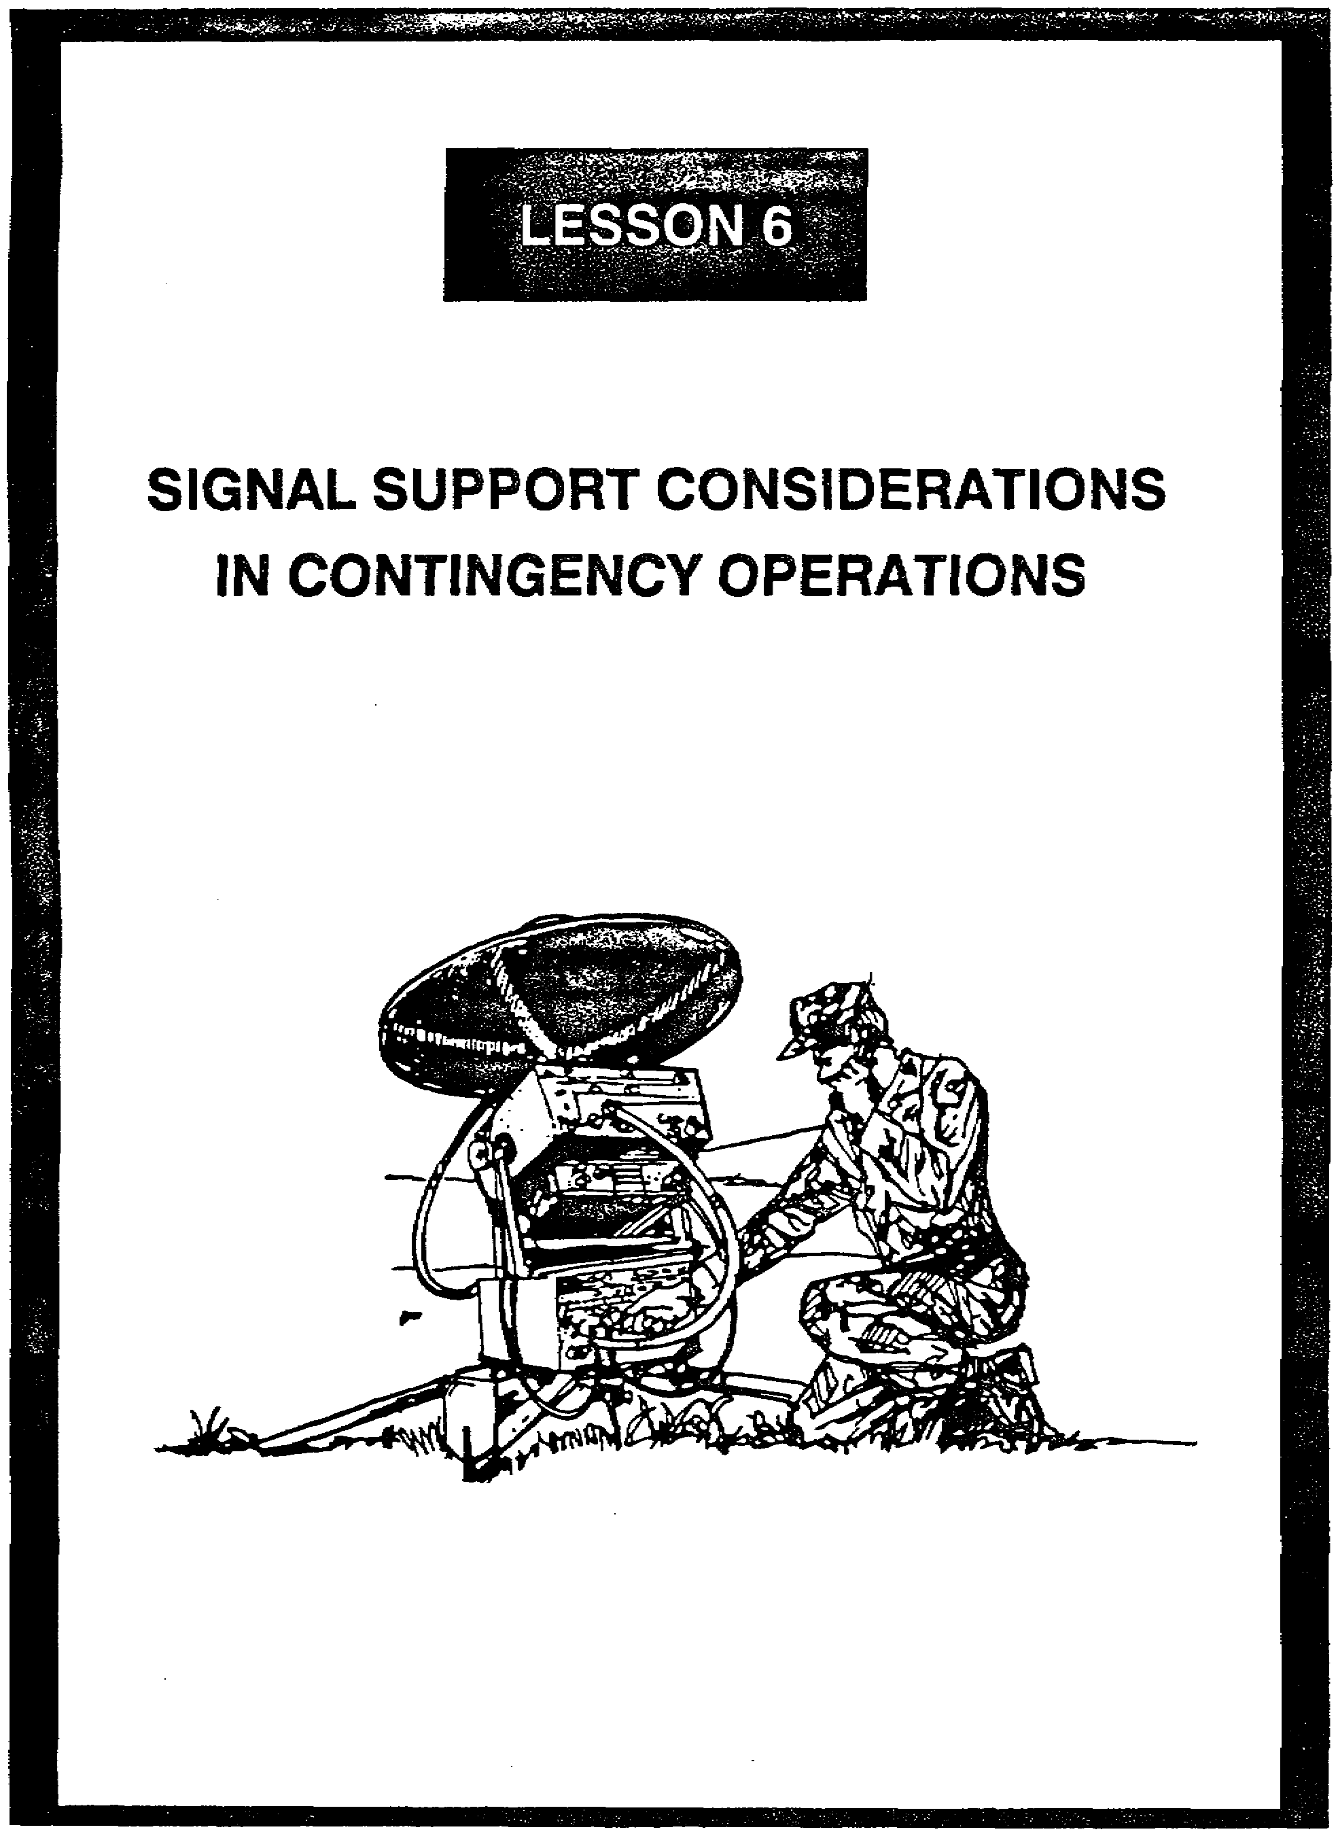

LESSON 6

SIGNAL SUPPORT CONSIDERATIONS
IN CONTINGENCY OPERATIONS

Critical Tasks: 01-5840.07-0002
01-5841.07-0001

OVERVIEW

LESSON DESCRIPTION:

In this lesson, you will learn about the signal support considerations for establishing communications in a developed vice an undeveloped theater. You will also learn the five phases of signal support planning associated with deployment to a low intensity conflict environment.

TERMINAL LEARNING OBJECTIVE:

ACTION: Explain the signal support planning considerations in a low intensity conflict environment.

CONDITION: You will have this lesson.

STANDARD: To demonstrate competency, you must achieve a minimum of 70% on the subcourse examination.

REFERENCES: The material in this lesson was derived from the following publications:
JCS Pub 1-02, FM 24-18, FM 100-20, and FC 11-50-1.

INTRODUCTION

Low intensity conflict (LIC) is a political-military confrontation between contending states or groups below conventional war and above the routine, peaceful competition among states. LIC frequently involves protracted struggles of competing principles and ideologies. LIC ranges from subversion to the use of armed force. It is waged by a combination of means, employing political, economic, informational, and military instruments. LICs are often localized, generally in the Third World, but contain regional and global security implications.

6-1 SS0120

LIC focuses on a nonlinear battlefield that is oriented on activities and the enemy, rather than on terrain (JCS Pub 1-02). Unfavorable LIC outcomes may gradually isolate the United States (U.S.), its allies, and its global trading partners from each other and from the world community (FM 100-20). Unfavorable LIC outcomes may also cause:

• The loss of U.S. access to strategic energy reserves and other natural resources.

• The loss of U.S. military basing, transit, and access rights.

• The movement of U.S. allies to positions of accommodation with hostile groups.

• The gain of long-term advantages for U.S. adversaries.

Conversely, successful LIC operations, consistent with U.S. interests and laws, can advance U.S. international goals such as the growth of freedom, democratic institutions, and free market economies.

The Army's involvement in LIC has grown in the last decade. Operations in 1983 in Grenada (Operation Urgent Fury) and in 1989 in Panama (Operation Just Cause) are two examples of the use of military force to protect U.S. interests. U.S. military personnel also serve with United Nations peacekeeping forces and the internal defense and development operations of various countries.

PART A - SIGNAL SUPPORT IN A LIC ENVIRONMENT

1. General. The type of communications support provided to units deployed to a LIC environment will depend on the mission, the size and type of force deployed, the location and type of terrain, and the indigenous facilities. The signal unit deployed will be tailored to meet communications needs, based on these factors. The Army must be prepared to operate in any developed or underdeveloped theater.

2. Developed Theater. Communications support in a developed theater may be considerably easier to provide than in an underdeveloped area. A developed theater will probably have a usable infrastructure, with a transportation network (roads, port facilities, rail lines, and airports) and communications systems. Coordination can be made with host country officials for the military use of telecommunications facilities (radio and television) to support LIC operations. In an insurgency scenario, broadcast facilities are usually targets for the insurgents, so special security precautions must be considered. Detailed frequency management planning must occur to preclude mutual interference.

SS0120 6-2

3. Undeveloped Theater. LIC operations in an undeveloped area can pose many difficulties for signal soldiers. The operational boundaries in this environment may not be clearly defined in terms of a linear battlefield, from the communications zone (COMMZ) to the forward line of own troops (FLOT). Instead, there may be numerous, isolated pockets of activity that are marked by frequent changes in signal support needs. The following environments are examples of where LIC contingencies may occur, along with some specific signal considerations:

a. Many nations are found in desert regions. Operation Desert Shield/Storm is the supreme example of the modern Army operating in a harsh desert environment. Extreme heat and dust take their toll on signal equipment and grounding is difficult.

(1) Radio propagation varies greatly, depending on the contour of the desert area of operations. Flat areas allow the signal to transmit unimpeded, while rugged, hilly terrain can mask it. To overcome extended ranges or obstacles, it will be necessary to establish retransmission sites. Radios will overheat and become nonfunctional if not kept out of the direct sunlight. Radios can be cooled by shading them and covering them with a damp towel.

(2) Wire may be used in static situations. Care should be exercised to ensure it is laid properly and out of the path of vehicular traffic. Troubleshooting a broken wire line at night takes much time and effort.

b. Jungle operations pose especially difficult conditions for signal support. Heat and humidity slow down soldiers and adversely affect equipment.

(1) The thick jungle vegetation can reduce the effectiveness of radio by reducing the range through absorption. If possible, locate the antenna near a clearing and as high as possible.

(2) The use of wire in the jungle is limited due to the difficulty in laying and recovering it. In addition, wire is very susceptible to enemy tapping.

c. Mountain operations can be extremely challenging for signal soldiers. Particularly difficult is establishing equipment on level ground and operating in the thinner air. Grounding can be a problem, especially if the terrain is very rocky.

(1) Line-of-sight (LOS) radio paths are difficult to achieve in mountainous terrain; therefore, relay stations are necessary to overcome terrain restrictions.

(2) Wire is very reliable in this environment, although it can be difficult to lay and maintain during winter months.

6-3 SS0120

PART B - SIGNAL SUPPORT PLANNING

1. The signal support planning associated with deployment to a LIC environment is comprised of five phases: predeployment, strategic deployment, tactical deployment, tactical employment, and sustainment operations. These phases are described below and in FC 11-50-1, Combat Communications Within the Light Infantry Division.

2. Predeployment Communications.

a. Deploying units and supporting organizations must take maximum advantage of the existing continental U.S. (CONUS) TDA and commercial infrastructure (in-place systems) and minimize the exposure of tactical communications to intercept. It is particularly important at this phase to emphasize the use of either automatic secure voice communications (AUTOSEVOCOM) or locally secured telephones, teletypewriter/data or automatic digital network (AUTODIN), and courier systems. These measures combine to protect the security of the planned operation and to free tactical communications systems for deployment. Table 6-1 contrasts predeployment missions and possible communications means. Note that tactical equipment is not used during this phase.

Table 6-1. Predeployment missions and communications means

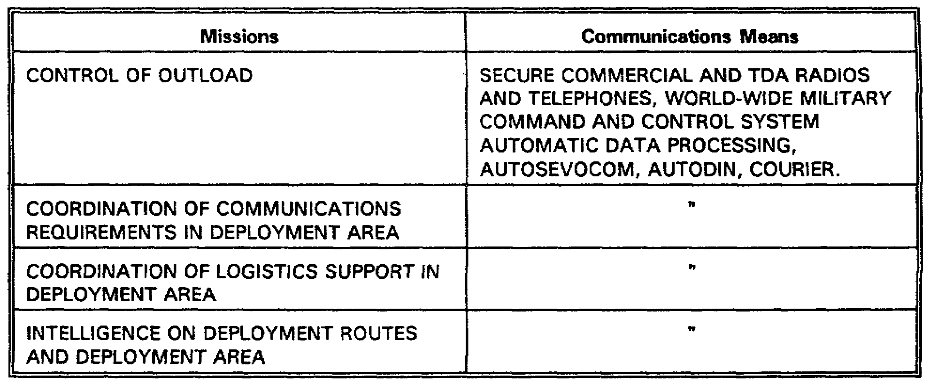

b. Tactical satellite (TACSAT) terminals should not be committed for administrative communications unless they can be quickly recovered and redeployed. These limited assets are critical in the initial deployment and employment phases because of their high mobility and ease of operation in almost any worldwide location.

SS0120 6-4

3. Strategic Deployment Communications.

a. Operations security (OPSEC) and free tactical communications systems are sustained by continued use of infrastructure and transportation services communications means. For example, ships normally remain in radio contact with the Navy area commander, either through ship-to-ship communications or through Navy communications stations ashore. Similarly, each deployed Military Airlift Command (MAC) airlift control element (ALCE) maintains contact with MAC headquarters in CONUS and with other MAC ALCE teams at intermediate staging bases. Table 6-2 contrasts missions and communication means for strategic deployment.

Table 6-2. Strategic deployment

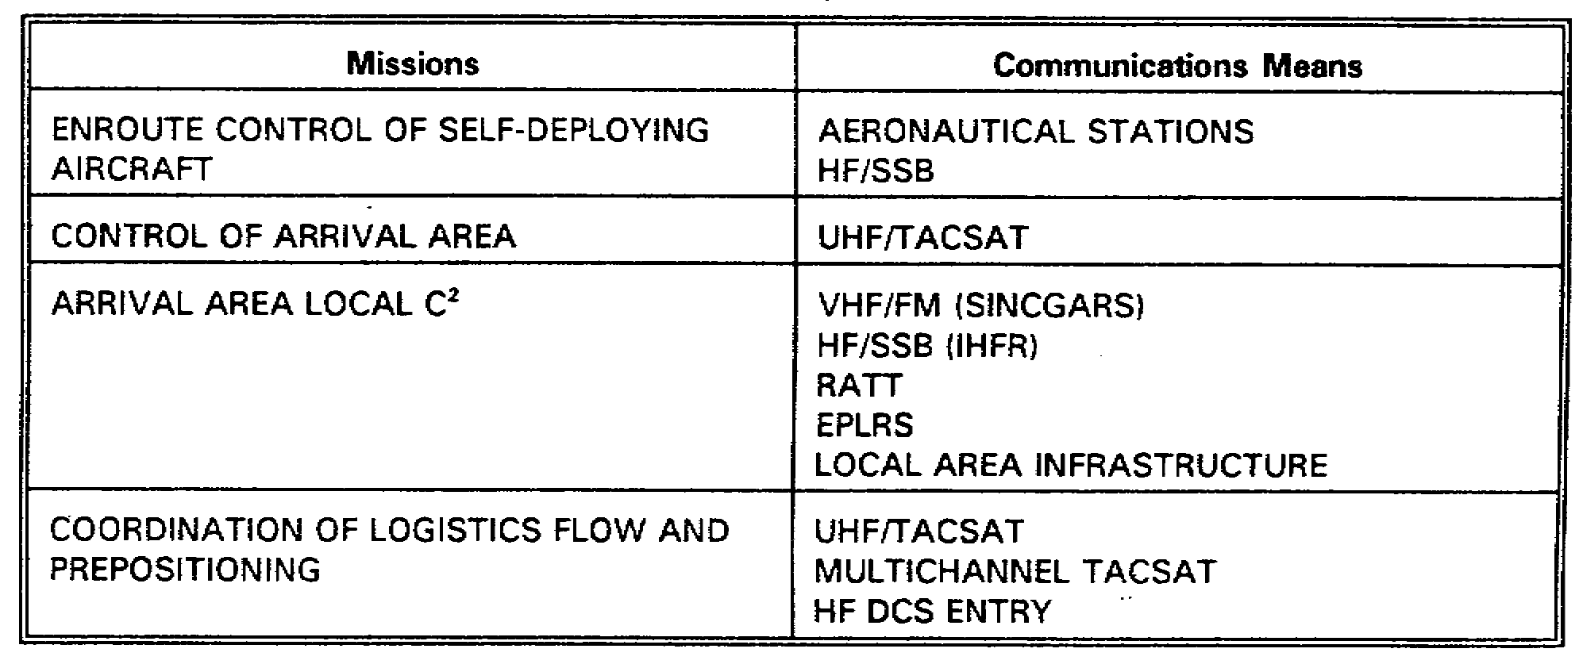

b. Early deployment of a TACSAT terminal into the secure base area provides both direct command and control communications and a means for the commander to access the Defense Communications System (DCS) secure voice network through a DCS gateway contingency station.

c. Deployed units require assistance to access the DCS through either multichannel TACSAT or high power HF DCS entry. DCS access provides automatic voice network (AUTOVON), AUTODIN, secure voice, and Worldwide Military Command and Control System (WWMCCS) access. This capability is not organic to the division and must be provided by the supporting command.

d. Planners must identify mission capability packages as mission planning develops. Incremental deployment may be required based on mission requirements and lift constraints. The essential integrity of communications system packages is retained for mission

6-5 SS0120

accomplishment. For example, the system must include the basic radio, a prime mover, a generator, and operators; otherwise any isolated part is useless. Any sustained operation includes a maintenance package, usually a combination of replacement components, repair parts, tools, and maintenance facility, plus the trained personnel.

4. Tactical Deployment Communications.

a. Combat forces are most vulnerable during the initial phase of tactical deployment. This phase is the process of assembling, uploading and preparing for combat.

b. Communications equipment is deployed forward to ensure essential command, control, and intelligence communications are immediately available upon arrival.

c. The existing infrastructure should continue to be exploited as much as possible, leaving the tactical communications systems free to deploy forward with the combat forces, facilitating evolution into tactical operations.

d. OPSEC is the key to survival as relays or any isolated signal elements are deployed. Wherever possible, deploying teams should move only during periods of limited visibility and should have camouflage systems installed before any opportunity for either direct or overhead observation occurs. Resupply vehicles and routes should be concealed. Failure to observe OPSEC leaves these small teams vulnerable to hostile action and simplifies hostile correlation of data on friendly force deployments.

5. Tactical Employment Communications.

a. U.S. Forces should continue the use of existing communications infrastructure, to include both U.S. and host nation asses (Table 6-3).

Table 6-3. Tactical employment

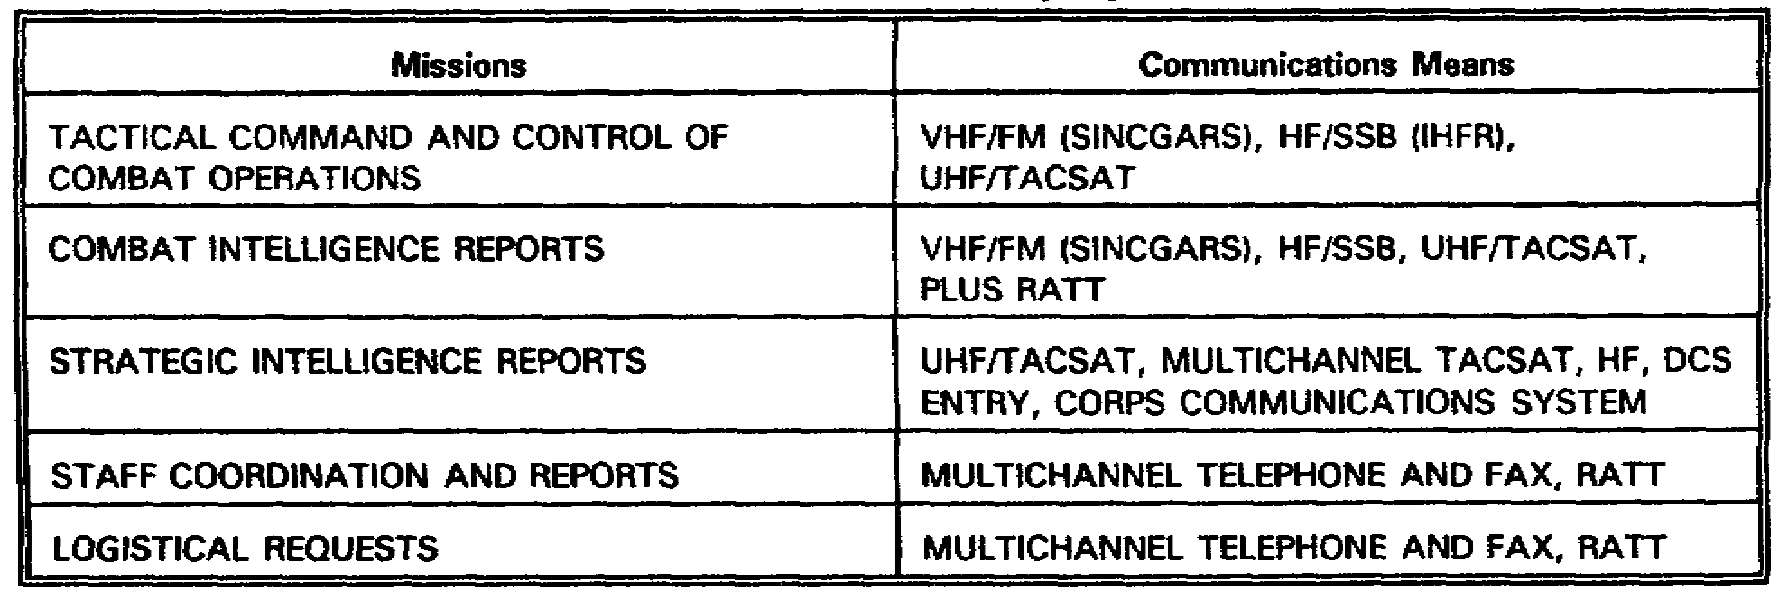

SS0120 6-6

b. Tactical employment reflects the maximum use of tactical communications systems. Any task force (TF) deployed separately should be supported by long-range communications systems from the division signal battalion if assets are available and not committed to a higher priority mission. Because of this uncertainty, each brigade and battalion must be prepared to provide long-range communications using organic HF radio systems. Host nation military and commercial interests in the contingency areas make constant and extensive use of HF radio systems. Figure 6-1 shows the battalion TF communications linkage.

(1) A separate battalion TF, deployed as either the initial combat element of a larger force or as a small force tailored for a short duration and limited mission, initially deploys with organic manpack VHF/FM plus limited vehicular mounted VHF/FM and HF/SSB radio sets if required and if within the movement constraints. If required by the mission, one or two TACSAT teams from the division signal battalion are attached to the TF.

(2) Wire is used to interconnect local elements within command post (CP) areas. However, long wire lines should be avoided because they can be monitored and their installation is extremely time consuming. In addition, the lines are vulnerable to destruction by vandals, track vehicles, or hostile forces. If any wire line is extended outside a secure area, then the entire telephone network must be considered unsecured.

(3) Deployment of a brigade TF is supported by a division CP to provide additional communications and logistical and personnel support. If appropriate, the division CP controls base area operations. The division CP includes a TF signal officer who provides signal planning and technical support directly or through coordination with a supporting signal element. The division TF signal officer exercises operational control of all deployed signal battalion elements. The brigade TF communications system is shown in Figure 6-2, page 6-8.
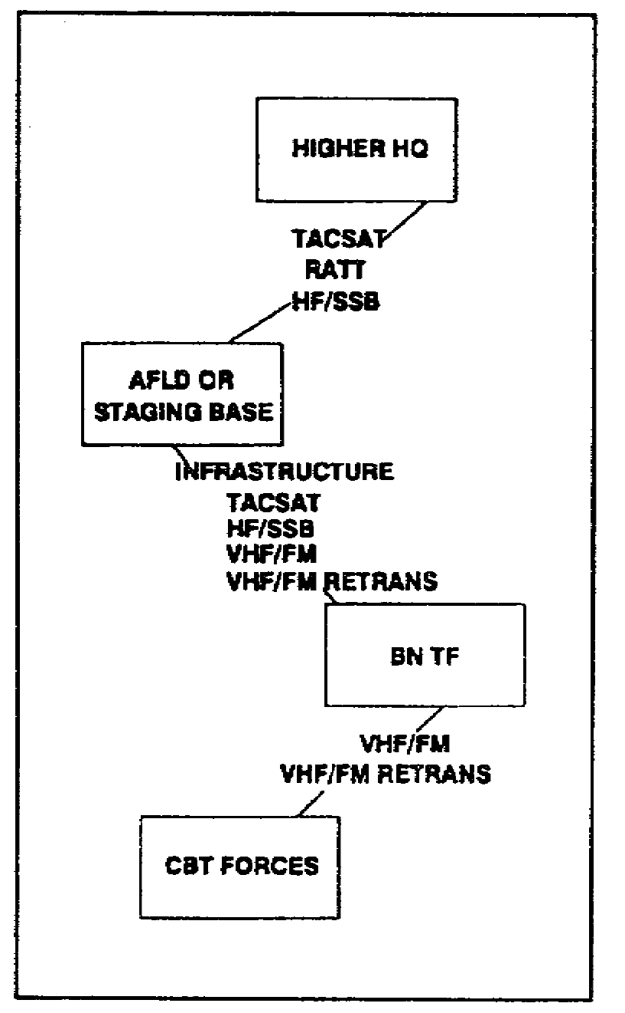

Figure 6-1. Battalion task force communications

6-7 SS0120

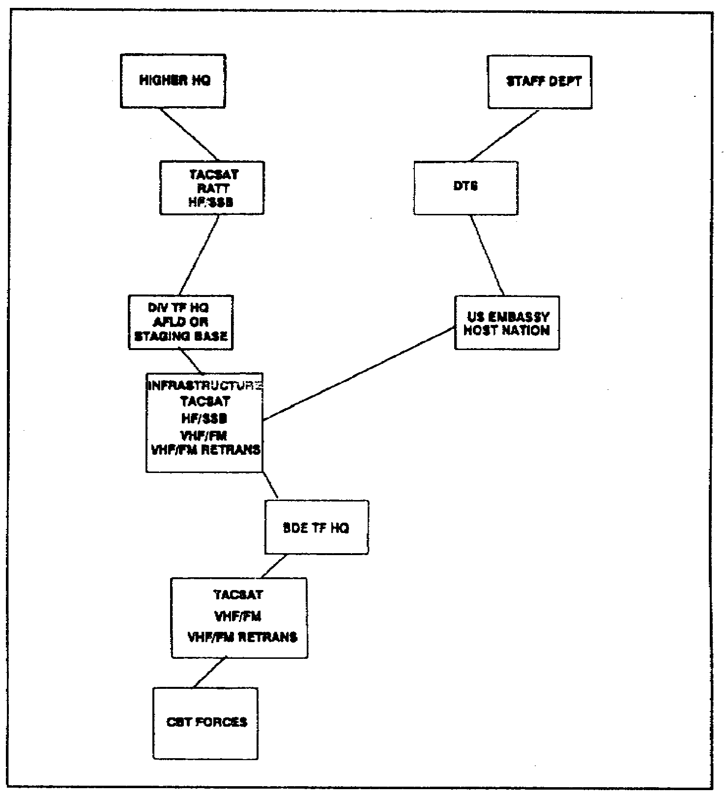

Figure 6-2. Brigade task force communications

(4) The reliability and security of the VHF/FM system should be used to full advantage, to include range extension by means of retransmission stations where required. Multichannel systems should not be deployed unless a requirement for sustained operations communications develops or additional divisional units deploy. Couriers should continue to carry the traffic which is not time sensitive.

(5) As VHF/FM retransmissions are employed, exercise care in antenna siting for best coverage, antenna siting to minimize intercept by hostile forces, resupply and recovery, and frequency management. In general, do not place the retransmission at the very peak of a crest or ridge. Use the higher elevation to mask transmissions from the Threat. Even if the signal is not completely attenuated, the mask distorts the location accuracy for direction finders. Thoughtful positioning allows ingress and egress of helicopters without exposure

SS0120 6-8

over the horizon. Wherever possible, locate sites where they are not dependent upon helicopters for resupply or extraction. Key terrain for radio relay becomes obvious in the course of a mission. Collocation of relays aids in their resupply and protection; however, collocation can offer the Threat a clear target.

(6) Unit signal officers need to take extracts of propagation predictions into the area for management of HF radio frequencies. The senior unit signal officer must control the frequencies used to preclude mutual interference from rendering the relays ineffective. The assistant division signal officer will have both prediction charts and a handheld calculator system for near real-time prediction. A skilled operator with the correct frequencies can maintain communications in the contingency area. The local forces will rely upon HF for non-LOS communications in the area.

c. The division signal battalion provides the division communications system when deployed.

(1) Single-channel TACSAT and VHF/FM are used for most critical command and control and intelligence communications (Figures 6-3 through 6-5, pages 6-10 and 6-11). A Parkhill secured HF/SSB tactical operations center (TOC) net and radio teletypewriter (RATT) provide non-LOS secure communications to all units. It is the only non-LOS system provided to most units because of the shortage of TACSAT assets. The division must take advantage of the reliability and security of the VHF/FM systems. The division must employ secure relays in positions that provide maximum coverage of the divisional area while still masking operations from Threat radio intercept stations.

(2) HF radio operations are significantly enhanced by an aggressive frequency management program, with frequency changes as required by atmospheric or other interference.

(3) A typical multichannel system deployment covers a broad frontal area. However, contingency operations could force the division into an elongated posture, with the deployed brigades as much as hundreds of kilometers in front of the division support area (DSA). It is likely that the multichannel system will require multiple relays to extend the range of the LOS systems. This resulting multichannel system may involve extensive use of relays requiring offload, air movement, and displacement of multichannel equipment. The extended communications ranges may result in a system which does not include DSA-brigade support area (BSA) systems or lateral systems between adjacent units. Rather than the grid-like system of nodes, they may be in a more linear alignment.

6-9 SS0120

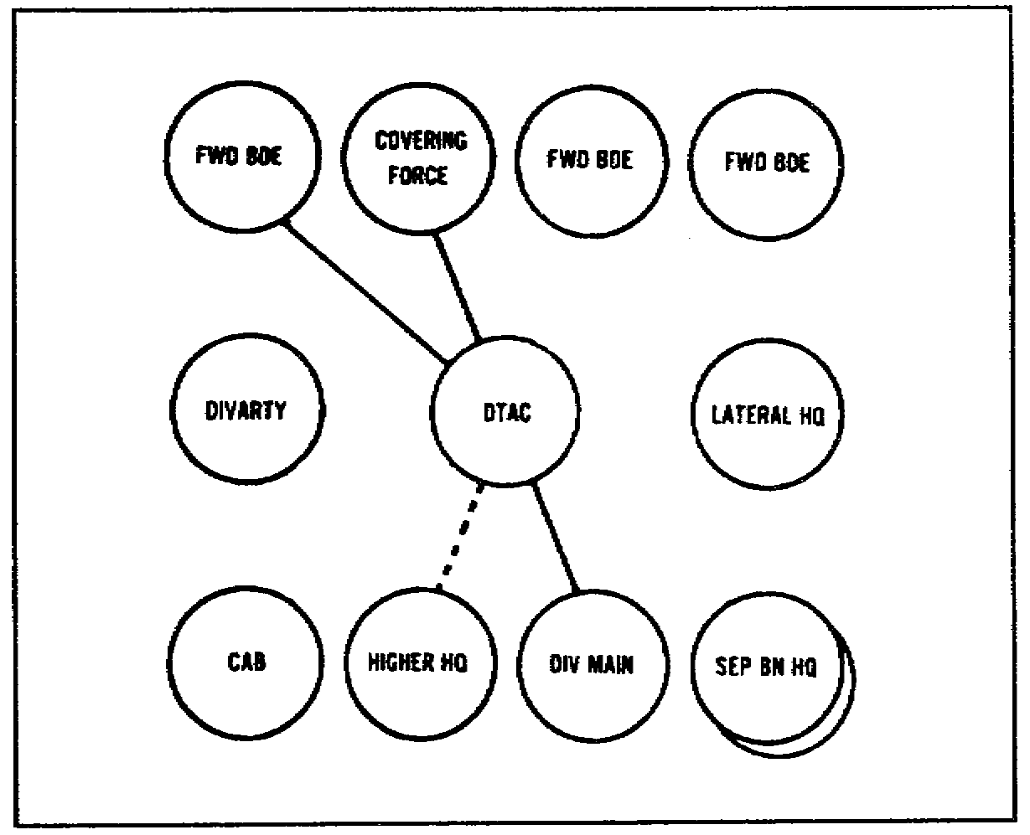

Figure 6-3. Tactical employment of single-channel radio UHF/TACSAT

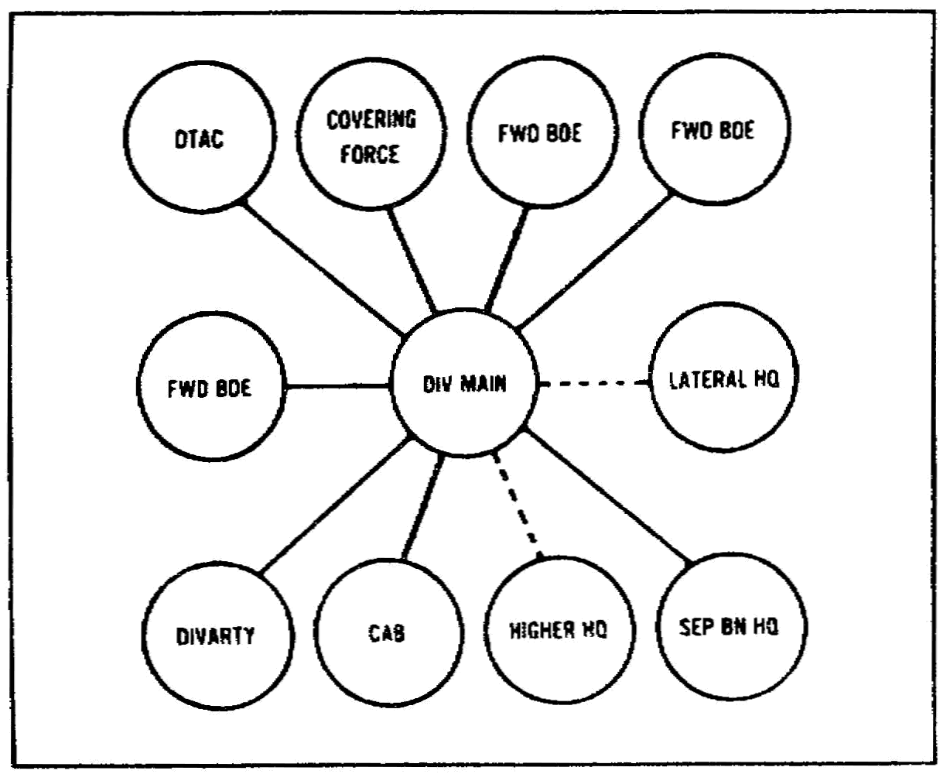

Figure 6-4. Tactical employment of single-channel radio HF/SSB TOC net
and division GP RATT net

SS0120 6-10

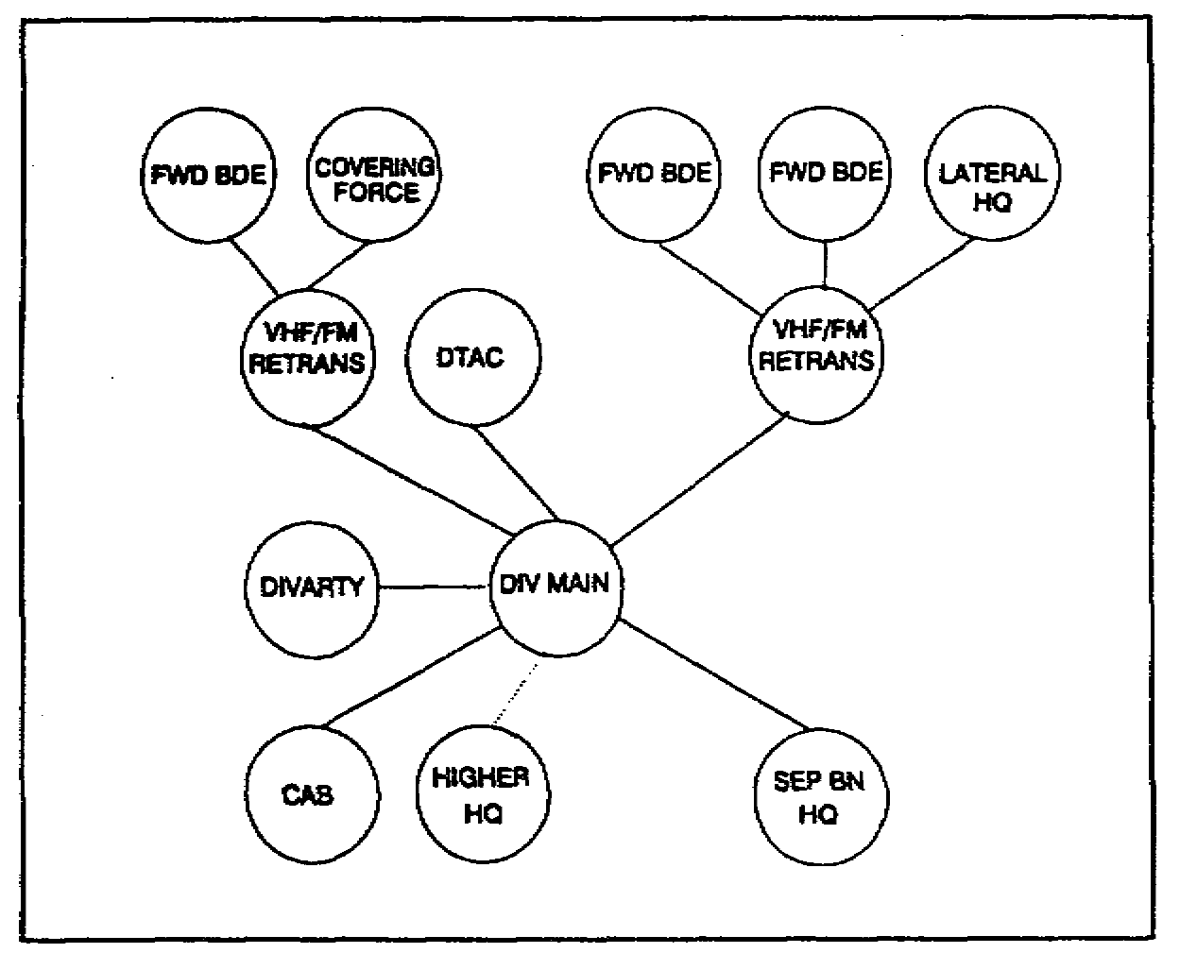

Figure 6-5. Tactical employment division command operations net VHF/FM

(4) The multichannel system does not always connect with the division's rear-most clement, whether it is a rear base or a DSA. Facsimile replaces internal land line teletype operations. Telephone and facsimile operations are secured with the protected wire line distribution system. Since the VHF/FM retransmission and the multichannel relays generally support the same headquarters, they are often collocated on favorable terrain.

(5) Electronic counter-countermeasures (ECCM) are critical to successful operations. Users must evade electronic intercept to avoid direct physical attack and jamming. Antenna siting and minimizing radio transmissions are the key elements for tactical ECCM. Each unit should include these elements in their communications battle drill.

(6) Liaison teams must be provided adequate communications back to their sponsoring headquarters when they are dispatched to lateral or other headquarters. In the best cases, the existing telephone and message network will be adequate. However, in most tactical situations, the only communications will probably be through the radio that the liaison team brings from their own organic assets. The radio must be adequate for the communications ranges, and the team must be provided signal operation instructions (SOI) and COMSEC or operations code material before departure.

6-11 SS0120

(7) Higher capacity communications may be provided to corps artillery and air defense units operating in the division area. The wide dispersion of assets may require extension of the division multichannel system to these units, or they may be collocated with the division artillery or the division air defense battalion, as appropriate. These measures ensure that the corps Tactical Fire Direction System (TACFIRE) network and the joint automated air warning network are made available to the division.

(8) Airspace management communications must be coordinated between the division air management element (DAME) and any combined or joint air operations in the area. The appropriate interface with air defense and artillery fire control center must also be coordinated.

6. Sustaining Operations Communications.

a. During sustaining operations, communications and COMSEC direct support maintenance facilities must be deployed forward in the division main area to ensure reliable operation of the secure communications systems. Figure 6-6 shows the sustainment communications system.

b. The development of supporting high capacity communications for the logistics base and high capacity systems linking that base and the deployed division is essential.

c. An expanded base communications system, to include the use of local infrastructure on a contract basis, and an expanded DCS access are required to fully support sustaining operations.

d. The division support command (DISCOM) commander or other specified commander is tasked to control rear area security. If required, the logistics nets and communications lines must be prepared to support limited combat operations. Major operations require augmentation of combat forces and their communications means, and possible augmentation from either division or higher headquarters.

e. The BSA and DSA are normally added into the division multichannel system in the initial deployment of the multichannel system. However, that may be deferred, depending on the timing of DSA or BSA moves through the operational area and their locations relative to the Threat force. In addition to the multichannel system, the division signal battalion installs a separate general RATT net to provide hard-copy communications traffic between the DSA and the BSA.

SS0120 6-12

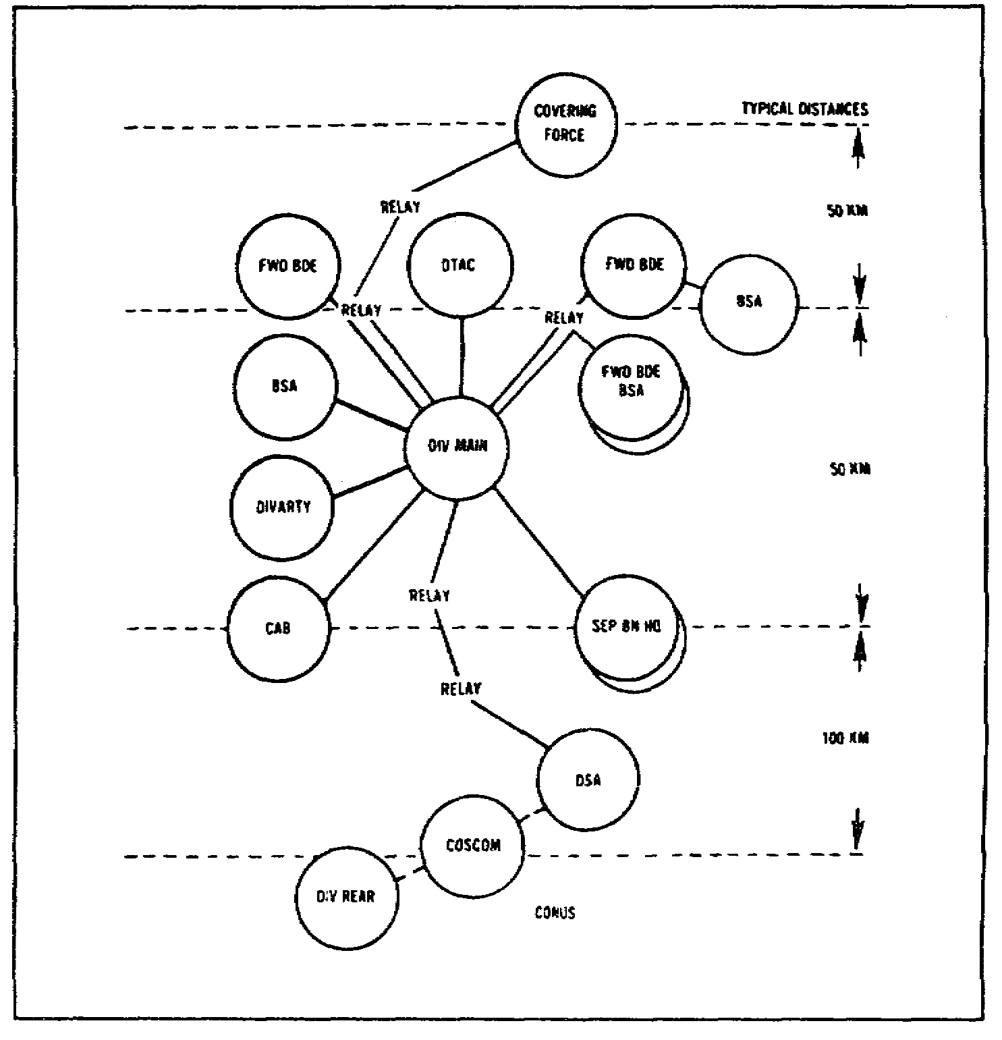

Figure 6-6. Sustainment communications system

PART C - SUMMARY

1. In this lesson, you learned about the signal considerations in supporting a unit in LIC operations. Providing communications support to units deployed to a LIC conflict will depend on the mission, the number and type of force deployed, the location and type of terrain, and indigenous facilities. Depending on these factors, the deployed signal unit will be specifically designed and tailored to meet the needs of the involved TF. This tailoring provides flexibility and versatility in supplying the proper communications equipment and personnel to meet the communications requirements and conserves signal resources. No single grouping of signal units can be developed which will satisfy all LIC requirements.

6-13 SS0120

2. a. LIC operations in a developed theater allows the use of the host nation's infrastructure (radio, TV, and telephone systems).

b. LIC operations in an underdeveloped theater are marked by frequent changes in signal support needs. In addition, harsh environments take their toll on soldiers and equipment.

(1) Desert operations present an increased challenge to the signal officer, as he works to battle the effects of heat and dust on radios.

(2) Jungle missions adversely affect radio operations. Jungle vegetation reduces radio range and heat and humidity slow down soldiers and adversely affect equipment.

(3) Mountain operations slow soldiers down. LOS paths are difficult to achieve in the mountains and a retransmission station is often needed.

3. Signal Support Planning. Five phases comprise signal support planning.

a. The predeployment phase emphasizes the use of CONUS infrastructure communications systems and minimizes the use of tactical signal systems.

b. Strategic deployment is noted for the use of infrastructure and transportation services communications means. Ships and planes can communicate with their controlling authority using their systems. TACSAT, RATT, EPLRS, and infrastructure systems are used upon arrival in the area of operation.

c. Tactical deployment is the phase when signal equipment is deployed forward, as forces prepare for combat. Infrastructure systems continue to be exploited in the rear.

d. Tactical employment reflects the maximum use of tactical systems. Command and control is served by VHF/FM (SINCGARS), HF (IHFR) and UHF/TACSAT, plus multichannel and RATT.

e. Sustaining operations communications links the deployed division and the logistics base. Communications and direct support maintenance facilities are deployed forward in the division to provide needed support. The base communications systems expand - exploiting the infrastructure system and increasing DCS use.

SS0120 6-14

LESSON 6

PRACTICE EXERCISE

The following items will test your grasp of the material covered in this lesson. There is only one correct answer for each item. When you complete the exercise, check your answer with the answer key that follows. If you answer any item incorrectly, study again that part of the lesson which contains the portion involved.

1. In low intensity conflict (LIC) operations, the operational boundaries of the battlefield are clearly defined in terms of a linear battlefield.

A. True.
B. False.

2. During the predeployment phase of signal support planning, the maximum use of tactical equipment is recommended.

A. True.
B. False.

3. In a secure base area of a LIC environment, a commander can access the Defense Communications System (DCS) by using a __________ terminal.

A. TACSAT.
B. SINCGARS.
C. EPLRS.
D. None of the above.

4. Once the tactical communications systems arrive on site in a LIC environment, use of infrastructure communications systems ceases.

A. True.
B. False.

5. When establishing a retransmission site, you should always place the antennas at the top of a hill.

A. True.
B. False

6-15 SS0120

6. In most tactical situations, the liaison team sent to a brigade will communicate with its sponsoring headquarters using __________.

A. Host nation infrastructure telephones.
B. Brigade organic communications.
C. Defense Communications Agency systems.
D. Organic radio assets the team brings.

7. The DISCOM commander can expect to be tasked to control rear area security during sustaining operations.

A. True.
B. False.

8. During tactical employment, __________ replaces internal land line teletype operations.

A. VHF/FM retransmission.
B. Facsimile.
C. TACSAT.
D. HF/SSB.

9. An advantage of establishing communications in a developed theater versus an undeveloped theater is the use of the host nation infrastructure (transportation network and communications systems).

A. True.
B. False.

10. In jungle operations, the range of a radio signal is reduced because of __________.

A. Heat.
B. Thick vegetation.
C. Humidity.
D. Sunspot activity.

11. The phase of signal support planning when signal equipment is deployed forward, as forces prepare for combat, is __________.

A. Tactical employment.
B. Tactical deployment.
C. Predeployment.
D. Strategic deployment.

SS0120 6-16

LESSON 6

PRACTICE EXERCISE

ANSWER KEY AND FEEDBACK

Item Correct Answer and Feedback

1. B. False.

LIC focuses on a nonlinear battlefield that is oriented on activities and the enemy, rather than on terrain. (page 6-2, Introduction)

2. B. False.

Tactical equipment is not used during the predeployment phase.
(page 6-4, para 1a)

3. A. TACSAT.

In a secure base area of a LIC environment, a commander can access the Defense Communications System (DCS) by using a TACSAT terminal. Deployed units require assistance to access the DCS through either multichannel TACSAT or high power HF DCS entry. (page 6-5, para 2b and c)

4. B. False.

U.S. Forces should continue the use of existing communications infrastructure, to include both U.S. and host nation assets. (page 6-6, para 4a)

5. B. False.

In general, do not place the retransmission at the very peak of a crest or ridge.
(page 6-8, para 4b(5))

6-17 SS0120

6. D. Organic radio assets the team brings.

In most tactical situations, the only communications will probably be through the radio that the liaison team brings from their own organic assets.
(page 6-10, para 4c(6))

7. A. True.

The DISCOM commander or other specified commander is tasked to control rear area security during sustaining operations. (page 6-12, para 5d)

8. B. Facsimile.

Facsimile replaces internal land line teletype operations. (page 6-11, para 4c(4))

9. A. True.

Communications support in a developed theater may be considerably easier to provide than in an underdeveloped area. A developed theater will probably have a usable infrastructure, with a transportation network (roads, port facilities, rail lines, and airports) and communications systems. (page 6-2, para 2)

10. B. Thick vegetation.

The thick jungle vegetation can reduce the effectiveness of radio by reducing the range through absorption. (page 6-3, para 3b(1))

11. B. Tactical deployment.

Tactical deployment is the phase when communications equipment is deployed forward to ensure essential command, control, and intelligence communications are immediately available upon arrival. (page 6-6, para 3b)

SS0120 6-18

